John – a casual gamer that does not play all the time and needs help to find games he might like.

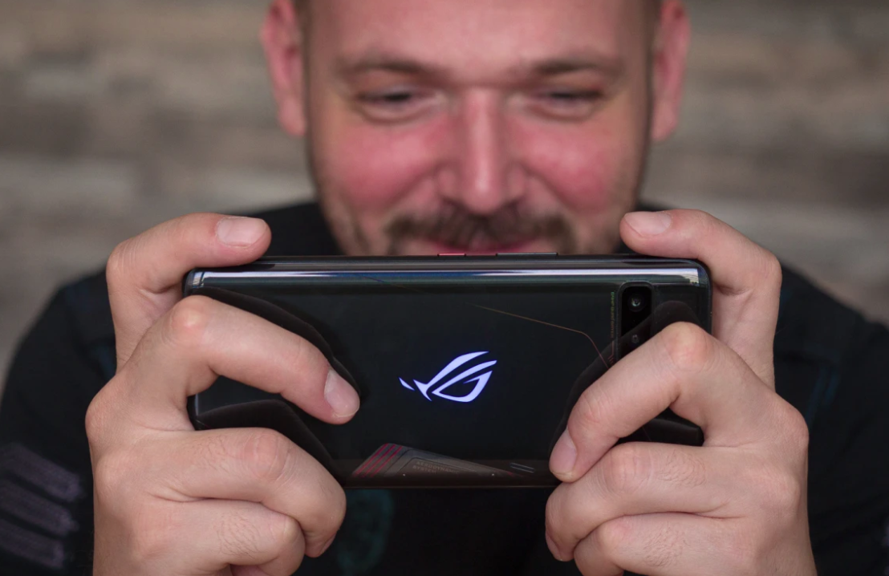

Traits - Age group(18-30), disposable income

We got this data by researching the age group that is most enthusiastic about gaming.

From within this age group, we wanted to make it more specific, so we chose a persona where the person is more of a casual gamer that wants to get more into gaming, and also has a high disposable income.

We found that these two traits would often correlate with each other.

<https://www.gamingscan.com/gaming-statistics/>