Lauren Hayward: Group Organization, Report, Backend, Communication

The main problems facing this project are organization, communication and the introduction to many new languages and functunalities. We need to coordinate 5 people, in which no single person knows everything about the project or how every utility works.

To combat this, I took it upon myself to facilitate organization and communication, as well as doing work in the Backend section, and giving structure regarding the project report.

Group Organization

It turns out group creation is stressful when you take responsibility for the group from the very start. Our group formed over a couple of days, with people joining as I heard of people I knew who still needed a group. Originally we were 6 members, but after 2 of those members were poached by another group, I replaced one of them and we were 5.

I then spoke to everyone, finding out who was interested in what. I knew that Sarah had been doing a internship a AWS over the previous holiday, working in web design, which made her a natural fit for front-end. I knew I wanted to do backend work, so I assigned that to myself and Christiaan. I paired Johan and Adam for what we jokingly called “middle”-end, being any auxilary sorting, filtering etc that was needed by any of the other components.

Now with our roles assigned, I briefed Sarah on what she could expect so that she could start working on a temporary website. I told her to figure out input fields in Flask. Then, I immediately started working on getting the database up and running. As we all know, Neo4j was not being friendly, and this process took very long. I consider this a great disappointment, as I really wanted to start working immediately. Once things were set up, I could finally start to understand how the project would practically work. At this point, I set up skeleton code for the various subgroups to start working on.

Report:

Early on I created a template for the individual reports, to make our reports more alike and to make it easier for everyone to write them. I also outlined what our report should consist of, and how long each section should be.

Later, I wrote the High Level Design (sort of) as Medium describes. I also wrote a section in which I illutrate which pieces of code satisfy the various parts of the spec. This was done to make our project easier to mark.

Backend:

Learning to write Cypher was daunting at first, but fun once I knew where I could find information. I combed through the Cypher Manual, figuring out commands as I needed to. I used the Neo4j Browser to test Cypher in real-time and learn. We used Py2neo, and I regularly read up on the Py2neo Handbook for how to use it.

I wrote the basis for most of the code in the backend section, however, both Christiaan and Johan fixed/improved my functions. After many iterations, we were left with:

Fetches all the restaurants in a given city and cuisine type.
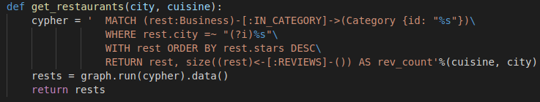
Fetches all the reviews of a given restaurant.
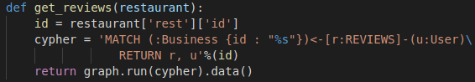
Fetches all the friends and friends of friends of a given user, capped at 50 people.
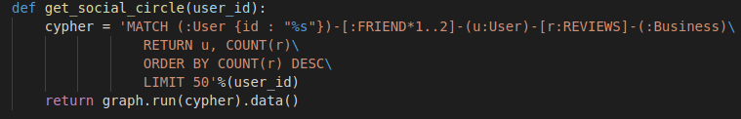
Fetches all reviews of restaurants in the given city and cuisine, made by the group described above.
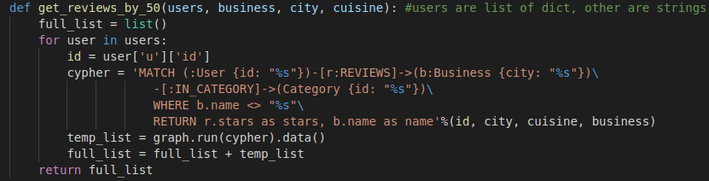
Fetches all food images of a given restaurant.
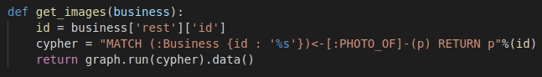
Johan also wrote some Cypher for use in the Web App:
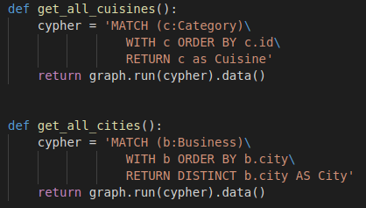

Besides working on Backend stuff, I was also testing the project as we were working and therefore I was picking up on bugs in the Middle section. Some of these bugs Christiaan fixed, some Johan fixed and some Adam fixed.

Communication:

We used various streams through which to communicate.

At the very beginning we created a Whatsapp group. We continued to use this group consistently. While it was very useful, I found it to be like talking into a void at times. I like to keep everyone up to date, letting the group know about any large breakthroughs. However, it would usually be met by no reaction and no one else regularly updated everyone else unless specifically asked.

Sarah suggested we use a Trello Board, which I then got her to make. This was very handy in the start, to get things going and assign everyone something to do. It fell out of use as the project progressed, as the work we were doing become more fluid and not easily defined anymore.

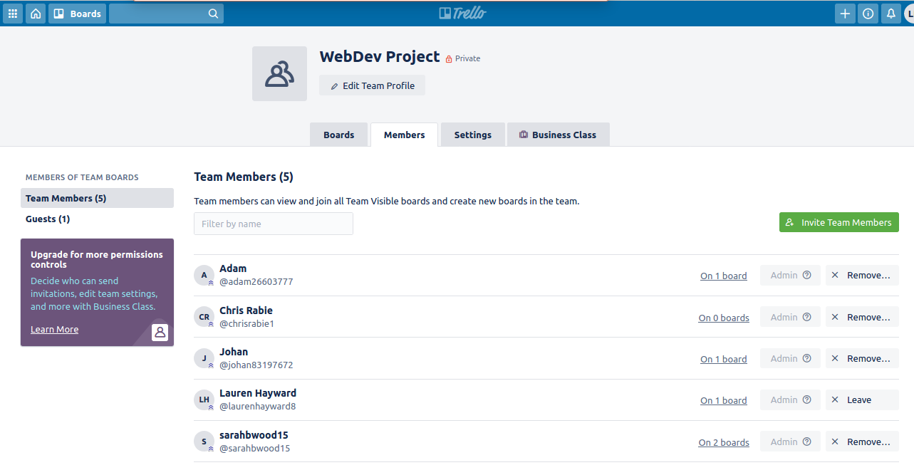
I also emailed my group twice, both times to do with the report. The first time I was simply notifying them of the templates I made for the individual reports, and the second time was to share a link to an online document through which we could all work on the report simultaneously. Both of these could been shared on Whatsapp, but I thought it might get lost in the flow of messages.

Finally, we also had one group meeting on Discord. This was great to get everyone back on track after the confusion that was the end of term and lockdown. I ran through everything we had done already, and made sure everyone knew what still needed to be done.

My Conclusion:

I think this project is too small for the recommended 6 people. Me reasonings:

When there are so many people, it makes communication so much harder. If there were just three people, then each person could be in charge of one componenet and just have to communicate what they were doing in their own section. We experienced a lot of work being done twice because we didn’t know that someone else had already done it elsewhere. I will accept that this could just be down to bad communication. However, I also don’t think it was really enough work for 6 people. If we had more work, we would probably have done this project faster. Feeling like things are “chilled” isn’t good for productivity.

I really enjoyed this project, and I’m very thankful for being introduced to databases and Neo4j specifically. Given more time, I would have liked to integrate Google Maps into our project to give the user directions to their Restaurant of choice.

