CUSTOMER CHURN ANALYSIS
Predictive Modeling and Retention Strategy for a 1,000,000-Customer Telecom Base
Business & Technical Report
July 19, 2026
Source: customer_churn_1M.csv (1,000,000 rows × 32 columns) · customer_churn_prediction_1.ipynb

1. Executive Summary
This report presents a full-cycle churn analysis of 1,000,000 telecom customers, of whom 9.92% (99,227) churned. The work covered data quality auditing, missing-value analysis, exploratory statistics, and the training and comparison of four machine-learning models, culminating in a risk-scoring framework and a costed retention business case.
Contract type is the dominant churn driver. Month-to-month customers churn at 26.5% — more than double the one-year rate (12.7%) and nearly five times the two-year rate (5.7%). Behavioral signals of dissatisfaction — lower satisfaction scores, more complaints, more service calls, and more late payments — are the strongest individual-level predictors.
The best model, LightGBM, delivers a 2.5x lift. Customers in the top-scoring risk decile churn at 24.6% versus the 9.9% baseline, and the top 20% of customers by score contain roughly 40% of all churners. Model discrimination overall is moderate (ROC-AUC 0.685, PR-AUC 0.205 against a 0.099 baseline), which is sufficient for targeting but leaves headroom for improvement.
The retention economics are attractive. Targeting the top 20% highest-risk customers with a $50 retention offer, and assuming 30% of contacted would-be churners are saved, yields an estimated $2.99M net savings per scoring cycle on the 200,000-customer test set — a 150% return on the $2.0M offer cost. Scaled to the full 1M-customer base on a monthly cadence, projected annual savings are on the order of $36M, subject to A/B validation of the 30% save-rate assumption.
Recommended immediate actions: launch contract-conversion incentives for month-to-month customers, trigger proactive outreach after a second complaint or third service call, and operationalize weekly model scoring with an A/B-tested retention workflow for the top risk segment.

2. Data Overview and Quality Audit

2.1 Dataset
The dataset contains 1,000,000 customer records with 32 attributes spanning demographics (age, gender, income, education, marital status, dependents, senior-citizen flag), account characteristics (signup date, tenure, contract type, payment method, paperless billing), service subscriptions (phone, internet, security, backup, device protection, tech support, streaming), billing (monthly and total charges), and behavioral indicators (satisfaction score, complaints, service calls, late payments, average monthly data usage, days since last interaction, credit score). The binary target, churn, has a 9.92% positive rate — a roughly 9:1 class imbalance that shaped every downstream modeling decision.

2.2 Integrity checks
The audit confirmed no duplicate or null customer IDs, no out-of-range values in the numeric fields, and no unexpected categories in any categorical column. Five columns contain missing values:
Column | Missing count | Missing %
avg_monthly_gb | 50,012 | 5.00%
credit_score | 40,395 | 4.04%
annual_income | 29,959 | 3.00%
num_complaints | 29,906 | 2.99%
customer_satisfaction | 19,921 | 1.99%

2.3 Missingness mechanism
Missingness was tested against both the target and other observed features. Churn rates were virtually identical for records with and without missing values (e.g., 9.92% vs 9.91% for annual_income), and while 3 of 25 missingness-vs-feature association tests returned p < 0.05, effect sizes were trivial (differences under 0.5 percentage points, or under $0.50 on an $86 average) — consistent with large-sample statistical noise at n = 1,000,000. Missingness was therefore treated as missing completely at random (MCAR), and median imputation was applied to all five columns. Median rather than mean was chosen because the affected variables are right-skewed.

3. Exploratory Findings

3.1 Distributions and outliers
Most numeric features are right-skewed: monthlycharges (skew 6.6) and avg_monthly_gb (3.4) most heavily, with days_since_last_interaction, annual_income, late_payments, totalcharges, complaints, dependents, tenure, and service calls moderately skewed (1–2). Age, credit score, and satisfaction are approximately symmetric. Boxplot review concluded that apparent outliers — premium-plan charges above $200, data usage above 300 GB, high service-call counts — are plausible real behavior and potentially informative churn signals, so they were retained (with winsorization at the 1st/99th percentiles noted as the planned treatment for extreme data usage). Because the final models are tree-based, no skew-correcting transformations were required.

3.2 Which features separate churners?
Welch t-tests with Cohen’s d ranked the numeric features by their ability to separate churners from non-churners:
Feature | Mean (stay) | Mean (churn) | Cohen's d | Effect
customer_satisfaction | 6.24 | 5.59 | 0.272 | Small
num_complaints | 0.69 | 0.91 | 0.249 | Small
num_service_calls | 1.72 | 2.11 | 0.244 | Small
late_payments | 0.39 | 0.49 | 0.152 | Small
num_services | 2.58 | 2.42 | 0.114 | Small
totalcharges | 1,847 | 1,748 | 0.056 | Negligible
monthlycharges | 86.57 | 85.29 | 0.046 | Negligible
tenure | 22.5 | 21.6 | 0.043 | Negligible
annual_income / age / credit_score / others | — | — | < 0.02 | Negligible

The behavioral cluster — satisfaction, complaints, service calls, and late payments — carries the clearest individual signal (all p < 1e-250). No single numeric feature is strongly separating on its own, which foreshadows the moderate model performance: churn in this dataset is driven by the accumulation of many weak signals plus contract type, rather than by one dominant continuous variable.

3.3 Categorical drivers
Among categorical features, contract type is by far the strongest association with churn (chi-squared 19,508, Cramér’s V = 0.14); every other categorical feature — education, marital status, payment method, paperless billing, gender, senior citizen — shows a Cramér’s V at or below 0.002, i.e., effectively no marginal association at this sample size.
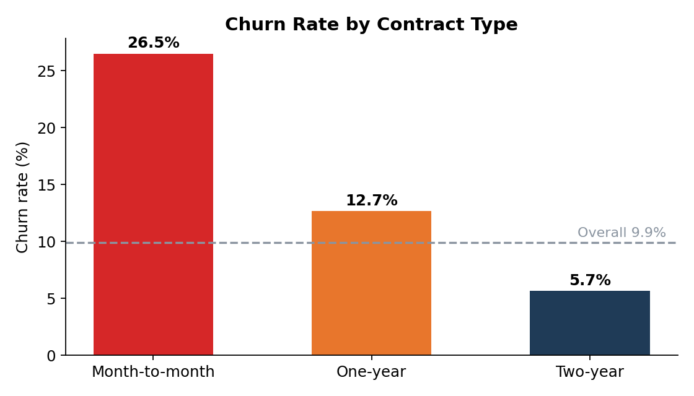
Figure 1. Churn rate by contract type (verified directly against the source data).
Note: the notebook’s narrative commentary describes senior_citizen, paperless_billing, and payment_method as moderate churn drivers, but the notebook’s own chi-squared output (above) does not support this — their associations are negligible. This report follows the computed results. Interaction heatmaps (contract × senior citizen, contract × tenure) confirm that contract type dominates: month-to-month customers with under six months of tenure are the highest-risk segment, while two-year contract holders churn at consistently low rates regardless of tenure or age.

3.4 Multicollinearity
totalcharges, monthlycharges, and tenure form a collinear triplet (r ≈ 0.83–0.85), as totalcharges is essentially the product of the other two. totalcharges was dropped prior to modeling to stabilize the linear baseline and simplify interpretation.

4. Modeling Methodology

4.1 Feature engineering and split
The final feature matrix contained 34 features after dropping customer_id (identifier), signup_date (redundant with tenure), and totalcharges (collinear). Education was ordinal-encoded on its natural five-level order; gender, marital status, contract, payment method, and paperless billing were one-hot encoded with k−1 dummies. The data was split 80/20 (800,000 train / 200,000 test) with stratification on the target, preserving the 9.92% churn rate in both sets.

4.2 Models and imbalance handling
Four classifiers of increasing complexity were trained: logistic regression (scaled features, class_weight balanced) as an interpretable baseline; random forest (max_depth 15); and two gradient-boosting models, XGBoost and LightGBM (learning rate 0.05, 300 estimators, scale_pos_weight 9). The class weighting and scale_pos_weight settings counteract the 9:1 imbalance by up-weighting the minority churn class. Evaluation deliberately avoided raw accuracy — a model that always predicts "no churn" would score 90% — in favor of ROC-AUC, PR-AUC, precision, recall, and F1 on the held-out test set.

5. Model Performance
Model | ROC-AUC | PR-AUC | Precision | Recall | F1
Logistic Regression | 0.6849 | 0.2028 | 0.159 | 0.639 | 0.254
Random Forest | 0.6683 | 0.1821 | 0.171 | 0.485 | 0.253
XGBoost | 0.6788 | 0.1978 | 0.164 | 0.592 | 0.257
LightGBM | 0.6851 | 0.2053 | 0.160 | 0.633 | 0.255

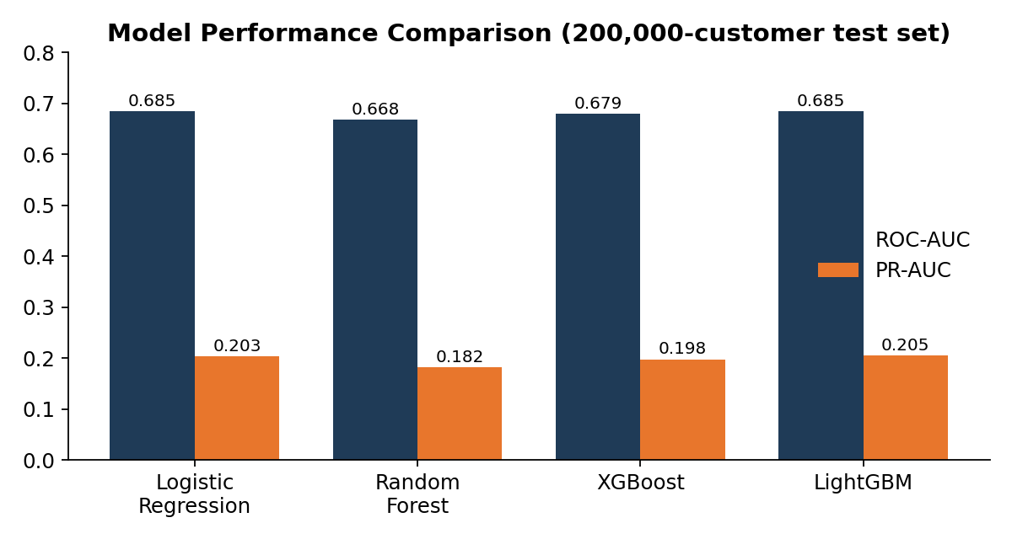
Figure 2. ROC-AUC and PR-AUC across the four models on the 200,000-customer test set.
LightGBM is the best performer (ROC-AUC 0.6851, PR-AUC 0.2053), though the margin over logistic regression (0.6849 / 0.2028) is slim. At its default threshold, LightGBM catches 63.3% of actual churners; about one in six customers it flags (16.0% precision) actually churns. A PR-AUC of 0.205 against a 0.099 baseline means the model roughly doubles precision over random targeting averaged across thresholds.
Two honest caveats deserve emphasis. First, discrimination is moderate, not strong: a ROC-AUC of 0.685 is useful for ranking customers but far from deterministic prediction — consistent with the exploratory finding that no feature has more than a small effect size. Second, contrary to the common expectation (stated in the notebook) that gradient boosting would clearly beat the linear baseline, logistic regression is essentially tied with LightGBM. This suggests churn here is driven largely by additive effects rather than complex interactions, and it makes the simpler, cheaper, more interpretable logistic model a legitimate production candidate.

5.1 What drives the predictions
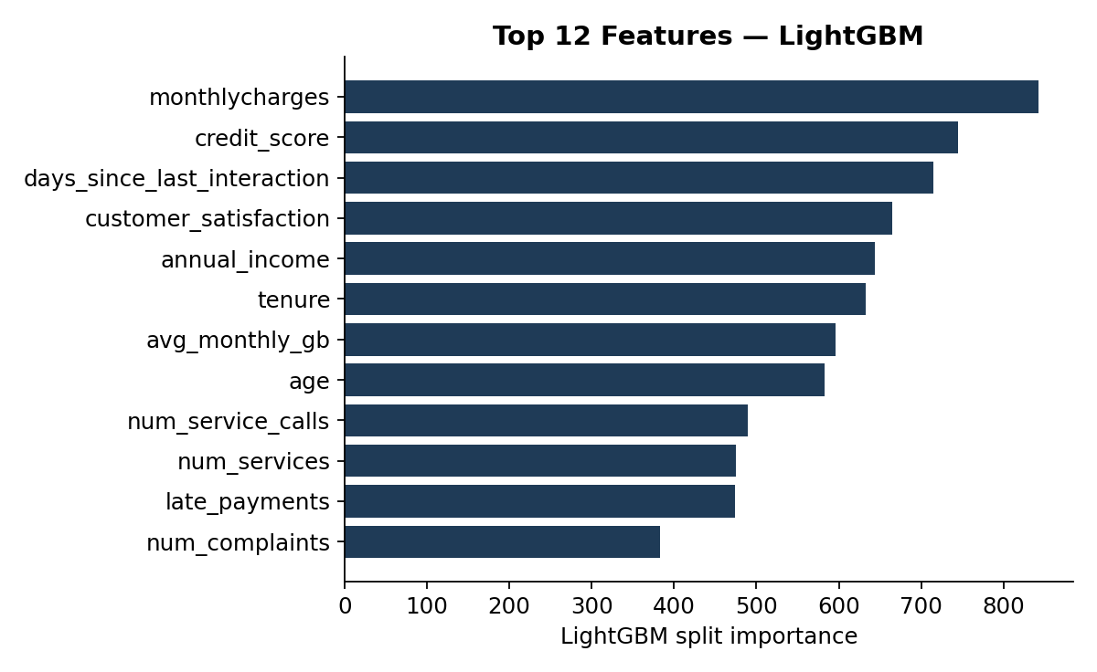
Figure 3. Top 12 features by LightGBM split importance.
LightGBM’s split-importance ranking is led by monthlycharges, credit_score, days_since_last_interaction, customer_satisfaction, annual_income, and tenure, with contract dummies further down. Split importance counts how often a feature is used, which favors high-cardinality continuous variables and understates low-cardinality dummies like contract type — the bivariate analysis and interaction heatmaps make clear that contract remains the strongest actionable driver. For production explainability, SHAP values would give a more faithful attribution than split counts.

6. Risk Segmentation and Lift
Scoring the 200,000-customer test set and sorting into deciles by predicted churn probability shows clean monotonic separation — the practical test of whether the model is useful for targeting:
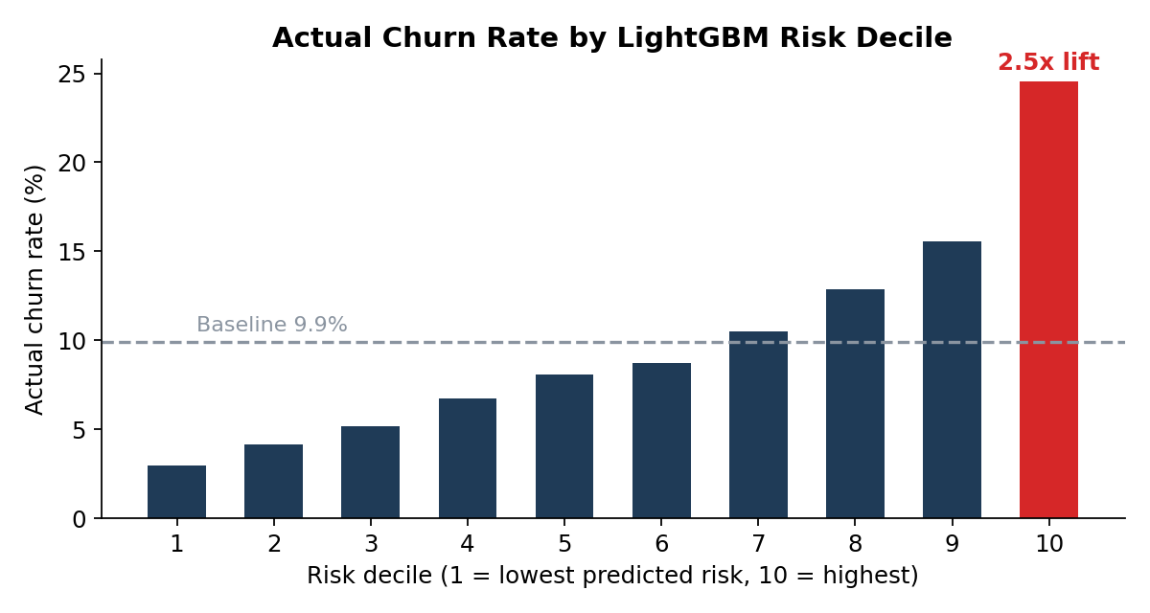
Figure 4. Actual churn rate by predicted-risk decile (LightGBM, test set).
Segment | Customers | Actual churners | Churn rate | Share of all churn
Top decile (10) | 20,000 | 4,910 | 24.6% | 24.7%
Top 2 deciles (9–10) | 40,000 | 8,019 | 20.0% | 40.4%
Top 3 deciles (8–10) | 60,000 | 10,591 | 17.7% | 53.4%
Bottom decile (1) | 20,000 | 593 | 3.0% | 3.0%
Overall | 200,000 | 19,845 | 9.9% | 100%

The top decile churns at 2.5 times the baseline rate, and the top 20% of customers by score contain 40% of all churners. A campaign aimed at the top two deciles therefore reaches four in ten future churners while contacting only one in five customers.

7. Financial Projection
The business case models a retention campaign against the top 20% highest-risk customers on the test set, using the dataset’s average monthly revenue of $86.44, an assumed 24-month remaining lifetime for a saved customer (lifetime value ≈ $2,075), a $50 retention offer per targeted customer, and a 30% intervention success rate:
Line item | Value
Customers targeted (top 20%) | 40,000
Expected churners in segment (20.0% rate) | 8,019
Churns prevented at 30% save rate | 2,406
Revenue saved (2,406 × ~$2,075) | $4,990,769
Retention offer cost (40,000 × $50) | $2,000,000
Net savings per scoring cycle | $2,990,769
ROI on offer spend | 150%

Scaled to the full 1M-customer base with monthly scoring, this implies annual net savings on the order of $36M. Three assumptions carry the result and must be validated before this figure is used in planning: the 30% save rate (the single most sensitive input — at 15% the campaign roughly breaks even), the 24-month retained lifetime, and the blanket $50 offer cost. An A/B test on the top decile is the fastest way to replace these assumptions with measured values. Note the projection also assumes every targeted customer receives the offer cost, while only prevented churners generate savings; savings from offers to customers who would have stayed anyway are counted at zero but their cost is included, so the structure is conservative on the cost side.

8. Recommendations
1. Convert month-to-month customers to term contracts (High priority). Only ~2% of the base (about 20,000 customers) is month-to-month, but they churn at 26.5%. Targeted conversion incentives — discounted annual pricing, benefits bundling — attack the single largest risk factor. One-year customers (55% of the base, churning at 12.7%) are the larger absolute opportunity for upgrades to two-year terms (5.7% churn).
2. Trigger proactive service recovery (High priority). Complaints, service calls, and late payments are the strongest behavioral predictors. Institute an automatic retention touch after a customer’s second complaint or third service call, and pair late-payment events with flexible-billing outreach rather than dunning alone.
3. Operationalize scoring (High priority). Deploy the model as a weekly batch pipeline, feed churn probabilities into the CRM so agents see risk at the point of contact, and route the top two risk deciles into retention workflows.
4. A/B test before scaling spend (High priority). Run offer vs. control on the top decile to measure the true save rate and offer elasticity; the financial case stands or falls on the 30% assumption.
5. Improve the model (Medium priority). Threshold optimization against campaign economics (rather than F1), SHAP-based explainability, probability calibration, and cost-sensitive learning are the highest-value next modeling steps. Monitor feature and score drift monthly (e.g., PSI) and retrain quarterly.

9. Limitations
- Discriminative power is moderate (ROC-AUC 0.685). The model is a targeting tool, not an oracle; roughly five of six customers flagged at the default threshold will not churn. Precision-oriented thresholds should be used where contact costs are high.
- The near-tie between logistic regression and LightGBM suggests limited non-linear signal in the current features. Feature enrichment (network quality, competitor pricing, support-ticket text) is likelier to move performance than model tuning.
- Median imputation of five columns (2–5% missing) is defensible under the MCAR finding but slightly compresses variance in those features.
- Some notebook narrative claims are not supported by its own outputs — e.g., senior-citizen and payment-method effects described as moderate are computationally negligible, and the "strong" performance characterization overstates a 0.685 ROC-AUC. This report reflects the computed results throughout.
- The financial projection is a scenario, not a forecast: save rate, retained lifetime, and offer cost are assumptions pending experimental validation.

Prepared from customer_churn_prediction_1.ipynb and customer_churn_1M.csv. All figures verified against notebook cell outputs and recomputed from the raw data where feasible. Report date: July 19, 2026.

