P.A.P.I.

(Pen And Paper Interface)

Index

Vision Statement 3

Requirement Analysis – General 3

Requirements Analysis – Player App 3

Platform 3

Creating a character 3

Player: Character Management 4

Requirements Analysis – Game Master App 5

Platform 5

Starting a New Game 5

Game Management 5

Scenes (Player) 6

1. Start Screen 6

2. Join Game 6

3. Options Screen 6

4. Character Creation – Name, Gender, Species, Characteristics 6

5. Motivations Selection 7

6. Career Selection 7

7. Stats Selection 7

8. Talents Selection 7

9. Talent 8

10. Character Overview 8

11. Skill Overview 8

12. Inventory 8

13. Equipment 9

14. Property Management 9

15. CriticalHits 9

16. Vehicle Overview 10

17. Vehicle Management 10

18. Headquarter Overview 10

19. Headquarters Management 11

20. Shop Screen 11

21. Modify Vehicle 11

22. Item 11

23. Storage 12

24. Character Selection 12

25. Talent Overview 13

26. Motivations Display 13

Literature 14

# Vision Statement

The Personal Pen And Paper Interface (PPAPI) is a cross-platform Application for Pen and Paper Game Players. It wraps the significant properties and components of a specific roleplaying name named “Genesys – The Roleplaying Game for all Settings”1. There are 2 different, interacting Apps. One, preferably mobile, for the players, to manage their characters, and one, best on a notebook for the Game/Dungeon Master to manage the game, characters, and more.

The Apps should help all players, including the Game Master, to concentrate more on the playing the game itself, than on searching the right values, write and erase and overwrite again and again and should prevent the Game Master from having to invent NPCs with all their values on the fly. It also provides some extra functions, such as puzzles, showing maps, hacking computers (in game) and managing inventories.

Additionally, players and Game Masters alike should be able to play their favourite Pen and Paper game from their own homes. Sometimes staying at home is saver.

# Requirement Analysis – General

1. Each User has to set a nickname
2. Each user gets a unique id
3. At the start of each Session there is a new randomly assigned Destiny Point pool
4. There always are as many Destiny Points as there are Players (+1 for the Game Master)
5. Each Destiny Point can be either good or bad, this is randomly assigned
6. Good Destiny Points can be used by the Players
7. Bad Destiny Points can be used by the Game Master
8. A Character must have a name and must be a member of a specific race or species

# Requirements Analysis – Player App

## Platform

1. The App must run on mobile Android systems, such as smartphones and tablets
2. The App is navigated through touch input
3. There must be a keyboard for text input
4. The Player App must be able to communicate with the Game Master App during an active game
5. The Player App receives messages from the Game Master App
6. All created characters and their things are saved on the device
7. The design of the interface can be changed in Options (Science Fiction/Medieval)
8. The language of the app can be changed in Options (English /Deutsch)

## Creating a character

1. Players must send a request to a Game Master to join a game
2. When joining a game for the first time, the player must create a new character
3. The character must have a name
4. There is a list of species/archetypes which varies with the setting
5. The character must have a species
6. Species start with different characteristics
7. Some species have special abilities which the characters gets
8. If the chosen species has abilities to choose from, the player must do so now
9. The characteristics change with the species the Player chooses
10. There is a list of careers, which varies with the setting
11. The character must have a career
12. There is a list of skills, which vary with the setting
13. Each career marks 8 skills as their speciality, from which the Player must choose 4 as “career skills”
14. The character gets a free rank in each of the four chosen skills (but not higher than 2)
15. These career skills are easier to learn (e.g. cost less exp) in the future)
16. The character gets a species-specified amount of starting exp
17. The player can purchase characteristic upgrades with exp
18. A characteristic can’t be trained over the value of 5
19. There are 6 characteristics: Brawn, Agility, Intellect, Cunning, Willpower and Presence
20. One upgrade of a characteristic costs $cost=(currentRank+1)∙10$ (for example, if a character has rank 2 in Brawn, and wants to upgrade to rank 3, the cost is 30 exp, from rank 3 to 4, its 40, and so on)
21. The player can purchase skill upgrades with exp
22. A skill upgrade costs $cost=\left(if career skill: -5\right)+(currentRank+1)∙5$, (e.g. for a non-career skill: Rank 1 = 5, Rank 2 = 10, Rank 3 = 15, …, for a career skill: Rank 1 = free, rank 2 = 5, rank 3 = 10, …)
23. A skill can’t be trained over the value of 5
24. A character must have Motivations (Desir, Fear, Strength and Flaw)
25. A Motivation can be randomly assigned or chosen from a list
26. The Player can choose from a set of different appearance options (some may vary with the setting)
27. The player can choose from a set of personality traits
28. There is a list of talents for each career
29. If the player has exp left, they can purchase Talents
30. Depending on the Game Masters choice, the character gets their starting equipment or their starting money
31. Every species/career has their own set of starting equipment

## Player: Character Management

1. There must be a screen on which the Player can see their characters Wounds, Strain, soak, defence and basic characteristics
2. There is a List of all available skills
3. On the skill list the player can blend in and out skills that their character possesses, and the ones that are just available for the setting
4. There is a list of the characters abilities
5. There is a List of the characters talents
6. At the end of the session the player can spend their received experience points for skills and talents, or save them for the next time
7. The player can add and remove wounds
8. The player can add and remove strain
9. The player can manage their inventory
10. The player can manage their equipped items
11. The player can use medicine/stimpacks/drugs or similar usable items
12. The player sees the current effects on characteristics/skills
13. The player can see the moral value of the character

# Requirements Analysis – Game Master App

## Platform

1. The App must run on Windows PCs and Notebooks
2. *Optional: The App can be started from a mobile device, such as a smartphone or a tablet*
3. The App is navigated through touch input or mouse clicks
4. *Optional: If the App runs on a mobile device, there has to be a keyboard for text input*
5. The App must be able to communicate with the App of the players during an active game
6. The Game Master App sends messages to one, all or selected Player Apps (of a session)
7. The player names, the game and its NPCs, vehicles, and everything except the player characters are saved on the Game Master device

## Starting a New Game

1. Only the Game Master App can start/create a game (-session)
2. Each game gets a unique id
3. At game creation one setting must be chosen by the Game Master
4. For now, there are 2 Settings: Postapocalyptic or Medieval Fantasy
5. More settings will be added later
6. The design of the Interface changes with the chosen setting
7. There are 2 different interface designs (for now): Postapocalyptic and Medieval Fantasy
8. Each game has it’s unique Id, which is a SHA1 hash of their creator’s nickname, and the time of creation
9. The Game Master can set an option, if the players get a set of equipment at start, or a starting amount of money
10. Once the game is created, players can join the game
11. If a Player wants to join a game, the Game Master must answer the request
12. Every time the game master opens the game, a new Sessions starts
13. At the start of each session a player character gets chosen randomly, who gets a malus on their strain for this session (Depending on their moral value)

## Game Management

1. The GM can give players bonus experience points, which they receive at the end of the session
2. The GM must set a value of experience that every player gets, at the end of each session
3. The GM can give money to characters
4. The GM can give vehicles to the party
5. The GM can give buildings to the party
6. The GM can build NPCs (like a player can build a character)
7. An NPC can be either a group of minions, a rival, or a nemesis

# Ein Bild, das Elektronik, Bildschirm, orange, Monitor enthält. Automatisch generierte BeschreibungViews (Player)

## Start Screen

* 1. “Join Game” Button (-> Join Game)
  2. “Options” Button (-> Options Screen)
  3. “Quit” Button (-> End game)
  4. “Create Character” Button (-> Character Creation)
  5. “Saved Characters” Button (-> List of created characters)

## Join Game

* 1. Input field for Game ID
  2. “Join” Button (greyed out, if no game ID is given) (-> Character Selection)
  3. “Return” Button (-> Start Screen)

## Options Screen

* 1. Dropdown for language (English/German)
  2. Dropdown for design (Green on Black/Black on Parchment)
  3. Input Field for Player Name
  4. “Return” Button (-> Start Screen)

## Character Creation – Name, Gender, Species, Characteristics

* 1. Input field for Character name (max. 30 symbols, no special characters except for ‘)
  2. Dropdown for Gender (Female, Male, Other)
  3. Dropdown for Species (Depends on Setting)
  4. Table of Characteristics (which changes with the chosen species) with following columns
     1. Name of Characteristic
     2. Current value
     3. Cost to upgrade
     4. “+” Button to upgrade
  5. Field that shows available and total experience points which changes with the chosen species
  6. Field that shows following (changing with species/Characteristic changes)
     1. Soak Value
     2. Wound Threshold
     3. Soak Threshold
     4. Defence Melee
     5. Defence Ranged
  7. “Cancel Character Creation” Button (-> Start Screen)
  8. “Next” Button (-> Motivation Selection)

## Motivations Selection

* 1. Table of Motivations (Strength, Flaw, Desire, Fear) with following columns
     1. Type of Motivation
     2. Motivation Dropdown
     3. “Random” Motivation Button
     4. Short description
  2. “Return” Button (-> Character Creation)
  3. “Next” Button (-> Career Selection)

## Career Selection

* 1. List of all available careers for the setting
  2. List of checkboxes of the career skills for the currently chosen career
  3. “Next” Button (-> Stats Selection)
  4. “Return” Button (-> Motivation Selection)

## Stats Selection

* 1. Table of all available stats for the setting with following columns:
     1. Name of stat, with an asterisk in front, if career skill
     2. Current value
     3. Dice preview
     4. “+” Button to upgrade stat
     5. Experience point cost for upgrade
  2. “Reset to Default values” Button
  3. “Return” Button ( if in Character Creation -> Career Selection, else -> Character Overview)
  4. “Turn page left” Button (if there is one)
  5. “Turn page right” Button (if there is one)
  6. “Next” Button (-> Talent Selection)

## Talents Selection

* 1. Table of all available Talents for the chosen career with following columns
     1. Clickable Name of talent (greyed out if not buyable) (-> Talent)
     2. Checkmark if it’s already bought
  2. “Finish & Save” Button (-> Character Overview)
  3. “Return” Button (-> Stats Selection)

## Talent

* 1. Name and short description of talent
  2. Active or passive
  3. Activated how/when?
  4. Cost to unlock
  5. Ranked?
  6. “Learn” Button (only if available)
  7. “Return” Button (-> Talent Selection)

## Character Overview

* 1. Display Name
  2. Display Characteristics
  3. Display Soak
  4. Display Wounds and Threshold
  5. Display Soak and Threshold
  6. Display Defence Ranged/Melee
  7. „Skills“ Button (-> Skill Overview)
  8. „Equipment“ Button (-> Equipment)
  9. „Inventory“ Button (-> Inventory)
  10. „Talents“ Button (-> Talent Overview)
  11. „Motivations“ Button (-> Motivations Display)
  12. „Properties“ Button (-> Property Management)
  13. „Level Up“ Button (Only available at end of session) (-> Skill Selection)
  14. “Exit” Button (-> End game)

## Skill Overview

* 1. “Show All”/ ”Only learned” Button
  2. Table of skills with following columns
     1. Name of skill
     2. Current Value
     3. Dice
     4. Modification Dice
  3. “Return” Button (-> Character Overview)

## Inventory

* 1. Table of Items with following columns
     1. Quantity
     2. Name of Item
     3. Encumbrance
     4. Price
  2. Items can be clicked for more information (-> Item)
  3. Display of current Encumbrance and Threshold
  4. “Shop” Button (-> Item Shop)
  5. “Return” Button (-> Character Overview)

## Equipment

* 1. Table of Weapons with following columns
     1. Name of weapon
     2. Required Skill
     3. Damage
     4. Critical Rating
     5. Range
     6. Checkbox if the weapon has special traits
     7. “Unequip” Button
  2. Weapons can be clicked for more information (-> Item)
  3. Table of Armour with following columns
     1. Name of armour
     2. Type of Armour
     3. Soak
     4. Defence Ranged
     5. Defence Melee
     6. Checkbox if the armour has special traits
     7. “Unequip” Button
  4. Armour can be clicked for more information (-> Item)
  5. “Shop” Button (-> Item Shop)
  6. “Return” Button (-> Character Overview)

## Property Management

* 1. “Headquarter” Button
  2. List of party vehicles with following columns
     1. Type of vehicle
     2. Name of vehicle (clickable)
     3. Checkbox if available to use
  3. “Shop” Button (-> Vehicle Shop)
  4. “Return” Button (-> Character Overview)

## CriticalHits

* 1. „Critical Wound Generator“ Button
  2. Table of current critical wounds with following columns
     1. Severity of wound
     2. Name of wound
     3. Short description of wound
     4. Checkbox if permanent
     5. “Heal” Button
  3. Value of Critical Hit Modifications
  4. “Return” Button (-> Character Overview)

## Vehicle Overview

* 1. Display Vehicle name
  2. Display Owner
  3. Display Make/Model
  4. Display Hard points (used/total)
  5. Display Encumbrance (current/threshold)
  6. Display silhouette
  7. Display speed (with modifications)
  8. Display Handling (with modifications)
  9. Display Defence (with modifications)
  10. Display Armour (with modifications)
  11. Display Hull Trauma (current/Threshold)
  12. Display System Strain (current/Threshold)
  13. Display number of required crewmembers (current/required)
  14. Display number of passengers (current/Threshold)
  15. List of weapons with following columns (-> Item)
      1. Name of weapon (clickable)
      2. Firing Arc
      3. Damage
      4. Range
      5. Critical rate
      6. Special
  16. “Manage” Button (-> Vehicle Management)
  17. “Return” Button (-> Property Management)

## Vehicle Management

* 1. „Rename“ Button
  2. „Give to party“ Button/“Give to player” Button
  3. “Modify” Button
  4. “Repair” Button
  5. “Suffer critical trauma” Button
  6. List of Critical Traumas with following columns
     1. Severity of trauma
     2. Name of trauma
     3. Short description of trauma
     4. Checkbox if permanent
  7. Value of Critical Hit Modifications
  8. “Shop” Button (-> Vehicle Shop)
  9. “Return” Button (-> Vehicle Overview)

## Headquarter Overview

* 1. Display Location of Headquarter
  2. Display Type of Headquarter
  3. Clickable List of Properties in the headquarter
  4. “Personal Storage” Button (-> Storage)
  5. “Manage” Button (-> Headquarter Management)
  6. “Return” Button (-> Property Management)

## Headquarters Management

* 1. List of all not carriable properties in Headquarter (Clickable -> Item) with following columns
     1. “Use” Button
     2. “Modify” Button
  2. “Shop” Button (-> Item Shop)
  3. “Return” Button (-> Property Management)

## Shop Screen

* 1. Clickable List of all buyable Items/Vehicles (-> Item) with following columns
     1. Name of Item
     2. Price
     3. “Buy” Button
  2. Clickable List of all sellable Items/Vehicles (-> Item) with following columns
     1. Name of Item
     2. Price
     3. “Sell” Button
  3. “Return” Button (-> previous site)

## Modify Vehicle

* 1. List of available modifications for vehicle with following columns
     1. Name of modification
     2. Part of vehicle
     3. Material needed
     4. “Modify” Button (if all material in vehicle)
  2. “Return” Button (-> Vehicle Management)

## Item

* 1. Display Name of Item
  2. Display Type
  3. Display base price
  4. Display Encumbrance
  5. Display Rarity
  6. If weapon additionally display following
     1. Required Skill
     2. Damage
     3. Critical Rating
     4. Range
     5. Special
  7. If Armour additionally display following
     1. Defence
     2. Soak
  8. If small item, but neither weapon, nor armour display following
     1. Short description of effect
  9. If vehicle display following
     1. Silhouette
     2. Handling
     3. Hard points
     4. Encumbrance Threshold
     5. Speed
     6. Defence
     7. Armour
     8. Hull Trauma Threshold
     9. System Strain Threshold
     10. List of weapons
     11. Number of Passengers/Crew
  10. “Return” Button (-> previous site)

## Storage

* 1. Capacity of Storage in Encumbrance (current/Threshold)
  2. Display cost for Storage Upgrade
  3. “Upgrade” Button
  4. List of Items in the storage with following columns
     1. Name of item (clickable -> Item)
     2. Quantity in storage
     3. “Take out” Button
  5. List of Items in inventory with following columns
     1. Name of item (clickable -> Item)
     2. Quantity in inventory
     3. “Put in storage” Button
  6. “Return” Button (-> Headquarter Overview)

## Character Selection

* 1. List of created characters available for the chosen setting with following columns
     1. Name of character
     2. Date of last save
     3. Species of character
     4. Career of character
     5. “Play” Button (-> Character Overview)
     6. “Delete” Button
  2. “New character” Button (-> Character creation)
  3. “Return” Button (-> Join Game)

## Talent Overview

* 1. List of learned talents with following columns
     1. Name of talent
     2. Active or passive
     3. Rank
     4. Short description
  2. “Return” Button (-> Character Overview)

## Motivations Display

* 1. List of motivations with following columns
     1. Type of Motivation
     2. Name
     3. Short description
     4. Count how often it was played
  2. “Return” Button (-> Character Overview)

# Views (Game Master)

## Options Screen

* 1. Dropdown for language (currently available options: English, German)
  2. Dropdown for design (currently available options: medieval, modern)
  3. Input field for Game Master Name
  4. Return Button

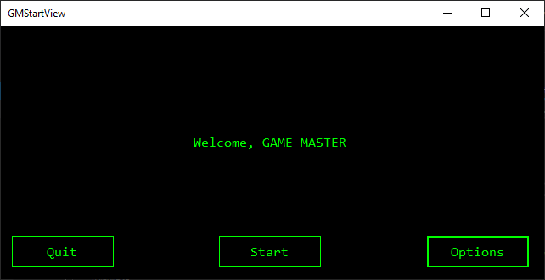

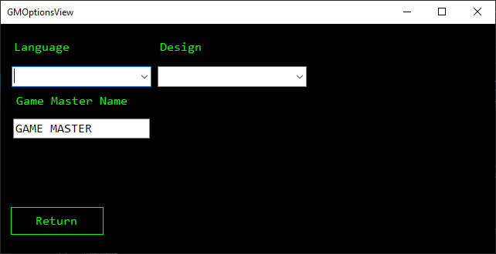

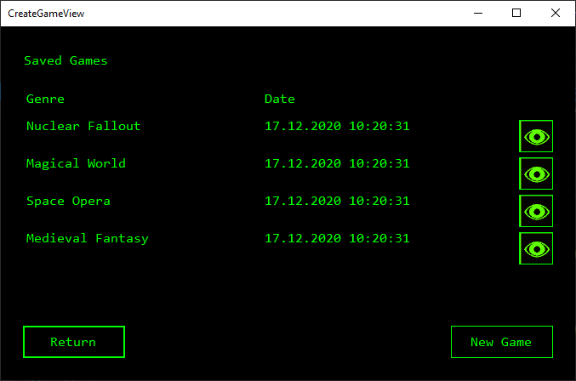

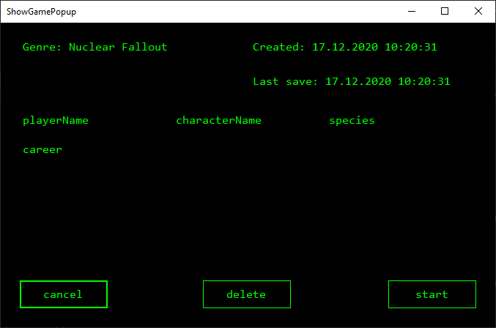

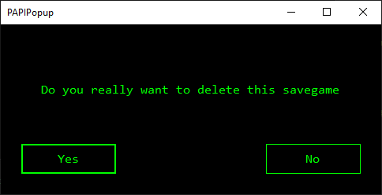

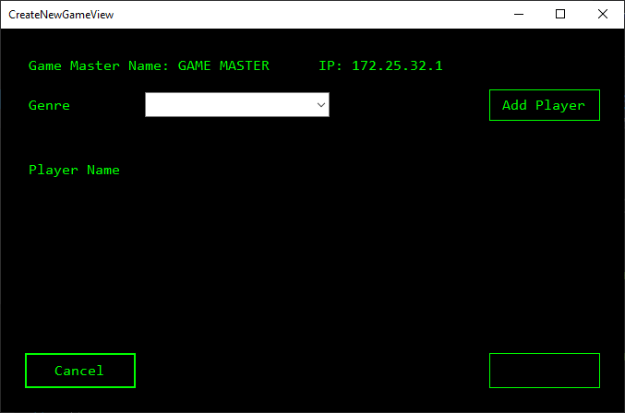

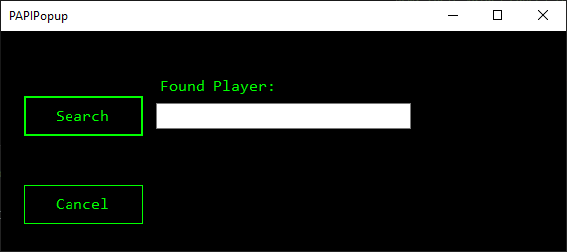

# Literature

1 Fantasy Flight Games: „Genesys Core Rulebook – The Roleplaying Game for all Settings”, 2017, USA, ISBN: 978-1-63344-320-4