Q1

Fix wing：

Strength: long flying range, large load, high flying speed.

Weakness: It cannot hang at a certain place, requires more for launching and landing

Rotorcraft UAS:

Strength: It can take off and land vertically, or hang at the same position. It can obtain stable image capturing

Weakness: low efficiency, low capacity of loading, short flying time.

Applications:

Fix wing: Aerial Mapping, Pipeline and Power line inspection

Rotorcraft UAS: Aerial Photography and Video Aerial Inspection

Q2

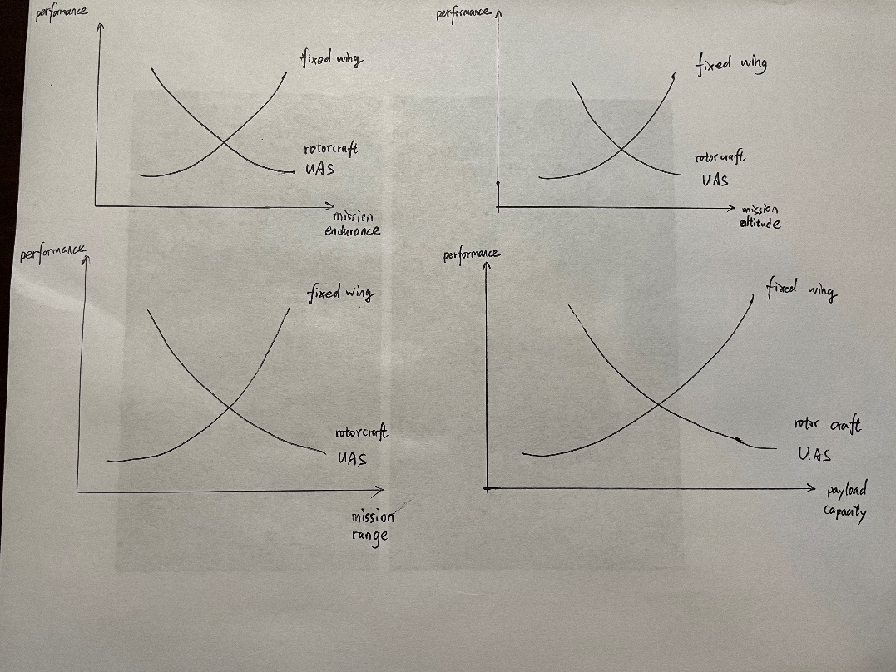

Q3

The FAA Part 107 is a set of rules for operating a drone commercially. It is kind of like a commercial driving license for flying drones. It is important because it stipulates what you can do and what you are forbidden when flying the drone. It is the one who operate the drone and should take the responsibility of any risk and safety.

Q4

Waypoints are a set of points that are on the routine. The UAV or UGV can plan the path base on them.

DJI GS PRO/ QGroundControl

Connect the drone to your equipment, and choose the waypoint mode. Select the way points you want the drone to fly and set some parameters such as flying height and flying speed. Then as we start the mission our drone will fly along the waypoints.

Q5

CHAMPAIGN-URBANA, UNIVERSITY OF ILLINOIS-WILLARD AIRPORT CLASS C Airspace.

Automated authorization available at or below 150 ft

FAA

Q6

UAV can provide a sky-view of the field, which can hardly be provided by other equipment. The sky-view image can provide much information, including the maturity of crops, surrounding environment, etc. Besides, it can obtain these images in a very short time, the image can cover very large area taken from the height of a flying UAV.

Q7

Ackermann steering model is like a normal car, whose front two wheels can rotate along the z-axis(up). When turning, the four wheels will rotate around a same center of turning circle. Ideally, no wheel will slide. The front wheels of a car with skid-to-turn steering model is fixed on the front axle. When turning, the inner side wheels are driven at a lower speed and the ones on the outer side moves faster. When turning, wheels will slide along the radius direction.

Ackermann steering:

Advantage: no slide, high efficiency, better maneuverability

Disadvantage: model does not fit well at high speed

skid-to-turn steering:

Advantage: simple mechanics, high load capacity, little turning circle

Disadvantage: large slip, unstable turning, large speed error

Q8

GPS sensor can give the robot the longitude and latitude of its position on earth, which can help it to navigate. If they use Lidar to navigate, it requires distinct objects nearby. However, some place is too clear to let the vehicle localize itself. Besides, SLAM by lidar is quite slow and requires large computing resource, and hardly can satisfy the real-time feature.

Q9.1

1. pixel resolutions 0.69 cm/px

altitude: 25.133119515885017m

1. pixel resolutions 1.37 cm/px

altitude: 49.90199092284419m

1. pixel resolutions 2.06 cm/px

altitude: 75.03511043872922m

1. pixel resolutions 2.06 cm/px

altitude: 99.80398184568838m

Q9.2

Side lap will be larger if the UAV fly along the 400m side.

1. pixel resolutions 0.69 cm/px

side lap: 0.6694569943997861

1. pixel resolutions 1.37 cm/px

side lap: 0.8717029331704707

1. pixel resolutions 2.06 cm/px

side lap: 0.9404417191846931

1. pixel resolutions 2.06 cm/px

side lap: 0.9743130050467738

Q10

1. GPS data：Latitude Longitude Altitude

[[-88.21044643946595, 40.07212684951429, 0],

[-88.21064671707745, 40.07190723519349, 0],

[-88.21100549559605, 40.07177075940288, 0],

[-88.21101423220432, 40.07137695768378, 0],

[-88.21102646329678, 40.07097374535917, 0],

[-88.20933246214224, 40.07095071378444, 0],

[-88.2093337876828, 40.07211491171131, 0]]

2）

