Q1
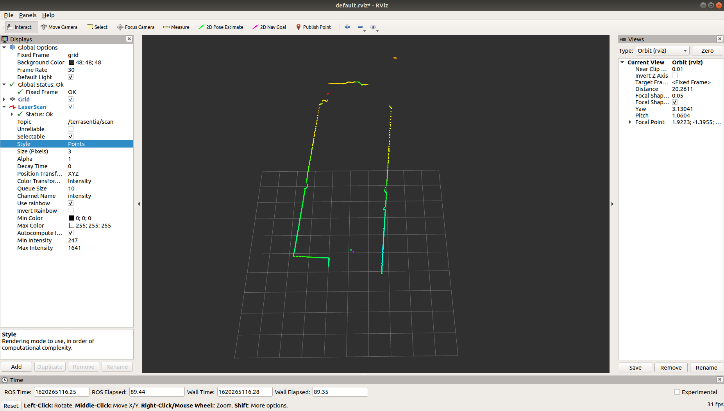
As is shown in the image, the color line is the wall detected by the lidar, the empty space beyond the line is the opening space.

Q2
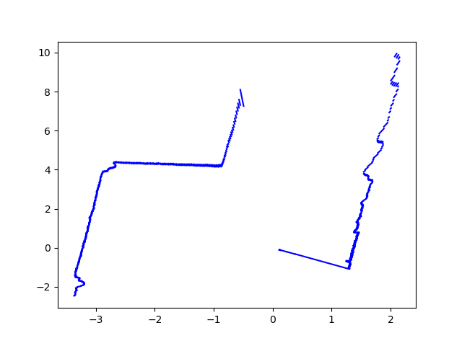

Q3
I Subscribe the ekf topic. I can read position and orientation of my robot. First, I create a rotation matrix by quaternions. Then I generate a transition matrix using x, y and rotation matrix. The position data of obstacles are transited by the transition matrix, so that I will get the position in the ground frame. Finally plot the detected line in the ground frame.

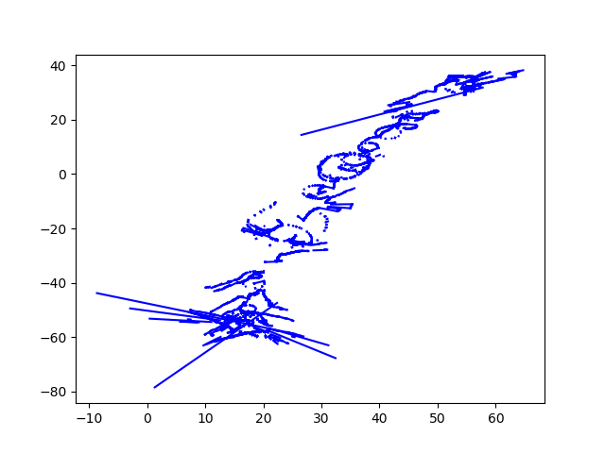
Q4

