Forward Kinematics:

To represent the position and pose with Debnavit-Hartenberg parameters, we need to draw the coordinates at each joint. According to the definition of each axis, the positive direction of z-axis should be coinciding with the positive direction of joints, x-axis should be vertical to both z-axis of its frame and the previous frame. And y-axis can be inferred from right-hand rules. The three frames are drawn as follows:

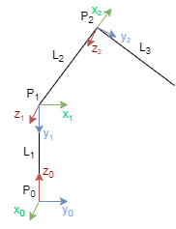

According to the frames, we can write the DH parameters:

|  |  |  |  |  |
| --- | --- | --- | --- | --- |
| Joint | ai | αi | di | θi |
| 1 | 0 | π/2 | 10 | θ1 |
| 2 | 10 | 0 | 0 | θ2 |
| 3 | 10 | 0 | 0 | θ3 |

For frame P0, x0 is vertical to the line P0P1, so a1=0. Z0 is vertical to z1, and the angle between that in the plane that vertical to x is 90 degree, so α1=π/2. And the distance along z is d1=L1=10. Since it is a rotate joint, so the joint angle is θ1.

For frame P1, z1 and z2 are parallel and x2 is along P1P2, so a2=L2=10. And because z1 is parallel to z2, α2=0. The two origin P1 and P2 are in the same plane that vertical to both z-axis, so d2=0. And since it is a rotate joint, so the joint angle is θ2..

For frame P2, z2 and z3 are parallel and x2 is along P1P2, so a2=L3=10. And because z1 is parallel to z2, α2=0. The two origin P2 and P3 are in the same plane that vertical to both z-axis, so d3=0. And since it is a rotate joint, so the joint angle is θ3.

After having the DH parameter tablet, we can calculate the parameter in the following equation between DH angle and motor angle of 2 and 3:



Using the parameter in joint1 and joint2, we can get the equation:



After that we can calculate the position of end-effector using motor angles:



The calculation of transition matrix and Jacobin matrix in Mathematics:

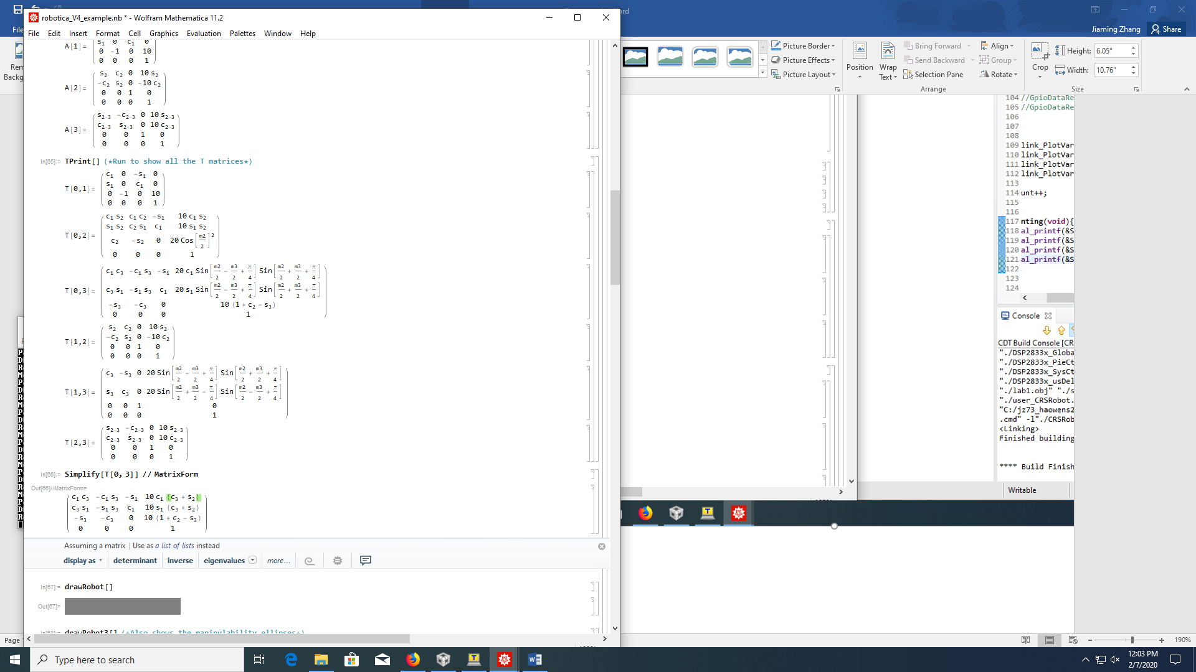

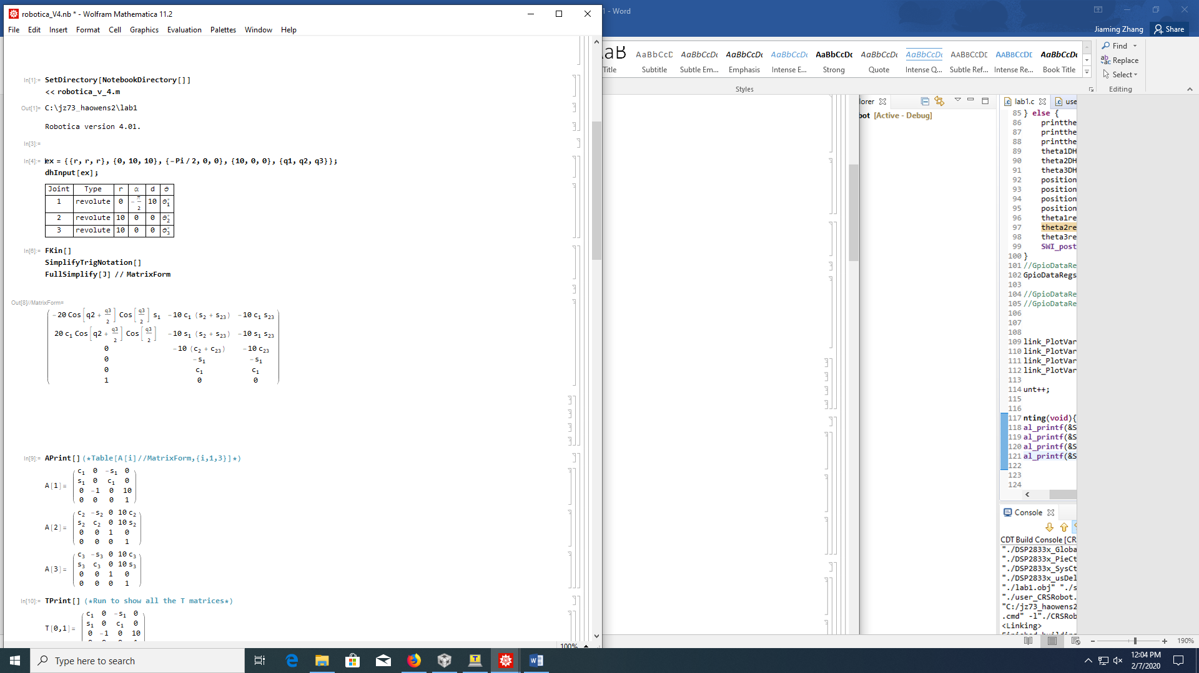

Inverse Kinematics:

To calculate each joint angle given the end-effector position, we can draw a middle line in triangle P2P3P1. Because L2=L3, so P2M is vertical to P1P3. We can define the distance betweenP1 and P3 in the horizontal plane is L. The geography relationship is shown:

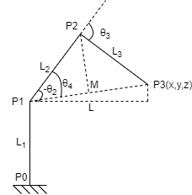

We can calculate P1P3 and L easily:



θ1 can be calculated easily by tangent function:



And we can calculate θ2 and θ3 by the following equation:



The answer is:



