FK:

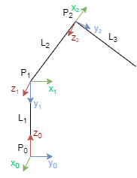

|  |  |  |  |  |
| --- | --- | --- | --- | --- |
| Joint | ai | αi | di | θi |
| 1 | 0 | π/2 | 10 | θ1 |
| 2 | 10 | 0 | 0 | θ2 |
| 3 | 10 | 0 | 0 | θ3 |









IK：

