1.

CONFIG:

Set FIFO_MODE as when the fifo is full, additional writes will be written to the fifo, replacing the oldest data.

Disable FSYNC.

IF FCHOICE is set as 0b11: Set the Gyroscope as: Bandwidth = 92Hz, Delay = 3.9ms, Fs = 1kHz; set Temperature Sensor: Bandwidth = 98Hz, Delay = 2.8ms

GYRO_CONFIG:

Select Gyro Full Scale as +250dps

Set FCHOICE as 0b00, so Set the Gyroscope as: Bandwidth = 8800Hz, Delay = 0.064ms, Fs = 32kHz; set Temperature Sensor: Bandwidth = 4000Hz, Delay = 0.04ms

ACCEL_CONFIG:

Select Accel Full Scale as ±8g

ACCEL_CONFIG2:

Set Accel Output: Bandwidth = 5Hz, Delay = 66.96ms, Noise = 250(ug/rtHz), Rate = 1;

2.

Bq32000 is a real-time clock chip, which can output the real-world time. Usually it has back-up battery, so it can continuously counting time even if the main device is shut down.

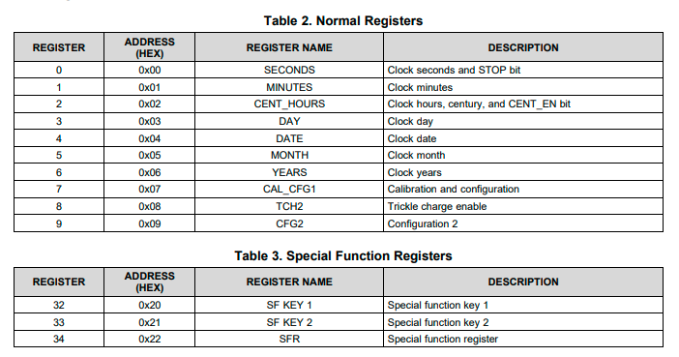

Each register is 8 bits.