3D Model:

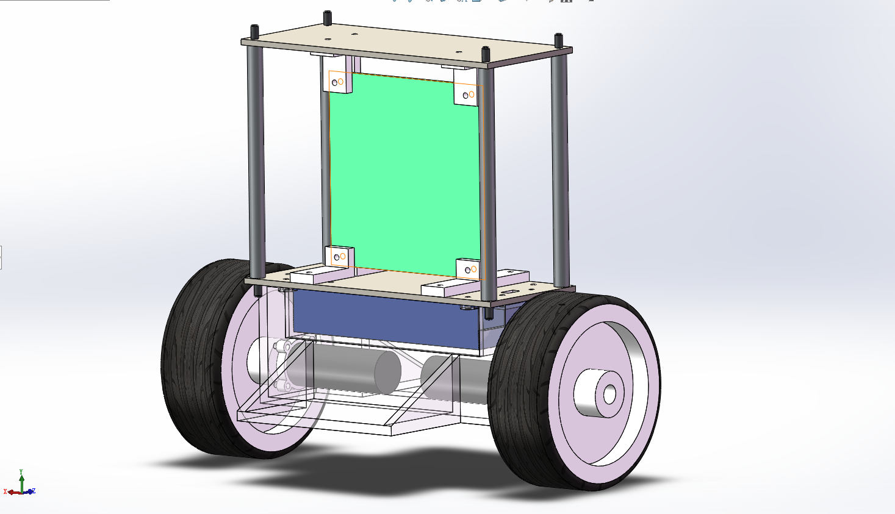

The blue cuboid in the image is the battery, and the black cylinder is the motor. The battery, motors and the wheels are the parts we buy, but I draw the approximate model to assembly in my model.

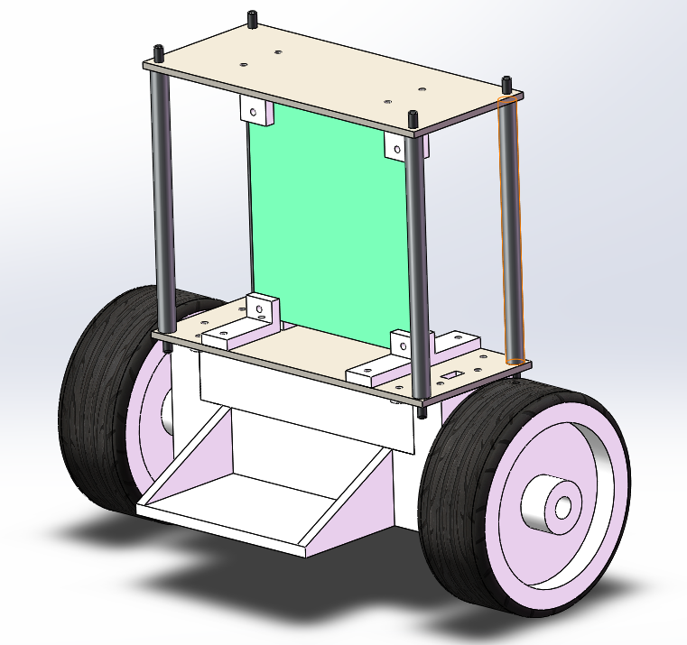

The cover of the battery and the motor is enclosed, so it can resist dust and water. And two side board is attached at the bottom of the case to avoid the robot fall over. Also a have square holes on the lower board for the wire go through

The wheel is bought and embedded a bearing in it. But the diameter of the bearing inner race is larger than the axle, so I add a sleeve between them.

The four long support columns connect the two board need 4mm nut to tight the board. And for all the holes on the board, PCB board, and the corner support need 3mm screw and nut to fixation.

Schematics:

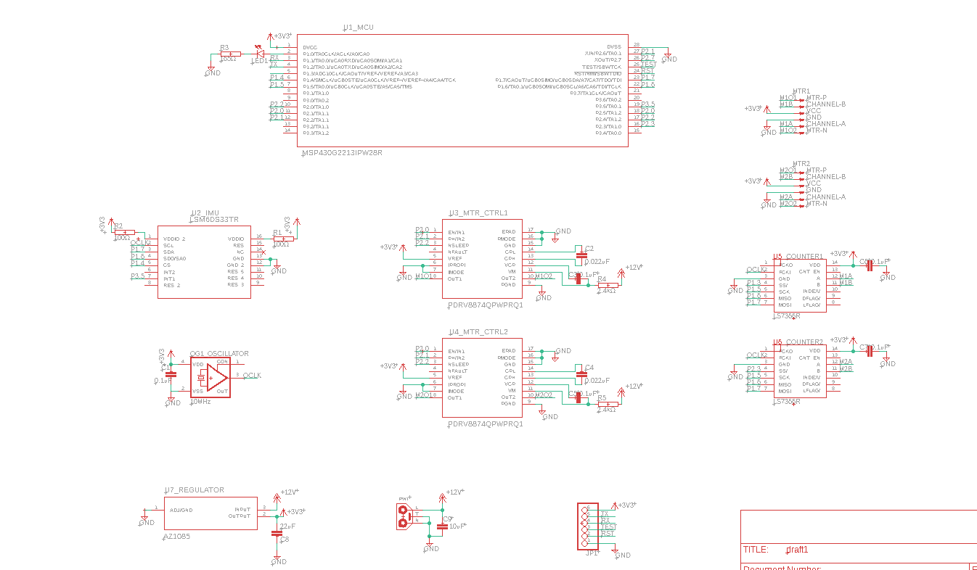

We use an MCU chip, an IMU chip, two motor drive chip, a crystal oscillator, a regulator, and two encoder read chip. Also, there are also a 12V battery connector, a URAT connector and two connectors for the motor.

PCB:

The part is placed as shown in the PCB screenshot. And the main rule is to place the parts have more connection closer, except in some situation some parts have negative influence on others.

The left large connector is connected to the battery, the two 6-pins connecters are used for the motors, which are placed near to the motors. And the UART connect is placed at the right side of the board.

The IMU chip is place at the middle of the board to increase sensing accuracy, and very high to stay away from the motor, will have magnetic field, which will bring large error to the IMU sensing information.

The capacitance which attach to the input and output of the regulator is place very closed to it, to maximum the function of eliminating AC component.

