**Induction Motor Project**

Jamie Langeveldt (LNGJAM012)

Marshall Ngari (NGRMAR007)

EEE3091F: Energy Conversion

University of Cape Town

3 April 2025

**Part A – MATLAB Code**

**Question 1**

The Thevenin circuit parameters were computed using the following formulae:

$$\left|V_{TH}\right|= \frac{X_{m}}{\sqrt{R_{1}^{2}+{\left(X_{1}+X_{m}\right)}^{2}}}*V_{1}$$

$$Z_{TH}= \frac{jX_{m}*\left(R_{1}+jX_{1}\right)}{R_{1}+j\left(X_{1}+X_{m}\right)}$$

The $R_{TH}$ and $X_{TH}$ terms were obtained from the real and imaginary components of $Z_{TH}$ respectively.

Results are listed below:

Figure 1: Computed Thevenin Equivalent circuit values.

**Question 2**

At start up the rotor speed is zero hence the slip, s, is equal to 1.

Torque was computed using the following equation: $$Torque= \frac{3*V_{TH}^{2}}{ω_{syn}}*\frac{{R^{'}}_{2}}{s\left({\left(R_{TH}+\frac{{R^{'}}_{2}}{s}\right)}^{2}+{\left(X_{TH}+{X^{'}}_{2}\right)}^{2}\right)} where ω_{syn}=\frac{2π*n_{s}}{60}$$

*(Note: For startup the s is set to 1. For the graph an array of s values is used.)*

$Torque(max)= \frac{3*V_{TH}^{2}}{{2*ω}_{syn}}*\frac{1}{{R_{TH}+\left({\left(R_{TH}\right)}^{2}+{\left(X_{TH}+{X^{'}}_{2}\right)}^{2}\right)}^{\frac{1}{2}}}$

$slip at\max{Torque} = \frac{{R^{'}}_{2}}{{R_{TH}+\left({\left(R_{TH}\right)}^{2}+{\left(X_{TH}+{X^{'}}_{2}\right)}^{2}\right)}^{\frac{1}{2}}}$

Speed at maximum Torque was computed using the slip stated above:

Figure : Graph of Torque vs Speed characteristic for Standard and Energy Efficient Motors

Figure : MATLAB results to questions posed

**Question 3**

Stator currents were computed using the following equation:

$$I_{1}=\frac{V_{1}}{Z_{1}} where Z_{1}= R_{1}+jX_{1}+\frac{jX_{m}*\left(\frac{{R'}_{2}}{s}+j{X'}_{2}\right)}{\frac{{R'}_{2}}{s}+j\left(X_{m}+{X'}_{2}\right)}$$*(Note: For startup the s is set to 1. For the graph an array of s values is used.)*

For no load, the slip dependent resistance is very large hence $I_{1}≈I_{∅}$ which is the magnetizing current. Input current was computed as follows:

Figure 4: Graph of Stator current vs Speed for Standard and Energy Efficient motor.

Figure 5: MATLAB output for Questions posed

**Question 4**

Power factor was computed from the cosine of the phase of input current.

Figure 6: Graph of Power factor vs speed for Energy Efficient and Standard Motor.

Figure : MATLAB results for questions posed

**Question 5**

The motor power values were computed as follows: $$Input Power=3*V_{1}*I_{1}*PF$$

$$Stator copper loss=3*I_{1}^{2}* R_{1}$$

$$Air gap Power=Input Power-stator copper loss$$

$$Rotor copper loss=slip*Air gap power$$

$$Shaft Power=Mech Power=\left(1-slip\right)*Air gap power(Negligible rototation losses)$$

*(Note: For start up and no load the corresponding current and slip was used)*

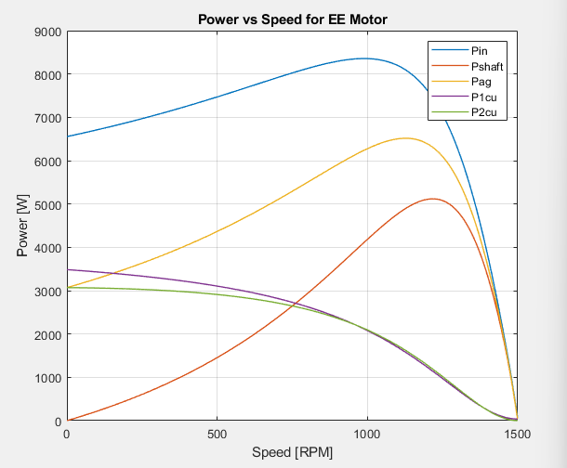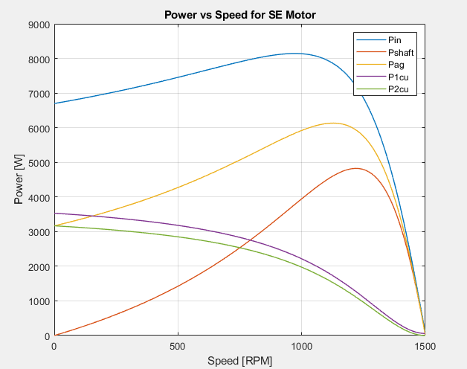

Figure : Graphs of Power vs speed for Standard and Energy Efficient motors

Figure : MATLAB results for questions posed

**Question 6**

The formulae listed in question 5 were used to compute the respective input and output(Shaft) power. Efficiency was computed as follows: $$Efficiency= \frac{Shaft Power}{Input power}*100$$

*(Note: The value of maximum efficiency and speed were retrieved from their respective arrays using the max() MATLAB function.)*

Figure 10: Graph of Efficiency vs speed for Standard and Energy Efficient motors

Figure 11: MATLAB results for questions posed

**Question 7**

To determine the speed, current, efficiency and power (both in and out) the point of intersection between the Load curve and motor curve was found. The index of Torque at this point was used to locate the required values.

Figure 12: Graph of Torque vs Speed for Standard and Energy Efficient motor (Load Torque line included).

Figure 13: MATLAB results for Questions posed

INDUCTION MOTOR PROJECT THEORY QUESTION ANSWERS

**Question 1:**

a) Larger motors generally have lower internal resistances hence suffer lower copper losses compared to smaller motors making them more efficient. This is because the windings of the stator and rotor in larger machines have more cross-sectional area hence lower resistance.

$$R= \frac{ρL}{A} :where ρ is resistivity, L is length and A the cross-sectional Area$$

b) The load the machine operates in directly affects the machines efficiency. A lower load (under 50% load) will lower the running conditions of the machine hence there will be low Torque output. This means for the same power input a lower load results in lower output power ($P_{out}=Tω$) hence the losses are increased, and the efficiency is lowered.

**Question 2:**

a) For standard motors:

$$P_{in}=P_{out}*(\frac{100}{Efficiency})$$

For the 3 kW:

$$P_{in}=3*\left(\frac{100}{81.9}\right)=3.663 kW$$

$$P\left(kWh\right)=3.663*12*150=6593.4 kWh per day$$

For the 7.5 kW:

$$P_{in}=7.5*\left(\frac{100}{86.8}\right)=8.641 kW$$

$$P\left(kWh\right)=8.641*12*110=11,406.12 kWh per day$$

For the 15 kW:

$$P_{in}=15*\left(\frac{100}{89.3}\right)=16.797 kW$$

$$P\left(kWh\right)=16.797*12*60=12,093.84 kWh per day$$

For the 55 kW:

$$P_{in}=55*\left(\frac{100}{93.2}\right)=59.013 kW$$

$$P\left(kWh\right)=59.013*12=708.15 kWh per day$$

$$P_{in}=55*\left(\frac{100}{94.2}\right)=58.386 kW (At 75\% load)$$

$$P\left(kWh\right)=58.386*4=233.55 kWh per day$$

$$Total input power per day=40*(233.55+708.15)=37,668 kWh per day$$

Total daily power input = 37,668 + 12,093.84 +11,406.12 +6593.4 = 67,761.36 kWh per day

Total Monthly input Power = 67,761.36 x 28 = 1,897,318.08 kWh per month

Electricity bill = 1,897,318.08 * 28.288 = 536,713.34 R

b) For energy efficient motors:

$$P_{in}=P_{out}*(\frac{100}{Efficiency})$$

For the 3 kW:

$$P_{in}=3*\left(\frac{100}{87.5}\right)=3.429 kW$$

$$P\left(kWh\right)=3.429*12*150=6172.2 kWh per day$$

For the 7.5 kW:

$$P_{in}=7.5*\left(\frac{100}{89.3}\right)=8.399 kW$$

$$P\left(kWh\right)=8.399*12*110=11,086.68 kWh per day$$

For the 15 kW:

$$P_{in}=15*\left(\frac{100}{91.5}\right)=16.393 kW$$

$$P\left(kWh\right)=16.393*12*60=11,802.96 kWh per day$$

For the 55 kW:

$$P_{in}=55*\left(\frac{100}{94.2}\right)=58.386 kW$$

$$P\left(kWh\right)=58.386*12=700.64 kWh per day$$

$$P_{in}=55*\left(\frac{100}{95.2}\right)=57.773 kW (At 75\% load)$$

$$P\left(kWh\right)=57.773*4=231.09 kWh per day$$

$$Total input power per day=40*(231.09+700.64)=37,269.2 kWh per day$$

Total daily power input =37,269.2 + 11,802.96 + 11,086.68 + 6172.2 = 66,331.04 kWh per day

Total Monthly input Power = 66,331.04 x 28 = 1,857,269.12 kWh per month

Electricity bill = 1,857,269.12 * 28.288 = 525,384.29 R

c) Monthly savings = Monthly cost standard – monthly cost energy efficient

= 536,713.34 – 525,384.29 = 11,329.05 R

**Question 3:**

For standard motor:

$$P_{in}=15*\left(\frac{100}{89.3}\right)=16.797 kW$$

$$P\left(kWh\right)=16.797*24=403.13 kWh per day$$

$$Daily running cost=403.13*28.288=114.04 R$$

For energy efficient motor:

$$P_{in}=15*\left(\frac{100}{91.5}\right)=16.393 kW$$

$$P\left(kWh\right)=16.393*24=393.43 kWh per day$$

$$Daily running cost=393.43*28.288=111.29 R$$

Daily Profit $=114.04 - 111.29=2.75 R$

The number of days required for the machine to make back the R4000 is:

$$= \frac{4000}{2.75}=1454.55 ≈1455 days$$