Game Engines – Phase 1

Task 1 - Conduct Research about the use of game engines in real-world projects.

Upon researching and testing other ‘Game and Watch’ games, one thing struck me. The addictiveness regarding its simplicity. Nowadays ‘simple’ games still consist of multiple mechanics or trickier levels with the art styles being well-polished whereas something as simple as a still shape in a ‘Game and Watch’ could still get you hooked.

These game types eventually got me thinking back on how many I’ve played in the past.  
  
A forgotten memory trying to be built again from scratch – that’s my aim for this unit.

The games’ aim is mainly trying to build as many buildings as you can while trying to avoid tools being thrown at you or falling from higher levels. Could be left to your imagination.

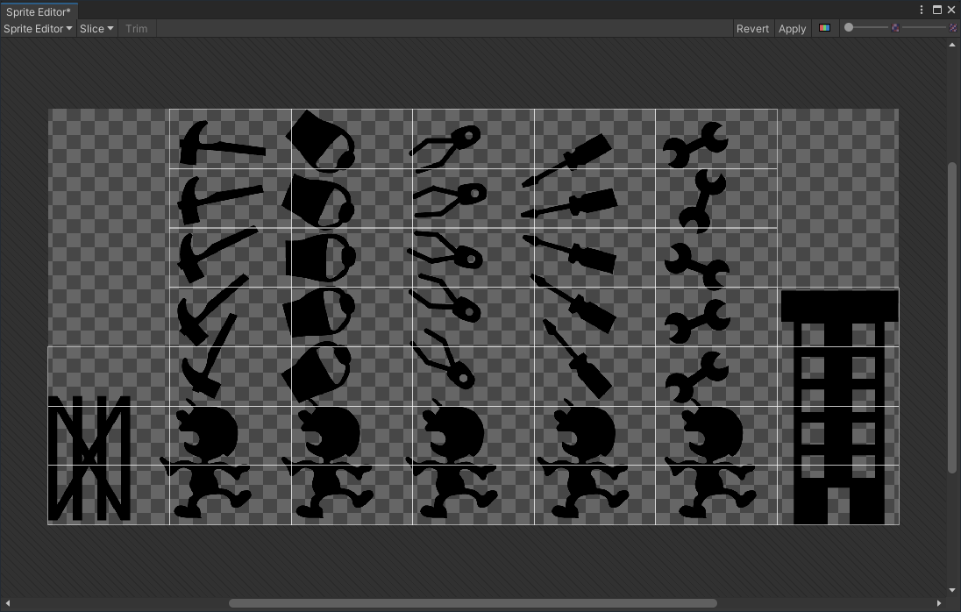

All the sprites shown in figure 1 have somewhat different movements and codes. The foundation on the left consisting of metal pillars would be the players’ spawn point. The objective is to run towards the building on the right to add 1 to the number of buildings built. The tools falling down consist of a hammer, spray can, wrench, screwdriver, and spanner. These tools must be dodged otherwise you will fail and game over. The number of falling objects would differ every wave or every 10 builds. (Still undecided).

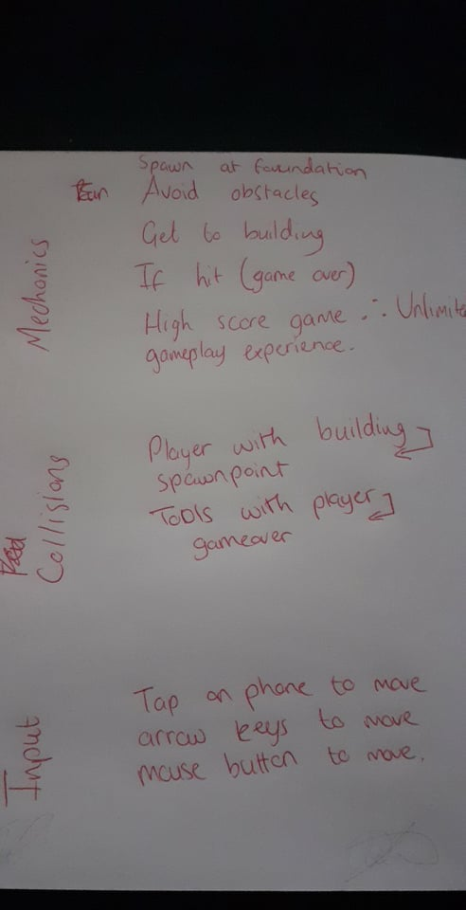

The CRC cards or main brainstorm for the game was based on a vague memory of a game I played when I was very young.  
  
Remembering the sprites popping up on the screen at the start of the level just to see what’s to come gave me nostalgic feelings.

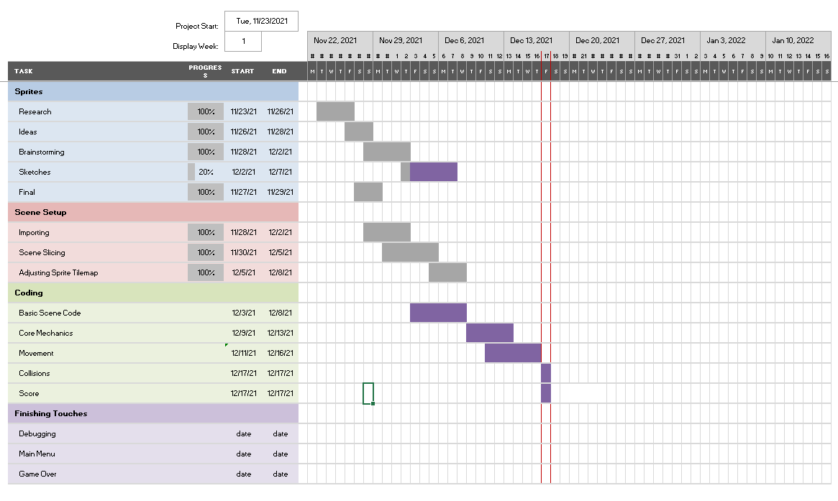

Gantt’s Chart Progress Report

Task 2 – Prepare workspace and assets for game development.

The objective of this game as previously mentioned is going to be trying to build as many structures as possible until you end up getting struck by any of the tools falling from above the main character. The spawn point or beginning will be set at the foundations on the left when you just need to get across to the other side of the screen to score a point. If the tools strike you. It will result in a game over. This has now been changed, however. The main character will now have 3 lives shown on the side of the screen for you to be able to achieve an even higher score making the game easier but with enough room for error to advance onto higher, more difficult waves of tools being thrown.

There isn’t a specific target device but this game would be featured both on mobile and pc as its game mechanics and controls are easily created for both. Screen resolution should not matter as much due to the fact it is a classic ‘game and watch’ stylized look. Only 2 colors are used. One for the background as if the screen is one of the old Nintendo, and the black sprites which is also how they used to be way back in the day.

Controls consist mainly of arrow keys, mouse clicks, or screen taps.

Game mechanics as mentioned above aren’t too complicated but enough to get one hooked trying to beat their high score or even their friend’s high score. Simple yet competitive.

Art assets were based on many ‘Game and watch’ products of the past. The art style also had to be unique enough to at least catch the eye of the user and not just some nonsense or impossible to cipher artworks.

The UI will be extremely simple to keep this project true to its inspiration, so just a main menu with a play button. As of now, a high score screen may not be feasible due to time spent trying to form the code but otherwise could be possible to add in the near future.

Flow Chart Regarding Mechanics : 