**PIZZA SALES SQL QUERIES**

1. **Total Revenue:**

select sum(total_price) as total_revenue from pizza_sales

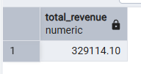

1. **Average Order Value:**

select (sum(total_price)/count(distinct order_id))

as Average_Order_Value from pizza_sales

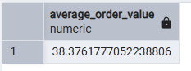

1. **Total Pizzas Sold:**

select sum(quantity) as total_pizzas_sold from pizza_sales

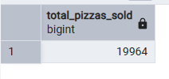

1. **Total Orders:**

select count(distinct order_id) as total_orders from pizza_sales

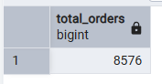

1. **Average Pizzas Per Order:**

select cast(cast(sum(quantity) as decimal(10,2))/

cast(count(distinct order_id) as decimal(10,2))as decimal(10,2))

as Avg_Pizzas_Per_Order

from pizza_sales

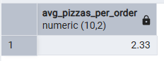

1. **Daily trend for total orders:**

select to_char(order_date, 'day') as order_day,

count(distinct order_id) as total_orders

from pizza_sales

group by order_day

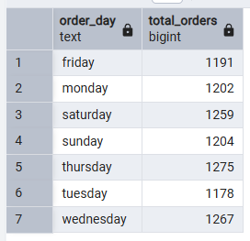

1. **Hourly trend for total orders:**

select to_char(order_time, 'hh24') as order_hour,

count(distinct order_id) as total_orders

from pizza_sales

group by order_hour

order by order_hour

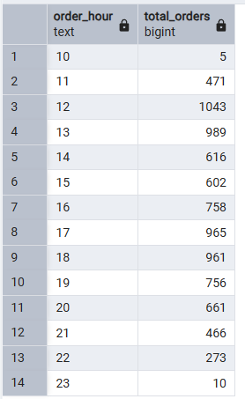

1. **Percentage of sales by pizza category:**

(select pizza_category, sum(total_price) as total_sales,

sum(total_price) * 100 / (select sum(total_price) from pizza_sales)

as percentage_of_total_sales

from pizza_sales

group by pizza_category)

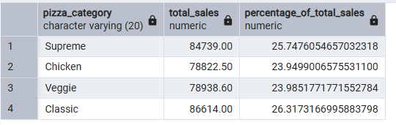

1. **Percentage of sales by pizza size:**

(select pizza_size, sum(total_price) as total_sales,

cast(sum(total_price) * 100 / (select sum(total_price) from pizza_sales)

as decimal(10,2))

as percentage_of_total_sales

from pizza_sales

group by pizza_size)

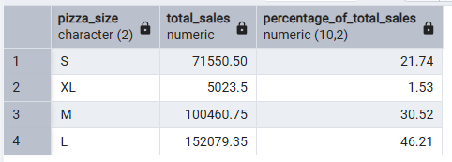

1. **Total Pizzas sold by pizza category:**

select pizza_category, count(quantity) as total_sold

from pizza_sales

group by 1

order by 2 desc

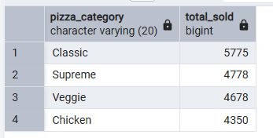

1. **Top 5 best sellers by total pizza sold:**

select pizza_name, sum(quantity) as total_sold

from pizza_sales

group by 1

order by 2 desc

limit 5

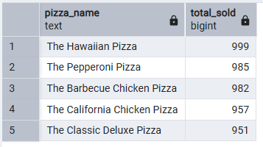

1. **Bottom 5 worst sellers by total pizzas sold:**

select pizza_name, sum(quantity) as total_sold

from pizza_sales

group by 1

order by 2 asc

limit 5

