Mini-SOC in a Box
WEEK 2 — STEP-BY-STEP LAB REPORT
Wazuh 4.14.8 • Suricata 7.0.3 • VMware Workstation Pro
This report shows what we configured and tested in Week 2. Each step has a short explanation followed by the relevant screenshot.
Machine | Host-only IP | Main purpose
siem-host | 10.10.10.10 | Wazuh Manager, Indexer and Dashboard
ubuntu-web | 10.10.10.20 | Apache, Wazuh agent and Suricata
win-client | 10.10.10.30 | Windows, Wazuh agent and Sysmon

1. Starting the Week 2 lab

01 Check the existing environment
We started the Week 1 VMs and verified the Wazuh containers, web server and endpoint agents. All three machines remained connected through the host-only lab network.
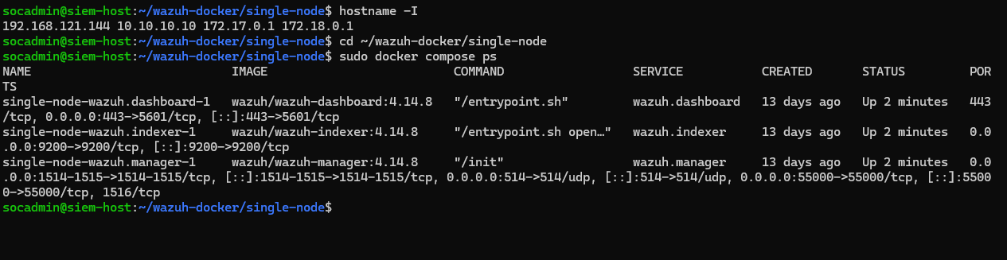
Wazuh services running on siem-host.
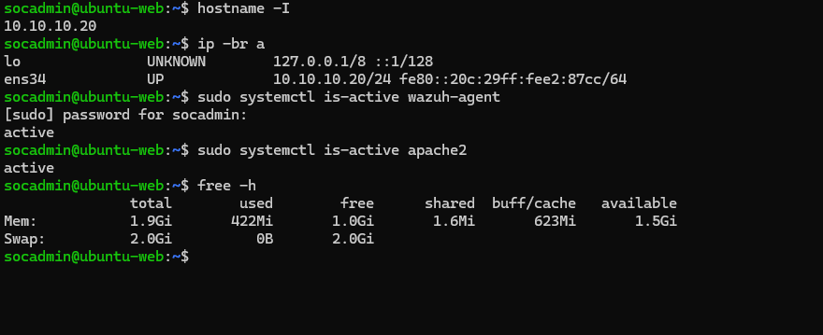
ubuntu-web IP, Wazuh agent and Apache service checks.

02 Create the LabShop application log
We created /var/log/labshop/app.log on ubuntu-web and configured the Wazuh agent to collect its syslog-format events.
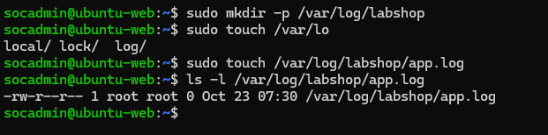
Creation of the LabShop log file.
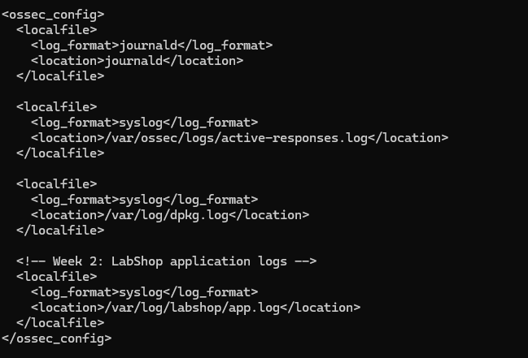
Wazuh ossec.conf collecting app.log.

2. Custom Wazuh detection rules

03 Install and test the custom decoder
We added labshop_decoder.xml to the Wazuh Manager and tested a sample LOGIN_FAILED event. The decoder extracted the action, destination user and source IP.
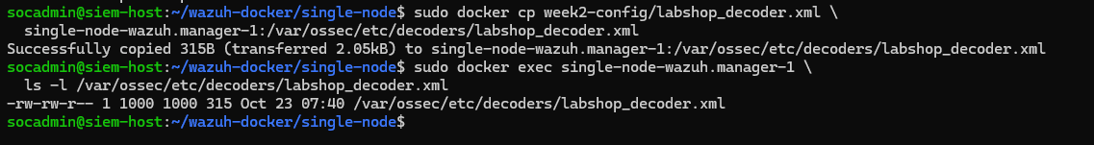
Custom decoder copied into the Wazuh Manager.
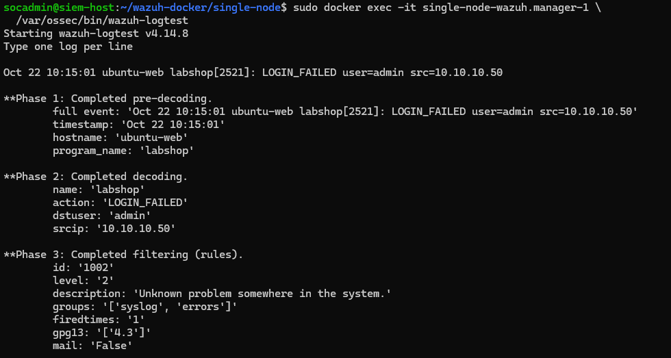
First decoding test showing the extracted event fields.

04 Create and troubleshoot the rules
We created rule 100102 for failed logins and rule 100103 for five failed logins from one IP within 60 seconds. An initial validation error was corrected by matching decoded dynamic fields.
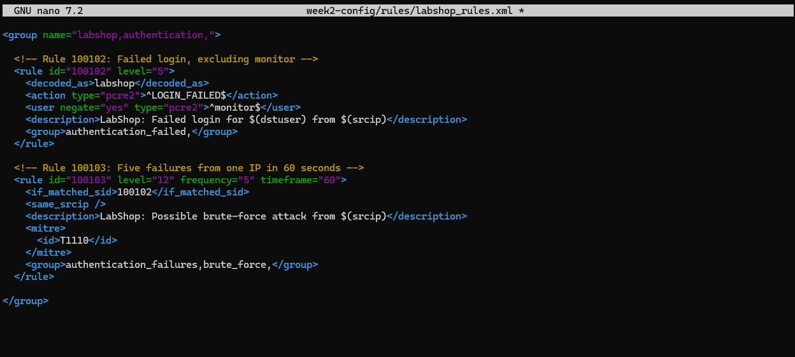
Corrected LabShop authentication and brute-force rules.
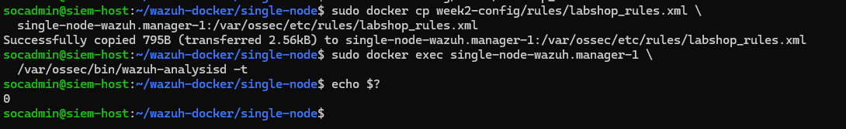
Wazuh configuration validation passed (exit code 0).

05 Confirm the authentication alerts
A failed login triggered rule 100102 (level 5). Repeated failures from the same source triggered rule 100103 (level 12), mapped to MITRE ATT&CK T1110.
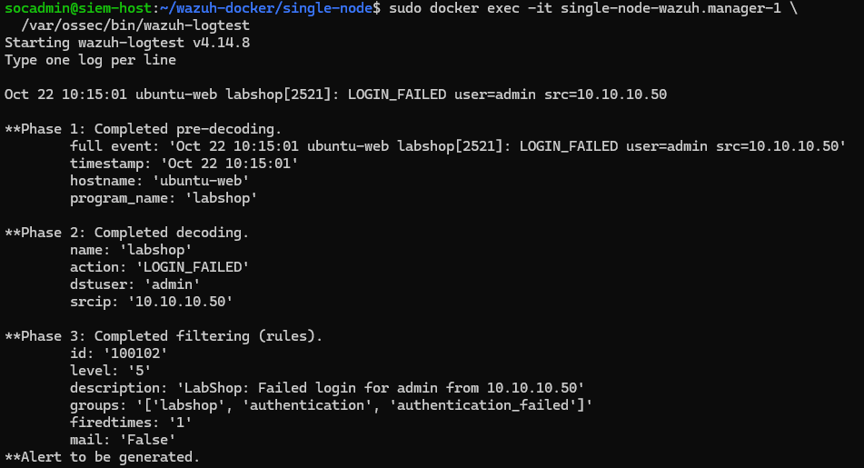
Single failed-login event matched rule 100102.
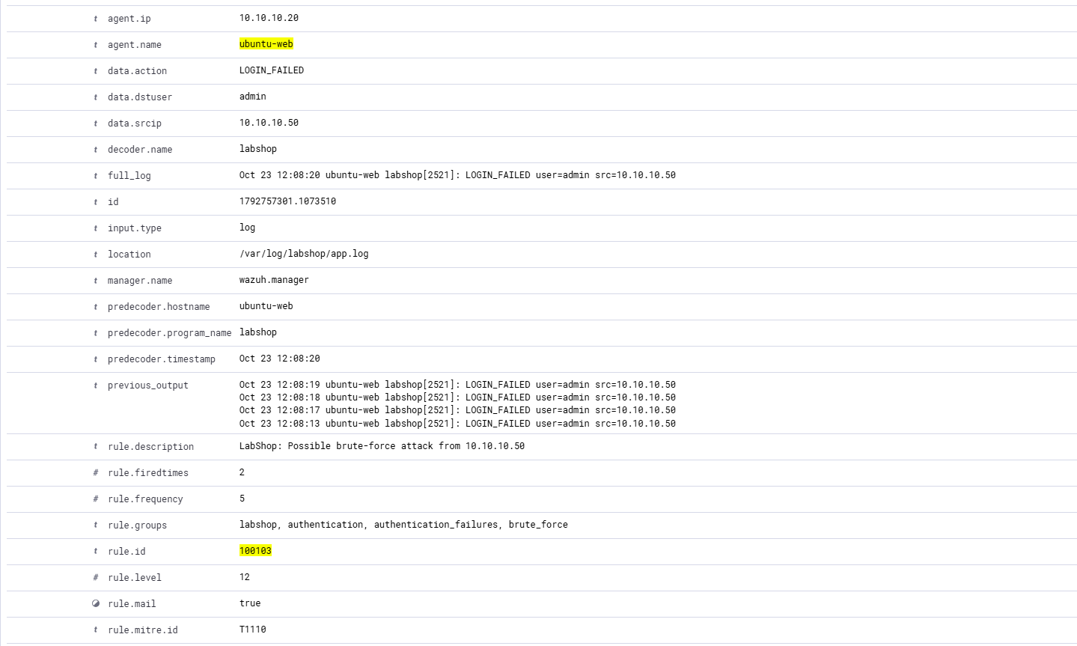
Live brute-force correlation alert matched rule 100103.

3. Linux File Integrity Monitoring

06 Enable real-time monitoring
We enabled real-time FIM for /var/www/html and restarted the Linux Wazuh agent after validating ossec.conf.
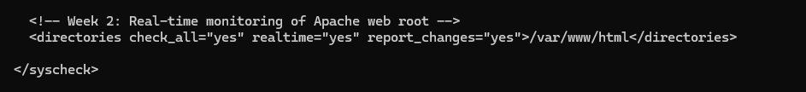
Linux Apache web root configured for real-time monitoring.

07 Create, modify and delete a Linux test file
We created a test file, changed its content and deleted it. Wazuh detected all three operations using rules 554, 550 and 553.
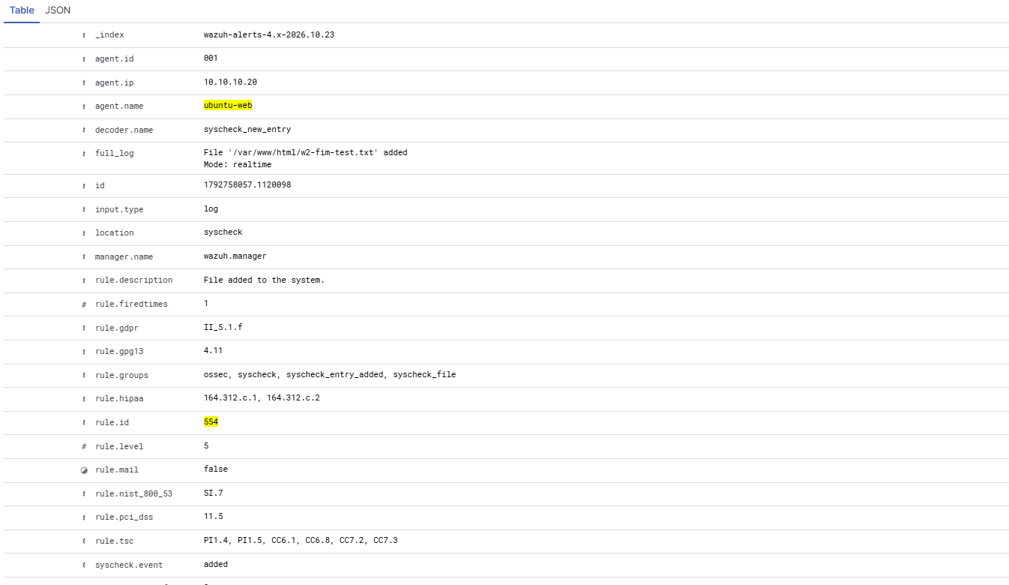
Linux file created — rule 554.
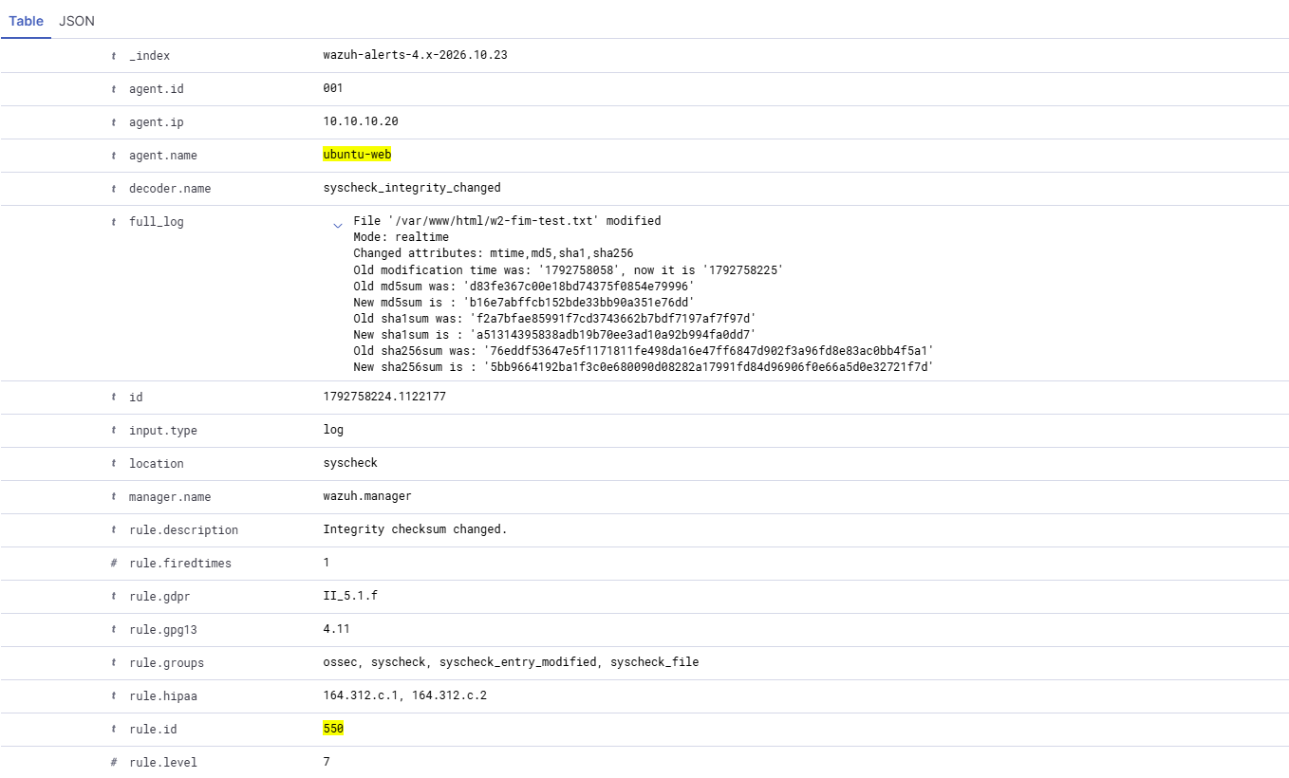
Linux file content modified — rule 550.
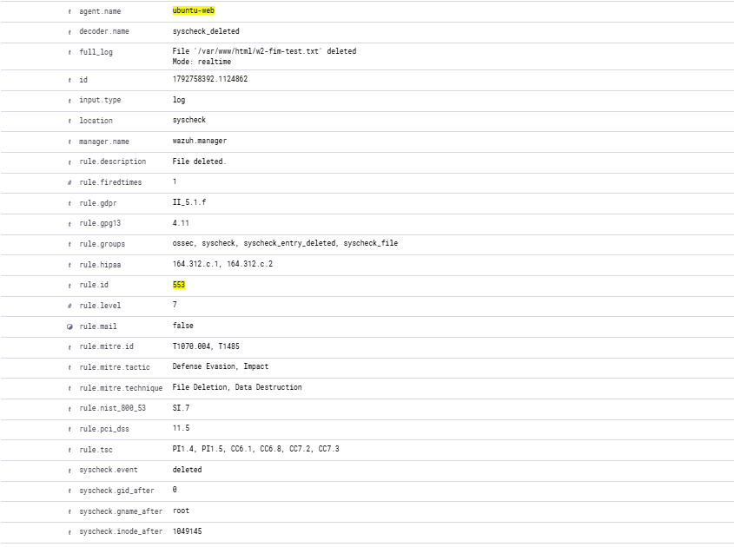
Linux file deleted — rule 553.

4. Windows File Integrity Monitoring

08 Configure file and Registry checks
We created C:\LabShopData and HKLM\SOFTWARE\LabShop, then configured the Windows agent for real-time folder monitoring and 64-bit Registry checks every 300 seconds.
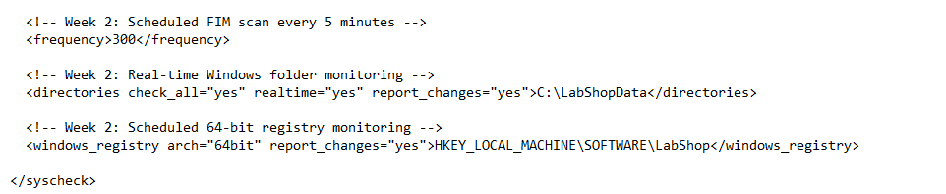
Windows FIM and Registry configuration.

09 Test Windows file changes
The Windows test file was created, modified and deleted. Wazuh detected these changes and recorded the original and modified content.
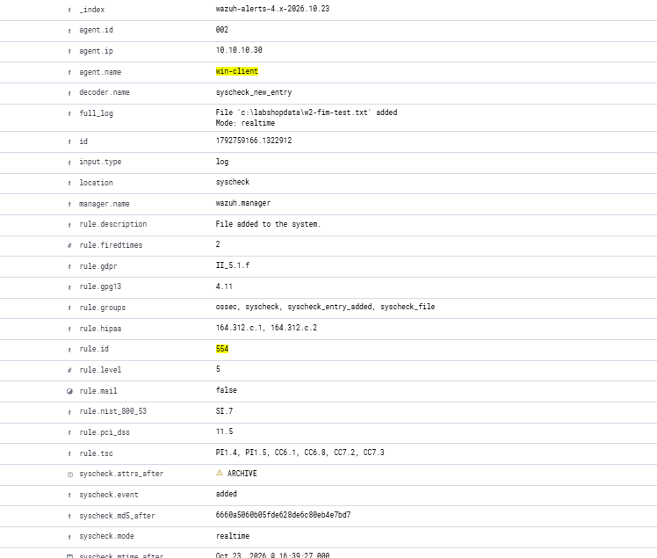
Windows file creation — Wazuh rule 554.
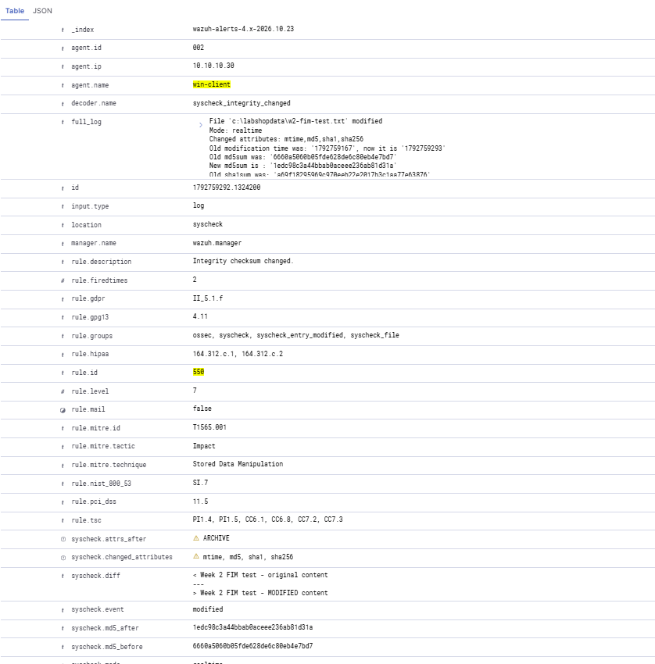
Windows file modification with content difference — rule 550.
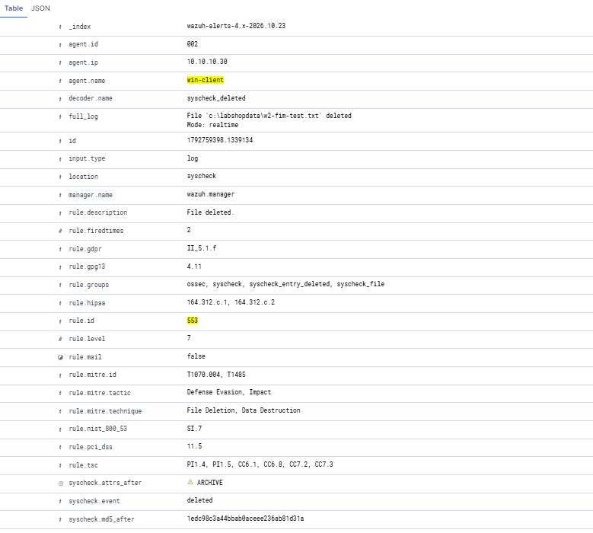
Windows file deletion — rule 553.

10 Verify scheduled Registry monitoring
We changed the Registry value Mode from baseline to modified. Wazuh detected the difference with rule 750 after the next scheduled scan.
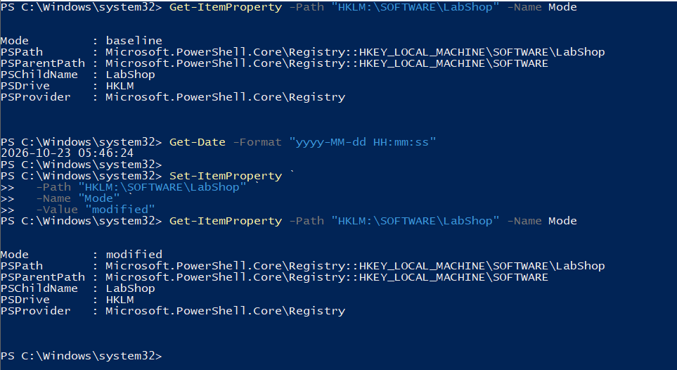
PowerShell changing the LabShop Registry value.
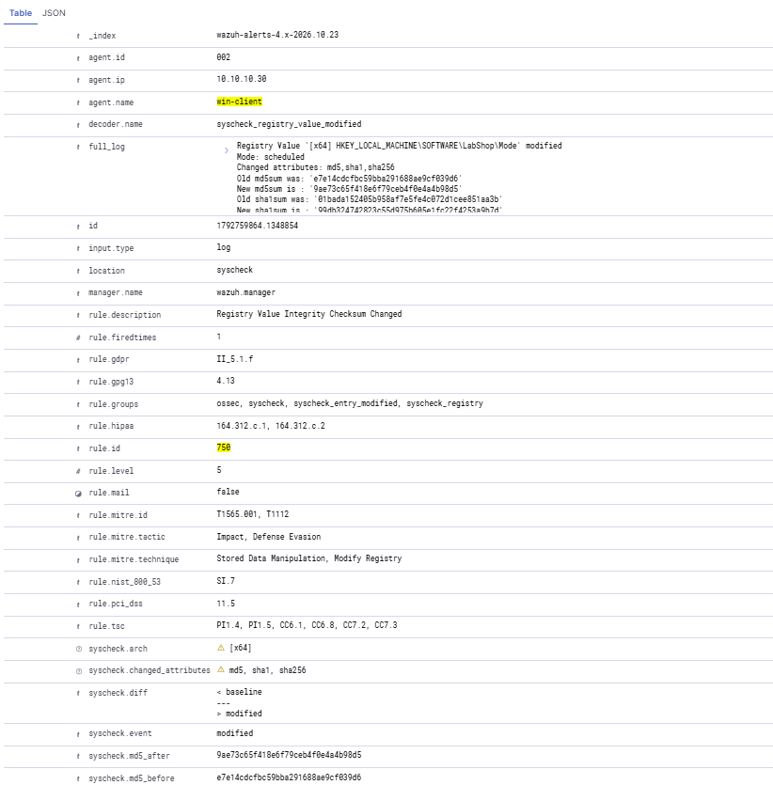
Wazuh rule 750 shows the scheduled Registry modification.

5. Scheduled versus real-time monitoring

11 Test scheduled Linux scanning
We temporarily set Linux FIM to scan every 60 seconds, then modified a harmless file in /etc. Wazuh detected the change as scheduled rule 550.
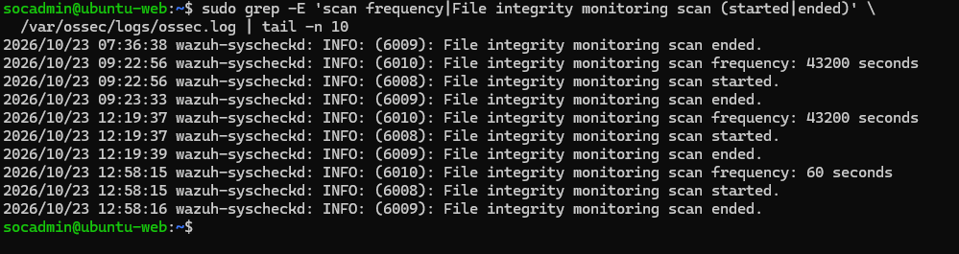
Temporary one-minute scheduled FIM interval.
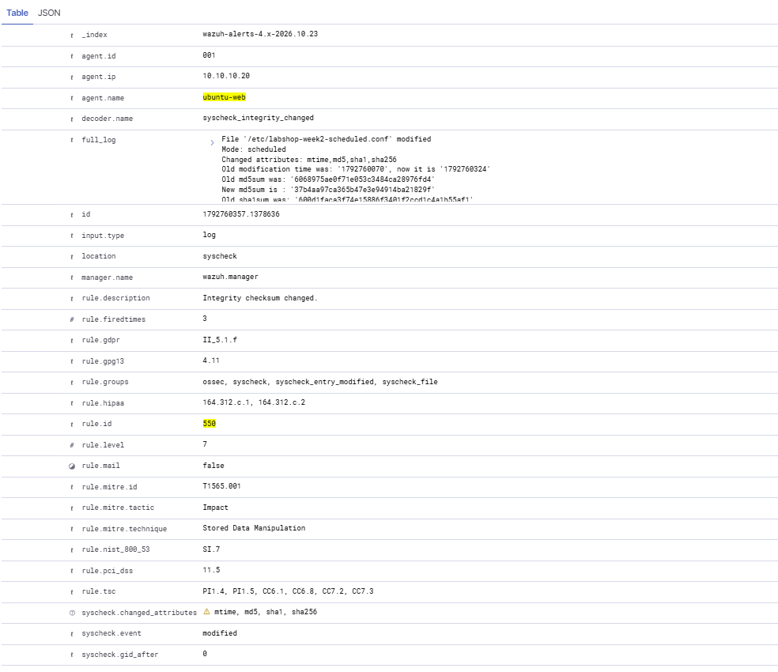
Scheduled /etc file modification detected by Wazuh.

12 Restore the default schedule
We returned the Linux scan frequency to 43,200 seconds (12 hours) and confirmed the Wazuh agent was active.
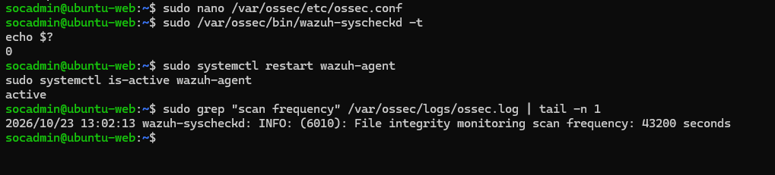
Linux FIM restored to its original 12-hour schedule.

6. Suricata IDS and Wazuh integration

13 Install Suricata and resolve the startup error
We installed Suricata 7.0.3 using temporary NAT access. It initially failed because its default capture interface eth0 did not exist, so we changed AF_PACKET to ens34.
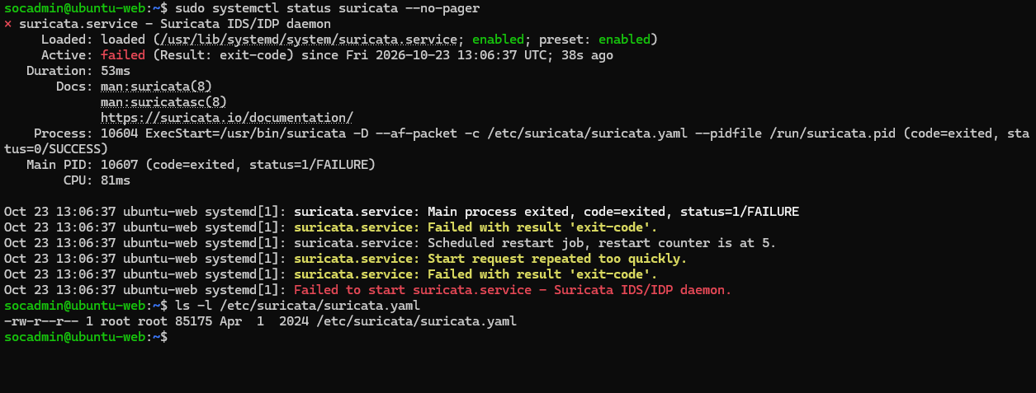
Suricata service initially failed to start.
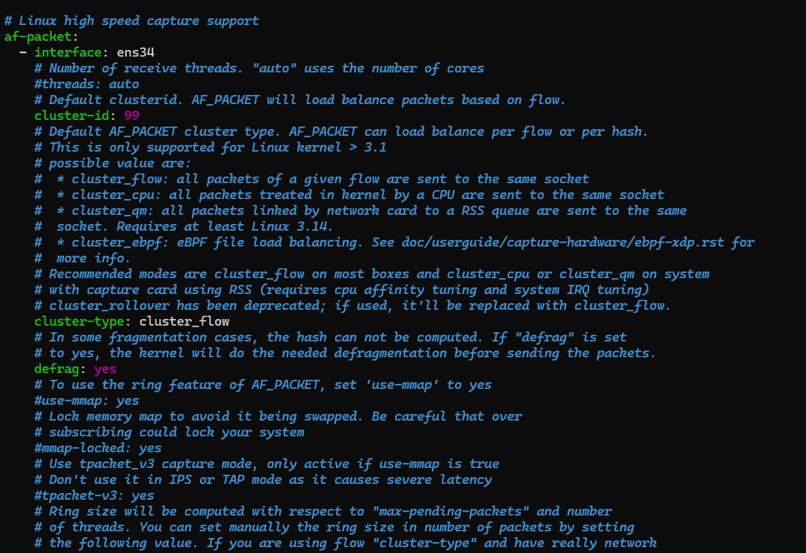
Suricata capture interface set to ens34.

14 Load a custom HTTP detection rule
We wrote a local Suricata rule for HTTP requests containing /admin. The configuration test confirmed one loaded signature with no rule failures, and the service started.
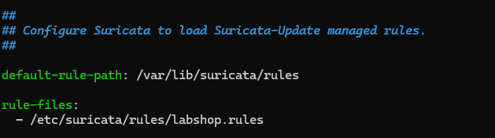
Custom labshop.rules included in Suricata configuration.
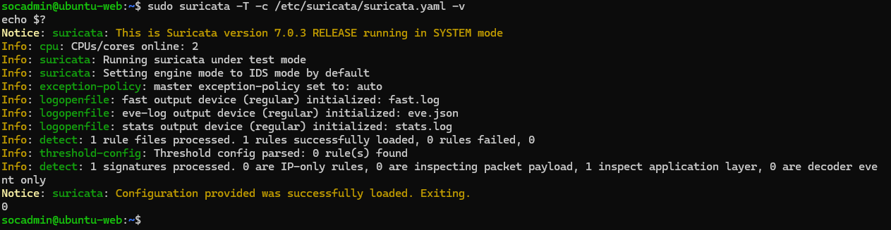
Suricata configuration test passed with one signature.
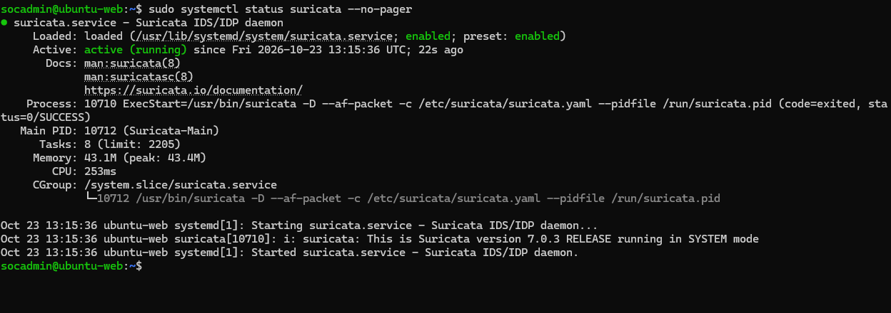
Suricata running after fixing the interface and rule settings.

15 Test the HTTP /admin signature
A request to http://10.10.10.20/admin returned HTTP 404 but produced Suricata signature 1000001. The alert appeared in fast.log and eve.json.
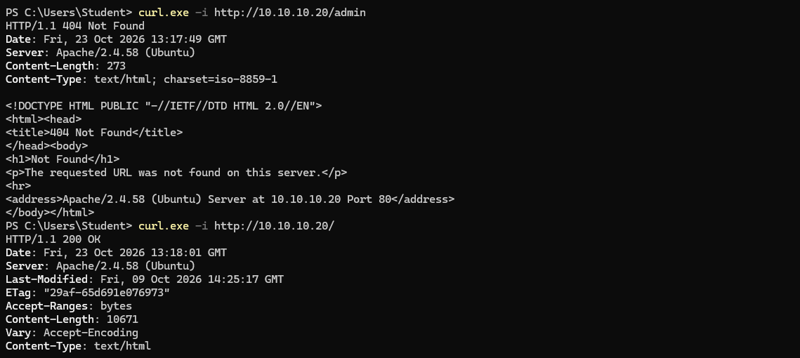
Windows host requests /admin and the normal home page.
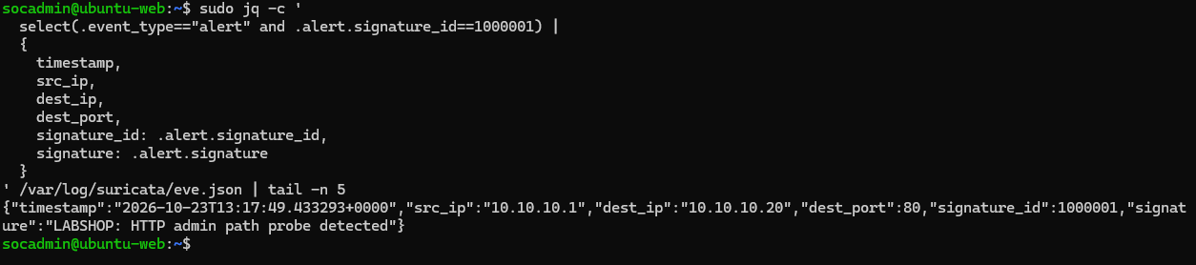
Suricata eve.json confirms the HTTP /admin alert.

16 Forward Suricata events to Wazuh
We configured the Ubuntu Wazuh agent to read eve.json as JSON. A new custom Wazuh rule 100110 raised the Suricata alert severity to level 10.
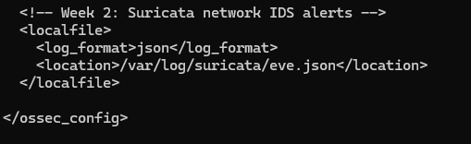
Wazuh agent collecting Suricata eve.json.
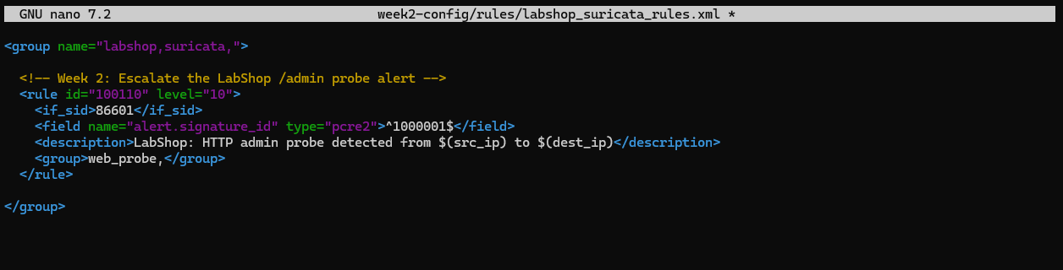
Custom Wazuh Suricata rule 100110.

17 Verify a real level 10 alert
After restarting the Wazuh Manager, a fresh /admin request generated a real Dashboard alert. It included the HTTP URI, source and destination, and rule 100110 at level 10.
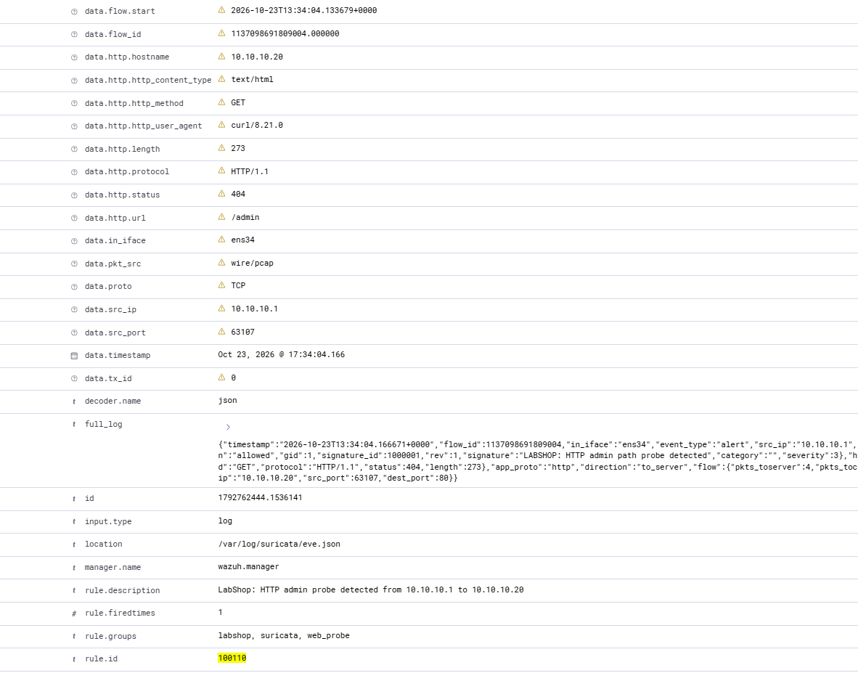
Live Suricata-to-Wazuh event with rule 100110.
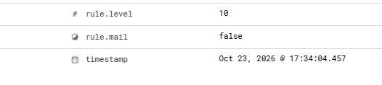
Rule 100110 severity confirmed as level 10.

18 Run the negative test and restore isolation
A normal GET / request returned 200 OK without adding a new custom alert. We removed NAT; only the host-only interface remained, and Suricata was active using about 45.8 MiB of RAM.
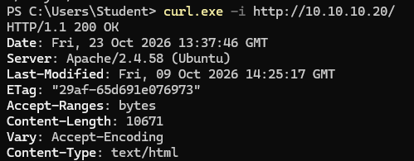
Normal home page request returned HTTP 200.
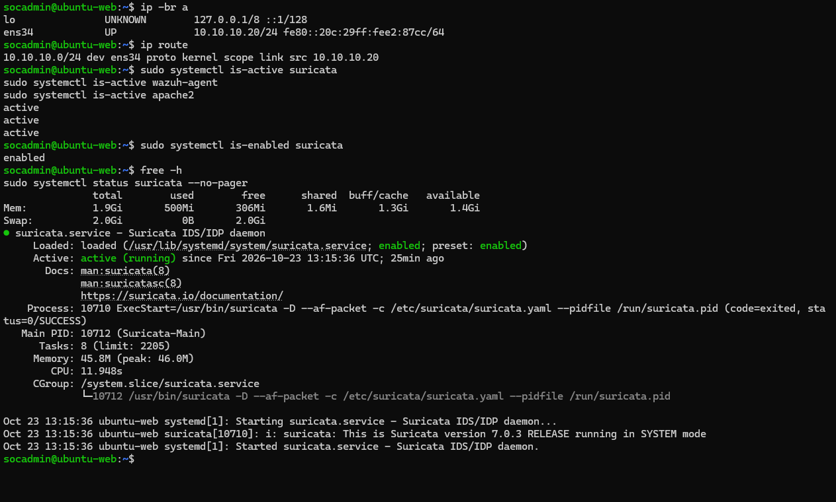
Final isolated networking, services and memory measurements.

7. Security Configuration Assessment

19 Record the original Ubuntu SCA score
The initial Ubuntu CIS assessment showed 119 passed, 118 failed and 42 not applicable checks (50%). We chose two safe login-banner findings to fix.
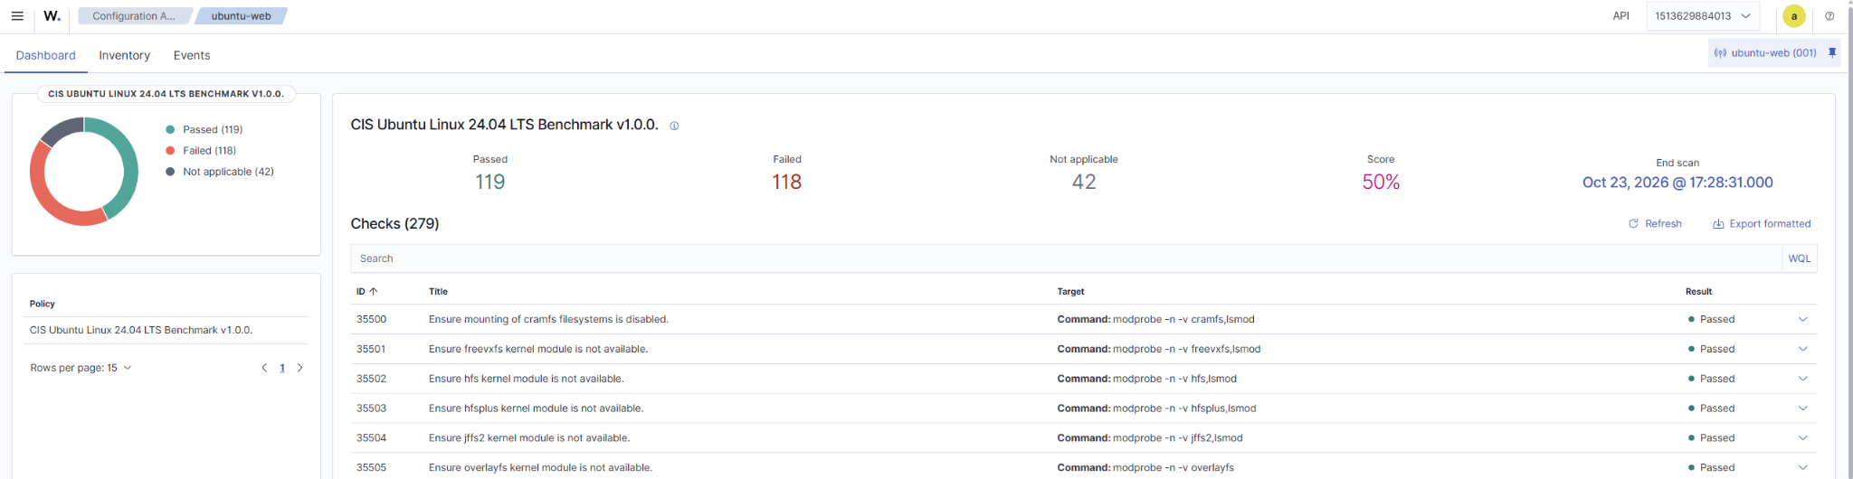
Ubuntu CIS baseline before remediation.

20 Fix two Ubuntu CIS findings
We replaced the operating-system login banners in /etc/issue and /etc/issue.net with an authorized-access warning. After a fresh scan, checks 35547 and 35548 both passed.
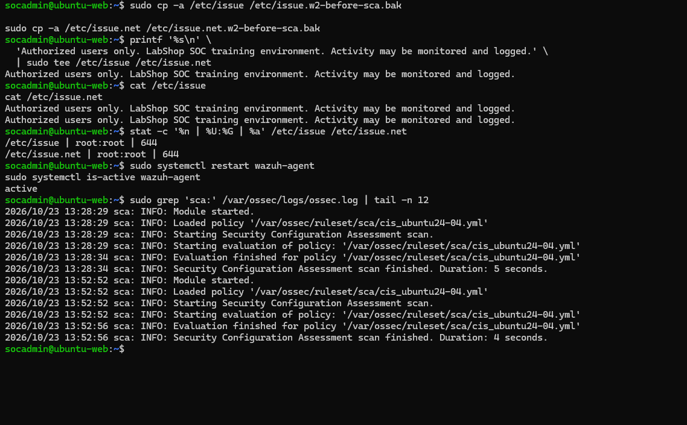
Banner changes, permissions check and SCA rescan.
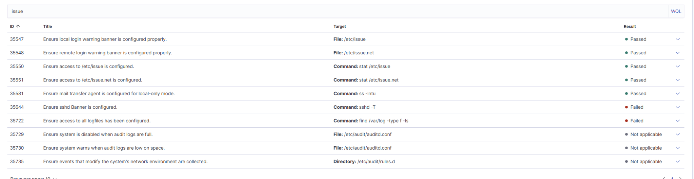
Both login-banner checks now Passed.

21 Confirm the final Ubuntu and Windows scores
Ubuntu improved to 121 passed and 116 failed (51%). Windows had 116 passed, 303 failed and 5 not applicable (27%) under the CIS Windows 10 Enterprise benchmark.
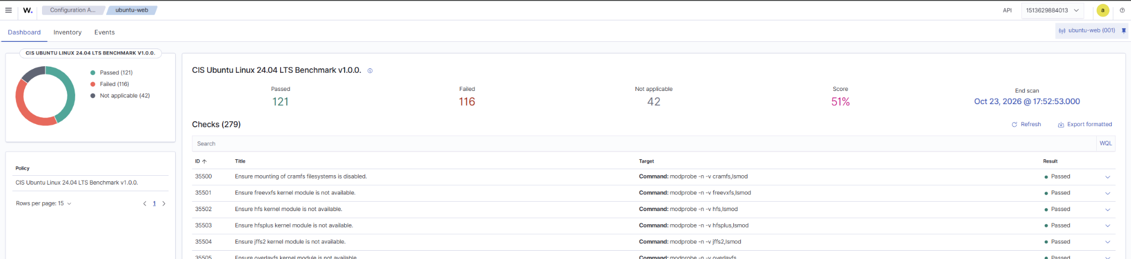
Ubuntu SCA after remediation: 121 passed, 116 failed (51%).
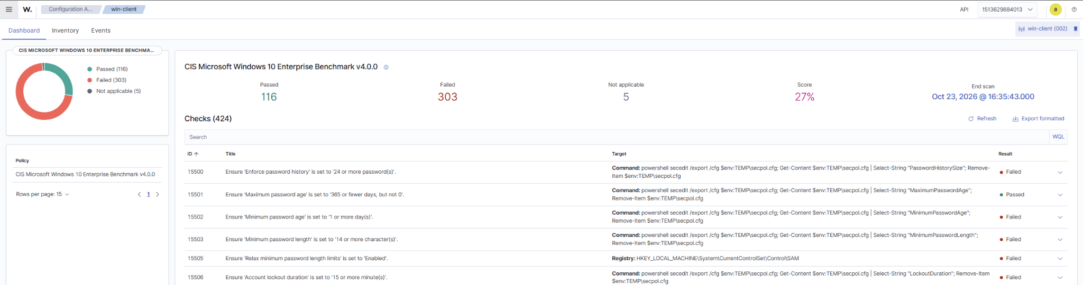
Windows SCA overview: 116 passed, 303 failed (27%).
One Ubuntu check, 35510 (/tmp not on a separate partition), was intentionally left unresolved to avoid changing the existing VM partition layout.

8. Vulnerability assessment

22 Review the highest-scoring CVEs
Wazuh Vulnerability Detection identified high-scoring findings on both agents. We filtered for Critical severity and sorted by CVSS to select three findings per endpoint.
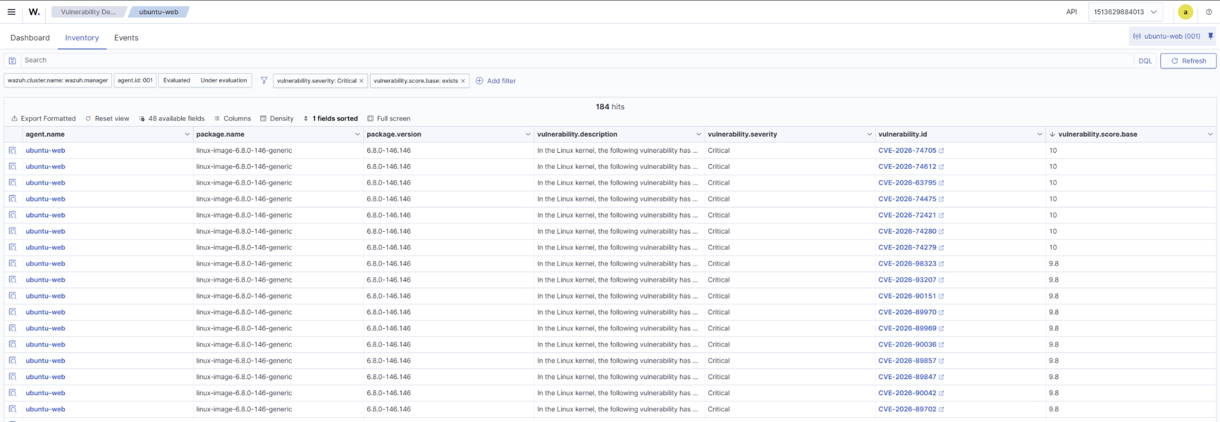
Ubuntu Critical findings sorted by CVSS.
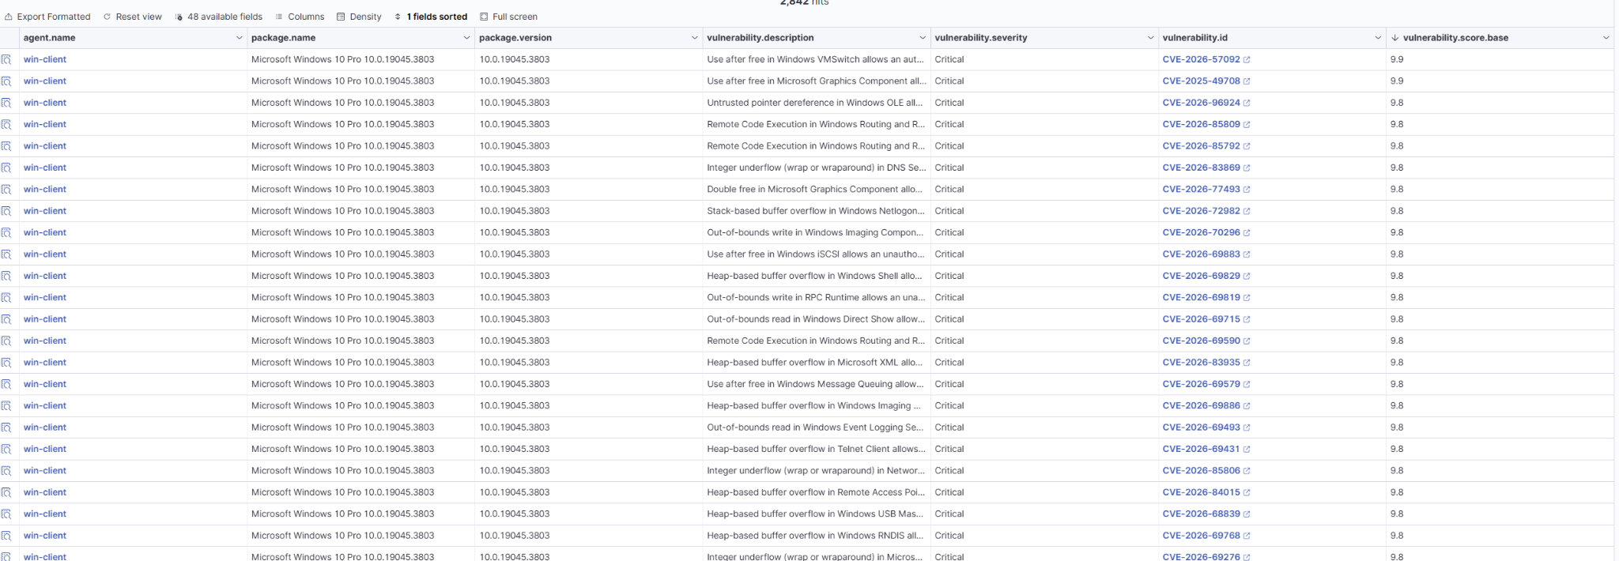
Windows Critical findings sorted by CVSS.
Agent | CVE | CVSS
ubuntu-web | CVE-2026-74705 | 10.0
ubuntu-web | CVE-2026-74612 | 10.0
ubuntu-web | CVE-2026-63795 | 10.0
win-client | CVE-2026-57092 | 9.9
win-client | CVE-2025-49708 | 9.9
win-client | CVE-2026-96924 | 9.8

For Windows, Wazuh reported affected builds below 19045.7548, 19045.6456 and 19045.7807 respectively. For the selected Ubuntu kernel findings, an exact fixed package version was not provided in the captured inventory. No patching was performed.

9. Final VMware snapshots

23 Save the completed Week 2 environment
We created w2-start and w2-done restore points for each VM, retaining all Week 1 snapshots. The resulting snapshot chains document the completed lab state.
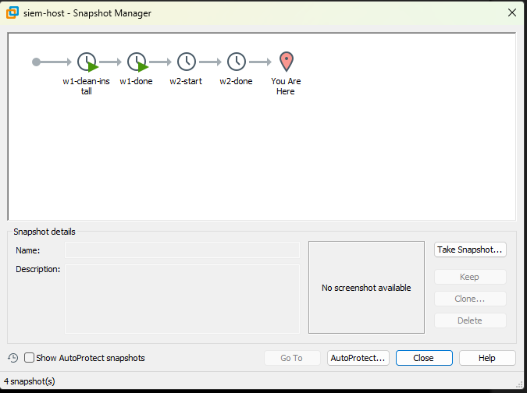
siem-host: Week 1 and Week 2 VMware snapshots.
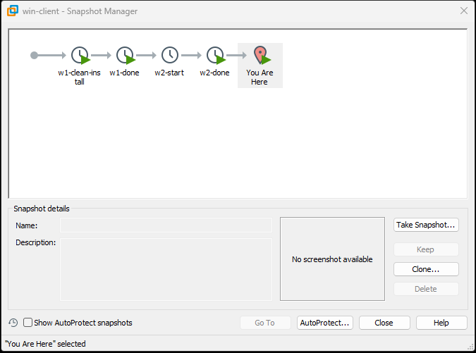
win-client: Week 1 and Week 2 VMware snapshots.
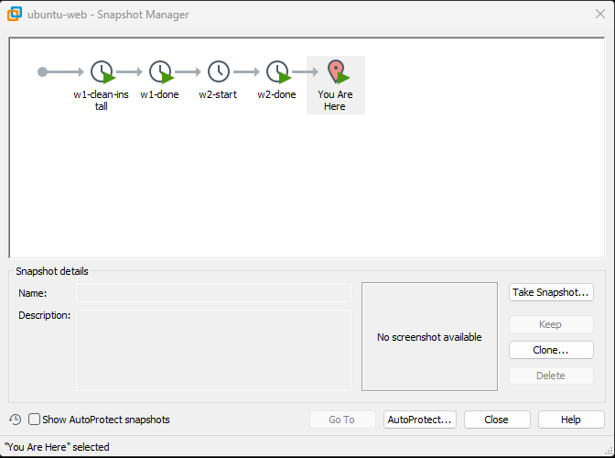
ubuntu-web: Week 1 and Week 2 VMware snapshots.

