

**Chapter 1 : INTRODUCTION**

## 1.1 Purpose

**The goal of the store is to offer a wide range of health products that meet the needs of health-conscious consumers.**

**By providing healthy products, the store supports customers on their wellness journey and helps them make informed choices.**

**The store's mission is to promote a healthier lifestyle by making healthy products easily accessible to everyone.**

**In doing so, the store distinguishes itself from other e-commerce sites that prioritize profit over health considerations.**

**This document uses the following conventions.**

|  |  |
| --- | --- |
| **NFR** | **Non-Functional Requirements** |
| **HTTP** | Hyper Text Transfer Protocol |

|  |  |
| --- | --- |
| **DDB** | Distributed Data Base |
| **ERD** | Entity Relationships Diagram |
| **HTML** | Hyper Text Markup Language |
| **CSS** | Cascading Style Sheets |
| **SQL** | Structured Query Language |

## Intended Audience and Reading Suggestions

Catering to the needs of all people with a special focus on health conscious people looking for healthy products.

## The Objective

It is commendable that an individual strives to have a healthy and fit body, but unfortunately, the lack of availability and support of healthy products can be a major hindrance. After creating the attached questionnaire and reviewing the results, we were able to choose this project to provide a selection of products that meet their needs.

: Our store is open 24 hours a day, 7 days a week, allowing customers to shop at any time that suits them, in addition to a wider range of products compared to physical stores.

 Our store provides detailed information about the products we sell, including ingredients and nutritional facts.

 We are committed to providing products that meet the highest standards of quality, safety and effectiveness.

: We also offer delivery services for all items with discounts that may exceed 30%, allowing customers to receive their orders with ease.



they need.

: A box will be provided to review their opinions and provide everything

## Project Scope

Each person can create an account by registering using his email and password so that he can

see many of the offers and brands provided by the site, know their prices, and add the selected products to the shopping cart. Payment can be made by bank, credit card, or cash. Thus, the site saves people. Time, effort and money, as there is a delivery service that transports products to customers in a short time without them leaving their home

We give priority to our customers’ needs and satisfaction above all else, and our motto is quality, excellence and innovation. We are committed to providing products that meet the highest standards of quality, safety and effectiveness. We constantly seek to find new and improved ways to enhance our products and services, and remain at the forefront of the industry.

## Methodology

##### Process Model

Software model used: Reuse-Oriented software engineering. with Incremental Model. Why These Models?

* + - **Reuse-Oriented Model because we will need some classes and implementations from**

previous successful projects and efficiency is high.

* + - **Incremental Model because the system will be developed incrementally with amount of prototypes, more flexible to use and less expensive to change requirements and It is easier to test and debug.**

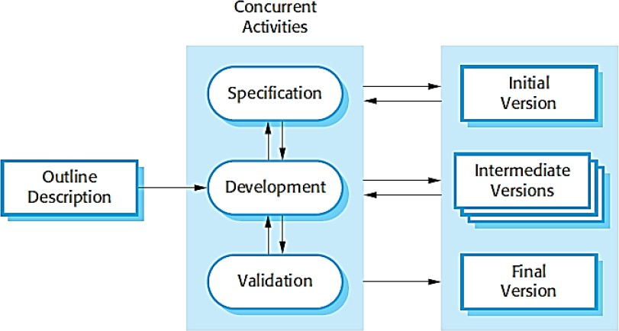

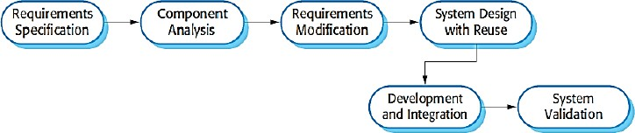

Our store is dedicated to offering a carefully selected range of healthy products that

meet the diverse needs of customers. We conduct comprehensive market research

and analyze customer preferences. additionally, we create targeted customer

surveys to better understand their needs and preferences. We ensure that the

selection of our products is in line with customer expectations and needs.

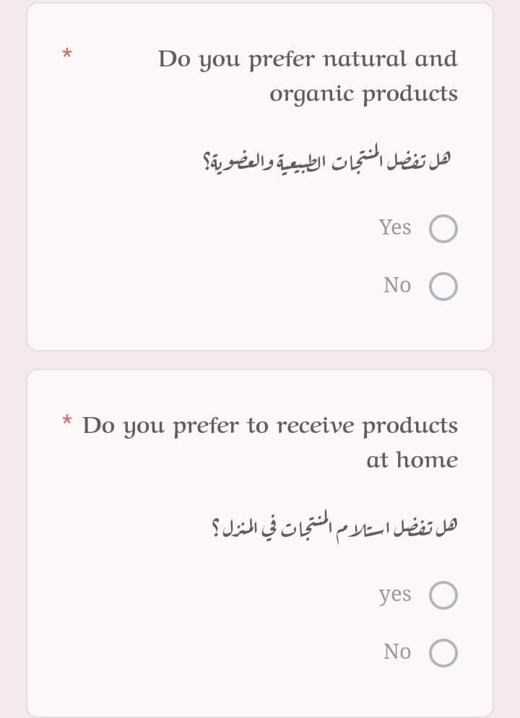

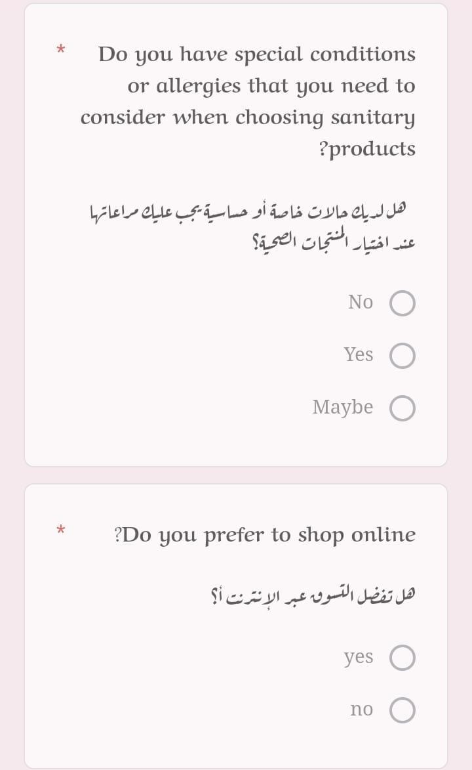

## 1.6 :Reference's

* [**https://docs.google.com/forms/d/e/1FAIpQLSefNt0yDRIzfq_PtnIcH6Yp9T5aKrqQ2nxw**](https://docs.google.com/forms/d/e/1FAIpQLSefNt0yDRIzfq_PtnIcH6Yp9T5aKrqQ2nxwcbgPCooFsEX5yA/viewform?usp=pp_url)[**cbgPCooFsEX5yA/viewform?usp=pp_url**](https://docs.google.com/forms/d/e/1FAIpQLSefNt0yDRIzfq_PtnIcH6Yp9T5aKrqQ2nxwcbgPCooFsEX5yA/viewform?usp=pp_url)
* [**https://app.diagrams.net/**](https://app.diagrams.net/)
* [**https://www.javatpoint.com/dbms-purpose-of-normalization**](https://www.javatpoint.com/dbms-purpose-of-normalization)
* [**https://www.lucidchart.com/**](https://www.lucidchart.com/)
* [**https://miro.com/app/dashboard/**](https://miro.com/app/dashboard/)
* [**https://online.visual-paradigm.com/**](https://online.visual-paradigm.com/)