**6.2 Class Diagram**

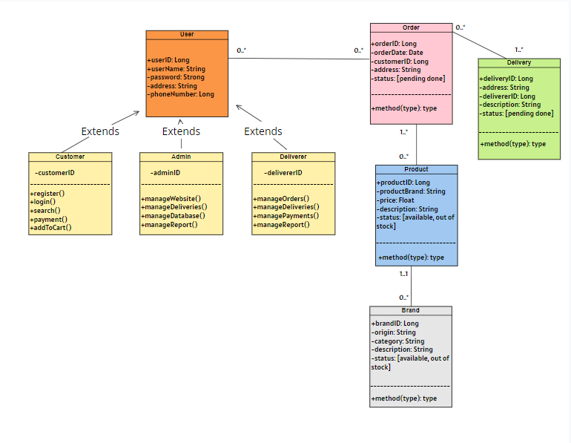

NutriFit system’s Class Diagram