

**Palestine Technical University – Kadoorie College of Engineering and Technology Department of Computer Systems Engineering**

**Course name:**

Software Engineering

**Project title:**

"NutriFit: Your One-Stop Solution for Healthy Living"



**By:**

Bushra Jaber – 202110414 Feryal Jaber– 202110451 Jamila HajAhmad–202110195 Masa Naser –202110022

**Supervisor:**

Dr. Osama Hamed

**Tulkarm, Palestine 9 April 2024**

Table of Contents

CAHPTER 0:Abstract CAHPTER 1: INTRODUCTION

* 1. **Purpose**
  2. **Intended Audience and Reading Suggestion**
  3. **The Objective**
  4. **Project Scope**

CAHPTER 2: CHAPTER 2 : OVERALLDESCRIPTION

* 1. **Product Perspective**
  2. **Product Features**



**Chapter 0 : Abstract**

**In the age of technology and development that we live in today, electronic platforms have become indispensable for various aspects of daily life, including shopping for nutritional needs and the NutriFit store is a website designed to meet the needs of all people with a focus on people searching for healthy products. This site offers many nutritional options with an emphasis on quality, variety, and supporting various health goals. By providing comprehensive product information and ensuring compliance with all quality standards, the NutriFit store aims to promote a safe and fast online shopping experience.**



**Chapter 1 : INTRODUCTION**

# Purpose

**The goal of the store is to offer a wide range of health products that meet the needs of health-conscious consumers. By providing healthy products, the store supports customers on their wellness journey and helps them make informed choices.**

**The store's mission is to promote a healthier lifestyle by making healthy products easily accessible to everyone. In doing so, the store distinguishes itself from other e- commerce sites that prioritize profit over health considerations.**

# Intended Audience and Reading Suggestions

Catering to the needs of all people with a special focus on health conscious people looking for healthy products.

# The Objective

It is commendable that an individual strives to have a healthy and fit body, but unfortunately, the lack of availability and support of healthy products can be a major hindrance. After creating the attached questionnaire and reviewing the results, we were able to choose this project to provide a selection of products that meet their needs.

: Our store is open 24 hours a day, 7 days a week, allowing customers to shop at any time that suits them, in addition to a wider range of products compared to physical stores.

 Our store provides detailed information about the products we sell, including ingredients and nutritional facts

 We are committed to providing products that meet the highest standards of quality, safety and effectiveness.

: We also offer delivery services for all items with discounts that may exceed 30%, allowing customers to receive their orders with ease.

: A box will be provided to review their opinions and provide everything they need

We constantly seek new and improved ways to enhance our products and services, and stay at the forefront of the

industry. Link:

**https://docs.google.com/forms/d/e/1FAIpQLSefNt0yDRIzfq_PtnIcH6 Yp9T5aKrqQ2nxwcbgPCooFsEX5yA/viewform?usp=pp_url**

# Project Scope

Each person can create an account by registering using his email and password so that he can see many of the offers and brands provided by the site, know their prices, and add the selected products to the shopping cart. Payment can be made by bank, credit card, or cash. Thus, the site saves people. Time, effort and money, as there is a delivery service that transports products to customers in a short time without them leaving their home

We give priority to our customers’ needs and satisfaction above all else, and our motto is quality, excellence and innovation. We are committed to providing products that meet the highest standards of quality, safety and effectiveness. We constantly seek to find new and improved ways to enhance our products and services, and remain at the forefront of the industry.



**Chapter 2: OVERALL DESCRIPTION**

# PRODUCT PERSPECTIVE

***A website that sells health products The ER diagram contains several tables:***

***First, the products table, as we know, there is no sale without products. It contains the product ID, product name, and brand ID***

***Customer table: As we know, the user (customer) is the active element in the application, so the customer table contains the customer’s ID, name, email, phone number, and address.***

***Each product has its own specific brand, so a brand table was created that contains the brand ID, the name of the brand, and the country of the brand.***

***What connects the customer and the product??***

***Yes, the order table contains the order ID, order name, delivery ID, customer ID, order address, and field***

***Clarification of the relationships in our store system:

1. **Every customer can log in, create an account, and give him a password**
2. **Each customer can place more than one order, and one order is for one customer**
3. **Each order may contain more than one product, and one product may be in more than one order**
4. **Every product has a specific brand, and the brand has more than one product**
5. **Every request can be serviced by delivery, and one delivery service includes several requests**

All of these relationships are explained in the ER diagram model in Section 2.2

# PRODUCT FEATURES

The major features of website database system as shown in below entity– relationship model (ER model):

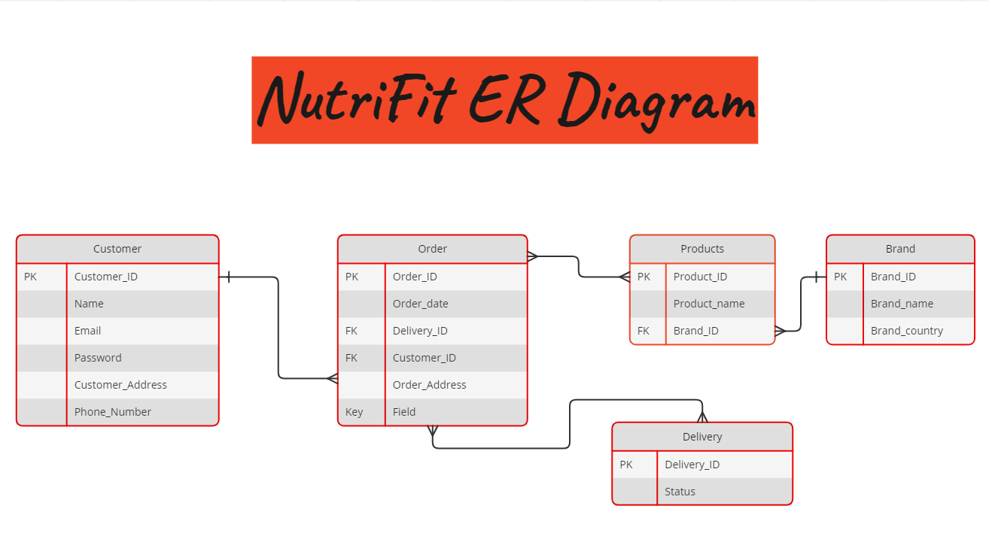

**The diagram shows the layout of the NutriFit Store database system–Entity relationship model.**

**If picture details aren’t clear, please follow this link:**

**https://miro.com/app/board/uXjVKZF1ay0=/?share_link_id=924080835463**

**Link of our project GitHub Repository:**

**https://github.com/JamilaHajAhmad/NutriFit**