**Explosive Soap Foam Picture Documentation**

**Earth Science**

**Members:**

**Banal, Mariel**

**Ilagan, Joshua Miguel**

**Mercado, Juliana**

**Nakamura, Aiko Yasmine**

**Novilla, Jamilla Nichole**

**Sotto, Agatha Ysabelle**

**(Grade 11 – STEM 3)**

**December 8, 2023**

**Materials and Measurements:**

**Dishwashing Liquid Soap**

* We consumed 3 sachets and the full jar of another liquid soap

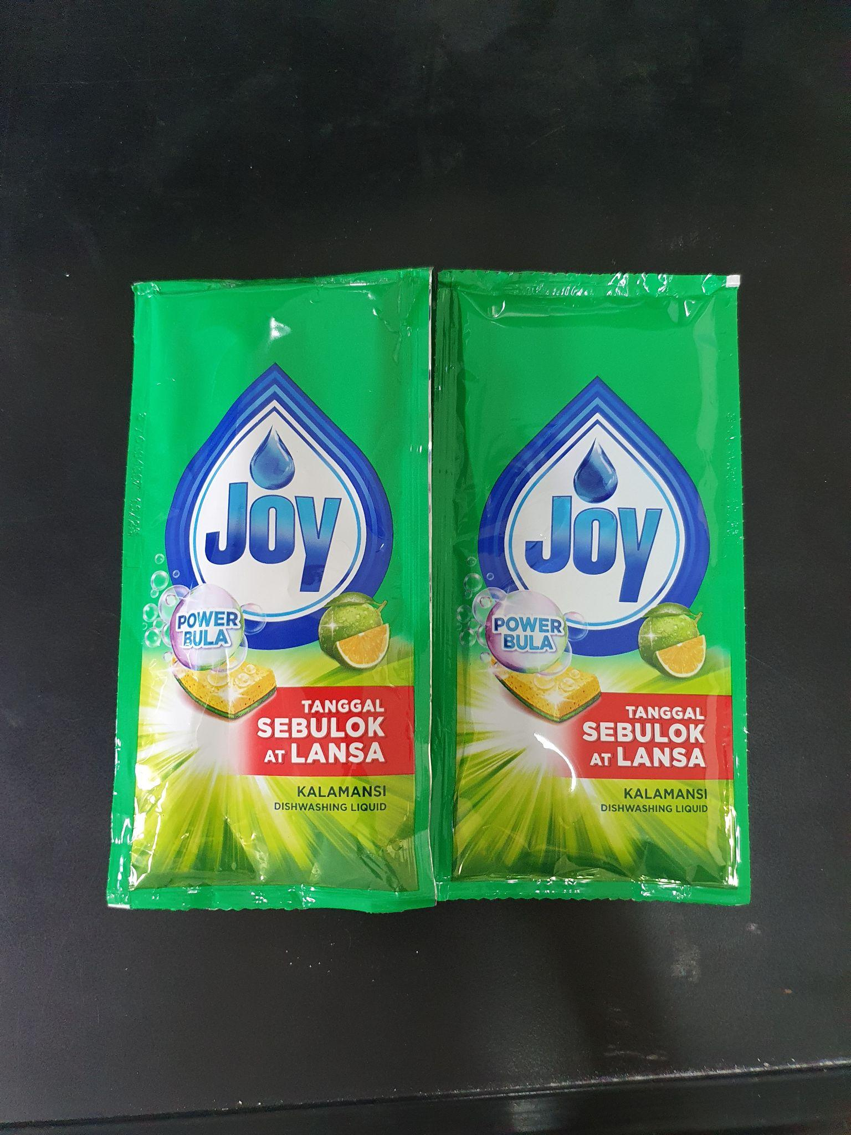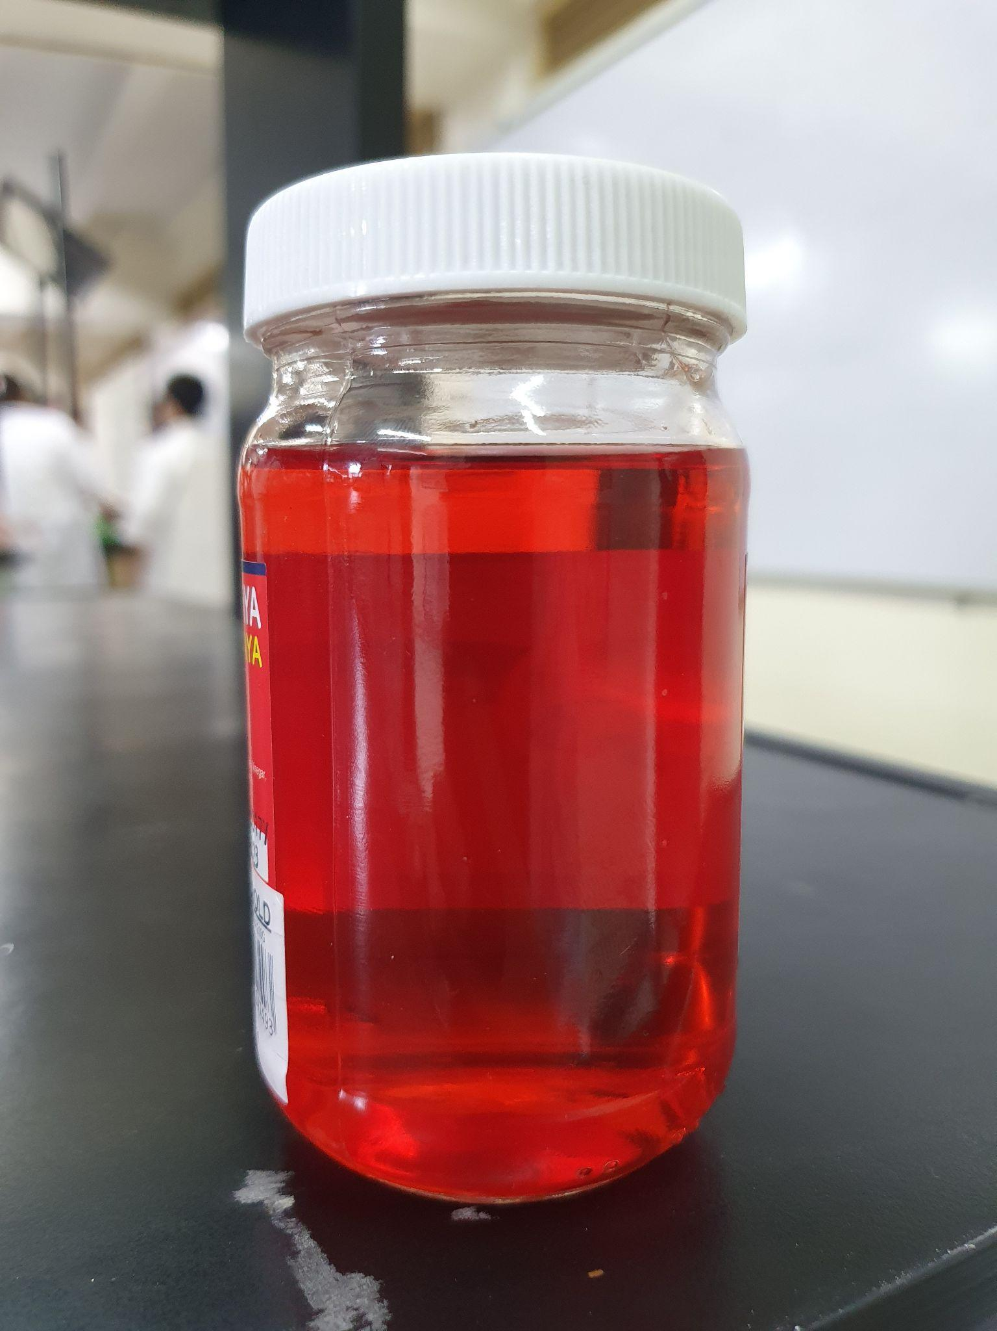

**Bubble Soap**

* One small bottle

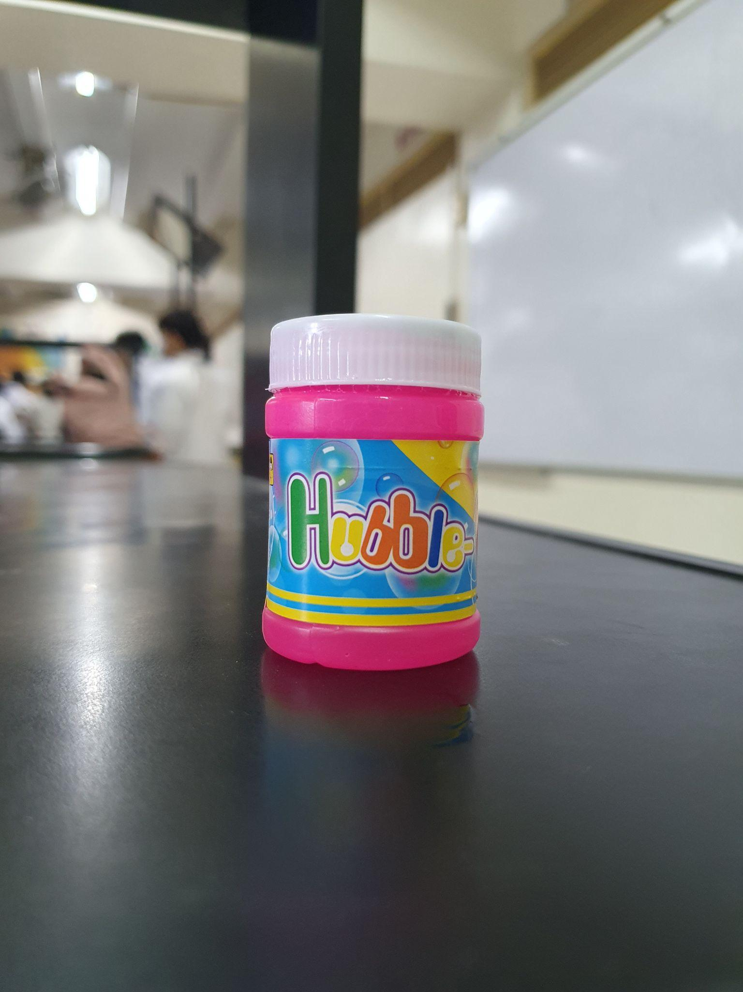

**Hydrochloric Acid**

* 50 ml

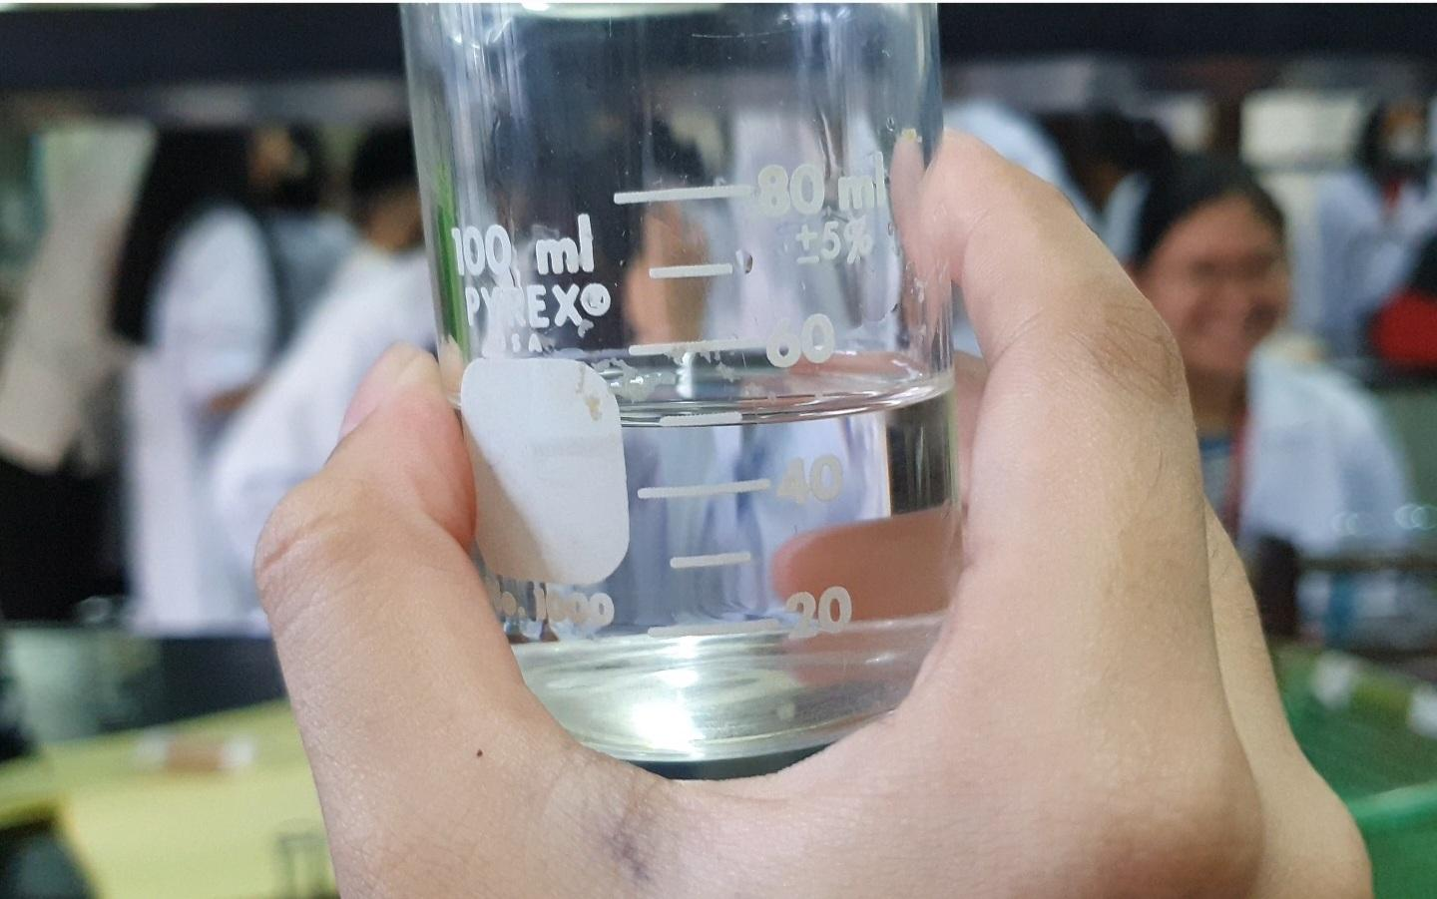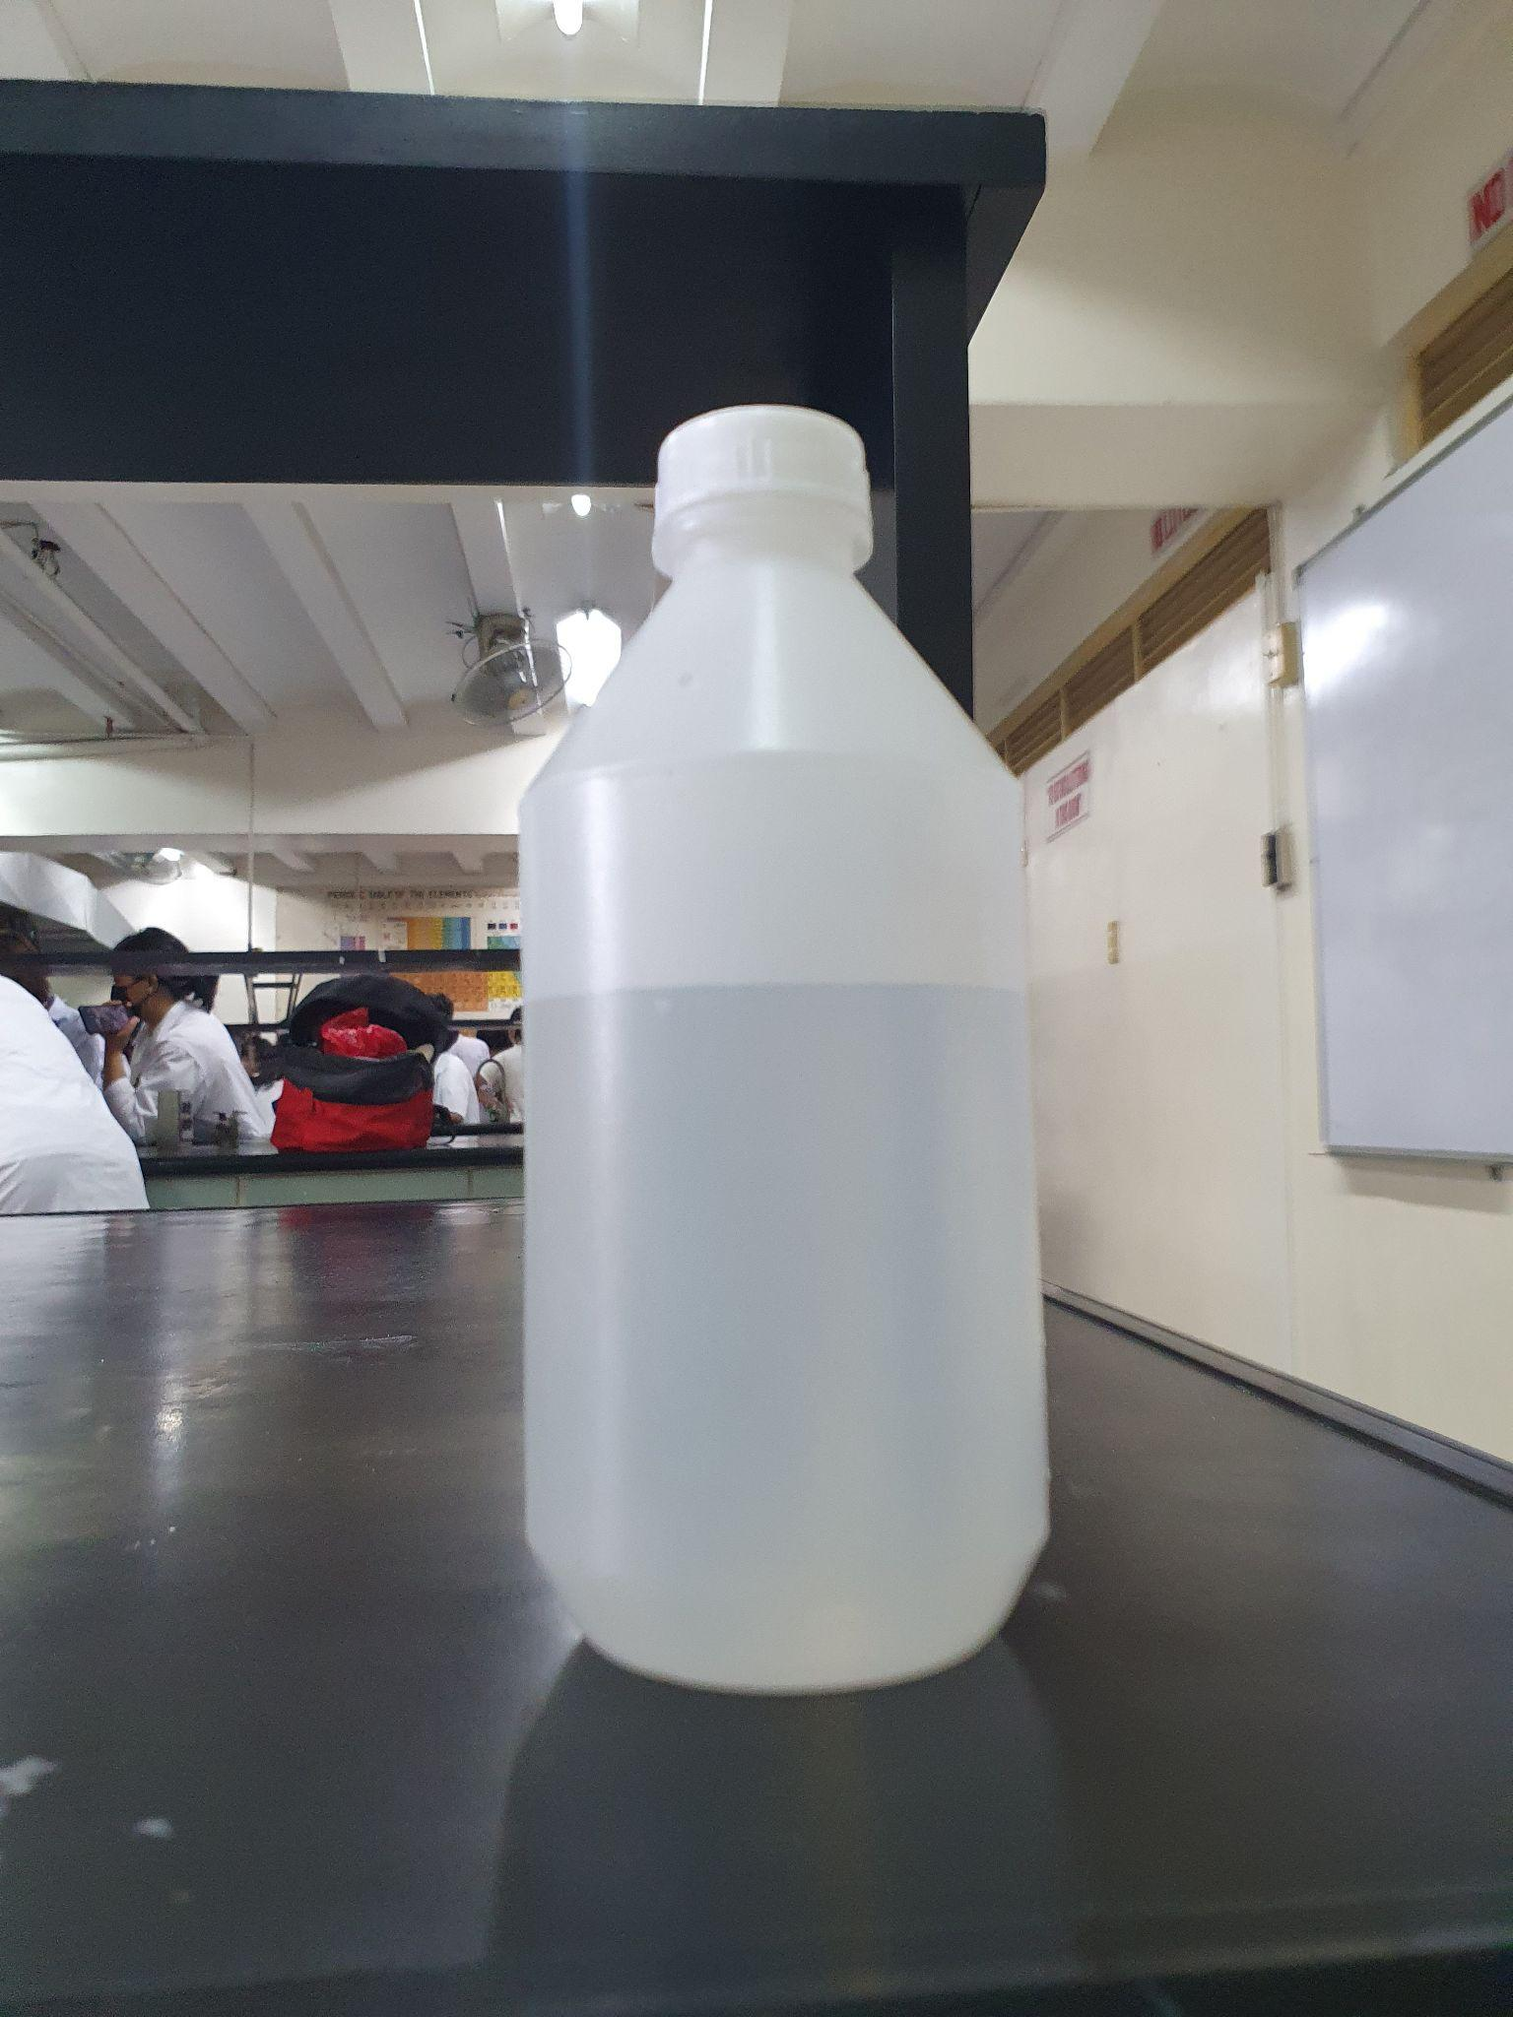

**Container and Tube**

* One large container and 1 yard tube filled with 44 oz of water

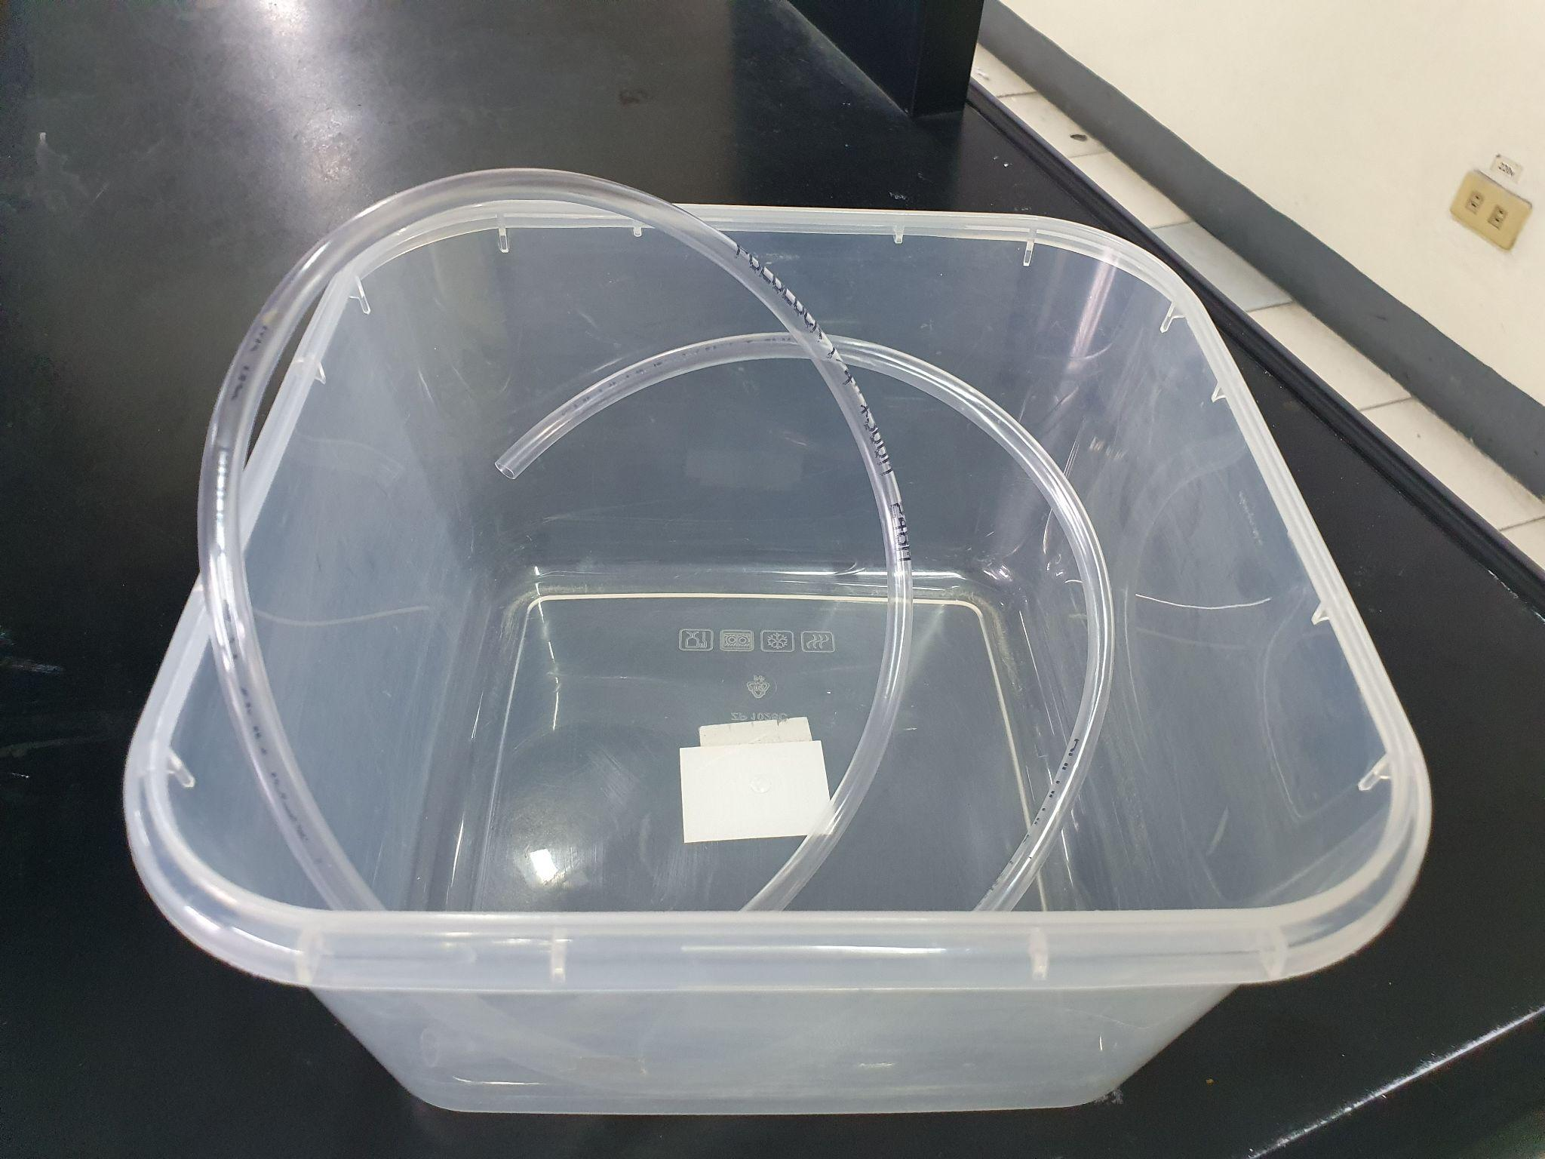

**Lighter**

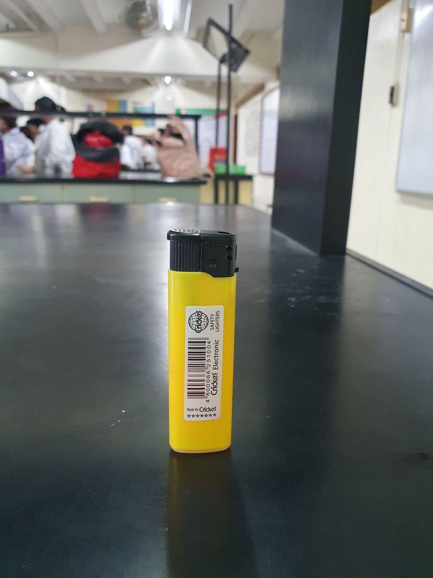

**Procedure:**

**First Step:**

Put the water, dishwashing soap, and bubble soap in the container. Mix thoroughly until bubbles start to form.

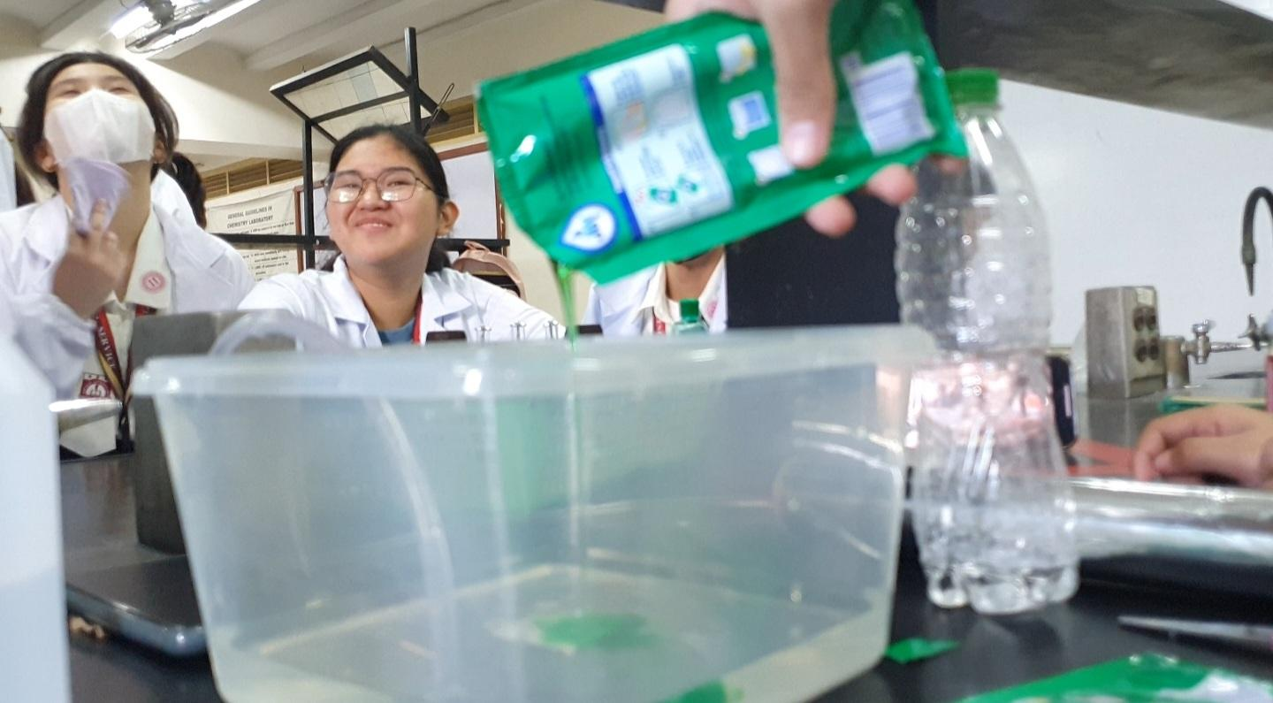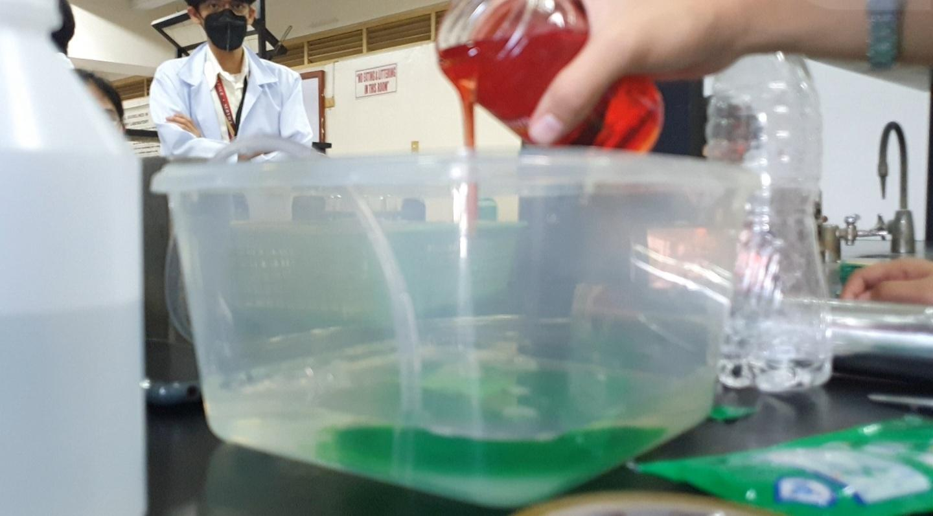

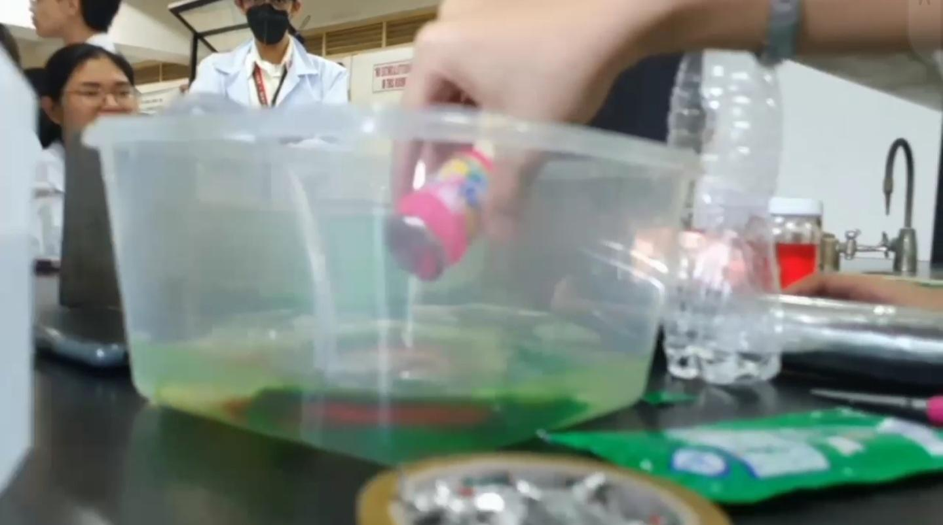

**2nd Step:**

Pour 50 ml Hydrochloric Acid in the bottle, we used improvised materials because buchner's flask is unavailable.

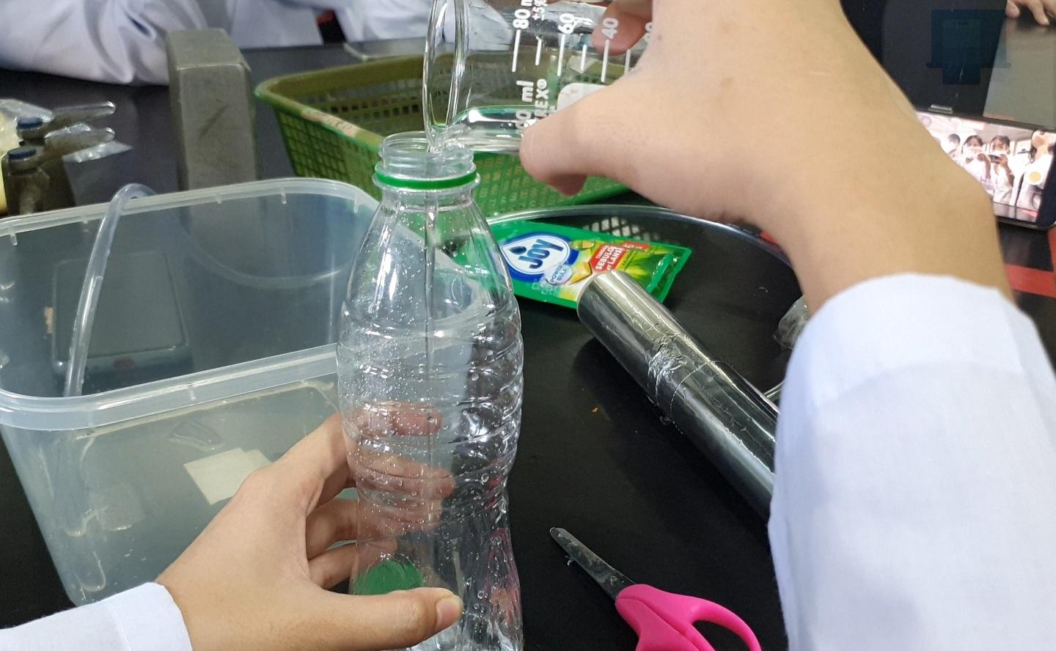

We secured its lid with tape after putting pieces of aluminum foil inside.

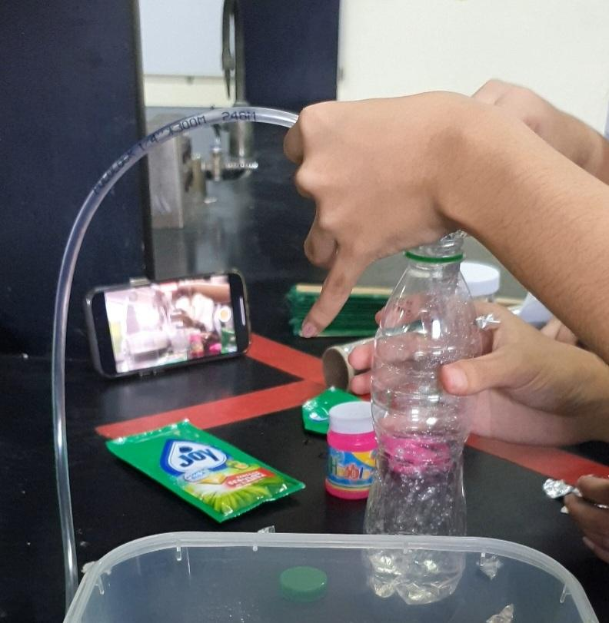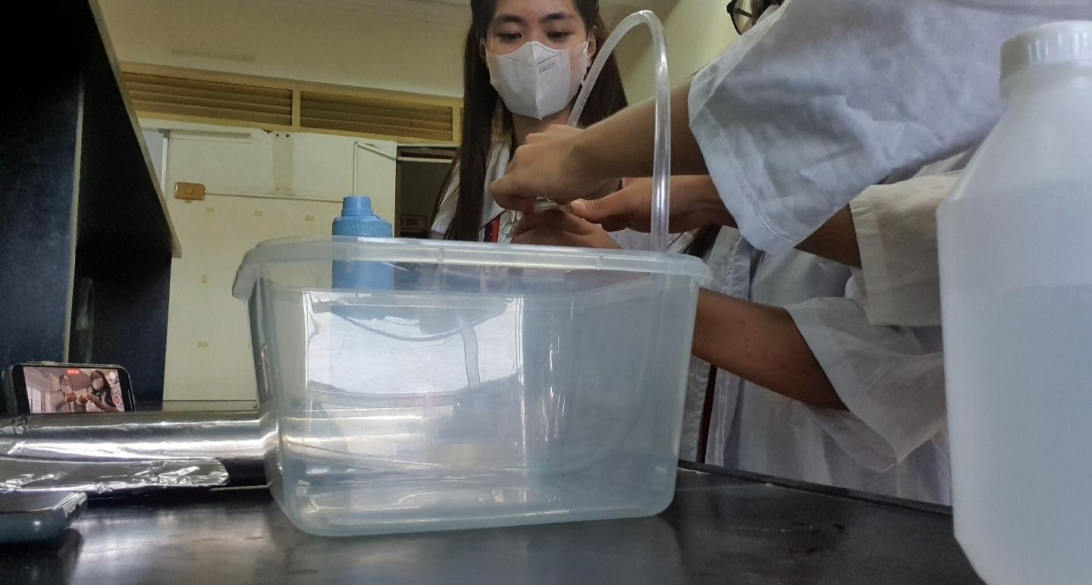

**Step 3:**

Once the lid is secured, we start stirring the bottle that contains hydrochloric acid and aluminum. We waited for a few seconds until gas started to form, however, the result of our improvised material was unsuccesful.

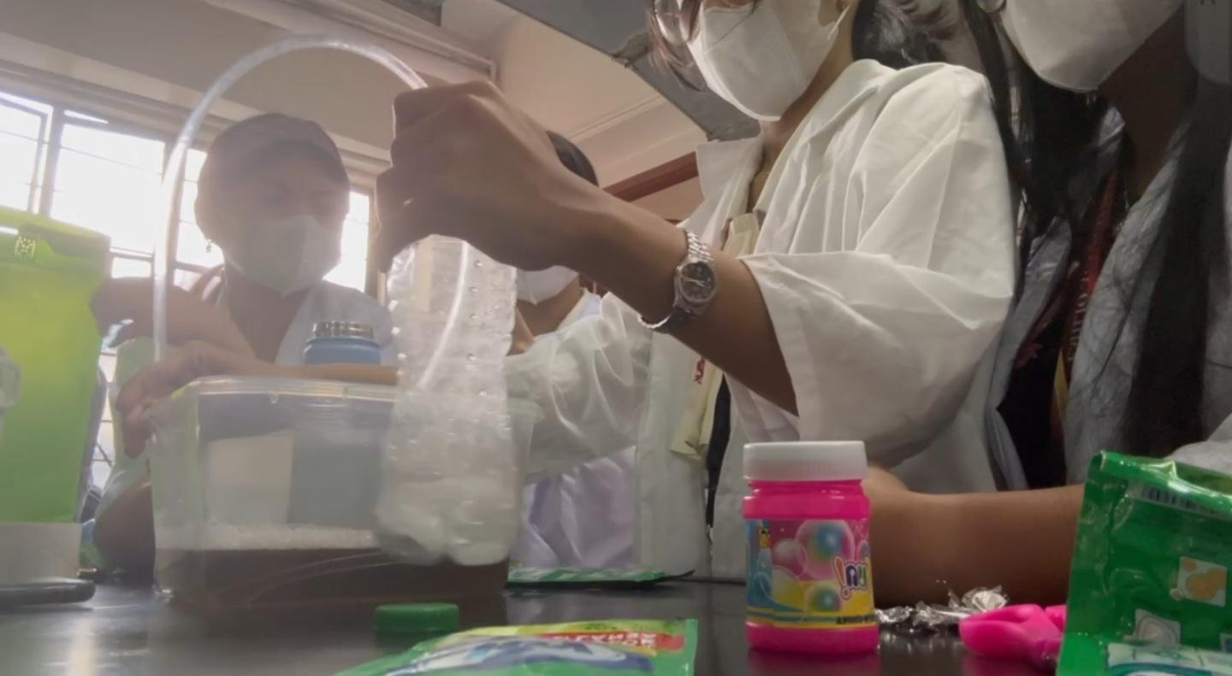

**Step 4:**

We looked for another alternative material, and used an erlenmeyer flask instead. In order to secure its lid, we used the bubble soap’s lid and created a hole on it to insert the tube. We pour another 50 ml of hydrochloric acid and pieces of aluminum foil before sealing it with a tape.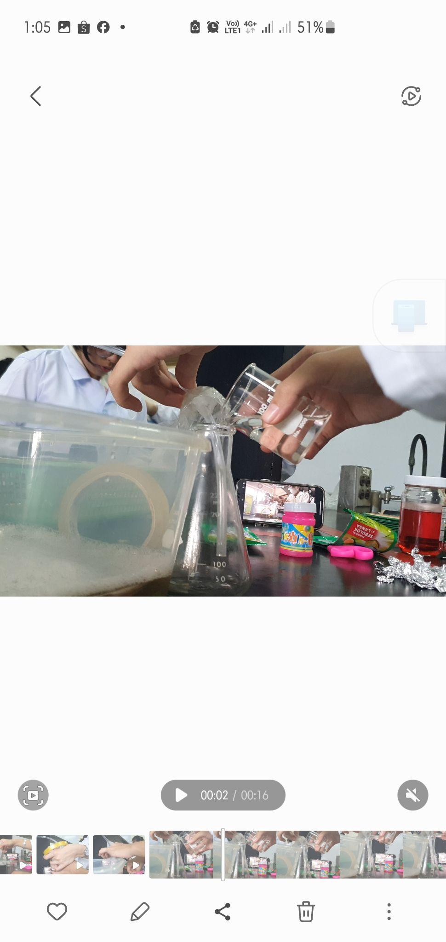

**Step 4:**

After wrapping the tape around the erlenmeyer flask, we started stirring it lightly until gas started forming again.



**Step 5:**

After countless of trial and errors in achieving Explosive Soap Foam, we were finally able to see the result as we tried to add fire on it to create an explosion,

