CULMINATING PERFORMANCE TASK

IN

GENERAL CHEMISTRY 1

Lab Title: Explosive Soap Foam

Performed by:

Banal, Mariel

Ilagan, Joshua

Mercado, Juliana

Nakamura, Aiko Yasmine

Novilla, Jamilla Nichole

Sotto, Agatha Ysabelle

**Submitted to:**

Mrs. Rachelle R. Casas, LPT

*Subject Teacher, General Chemistry 1*

**Introduction**

The "Explosive Soap Foam" experiment showcases a captivating reaction between aluminum foil and hydrochloric acid. This reaction generates hydrogen gas, which gets trapped by dish soap, creating a stable foam. When ignited, this foam can produce spectacular explosions and impressive shockwaves, revealing the principles of chemical reactivity and exothermic reactions. This experiment aims to investigate the reaction speed using the single displacement method and analyze the conditions necessary for the foam's explosive behavior, providing valuable insights into the underlying science of this fascinating phenomenon.

**Objectives**

1. Observe the reaction between aluminum foil and hydrochloric acid:

* Determine the speed of the reaction.
  + Identify the products of the reaction.
  + Analyze the changes in temperature and volume during the reaction.

1. Investigate the formation of the soap foam:
   * Analyze the role of soap in trapping the hydrogen gas generated in the reaction.
   * Observe the behavior of the soap foam under different conditions.
2. Examine the explosive properties of the soap foam:
   * Determine the conditions required for the soap foam to explode.
   * Analyze the energy released during the explosion.
3. Apply the principles of chemical reactivity and exothermic reactions to explain the observed phenomena.
4. Communicate the findings of the experiment in a clear, concise, and organized manner.

**Hypothesis**

The reaction between aluminum foil, hydrochloric acid, and dish soap will result in a significant change in the volume and behavior of the mixture. This change could manifest as a rapid eruption, controlled expansion, or sustained foaming, depending on the balance between gas production, heat generation, and the soap's ability to trap gas bubbles.

**Materials**

•Water

•50mL Hydrochloric Acid (HCI)

•Dish Soap

•Bubble Soap

•Aluminum (Al) foil

•Buchner flask

•glass box/water container

•Tube

•Gas lighter

**Procedure**

1. Put 50mL Hydrochloric Acid (10-15%) in a buchner flask. Set aside.
2. Pour dish soap and liquid soap in a water container/glass box. Stir it well.
3. Add a few cutted pieces of aluminum (Al) foil in the mixture of dish and liquid soap.
4. Insert the tube on the buchner flask and place the other end of the tube on the water container/glass box.
5. Observe its speed reaction (Hydrogen H2 bubbles).
6. When the mixture in the water container/glass box begins to react by foaming bubbles, ignite it using gas lighters then observe.

**Experiment Results**

**Results:**

This experiment demonstrated the process by which aluminum foil responds to hydrochloric acid, emitting gas and causing a minor explosion in the soap foam solution. Small alterations were seen, particularly in the color of the hydrochloric acid as the foil dissolved with it. It is irreversible; the process stopped and the finished product did not react with itself.

**Observations:** 

1. **Rapid Reaction:** The metal's instant reaction with hydrochloric acid appears as we begin to shake the Erlenmeyer flask.

1. **Color Changes:** Changes in color were observed as aluminum melts in the acidic substance to release a gas.

1. **Overflow:** Several pieces of aluminum foil in the HCL increased the risk of burns from acid overflow

Our group saw that the aluminum foil took around 30 seconds to react with HCL during the experiment. The reaction did not happen promptly. The reaction only continued for a maximum of 20 seconds before stopping to release gas. Since the right materials were not used, the experiment's duration did not exceed 20 seconds. After a few seconds, the gas was transferred to the soap solution, where it formed gas bubbles that burst when we introduced it to fire for a brief period of time—less than five seconds.

**Data Analysis**

**(Hydrochloric and Aluminum)**

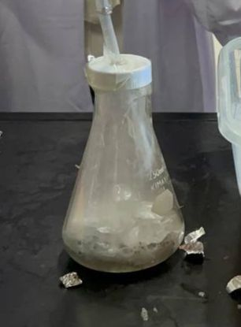

Based on our group's analytical observation, when you put aluminum foil in a 50mL hydrochloric acid, a chemical reaction occurs. The hydrochloric acid acts as a reactant, while the aluminum foil is the substance that undergoes a chemical change. The hydrochloric acid (HCl) reacts with the aluminum (Al) to produce aluminum chloride (AlCl3) and hydrogen gas (H2). The reaction can be represented by this equation:

**2 Al + 6 HCl → 2 AlCl3 + 3 H2**

The reaction became possible due to the Acid-Base Reaction wherein when aluminum foil is added to the hydrochloric acid solution, the aluminum reacts with the hydrogen ions, resulting in the formation of aluminum ions (Al3+), and hydrogen gas (H2). The aluminum foil undergoes a chemical reaction with hydrochloric acid, resulting in the dissolution of aluminum atoms and the formation of aluminum ions. This reaction process is called an oxidation-reduction reaction or a redox, occurs when metallic aluminum reacts with hydrochloric acid.

As the reaction proceeds, you will observe that the aluminum foil will start dissolving with the presence of Hydrochloric Acid forming aluminum chloride. Following the reaction between aluminum foil and hydrochloric acid, the container will experience effervescence or bubbling as hydrogen gas is released. Subsequently, the solution will begin to evaporate. The hydrogen gas forms bubbles that ascend to the solution's surface. These bubbles are a direct consequence of the chemical reaction that generates hydrogen gas.

That is why we logically predicted that the container must be totally sealed to block the hydrogen gas from releasing into the air. The reaction of this mixture can be classified as exothermic in which energy is released in the form of heat. For this reason, it is important to note that this reaction should be conducted with caution in a well-ventilated area and appropriate safety measures should be taken, as it involves the use of a strong corrosive acid.

**measurement of HCl before releasing hydrogen gas: 50mL (10-15%)**

**measurement of HCl after releasing hydrogen gas through aluminum: approximately 40mL**

**room temp. of HCl : 25°C (77°F)**

**room temp. of Aluminum foil : 20 - 22°C (68-71°F)**

**temp. of HCl and Aluminum foil mixture: boiling point (40<°C)**

*-The exact temperature of the mixture will depend on the quantity of HCl solution and the quantity of Aluminum foil that has been take place.*

**(Water and Liquid Soap/Bubble Soap)**

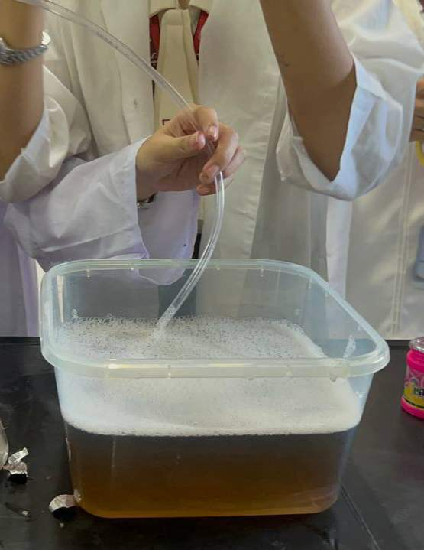

When water and liquid soap are mixed, since soap is typically a surfactant that reduces the surface tension of water, the mixture started to form micelles. As more soap molecules dissolve in water, they arrange themselves in spherical structures or molecules, forming a colloidal particle called micelles. Moreover, a bubble formation occurs as the soap molecules form a thin film around the air, trapping it inside and creating bubbles. Air bubbles formed when a gas is dissolved in water beyond its solubility limit and the gas molecules come together and create clusters.

As for our experiment's data, we put 3 sachets of liquid/bubble soap in a water as many as to filled our container. In this cause, we analyze that more soap allows for bigger bubbles. When soap molecules interact with water molecules, they tend to divide small portions of water and create bubbles. Soap molecules possess two distinct ends: one end attracts water (hydrophilic), while the other end repels water (hydrophobic). These bubbles eventually pop out as the water evaporates. On the other hand, our experiment introduced you that as you bring the lighter closer to the soap bubbles, the gas within them becomes heated to a high temperature, causing it to ignite. Consequently, the butane and propane present in the bubbles swiftly react with oxygen, resulting in the formation of water and carbon dioxide. This chemical reaction is exothermic because it releases heat energy.

**type of liquid soap: "Joy kalamansi" dishwashing liquid**

**room temp. of water: 26°C (78°F)**

**room temp. of liquid soap: 25°C (77°F)**

**temp. of the mixture: normal**

**("Explosive Soap Foam" experiment occurrence)**

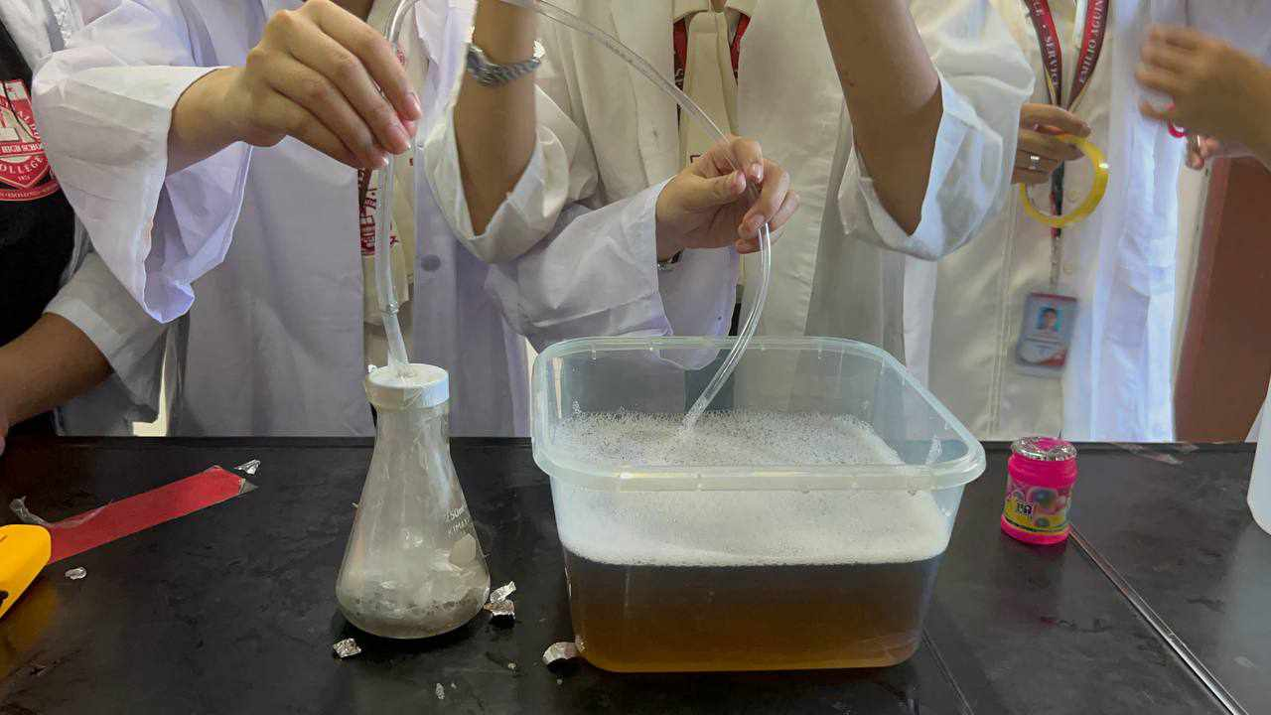

The explosion of this experiment is obtained by igniting an explosive gaseous mixture, confined in a soap bubble and obtained by the highly energetic electric discharge, which takes place at the center of the bubble. The mixture consists of hydrogen and oxygen. By the 50mL Hydrochloric Acid substance and Aluminum Foil, the evaporated hydrogen gas transfer to the mixture of water and soap through a tube producing a more particles of air bubbles, resulting into a successful experiment of exploding these bubbles foam. This experiment is a demonstration of a rapid exothermic reaction. Several factors contribute to the occurrence of explosive soap foam. These include the heat gases released by the HCl and Aluminum Foil allowing to flow through the liquid soap producing more bubbles. The reason why soap foam can become explosive is because it contains flammable gas. When this mixture is ignited, the heat causes the gas to rapidly expand, creating a sudden increase in pressure within the foam. This pressure becomes too much for the foam to handle, causing it to explode.

**temp. of the water and liquid soap mixture after igniting by gas lighter: approximately 600°C (1112°F)**

**Discussion**

1. What equipment did you use in the experiment?

- To complete the experiment, our group used hydrochloric acid, bubble soap, dish soap, water, tube hose, stirring rod, flask, a tub, and aluminum foil.

2. What changes did you see during and after the experiment? How quickly did the reaction start to happen and how quickly did it stop?

- What I noticed in this experiment was that the substances in both containers (the water bottle and the transparent container) reacted. As the aluminum foil was placed in the bottle of water containing hydrochloric acid, it began to react so when it was covered with tape it continued to bubble and the liquid rose. Even in the container that contains the ingredients of the soaps, it swells and rises especially when exposed to the flame coming from the lighter. In total, the reaction took less than 20 seconds.

3. What are the effects and modifications that can be made if more or less chemicals are used in the experiment?

- If the measurements are misaligned, it can lead to weird results in your experiment. For example, if you add more acid, the reaction will increase or become more intense. On the other hand, If you have only a few ingredients, the reaction won’t work because the proportions aren’t correct. So, if the measurement of the ingredients used in your experiment isn’t right, you won’t get the results you expected. This is why we need to focus and be serious about measuring and adding the ingredients to the experiment in order to improve the outcome of our experiment.

4. What happens if you change the size of the bottle (or the one we used as an alternative for buchner flask) in the explosive soap foam experiment?

- The amount of foam produced in the explosive soap foam experiment can be vary by changing the bottle's size, since there is more space in the bottle for the reaction to happen, when the size of the bottle is raised, more foam can be formed. On the other hand, using a smaller bottle can cause the amount of foam to decrease, due to the fact that the reaction rate and foam expansion may be impacted by the container's size. Therefore, the size of the bottle is a factor that can affect the outcome of the experiment.

5. What do you think will happen if the mixture you made from the experiment touched your skin?

- It will cause severe burns depending on the concentration of the acid. It will also cause blindness if it made contact with the eyes.

6. What safety precautions should be taken when conducting the explosive soap foam experiment?

- To ensure the safety of those who conducted the experiment, we wore a lab coat and face mask. As one of the materials that was used in the experiment is a toxic substance: Hydrochloric acid is a strong acid and a highly corrosive liquid. This chemical compound is the aqueous (water-based) solution of hydrogen chloride gas. 36% hydrochloric acid is highly volatile and is a high-risk inhalation hazard. If inhaled, it can cause nose and throat burning, difficulty breathing, and coughing. If skin contact occurs it can cause severe burns. Ingestion of concentrated hydrochloric acid can cause severe injury to the mouth, throat, esophagus and stomach.

7. How did the experiment illustrate how different chemicals interact?

In this experiment, chemicals are usually combined and allowed to react to produce gas and a foamy explosion. This demonstrates the dynamic interplay between the chemical components since the reaction produces gas, which modifies the components' states in a way that is observable.

**Conclusion**

In conclusion, the "Explosive Soap Foam" experiment provided a captivating and informative demonstration of several key scientific concepts. The experiment successfully confirmed the hypothesis that combining aluminum foil with hydrochloric acid would produce a rapid exothermic reaction, generating hydrogen gas and a significant increase in volume. This reaction was further enhanced by the presence of soap, which trapped the hydrogen gas, creating a visible and explosive foam upon ignition.

The experiment effectively showcased the following principles:

* Acid-metal reaction: The vigorous reaction between hydrochloric acid and aluminum foil highlighted the basic principle of metals readily reacting with acids to produce hydrogen gas. This reaction served as the foundation for the entire experiment.
* Gas production and foam formation: The experiment clearly demonstrated the generation of hydrogen gas as a byproduct of the acid-metal reaction. Additionally, the introduction of soap facilitated the trapping of this gas, forming a stable foam that provided the platform for the explosive eruption.
* Exothermic reaction: The significant increase in temperature observed during the experiment underscored the exothermic nature of the acid-metal reaction. This heat generation contributed to the expansion of the foam and ultimately intensified the "explosive" effect.
* Alternative fuel potential: The experiment revealed the potential of the generated hydrogen gas to serve as a valuable alternative fuel source. This observation sparked curiosity and ignited further investigation into the practical applications of this readily available and clean-burning fuel.

Furthermore, the experiment highlighted the importance of various nuanced factors, such as:

* Aluminum foil presence: The increased presence of aluminum foil was directly linked to a more intense reaction with hydrochloric acid, resulting in higher temperatures, faster evaporation rates, and a more prominent "boiling" effect. This observation emphasized the crucial role of reactant concentration in chemical reactions.
* Safety considerations: The experiment underscored the importance of proper safety precautions when working with chemicals like hydrochloric acid. This included wearing appropriate protective gear and handling the materials with utmost care.
* Scientific curiosity: The engaging and mesmerizing nature of the experiment sparked scientific curiosity and a deeper understanding of fundamental chemical principles. This ignited a passion for further exploration and investigation, paving the way for future research endeavors.

By effectively demonstrating these key concepts and highlighting the importance of various factors, the "Explosive Soap Foam" experiment served as an invaluable tool for fostering scientific understanding and appreciation. The experiment's impact extended beyond mere observation, igniting a spark of curiosity and inspiring further exploration into the fascinating world of chemical reactions and their diverse applications.

**Applications and Real-Life Connections**

We anticipate that the findings of this experiment will not only provide us with a deeper understanding of the principles governing explosive soap foam but also serve as an inspiration for further exploration in the realms of chemistry, physics, and materials science. Simply put, we applied how flammable H2 makes a loud sound when combined with O2 in the air.

On a real-life connection we can compared it to the following;

* This experiment can be applied when boiling water using heat or flame, where the gasoline is produced or contains hydrocarbons. And as the water starts to boil, a foaming of bubbles reaction occurs.
* Providing a visual representation of the flammability and combustion properties of certain substances will also demonstrate the importance of safety protocols related to this experiment.
* Illustrate the gas law of Charles Darwin, the principles of exothermic reactions, the behavior of foams, and the relation between reactivity and the release of energy.
* An application of a chemical reaction when produces a gas, bubbles may form as a visible sign of the reaction taking place. For instance, this is commonly observed in baking, where the release of carbon dioxide gas causes the dough to rise or to release a heat energy for it to be baked. And that is what we can see in the reaction between the hydrogen gas, bubbles, and fire causing it to explode.

* This experiment involves the relevance of metal recycling, wherein aluminum foil can be dissolved in hydrochloric acid to extract aluminum metal, which is a common method used in recycling facilities to separate aluminum from other materials and recycle it for future use. This process is also known as "hydrometallurgical" or "thermal degradation process".

* **I**t also applies the chemical stoichiometry in which we are getting the quantitative study of the reactants and products involved in a chemical reaction, just like the comparison with the mass of HCl before and after the release of hydrogen gas.

**REFERENCES**

Robocraze (2023). Metal Detector: Working and Demo.

Robocraze. (2023). Metal Detector: Working and Demo. Retrieved from<https://robocraze.com/blogs/post/metal-detector>

Michael, B. (2023). How Deep Can A Metal Detector Search.

Michael, B. (2023). How Deep Can A Metal Detector Search. Retrieved from<https://www.metaldetector.com/pages/learnbuying-guide-articlesgetting-startedhow-deep-can-a-metal-detector-search#:~:text=Most%20metal%20detectors%20can%20detect,feet%20for%20large%20deep%20treasures>.

Frontier technologycorp (2023). Californium Uses.

Frontier technologycorp. (2023). Californium Uses. Retrieved from<https://www.frontier-cf252.com/californium-information/uses/>

Frontier technologycorp (2023). Complete Guide to Californium.

Frontier technologycorp. (2023). Complete Guide to Californium. Retrieved from<https://www.frontier-cf252.com/californium-information/complete-guide-californium/>

ScienceDirect (2023). Genetic Effects.

ScienceDirect. (2023). Genetic Effects. Retrieved from<https://www.sciencedirect.com/topics/earth-and-planetary-sciences/genetic-effect#:~:text=Genetic%20effects%20may%20result%20in,impacting%20offspring%20and%20future%20generations>.

Homework Study. (2023, December 9). When Aluminum Foil is Placed in Hydrochloric Acid: Explanation.

Homework Study. (2023, December 9). When Aluminum Foil is Placed in Hydrochloric Acid: Explanation. Retrieved from<https://homework.study.com/explanation/when-aluminum-foil-is-placed-in-hydrochloric-acid-nothing-happens-for-the-first-30-seconds-or-so-this-is-followed-by-vigorous-bubbling-and-the-eventual-disappearance-of-the-foil-explain-these-observations.html?fbclid=IwAR3b_YFhZ-H6DAF99WAn_veqCtpMQ7FHIZNU9S5u0Qx9O_3rLYex8GtPVEY#:~:text=Answer%20and%20Explanation%3A&text=Once%20the%20hydrochloric%20acid%20reacts,converts%20it%20to%20the%20products>

Vedantu. (n.d.). Explain what happens when Aluminium reacts with dilute Hydrochloric acid.

Vedantu. (n.d.). Explain what happens when Aluminium reacts with dilute Hydrochloric acid. Retrieved from<https://www.vedantu.com/question-answer/explain-what-happens-when-aluminium-reacts-with-class-10-chemistry-cbse-5f2b8acc92c0b3619e2daf70?fbclid=IwAR0HJJdWrnm1cITHWxfxuQPoNvHd7duAeXW2XPIbjn7w8amPe5RWhh0ssa8>

BYJU'S. (2022, July 4). Why the temperature of the mixture of HCl rises when aluminium is added to it-.

BYJU'S. (2022, July 4). Why the temperature of the mixture of HCl rises when aluminium is added to it-. Retrieved from<https://byjus.com/question-answer/why-the-temperature-of-the-mixture-of-hcl-rises-when-aluminium-is-added-to-it/?fbclid=IwAR20fykDeUQxnUXy2Axrqluc8qv-kjpdOmTWyhedPsZPx5AyJxgAO1HbV9M>