Background

I intend to create a Viewer Reward Currency, which will reward members of the configured streamers community, for their time spent viewing and chatting in Twitch and Discord.  
The main improvement over similar systems, will be the ability to use the currency in both Discord and Twitch. Along with the introduction of a web based API that will allow for future integration with other platforms/services.

The inspiration for this idea was StreamElements viewer reward currency, which will share multiple similarities, such as integration with Nightbot, an auto-DJ system that allows viewers to request songs, along with multiple commands which will perform the same function.

The integration with Discord, Twitch will require the use of their respective API’s, to simplify this we will be using TwitchLib and Discord.Net, a set of packages acquired through NuGet which will greatly simplify the integration.  
Along with the Discord and Twitch integrations, we will be using Nightbot, StreamLabs, Youtube and our own API, which will require the use of Web Requests in order to interact. Hence I will have to manually keep track of refresh and authentication tokens, which will be required to correctly interact with the 0Auth systems.

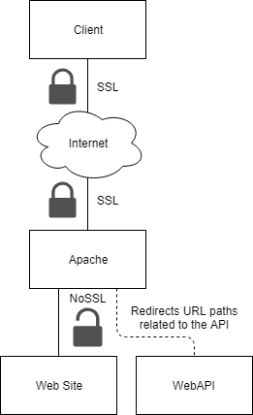Our API will consist of a HTTP server, which will interact with the database, to either return data or manipulate data. The latter will require a valid Auth Token, whereas the prior will not. Most of the prior will be performed using GET and the latter POST.

Auth Tokens can be acquired by performing 0Auth using a valid Refresh Token.

The HTTP server will not be SSL enabled locally, however the use of an Apache server to redirect traffic from the external SSL enabled site, using a VirtualHost, will provide sufficient protection to the data.

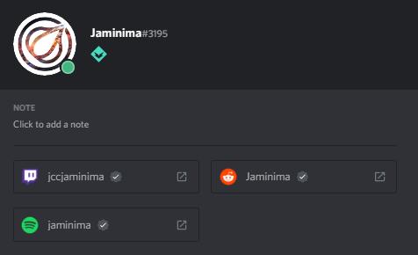Due to the requirement for users to access their account on both Discord and Twitch, the User object will have to track both their DiscordID and TwitchID, which will be unique identifiers.  
We will only be able to create the Discord-Twitch link when the users Discord account is connected to their twitch. When we start to create the link we will check if a user already exists with the TwitchID , if there is we will merge the accounts. Unless they have a DiscordID in which case we will not merge as we don’t want to overwrite another users details.

Objectives

1. Web API
   1. Interacts with a fully normalised database
   2. Ability to respond to GET requests
      1. Users and Accounts on an individual basis
      2. All Users or Accounts
   3. Ability to respond to POST requests
      1. User from DiscordID and/or TwitchID
      2. Create & Update & Delete User
      3. Give & Take & Set Account
      4. 0Auth
      5. Check AuthToken
      6. View Log
2. Apache Server to redirect traffic from SSL enabled external connection
3. Objects to represent database tables
   1. User
   2. Account
   3. 0Auth Token
4. Discord-Twitch Bot
   1. Use of Discord.Net and TwitchLib C# Libraries
   2. Interaction with Youtube’s’, Nightbots’, StreamElements’ and our own Web API
      1. Perform 0Auth correctly in order to acquire Authorization tokens.
   3. Have easy to edit configuration files, to allow for easy customisability
   4. Reward Users for
      1. Watching Stream
      2. Messaging in Discord or Twitch
   5. Twitch+Discord User
      1. Ability to Pay other users
      2. Gamble / Slot, Slot has lower odds but higher multiplier
      3. Duel another user, to win or lose the duel amount
      4. Easily add simple “echo” commands, like social platforms
      5. View the latest video on the youtube channel
   6. Twitch User
      1. Fish, cast a “line” and gain a “item” which has an equivalent value
      2. View information relating to the music player
      3. Request a song
      4. Cancel last requested song
      5. Alert, play a sound effect
   7. Twitch+Discord Moderator
      1. Give a user some currency
      2. Refresh the configuration files
   8. Twitch Moderator
      1. Set game or title of stream
      2. Remove a song from queue
      3. Play/pause or skip the song

Interview W/Harbonator – The Main Client

Q: What do you look for in a Viewer Reward Currency?

A: Mainly the simplicity for me to setup and maintain it. Our current system requires basically no work on my part, as all of the complexity is hidden away. Also the ability to fairly reward viewers which feels progressive and satisfying.

Q: What is good about the current system?

A: It works consistently, also it was incredibly easy to setup and required no maintenance/upkeep on my end.

Q: What problems do you have with the current system?

A: The inability to create new features/commands greatly restricts what can be achieved and the rewards where quite lacklustre.

Q: What new features would you want in the new system?

A: A vast variety of rewards, easily customizable and easy for the user to interact with.

Q: How would you like people to be able to use the new system?

A: In twitch chat and discord. And perhaps with some sort of UI for stream or on a website.