**ESCUELA SUPERIOR POLITÉCNICA DEL LITORAL**

**ORGANIZACIÓN DE COMPUTADORES**

**FIRST PROJECT**

**Members:**

* Jacome Hidalgo Ginger
* Riascos Muguerza Jaminson

**Clock-Timer**

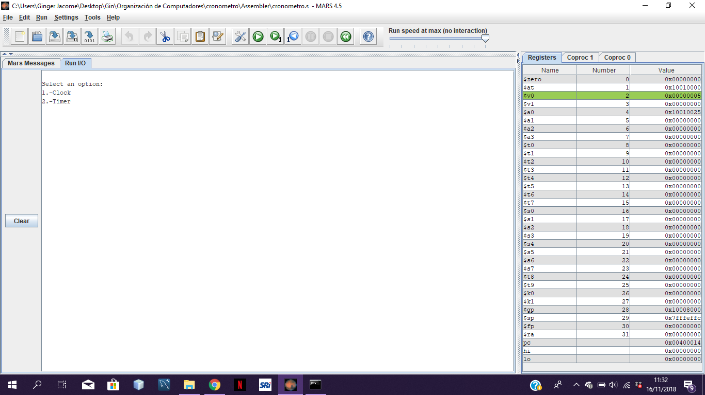First of all our project has a menu which has two options, the first one is a clock and the second one is a timer

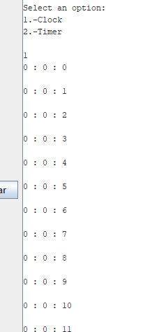We perform a function for each option, the ***clock*** function simply runs automatically with a 24-hour format; start with 00:00:00 and ends with 23:59:59

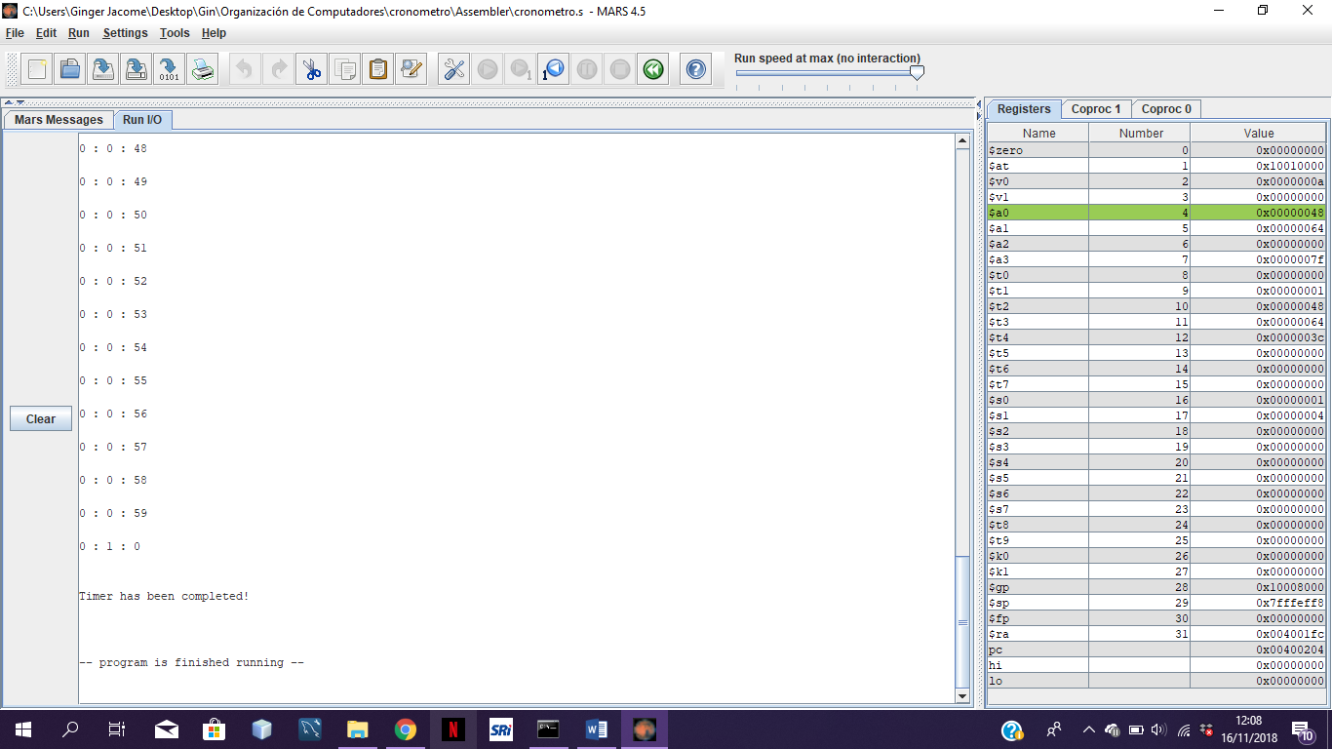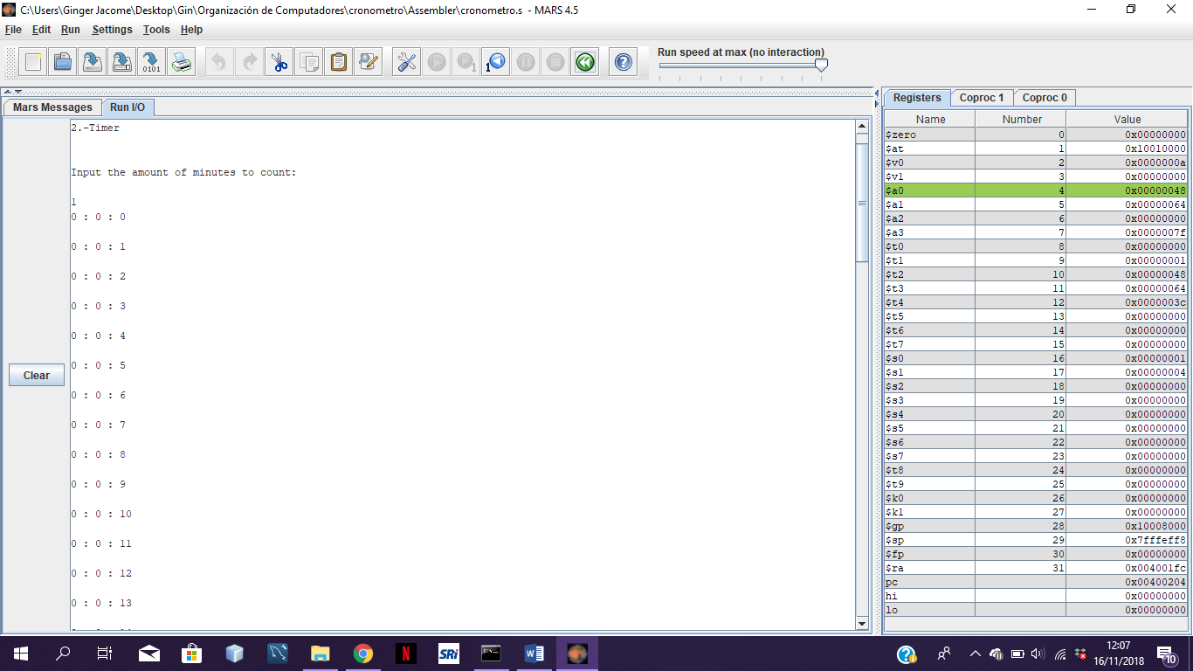The second, the ***timer*** function, which first requests the number of minutes that the user wants to count; in the same way as the clock, it has a 24-hour clock and starts at 00:00:00 and ends at the chosen minute with a completion message.

# Referencias

*MIssouri State University*. (s.f.). Obtenido de http://courses.missouristate.edu/kenvollmar/mars/help/syscallhelp.html