Full Model

Live Laugh Life Expectancy

# Model Reduction

After cleaning the data, we are left with 15 explanatory variables for life expectancy, being Infant deaths, Under-five deaths, Adult mortality, Alcohol consumption, Hepatitis B, Measles, BMI, Polio, Diphtheria, Incidents of HIV, GDP per capita, Population (in millions), Thinness (ages 10–19 years), Thinness (ages 5–9 years), and Schooling.

# load data  
data <- read.csv("Life-Expectancy-Data-Updated.csv")  
  
# fit initial model  
model <- lm(Life_expectancy ~   
 Infant_deaths +  
 Under_five_deaths +  
 Adult_mortality +  
 Alcohol_consumption +  
 Hepatitis_B +  
 Measles +  
 BMI +  
 Polio +  
 Diphtheria +  
 Incidents_HIV +  
 GDP_per_capita +  
 Population_mln +  
 Thinness_ten_nineteen_years +  
 Thinness_five_nine_years +  
 Schooling,  
 data = data  
)  
  
summary(model)

##   
## Call:  
## lm(formula = Life_expectancy ~ Infant_deaths + Under_five_deaths +   
## Adult_mortality + Alcohol_consumption + Hepatitis_B + Measles +   
## BMI + Polio + Diphtheria + Incidents_HIV + GDP_per_capita +   
## Population_mln + Thinness_ten_nineteen_years + Thinness_five_nine_years +   
## Schooling, data = data)  
##   
## Residuals:  
## Min 1Q Median 3Q Max   
## -4.7675 -0.9412 -0.0560 0.8826 7.9078   
##   
## Coefficients:  
## Estimate Std. Error t value Pr(>|t|)   
## (Intercept) 8.507e+01 6.114e-01 139.141 < 2e-16 ***  
## Infant_deaths -5.152e-02 6.187e-03 -8.328 < 2e-16 ***  
## Under_five_deaths -5.295e-02 3.829e-03 -13.830 < 2e-16 ***  
## Adult_mortality -4.893e-02 6.147e-04 -79.604 < 2e-16 ***  
## Alcohol_consumption 9.023e-02 8.950e-03 10.081 < 2e-16 ***  
## Hepatitis_B -9.262e-03 2.560e-03 -3.618 0.000302 ***  
## Measles 1.228e-03 1.728e-03 0.711 0.477264   
## BMI -1.674e-01 1.891e-02 -8.854 < 2e-16 ***  
## Polio 8.691e-04 5.876e-03 0.148 0.882421   
## Diphtheria 3.257e-03 5.926e-03 0.550 0.582629   
## Incidents_HIV 1.005e-01 1.827e-02 5.502 4.08e-08 ***  
## GDP_per_capita 3.043e-05 2.146e-06 14.181 < 2e-16 ***  
## Population_mln -1.814e-04 2.011e-04 -0.902 0.366939   
## Thinness_ten_nineteen_years -3.313e-02 1.725e-02 -1.921 0.054867 .   
## Thinness_five_nine_years -2.449e-03 1.690e-02 -0.145 0.884797   
## Schooling 1.119e-01 1.668e-02 6.709 2.35e-11 ***  
## ---  
## Signif. codes: 0 '***' 0.001 '**' 0.01 '*' 0.05 '.' 0.1 ' ' 1  
##   
## Residual standard error: 1.369 on 2848 degrees of freedom  
## Multiple R-squared: 0.9789, Adjusted R-squared: 0.9788   
## F-statistic: 8817 on 15 and 2848 DF, p-value: < 2.2e-16

After fitting the full model, we have 9 highly statistically significant variables (Infant_deaths, Under_five_deaths, Adult_mortality, Alcohol_consumption, Hepatitis_B, BMI, Incidents_HIV, GDP_per_capita, and Schooling). We have an overall p-value or 2.2e-16 Additionally, our R-squared is 0.9789 and Adjusted R-squared is 0.9788. This indicates that there might be overfitting issues within our model Next, we look at the variance inflation factors of each regressor variable to determine if there are any multicollinearity issues.

library(car)

## Warning: package 'car' was built under R version 4.3.3

## Loading required package: carData

## Warning: package 'carData' was built under R version 4.3.3

vif(model)

## Infant_deaths Under_five_deaths   
## 44.329144 44.469991   
## Adult_mortality Alcohol_consumption   
## 7.618888 1.939630   
## Hepatitis_B Measles   
## 2.560952 1.587422   
## BMI Polio   
## 2.627136 11.990081   
## Diphtheria Incidents_HIV   
## 12.940367 2.890280   
## GDP_per_capita Population_mln   
## 2.016715 1.150097   
## Thinness_ten_nineteen_years Thinness_five_nine_years   
## 8.949993 8.936053   
## Schooling   
## 4.273524

Multicollinearity issues, that is variables with a vif greater than 10 arise within the regressors Infant_deaths (44.329144), Under_five_deaths (44.469991), Polio (11.990081), Diphtheria (12.940367). Additionally, Thinness_ten_nineteen_years (8.949993) and Thinness_five_nine_years (8.936053) also have rather high vif’s, but still bellow 10.

To combat this we will begin by removing Under_five_deaths.

model1 <- lm(Life_expectancy ~   
 Infant_deaths +  
 Adult_mortality +  
 Alcohol_consumption +  
 Hepatitis_B +  
 Measles +  
 BMI +  
 Polio +  
 Diphtheria +  
 Incidents_HIV +  
 GDP_per_capita +  
 Population_mln +  
 Thinness_ten_nineteen_years +  
 Thinness_five_nine_years +  
 Schooling,  
 data = data  
)  
  
summary(model1)

##   
## Call:  
## lm(formula = Life_expectancy ~ Infant_deaths + Adult_mortality +   
## Alcohol_consumption + Hepatitis_B + Measles + BMI + Polio +   
## Diphtheria + Incidents_HIV + GDP_per_capita + Population_mln +   
## Thinness_ten_nineteen_years + Thinness_five_nine_years +   
## Schooling, data = data)  
##   
## Residuals:  
## Min 1Q Median 3Q Max   
## -4.3062 -0.9366 -0.0298 0.9301 5.1858   
##   
## Coefficients:  
## Estimate Std. Error t value Pr(>|t|)   
## (Intercept) 8.398e+01 6.262e-01 134.110 < 2e-16 ***  
## Infant_deaths -1.290e-01 2.715e-03 -47.501 < 2e-16 ***  
## Adult_mortality -5.019e-02 6.279e-04 -79.934 < 2e-16 ***  
## Alcohol_consumption 7.103e-02 9.132e-03 7.778 1.02e-14 ***  
## Hepatitis_B -1.337e-02 2.626e-03 -5.090 3.82e-07 ***  
## Measles 2.159e-04 1.783e-03 0.121 0.9036   
## BMI -1.317e-01 1.934e-02 -6.806 1.22e-11 ***  
## Polio 1.491e-03 6.068e-03 0.246 0.8059   
## Diphtheria 1.166e-02 6.088e-03 1.915 0.0556 .   
## Incidents_HIV 9.555e-02 1.886e-02 5.065 4.35e-07 ***  
## GDP_per_capita 2.312e-05 2.148e-06 10.762 < 2e-16 ***  
## Population_mln -1.072e-04 2.076e-04 -0.516 0.6058   
## Thinness_ten_nineteen_years -3.595e-02 1.781e-02 -2.018 0.0437 *   
## Thinness_five_nine_years 1.355e-02 1.742e-02 0.778 0.4366   
## Schooling 1.485e-01 1.701e-02 8.728 < 2e-16 ***  
## ---  
## Signif. codes: 0 '***' 0.001 '**' 0.01 '*' 0.05 '.' 0.1 ' ' 1  
##   
## Residual standard error: 1.414 on 2849 degrees of freedom  
## Multiple R-squared: 0.9775, Adjusted R-squared: 0.9774   
## F-statistic: 8842 on 14 and 2849 DF, p-value: < 2.2e-16

vif(model1)

## Infant_deaths Adult_mortality   
## 8.003745 7.452012   
## Alcohol_consumption Hepatitis_B   
## 1.892972 2.526519   
## Measles BMI   
## 1.584574 2.578076   
## Polio Diphtheria   
## 11.989379 12.804362   
## Incidents_HIV GDP_per_capita   
## 2.889161 1.894235   
## Population_mln Thinness_ten_nineteen_years   
## 1.149276 8.948743   
## Thinness_five_nine_years Schooling   
## 8.894194 4.166226

After removing Under_five_deaths, we have the same highly statistically predictors, as well as Thinness_ten_nineteen_years being a somewhat significant predictor. Furthermore, The vif for Infant_deaths have improved. We still have a multicollinearity issue with Polio and Diphtheria, so it is in our best interest to remove one of them. We will remove polio because it has the highest p-value (0.8059) while having a large vif.

model2 <- lm(Life_expectancy ~   
 Infant_deaths +  
 Adult_mortality +  
 Alcohol_consumption +  
 Hepatitis_B +  
 Measles +  
 BMI +  
 Diphtheria +  
 Incidents_HIV +  
 GDP_per_capita +  
 Population_mln +  
 Thinness_ten_nineteen_years +  
 Thinness_five_nine_years +  
 Schooling,  
 data = data  
)  
  
summary(model2)

##   
## Call:  
## lm(formula = Life_expectancy ~ Infant_deaths + Adult_mortality +   
## Alcohol_consumption + Hepatitis_B + Measles + BMI + Diphtheria +   
## Incidents_HIV + GDP_per_capita + Population_mln + Thinness_ten_nineteen_years +   
## Thinness_five_nine_years + Schooling, data = data)  
##   
## Residuals:  
## Min 1Q Median 3Q Max   
## -4.3159 -0.9363 -0.0284 0.9320 5.1873   
##   
## Coefficients:  
## Estimate Std. Error t value Pr(>|t|)   
## (Intercept) 8.399e+01 6.225e-01 134.927 < 2e-16 ***  
## Infant_deaths -1.291e-01 2.678e-03 -48.198 < 2e-16 ***  
## Adult_mortality -5.018e-02 6.276e-04 -79.966 < 2e-16 ***  
## Alcohol_consumption 7.097e-02 9.127e-03 7.775 1.04e-14 ***  
## Hepatitis_B -1.338e-02 2.625e-03 -5.096 3.69e-07 ***  
## Measles 2.616e-04 1.773e-03 0.148 0.882688   
## BMI -1.314e-01 1.932e-02 -6.803 1.24e-11 ***  
## Diphtheria 1.291e-02 3.341e-03 3.864 0.000114 ***  
## Incidents_HIV 9.567e-02 1.886e-02 5.074 4.15e-07 ***  
## GDP_per_capita 2.309e-05 2.146e-06 10.764 < 2e-16 ***  
## Population_mln -1.082e-04 2.075e-04 -0.521 0.602240   
## Thinness_ten_nineteen_years -3.580e-02 1.780e-02 -2.011 0.044412 *   
## Thinness_five_nine_years 1.348e-02 1.741e-02 0.774 0.438837   
## Schooling 1.484e-01 1.701e-02 8.728 < 2e-16 ***  
## ---  
## Signif. codes: 0 '***' 0.001 '**' 0.01 '*' 0.05 '.' 0.1 ' ' 1  
##   
## Residual standard error: 1.414 on 2850 degrees of freedom  
## Multiple R-squared: 0.9775, Adjusted R-squared: 0.9774   
## F-statistic: 9526 on 13 and 2850 DF, p-value: < 2.2e-16

vif(model2)

## Infant_deaths Adult_mortality   
## 7.789556 7.447236   
## Alcohol_consumption Hepatitis_B   
## 1.891505 2.525566   
## Measles BMI   
## 1.567283 2.573423   
## Diphtheria Incidents_HIV   
## 3.857871 2.887258   
## GDP_per_capita Population_mln   
## 1.890494 1.148823   
## Thinness_ten_nineteen_years Thinness_five_nine_years   
## 8.937990 8.891916   
## Schooling   
## 4.166107

Another solution to this could possibly combining all of the vaccine percentage variables, Hepatitis_B, Measles, Polio, and Diphtheria, into one variable, Vaccine_percentage

data$Vaccine_percentage <- rowMeans(data[, c("Hepatitis_B", "Measles", "Polio", "Diphtheria")], na.rm = TRUE)  
  
model3 <- lm(Life_expectancy ~   
 Infant_deaths +  
 Adult_mortality +  
 Alcohol_consumption +  
 BMI +  
 Incidents_HIV +  
 GDP_per_capita +  
 Population_mln +  
 Thinness_ten_nineteen_years +  
 Thinness_five_nine_years +  
 Schooling +  
 Vaccine_percentage,  
 data = data  
)  
  
summary(model3)

##   
## Call:  
## lm(formula = Life_expectancy ~ Infant_deaths + Adult_mortality +   
## Alcohol_consumption + BMI + Incidents_HIV + GDP_per_capita +   
## Population_mln + Thinness_ten_nineteen_years + Thinness_five_nine_years +   
## Schooling + Vaccine_percentage, data = data)  
##   
## Residuals:  
## Min 1Q Median 3Q Max   
## -4.2787 -0.9358 -0.0158 0.9075 5.3886   
##   
## Coefficients:  
## Estimate Std. Error t value Pr(>|t|)   
## (Intercept) 8.452e+01 6.139e-01 137.674 < 2e-16 ***  
## Infant_deaths -1.313e-01 2.618e-03 -50.133 < 2e-16 ***  
## Adult_mortality -5.023e-02 6.290e-04 -79.851 < 2e-16 ***  
## Alcohol_consumption 7.140e-02 9.147e-03 7.805 8.26e-15 ***  
## BMI -1.420e-01 1.923e-02 -7.384 2.00e-13 ***  
## Incidents_HIV 9.834e-02 1.893e-02 5.196 2.18e-07 ***  
## GDP_per_capita 2.354e-05 2.153e-06 10.932 < 2e-16 ***  
## Population_mln -5.310e-05 2.080e-04 -0.255 0.7985   
## Thinness_ten_nineteen_years -3.872e-02 1.781e-02 -2.174 0.0298 *   
## Thinness_five_nine_years 1.548e-02 1.739e-02 0.890 0.3736   
## Schooling 1.531e-01 1.693e-02 9.039 < 2e-16 ***  
## Vaccine_percentage -2.668e-03 2.861e-03 -0.933 0.3511   
## ---  
## Signif. codes: 0 '***' 0.001 '**' 0.01 '*' 0.05 '.' 0.1 ' ' 1  
##   
## Residual standard error: 1.42 on 2852 degrees of freedom  
## Multiple R-squared: 0.9773, Adjusted R-squared: 0.9772   
## F-statistic: 1.116e+04 on 11 and 2852 DF, p-value: < 2.2e-16

vif(model3)

## Infant_deaths Adult_mortality   
## 7.383893 7.418883   
## Alcohol_consumption BMI   
## 1.883987 2.528624   
## Incidents_HIV GDP_per_capita   
## 2.885007 1.887546   
## Population_mln Thinness_ten_nineteen_years   
## 1.144758 8.876975   
## Thinness_five_nine_years Schooling   
## 8.797860 4.095898   
## Vaccine_percentage   
## 2.236409

There does not seem to be a significant difference between these two models. If we chose to go with removing polio, we would have to remove each of the vaccines other than Diphteria as it is the only one that was statistically significant. This is likely because the vaccination somewhat consistent on each vaccine, if they had one they are likely to have the others.

Moving forward with removing Polio, our next highest p-value is measles, so we will remove that.

model4 <- lm(Life_expectancy ~   
 Infant_deaths +  
 Adult_mortality +  
 Alcohol_consumption +  
 Hepatitis_B +  
 BMI +  
 Diphtheria +  
 Incidents_HIV +  
 GDP_per_capita +  
 Population_mln +  
 Thinness_ten_nineteen_years +  
 Thinness_five_nine_years +  
 Schooling,  
 data = data  
)  
  
summary(model4)

##   
## Call:  
## lm(formula = Life_expectancy ~ Infant_deaths + Adult_mortality +   
## Alcohol_consumption + Hepatitis_B + BMI + Diphtheria + Incidents_HIV +   
## GDP_per_capita + Population_mln + Thinness_ten_nineteen_years +   
## Thinness_five_nine_years + Schooling, data = data)  
##   
## Residuals:  
## Min 1Q Median 3Q Max   
## -4.3119 -0.9347 -0.0306 0.9271 5.1925   
##   
## Coefficients:  
## Estimate Std. Error t value Pr(>|t|)   
## (Intercept) 8.400e+01 6.194e-01 135.609 < 2e-16 ***  
## Infant_deaths -1.291e-01 2.678e-03 -48.210 < 2e-16 ***  
## Adult_mortality -5.019e-02 6.262e-04 -80.157 < 2e-16 ***  
## Alcohol_consumption 7.104e-02 9.113e-03 7.795 8.96e-15 ***  
## Hepatitis_B -1.333e-02 2.604e-03 -5.119 3.28e-07 ***  
## BMI -1.314e-01 1.931e-02 -6.803 1.24e-11 ***  
## Diphtheria 1.295e-02 3.327e-03 3.893 0.000101 ***  
## Incidents_HIV 9.575e-02 1.884e-02 5.082 3.98e-07 ***  
## GDP_per_capita 2.309e-05 2.145e-06 10.765 < 2e-16 ***  
## Population_mln -1.102e-04 2.070e-04 -0.532 0.594600   
## Thinness_ten_nineteen_years -3.554e-02 1.771e-02 -2.007 0.044885 *   
## Thinness_five_nine_years 1.317e-02 1.728e-02 0.762 0.446030   
## Schooling 1.487e-01 1.688e-02 8.810 < 2e-16 ***  
## ---  
## Signif. codes: 0 '***' 0.001 '**' 0.01 '*' 0.05 '.' 0.1 ' ' 1  
##   
## Residual standard error: 1.414 on 2851 degrees of freedom  
## Multiple R-squared: 0.9775, Adjusted R-squared: 0.9774   
## F-statistic: 1.032e+04 on 12 and 2851 DF, p-value: < 2.2e-16

vif(model4)

## Infant_deaths Adult_mortality   
## 7.788875 7.416150   
## Alcohol_consumption Hepatitis_B   
## 1.886438 2.486117   
## BMI Diphtheria   
## 2.570657 3.827148   
## Incidents_HIV GDP_per_capita   
## 2.884409 1.890421   
## Population_mln Thinness_ten_nineteen_years   
## 1.143810 8.851921   
## Thinness_five_nine_years Schooling   
## 8.762341 4.106941

Running the new model, we can see both Diphtheria and Hepatitis_B are highly significant predictors so it is preferable to use this model rather than the average, Vaccine_percentage. The next highest p-value is Population_mlm, so we will move forward with removing that. This makes sense to not be a significatn predictor of life expectancy because there are plenty of high quality of life areas with low populations, low quality of life areas with high populations, and everything in between.

model5 <- lm(Life_expectancy ~   
 Infant_deaths +  
 Adult_mortality +  
 Alcohol_consumption +  
 Hepatitis_B +  
 BMI +  
 Diphtheria +  
 Incidents_HIV +  
 GDP_per_capita +  
 Thinness_ten_nineteen_years +  
 Thinness_five_nine_years +  
 Schooling,  
 data = data  
)  
  
summary(model5)

##   
## Call:  
## lm(formula = Life_expectancy ~ Infant_deaths + Adult_mortality +   
## Alcohol_consumption + Hepatitis_B + BMI + Diphtheria + Incidents_HIV +   
## GDP_per_capita + Thinness_ten_nineteen_years + Thinness_five_nine_years +   
## Schooling, data = data)  
##   
## Residuals:  
## Min 1Q Median 3Q Max   
## -4.3152 -0.9332 -0.0287 0.9246 5.1923   
##   
## Coefficients:  
## Estimate Std. Error t value Pr(>|t|)   
## (Intercept) 8.397e+01 6.157e-01 136.384 < 2e-16 ***  
## Infant_deaths -1.291e-01 2.677e-03 -48.213 < 2e-16 ***  
## Adult_mortality -5.016e-02 6.228e-04 -80.537 < 2e-16 ***  
## Alcohol_consumption 7.090e-02 9.109e-03 7.784 9.75e-15 ***  
## Hepatitis_B -1.322e-02 2.596e-03 -5.093 3.75e-07 ***  
## BMI -1.302e-01 1.919e-02 -6.786 1.39e-11 ***  
## Diphtheria 1.293e-02 3.327e-03 3.887 0.000104 ***  
## Incidents_HIV 9.540e-02 1.883e-02 5.067 4.31e-07 ***  
## GDP_per_capita 2.318e-05 2.139e-06 10.835 < 2e-16 ***  
## Thinness_ten_nineteen_years -3.620e-02 1.767e-02 -2.049 0.040560 *   
## Thinness_five_nine_years 1.277e-02 1.726e-02 0.739 0.459688   
## Schooling 1.480e-01 1.683e-02 8.797 < 2e-16 ***  
## ---  
## Signif. codes: 0 '***' 0.001 '**' 0.01 '*' 0.05 '.' 0.1 ' ' 1  
##   
## Residual standard error: 1.414 on 2852 degrees of freedom  
## Multiple R-squared: 0.9775, Adjusted R-squared: 0.9774   
## F-statistic: 1.126e+04 on 11 and 2852 DF, p-value: < 2.2e-16

vif(model5)

## Infant_deaths Adult_mortality   
## 7.788245 7.338100   
## Alcohol_consumption Hepatitis_B   
## 1.884960 2.470324   
## BMI Diphtheria   
## 2.539707 3.826591   
## Incidents_HIV GDP_per_capita   
## 2.880807 1.880260   
## Thinness_ten_nineteen_years Thinness_five_nine_years   
## 8.808948 8.745244   
## Schooling   
## 4.080587

Thinness_five_nine_years has the next highest p-value as well as rather high vif along with Thinness_ten_nineteen_years, so it makes sense to remove Thinness_five_nine_years.

model6 <- lm(Life_expectancy ~   
 Infant_deaths +  
 Adult_mortality +  
 Alcohol_consumption +  
 Hepatitis_B +  
 BMI +  
 Diphtheria +  
 Incidents_HIV +  
 GDP_per_capita +  
 Thinness_ten_nineteen_years +  
 Schooling,  
 data = data  
)  
  
summary(model6)

##   
## Call:  
## lm(formula = Life_expectancy ~ Infant_deaths + Adult_mortality +   
## Alcohol_consumption + Hepatitis_B + BMI + Diphtheria + Incidents_HIV +   
## GDP_per_capita + Thinness_ten_nineteen_years + Schooling,   
## data = data)  
##   
## Residuals:  
## Min 1Q Median 3Q Max   
## -4.3181 -0.9414 -0.0269 0.9250 5.1922   
##   
## Coefficients:  
## Estimate Std. Error t value Pr(>|t|)   
## (Intercept) 8.403e+01 6.089e-01 138.006 < 2e-16 ***  
## Infant_deaths -1.291e-01 2.676e-03 -48.253 < 2e-16 ***  
## Adult_mortality -5.017e-02 6.225e-04 -80.585 < 2e-16 ***  
## Alcohol_consumption 7.055e-02 9.095e-03 7.756 1.21e-14 ***  
## Hepatitis_B -1.331e-02 2.593e-03 -5.133 3.04e-07 ***  
## BMI -1.324e-01 1.896e-02 -6.982 3.60e-12 ***  
## Diphtheria 1.297e-02 3.326e-03 3.901 9.80e-05 ***  
## Incidents_HIV 9.622e-02 1.879e-02 5.119 3.27e-07 ***  
## GDP_per_capita 2.304e-05 2.130e-06 10.812 < 2e-16 ***  
## Thinness_ten_nineteen_years -2.461e-02 8.147e-03 -3.020 0.00255 **   
## Schooling 1.485e-01 1.681e-02 8.831 < 2e-16 ***  
## ---  
## Signif. codes: 0 '***' 0.001 '**' 0.01 '*' 0.05 '.' 0.1 ' ' 1  
##   
## Residual standard error: 1.413 on 2853 degrees of freedom  
## Multiple R-squared: 0.9775, Adjusted R-squared: 0.9774   
## F-statistic: 1.239e+04 on 10 and 2853 DF, p-value: < 2.2e-16

vif(model6)

## Infant_deaths Adult_mortality   
## 7.782878 7.333802   
## Alcohol_consumption Hepatitis_B   
## 1.879719 2.465090   
## BMI Diphtheria   
## 2.480304 3.825432   
## Incidents_HIV GDP_per_capita   
## 2.870815 1.865489   
## Thinness_ten_nineteen_years Schooling   
## 1.873529 4.074861

After this, all of the predictors are highly statistically significant. We still have a very high R-squared value of 0.9775. To combat this I think it may be a good idea to only have either Infant_deaths or adult mortality, as they both measure their respective deaths per 1000 in the population.

model7 <- lm(Life_expectancy ~   
 Adult_mortality +  
 Alcohol_consumption +  
 Hepatitis_B +  
 BMI +  
 Diphtheria +  
 Incidents_HIV +  
 GDP_per_capita +  
 Thinness_ten_nineteen_years +  
 Schooling,  
 data = data  
)  
  
summary(model7)

##   
## Call:  
## lm(formula = Life_expectancy ~ Adult_mortality + Alcohol_consumption +   
## Hepatitis_B + BMI + Diphtheria + Incidents_HIV + GDP_per_capita +   
## Thinness_ten_nineteen_years + Schooling, data = data)  
##   
## Residuals:  
## Min 1Q Median 3Q Max   
## -8.3883 -1.2058 -0.0079 1.2484 8.7670   
##   
## Coefficients:  
## Estimate Std. Error t value Pr(>|t|)   
## (Intercept) 7.098e+01 7.350e-01 96.567 < 2e-16 ***  
## Adult_mortality -6.732e-02 6.886e-04 -97.767 < 2e-16 ***  
## Alcohol_consumption 1.346e-01 1.212e-02 11.100 < 2e-16 ***  
## Hepatitis_B -1.467e-02 3.493e-03 -4.200 2.75e-05 ***  
## BMI 4.859e-02 2.505e-02 1.940 0.0525 .   
## Diphtheria 7.365e-02 4.149e-03 17.751 < 2e-16 ***  
## Incidents_HIV 3.077e-01 2.463e-02 12.496 < 2e-16 ***  
## GDP_per_capita 1.137e-05 2.852e-06 3.987 6.86e-05 ***  
## Thinness_ten_nineteen_years -1.667e-02 1.097e-02 -1.519 0.1289   
## Schooling 4.601e-01 2.092e-02 21.996 < 2e-16 ***  
## ---  
## Signif. codes: 0 '***' 0.001 '**' 0.01 '*' 0.05 '.' 0.1 ' ' 1  
##   
## Residual standard error: 1.904 on 2854 degrees of freedom  
## Multiple R-squared: 0.9591, Adjusted R-squared: 0.959   
## F-statistic: 7442 on 9 and 2854 DF, p-value: < 2.2e-16

vif(model7)

## Adult_mortality Alcohol_consumption   
## 4.942269 1.839719   
## Hepatitis_B BMI   
## 2.464798 2.383265   
## Diphtheria Incidents_HIV   
## 3.278703 2.714672   
## GDP_per_capita Thinness_ten_nineteen_years   
## 1.841474 1.872765   
## Schooling   
## 3.473744

After removing Infant_deaths, we still have a high R-squared of 0.9591. Now we will try removing Adult_mortality and keeping Infant_deaths.

model8 <- lm(Life_expectancy ~   
 Infant_deaths +  
 Alcohol_consumption +  
 Hepatitis_B +  
 BMI +  
 Diphtheria +  
 Incidents_HIV +  
 GDP_per_capita +  
 Thinness_ten_nineteen_years +  
 Schooling,  
 data = data  
)  
  
summary(model8)

##   
## Call:  
## lm(formula = Life_expectancy ~ Infant_deaths + Alcohol_consumption +   
## Hepatitis_B + BMI + Diphtheria + Incidents_HIV + GDP_per_capita +   
## Thinness_ten_nineteen_years + Schooling, data = data)  
##   
## Residuals:  
## Min 1Q Median 3Q Max   
## -10.8589 -1.5134 0.1144 1.6817 11.4451   
##   
## Coefficients:  
## Estimate Std. Error t value Pr(>|t|)   
## (Intercept) 7.423e+01 1.080e+00 68.748 < 2e-16 ***  
## Infant_deaths -2.523e-01 3.976e-03 -63.456 < 2e-16 ***  
## Alcohol_consumption -6.113e-02 1.619e-02 -3.776 0.000163 ***  
## Hepatitis_B -1.684e-02 4.692e-03 -3.589 0.000337 ***  
## BMI 8.984e-02 3.395e-02 2.646 0.008186 **   
## Diphtheria 1.453e-02 6.019e-03 2.414 0.015829 *   
## Incidents_HIV -1.044e+00 2.240e-02 -46.587 < 2e-16 ***  
## GDP_per_capita 8.872e-05 3.562e-06 24.906 < 2e-16 ***  
## Thinness_ten_nineteen_years 2.926e-02 1.469e-02 1.991 0.046562 *   
## Schooling 3.488e-02 3.032e-02 1.150 0.250042   
## ---  
## Signif. codes: 0 '***' 0.001 '**' 0.01 '*' 0.05 '.' 0.1 ' ' 1  
##   
## Residual standard error: 2.558 on 2854 degrees of freedom  
## Multiple R-squared: 0.9263, Adjusted R-squared: 0.926   
## F-statistic: 3984 on 9 and 2854 DF, p-value: < 2.2e-16

vif(model8)

## Infant_deaths Alcohol_consumption   
## 5.244902 1.819045   
## Hepatitis_B BMI   
## 2.464386 2.427842   
## Diphtheria Incidents_HIV   
## 3.825303 1.245089   
## GDP_per_capita Thinness_ten_nineteen_years   
## 1.592441 1.860918   
## Schooling   
## 4.046216

Once again, the R-Squared is still very high, with a value of 0.9263. I think the effort if trying to figure this out is not worth it, we will keep both variables and use model6. We opted for this model as it strikes a balance between high explanatory power and acceptable multicollinearity

# Residual Analysis

library(MASS)  
  
# residuals vs fitted values  
plot(fitted(model6), studres(model6),  
 main="Residuals vs Fitted",  
 xlab="Fitted Values", ylab="Residuals")  
abline(h = 0, col = "red")

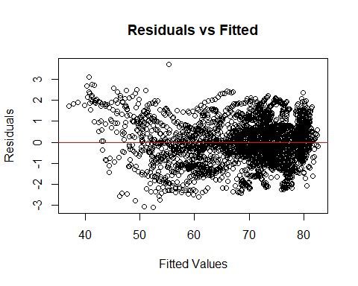

# QQ plot  
qqPlot(model6)

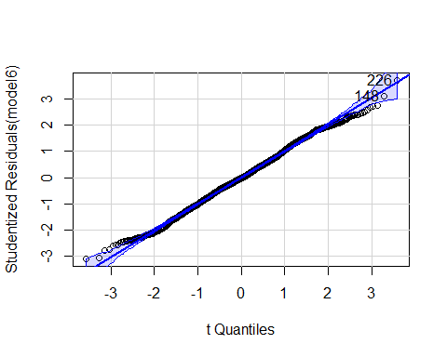

## [1] 148 226

# histogram of residuals  
hist(studres(model6), breaks = 15, freq = F, col="cornflowerblue",  
 xlab = "Studentized Residuals")

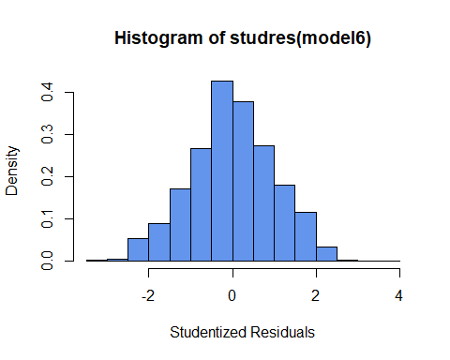

The QQ plot values are very close to the line which is good. The histogram of the residuals also appears to follow a normal distribution. However, the Residuals vs. Fitted value plot indicates a transformation is needed.

# Assessment of model fit

Before we perform any transformations, we want to ensure that we have the best possible model fit. We can do this by using the ols_step_all_possible, ols_step_forward_p, and ols_step_backward_p to see if those results match up with ours. Truth be told, we did not realize those functions existed before we began reducing the model manually.

# find all possible permutations of the full model (this is commented out because it took so long, it is saved as a csv file now)  
# MS_ALL = ols_step_all_possible(model)  
# write.csv(MS_ALL$result, "MS_ALL_results.csv", row.names = FALSE)  
MS_ALL <- read.csv("MS_ALL_results.csv")  
  
library(dplyr)

## Warning: package 'dplyr' was built under R version 4.3.2

##   
## Attaching package: 'dplyr'

## The following object is masked from 'package:MASS':  
##   
## select

## The following object is masked from 'package:car':  
##   
## recode

## The following objects are masked from 'package:stats':  
##   
## filter, lag

## The following objects are masked from 'package:base':  
##   
## intersect, setdiff, setequal, union

library(olsrr)

## Warning: package 'olsrr' was built under R version 4.3.3

##   
## Attaching package: 'olsrr'

## The following object is masked from 'package:MASS':  
##   
## cement

## The following object is masked from 'package:datasets':  
##   
## rivers

# find model with highest adjusted r squared  
# adjr <- MS_ALL$result$adjr  
# max_adjr <- which.max(adjr)  
# best_model_adjr <- MS_ALL$result[max_adjr, ]  
# (commenting out original code and using new working with loaded data frame)  
  
adjr <- MS_ALL$adjr  
max_adjr <- which.max(adjr)  
best_model_adjr <- MS_ALL[max_adjr, ]  
  
best_model_adjr$predictors

## [1] "Infant_deaths Under_five_deaths Adult_mortality Alcohol_consumption Hepatitis_B BMI Diphtheria Incidents_HIV GDP_per_capita Thinness_ten_nineteen_years Schooling"

# find model with lowest AIC  
# aic <- MS_ALL$result$aic  
# min_aic <- which.min(aic)  
# best_model_aic <- MS_ALL$result[min_aic, ]  
  
aic <- MS_ALL$aic  
min_aic <- which.min(aic)  
best_model_aic <- MS_ALL[min_aic, ]  
  
best_model_aic$predictors

## [1] "Infant_deaths Under_five_deaths Adult_mortality Alcohol_consumption Hepatitis_B BMI Incidents_HIV GDP_per_capita Thinness_ten_nineteen_years Schooling"

# find model with lowest BIC  
# bic <- MS_ALL$result$sbic  
# min_bic <- which.min(bic)  
  
bic <- MS_ALL$sbic  
min_bic <- which.min(bic)  
min_bic == min_aic

## [1] TRUE

# note: did not run best model because the best bic has the same model as the best aic  
  
# stepwise selection with p-values  
ols_stepwise_forward <- ols_step_forward_p(model)  
ols_stepwise_forward$metrics$variable

## [1] "Adult_mortality" "Infant_deaths"   
## [3] "GDP_per_capita" "Alcohol_consumption"   
## [5] "Under_five_deaths" "Schooling"   
## [7] "BMI" "Incidents_HIV"   
## [9] "Thinness_ten_nineteen_years" "Hepatitis_B"   
## [11] "Diphtheria"

ols_stepwise_backward <- ols_step_backward_p(model)  
ols_stepwise_backward$metrics$variable

## [1] "Thinness_five_nine_years" "Polio"   
## [3] "Measles" "Population_mln"

# fit the best models that we found  
adjr_model <- lm(Life_expectancy ~ Infant_deaths+Under_five_deaths+Adult_mortality+Alcohol_consumption+Hepatitis_B+BMI+Diphtheria+Incidents_HIV+GDP_per_capita+Thinness_ten_nineteen_years+Schooling, data = data)  
summary(adjr_model)

##   
## Call:  
## lm(formula = Life_expectancy ~ Infant_deaths + Under_five_deaths +   
## Adult_mortality + Alcohol_consumption + Hepatitis_B + BMI +   
## Diphtheria + Incidents_HIV + GDP_per_capita + Thinness_ten_nineteen_years +   
## Schooling, data = data)  
##   
## Residuals:  
## Min 1Q Median 3Q Max   
## -4.7560 -0.9335 -0.0503 0.8733 7.9179   
##   
## Coefficients:  
## Estimate Std. Error t value Pr(>|t|)   
## (Intercept) 8.503e+01 5.940e-01 143.147 < 2e-16 ***  
## Infant_deaths -5.200e-02 6.155e-03 -8.448 < 2e-16 ***  
## Under_five_deaths -5.265e-02 3.811e-03 -13.815 < 2e-16 ***  
## Adult_mortality -4.890e-02 6.097e-04 -80.198 < 2e-16 ***  
## Alcohol_consumption 9.031e-02 8.922e-03 10.122 < 2e-16 ***  
## Hepatitis_B -8.838e-03 2.531e-03 -3.491 0.000488 ***  
## BMI -1.639e-01 1.850e-02 -8.857 < 2e-16 ***  
## Diphtheria 4.194e-03 3.283e-03 1.278 0.201516   
## Incidents_HIV 1.001e-01 1.820e-02 5.498 4.18e-08 ***  
## GDP_per_capita 3.056e-05 2.134e-06 14.324 < 2e-16 ***  
## Thinness_ten_nineteen_years -3.713e-02 7.940e-03 -4.676 3.06e-06 ***  
## Schooling 1.121e-01 1.649e-02 6.798 1.29e-11 ***  
## ---  
## Signif. codes: 0 '***' 0.001 '**' 0.01 '*' 0.05 '.' 0.1 ' ' 1  
##   
## Residual standard error: 1.369 on 2852 degrees of freedom  
## Multiple R-squared: 0.9789, Adjusted R-squared: 0.9788   
## F-statistic: 1.203e+04 on 11 and 2852 DF, p-value: < 2.2e-16

vif(adjr_model)

## Infant_deaths Under_five_deaths   
## 43.911168 44.101047   
## Adult_mortality Alcohol_consumption   
## 7.503580 1.929304   
## Hepatitis_B BMI   
## 2.506062 2.518500   
## Diphtheria Incidents_HIV   
## 3.974430 2.871487   
## GDP_per_capita Thinness_ten_nineteen_years   
## 1.995601 1.898273   
## Schooling   
## 4.181415

adjr_model1 <- lm(Life_expectancy ~ Infant_deaths+Adult_mortality+Alcohol_consumption+Hepatitis_B+BMI+Diphtheria+Incidents_HIV+GDP_per_capita+Thinness_ten_nineteen_years+Schooling, data = data)  
summary(adjr_model1)

##   
## Call:  
## lm(formula = Life_expectancy ~ Infant_deaths + Adult_mortality +   
## Alcohol_consumption + Hepatitis_B + BMI + Diphtheria + Incidents_HIV +   
## GDP_per_capita + Thinness_ten_nineteen_years + Schooling,   
## data = data)  
##   
## Residuals:  
## Min 1Q Median 3Q Max   
## -4.3181 -0.9414 -0.0269 0.9250 5.1922   
##   
## Coefficients:  
## Estimate Std. Error t value Pr(>|t|)   
## (Intercept) 8.403e+01 6.089e-01 138.006 < 2e-16 ***  
## Infant_deaths -1.291e-01 2.676e-03 -48.253 < 2e-16 ***  
## Adult_mortality -5.017e-02 6.225e-04 -80.585 < 2e-16 ***  
## Alcohol_consumption 7.055e-02 9.095e-03 7.756 1.21e-14 ***  
## Hepatitis_B -1.331e-02 2.593e-03 -5.133 3.04e-07 ***  
## BMI -1.324e-01 1.896e-02 -6.982 3.60e-12 ***  
## Diphtheria 1.297e-02 3.326e-03 3.901 9.80e-05 ***  
## Incidents_HIV 9.622e-02 1.879e-02 5.119 3.27e-07 ***  
## GDP_per_capita 2.304e-05 2.130e-06 10.812 < 2e-16 ***  
## Thinness_ten_nineteen_years -2.461e-02 8.147e-03 -3.020 0.00255 **   
## Schooling 1.485e-01 1.681e-02 8.831 < 2e-16 ***  
## ---  
## Signif. codes: 0 '***' 0.001 '**' 0.01 '*' 0.05 '.' 0.1 ' ' 1  
##   
## Residual standard error: 1.413 on 2853 degrees of freedom  
## Multiple R-squared: 0.9775, Adjusted R-squared: 0.9774   
## F-statistic: 1.239e+04 on 10 and 2853 DF, p-value: < 2.2e-16

aic_bic_model <- lm(Life_expectancy ~ Infant_deaths+Under_five_deaths+Adult_mortality+Alcohol_consumption+Hepatitis_B+BMI+Incidents_HIV+GDP_per_capita+Thinness_ten_nineteen_years+Schooling, data = data)  
summary(aic_bic_model)

##   
## Call:  
## lm(formula = Life_expectancy ~ Infant_deaths + Under_five_deaths +   
## Adult_mortality + Alcohol_consumption + Hepatitis_B + BMI +   
## Incidents_HIV + GDP_per_capita + Thinness_ten_nineteen_years +   
## Schooling, data = data)  
##   
## Residuals:  
## Min 1Q Median 3Q Max   
## -4.7541 -0.9321 -0.0426 0.8609 8.0225   
##   
## Coefficients:  
## Estimate Std. Error t value Pr(>|t|)   
## (Intercept) 8.534e+01 5.423e-01 157.367 < 2e-16 ***  
## Infant_deaths -5.185e-02 6.154e-03 -8.424 < 2e-16 ***  
## Under_five_deaths -5.359e-02 3.739e-03 -14.332 < 2e-16 ***  
## Adult_mortality -4.888e-02 6.096e-04 -80.182 < 2e-16 ***  
## Alcohol_consumption 9.046e-02 8.922e-03 10.139 < 2e-16 ***  
## Hepatitis_B -6.709e-03 1.906e-03 -3.520 0.000438 ***  
## BMI -1.677e-01 1.826e-02 -9.182 < 2e-16 ***  
## Incidents_HIV 1.020e-01 1.814e-02 5.625 2.04e-08 ***  
## GDP_per_capita 3.067e-05 2.132e-06 14.382 < 2e-16 ***  
## Thinness_ten_nineteen_years -3.744e-02 7.937e-03 -4.717 2.50e-06 ***  
## Schooling 1.118e-01 1.649e-02 6.782 1.44e-11 ***  
## ---  
## Signif. codes: 0 '***' 0.001 '**' 0.01 '*' 0.05 '.' 0.1 ' ' 1  
##   
## Residual standard error: 1.369 on 2853 degrees of freedom  
## Multiple R-squared: 0.9789, Adjusted R-squared: 0.9788   
## F-statistic: 1.323e+04 on 10 and 2853 DF, p-value: < 2.2e-16

vif(aic_bic_model)

## Infant_deaths Under_five_deaths   
## 43.894505 42.447727   
## Adult_mortality Alcohol_consumption   
## 7.499440 1.928949   
## Hepatitis_B BMI   
## 1.420436 2.453165   
## Incidents_HIV GDP_per_capita   
## 2.851115 1.992647   
## Thinness_ten_nineteen_years Schooling   
## 1.896451 4.180747

aic_bic_model1 <- lm(Life_expectancy ~ Infant_deaths+Adult_mortality+Alcohol_consumption+Hepatitis_B+BMI+Incidents_HIV+GDP_per_capita+Thinness_ten_nineteen_years+Schooling, data = data)  
summary(aic_bic_model1)

##   
## Call:  
## lm(formula = Life_expectancy ~ Infant_deaths + Adult_mortality +   
## Alcohol_consumption + Hepatitis_B + BMI + Incidents_HIV +   
## GDP_per_capita + Thinness_ten_nineteen_years + Schooling,   
## data = data)  
##   
## Residuals:  
## Min 1Q Median 3Q Max   
## -4.2869 -0.9260 -0.0151 0.9119 5.3714   
##   
## Coefficients:  
## Estimate Std. Error t value Pr(>|t|)   
## (Intercept) 8.497e+01 5.608e-01 151.531 < 2e-16 ***  
## Infant_deaths -1.331e-01 2.484e-03 -53.581 < 2e-16 ***  
## Adult_mortality -5.018e-02 6.241e-04 -80.409 < 2e-16 ***  
## Alcohol_consumption 6.991e-02 9.116e-03 7.668 2.37e-14 ***  
## Hepatitis_B -6.725e-03 1.973e-03 -3.408 0.000662 ***  
## BMI -1.428e-01 1.882e-02 -7.589 4.34e-14 ***  
## Incidents_HIV 1.023e-01 1.878e-02 5.448 5.53e-08 ***  
## GDP_per_capita 2.294e-05 2.136e-06 10.741 < 2e-16 ***  
## Thinness_ten_nineteen_years -2.490e-02 8.167e-03 -3.048 0.002321 **   
## Schooling 1.497e-01 1.685e-02 8.884 < 2e-16 ***  
## ---  
## Signif. codes: 0 '***' 0.001 '**' 0.01 '*' 0.05 '.' 0.1 ' ' 1  
##   
## Residual standard error: 1.417 on 2854 degrees of freedom  
## Multiple R-squared: 0.9774, Adjusted R-squared: 0.9773   
## F-statistic: 1.37e+04 on 9 and 2854 DF, p-value: < 2.2e-16

vif(aic_bic_model1)

## Infant_deaths Adult_mortality   
## 6.670553 7.333555   
## Alcohol_consumption Hepatitis_B   
## 1.879108 1.420435   
## BMI Incidents_HIV   
## 2.431035 2.851112   
## GDP_per_capita Thinness_ten_nineteen_years   
## 1.865240 1.873373   
## Schooling   
## 4.073410

backward_model <- lm(Life_expectancy ~ Thinness_five_nine_years+Polio+Measles+Population_mln, data = data)  
summary(backward_model)

##   
## Call:  
## lm(formula = Life_expectancy ~ Thinness_five_nine_years + Polio +   
## Measles + Population_mln, data = data)  
##   
## Residuals:  
## Min 1Q Median 3Q Max   
## -26.5921 -3.3228 0.8005 4.4436 17.6780   
##   
## Coefficients:  
## Estimate Std. Error t value Pr(>|t|)   
## (Intercept) 39.7593747 0.8457433 47.011 <2e-16 ***  
## Thinness_five_nine_years -0.6028491 0.0302874 -19.904 <2e-16 ***  
## Polio 0.2990299 0.0095698 31.247 <2e-16 ***  
## Measles 0.0756454 0.0079028 9.572 <2e-16 ***  
## Population_mln 0.0091009 0.0009285 9.802 <2e-16 ***  
## ---  
## Signif. codes: 0 '***' 0.001 '**' 0.01 '*' 0.05 '.' 0.1 ' ' 1  
##   
## Residual standard error: 6.539 on 2859 degrees of freedom  
## Multiple R-squared: 0.5173, Adjusted R-squared: 0.5167   
## F-statistic: 766.1 on 4 and 2859 DF, p-value: < 2.2e-16

The models that the functions from the olsrr library provided were quite similar our model6. It is important to note that these functions do not check for multicollinearity issues.

The model based on the highest adjusted R-squared value had predictors Infant_deaths, Under_five_deaths, Adult_mortality, Alcohol_consumption, Hepatitis_B, BMI, Diphtheria, Incidents_HIV, GDP_per_capita, Thinness_ten_nineteen_years, and Schooling. When looking at the vif’s we can see Infant_deaths and Under_five_deaths are highly correlated, so it makes sense to remove Under_five_deaths as it has the higher vif. After doing so we can see that adjr_model1 is the exact same model as our main model, model6.

The model based on the lowest AIC and BIC values (remember they are the same model) had predictors Infant_deaths, Under_five_deaths, Adult_mortality, Alcohol_consumption, Hepatitis_B, BMI, Incidents_HIV, GDP_per_capita, Thinness_ten_nineteen_years, and Schooling. Notice that this contains the same exact values as adj_model other than the fact that it omits Diphtheria. After removing Under_five_deaths once more due to multicollinearity, we are left with the final model based on the AIC/BIC values, aic_bic_model1. Simillarly to our other models, this model’s adjusted R-squared was 0.9773

The model obtained by the forward stepwise method had the same predictors as the adjr_model, meaning after cleaning it will be the same model as our main model, model6.

The model obtained by the backward stepwise method was the most different out of every model and had predictors Thinness_five_nine_years, Polio, Measles, and Population_mln. Interestingly enough, these are all variables that were removed from other models. This was the worst fit model, with an adjusted R-squared of 0.5167.

Taking all of this into consideration, the best choice of action is likely to go with aic_bic_model1, as the change caused by Diphtheria was rather insignificant.

# Transformations

# fit model taking log(Life_expectancy)  
  
log_aic_bic_model1 <- lm(log(Life_expectancy) ~   
 Infant_deaths +  
 Adult_mortality +  
 Alcohol_consumption +  
 Hepatitis_B +  
 BMI +  
 Incidents_HIV +  
 GDP_per_capita +  
 Thinness_ten_nineteen_years +  
 Schooling,  
 data = data  
)  
  
summary(log_aic_bic_model1)

##   
## Call:  
## lm(formula = log(Life_expectancy) ~ Infant_deaths + Adult_mortality +   
## Alcohol_consumption + Hepatitis_B + BMI + Incidents_HIV +   
## GDP_per_capita + Thinness_ten_nineteen_years + Schooling,   
## data = data)  
##   
## Residuals:  
## Min 1Q Median 3Q Max   
## -0.07946 -0.01353 0.00153 0.01308 0.10058   
##   
## Coefficients:  
## Estimate Std. Error t value Pr(>|t|)   
## (Intercept) 4.466e+00 8.305e-03 537.745 < 2e-16 ***  
## Infant_deaths -2.229e-03 3.678e-05 -60.606 < 2e-16 ***  
## Adult_mortality -7.677e-04 9.243e-06 -83.060 < 2e-16 ***  
## Alcohol_consumption 8.278e-04 1.350e-04 6.131 9.95e-10 ***  
## Hepatitis_B -8.465e-05 2.922e-05 -2.897 0.00380 **   
## BMI -1.585e-03 2.787e-04 -5.685 1.44e-08 ***  
## Incidents_HIV -8.302e-04 2.781e-04 -2.985 0.00286 **   
## GDP_per_capita 6.804e-09 3.163e-08 0.215 0.82970   
## Thinness_ten_nineteen_years 8.982e-05 1.210e-04 0.743 0.45775   
## Schooling 1.847e-03 2.496e-04 7.402 1.76e-13 ***  
## ---  
## Signif. codes: 0 '***' 0.001 '**' 0.01 '*' 0.05 '.' 0.1 ' ' 1  
##   
## Residual standard error: 0.02099 on 2854 degrees of freedom  
## Multiple R-squared: 0.9797, Adjusted R-squared: 0.9797   
## F-statistic: 1.533e+04 on 9 and 2854 DF, p-value: < 2.2e-16

# WAIT

By including the predictors that relate directly to death we have essentially just found that when less adults/babies die, the life expectancy is longer. WOW!!! This is not exactly the information we wanted to capture, it is a pretty obvious assumption, so it makes sense to try to refit the model with out it. So yes, everything up til now was all in vain.

# New Initial Model Selection

new_model <- lm(Life_expectancy ~   
 Alcohol_consumption +  
 Hepatitis_B +  
 Measles +  
 BMI +  
 Polio +  
 Diphtheria +  
 Incidents_HIV +  
 GDP_per_capita +  
 Population_mln +  
 Thinness_ten_nineteen_years +  
 Thinness_five_nine_years +  
 Schooling +  
 Economy_status_Developed,  
 data = data  
)  
  
summary(new_model)

##   
## Call:  
## lm(formula = Life_expectancy ~ Alcohol_consumption + Hepatitis_B +   
## Measles + BMI + Polio + Diphtheria + Incidents_HIV + GDP_per_capita +   
## Population_mln + Thinness_ten_nineteen_years + Thinness_five_nine_years +   
## Schooling + Economy_status_Developed, data = data)  
##   
## Residuals:  
## Min 1Q Median 3Q Max   
## -14.844 -2.660 0.206 2.978 13.215   
##   
## Coefficients:  
## Estimate Std. Error t value Pr(>|t|)   
## (Intercept) 2.418e+01 1.206e+00 20.039 < 2e-16 ***  
## Alcohol_consumption -9.599e-02 2.727e-02 -3.521 0.000437 ***  
## Hepatitis_B -1.744e-02 7.199e-03 -2.423 0.015470 *   
## Measles 1.678e-02 4.855e-03 3.457 0.000554 ***  
## BMI 8.963e-01 4.998e-02 17.933 < 2e-16 ***  
## Polio 1.160e-01 1.631e-02 7.115 1.41e-12 ***  
## Diphtheria 7.766e-02 1.658e-02 4.684 2.94e-06 ***  
## Incidents_HIV -1.512e+00 3.194e-02 -47.349 < 2e-16 ***  
## GDP_per_capita 1.012e-04 6.079e-06 16.639 < 2e-16 ***  
## Population_mln 3.760e-03 5.617e-04 6.693 2.62e-11 ***  
## Thinness_ten_nineteen_years -7.855e-02 4.863e-02 -1.615 0.106406   
## Thinness_five_nine_years 1.725e-01 4.755e-02 3.627 0.000292 ***  
## Schooling 6.899e-01 4.318e-02 15.977 < 2e-16 ***  
## Economy_status_Developed 2.239e+00 3.003e-01 7.456 1.18e-13 ***  
## ---  
## Signif. codes: 0 '***' 0.001 '**' 0.01 '*' 0.05 '.' 0.1 ' ' 1  
##   
## Residual standard error: 3.862 on 2850 degrees of freedom  
## Multiple R-squared: 0.8322, Adjusted R-squared: 0.8314   
## F-statistic: 1087 on 13 and 2850 DF, p-value: < 2.2e-16

vif(new_model)

## Alcohol_consumption Hepatitis_B   
## 2.262824 2.545358   
## Measles BMI   
## 1.575468 2.308078   
## Polio Diphtheria   
## 11.609133 12.733138   
## Incidents_HIV GDP_per_capita   
## 1.110464 2.034717   
## Population_mln Thinness_ten_nineteen_years   
## 1.128290 8.944351   
## Thinness_five_nine_years Schooling   
## 8.886990 3.600979   
## Economy_status_Developed   
## 2.840275

# find all possible permutations of the new model   
# new_MS_ALL = ols_step_all_possible(new_model)  
# write.csv(new_MS_ALL$result, "new_MS_ALL_results.csv", row.names = FALSE)  
new_MS_ALL <- read.csv("new_MS_ALL_results.csv")  
  
new_adjr <- new_MS_ALL$adjr  
new_max_adjr <- which.max(new_adjr)  
new_best_model_adjr <- new_MS_ALL[new_max_adjr, ]  
new_best_model_adjr$predictors

## [1] "Alcohol_consumption Hepatitis_B Measles BMI Polio Diphtheria Incidents_HIV GDP_per_capita Population_mln Thinness_ten_nineteen_years Thinness_five_nine_years Schooling Economy_status_Developed"

new_aic <- new_MS_ALL$aic  
new_min_aic <- which.min(new_aic)  
new_best_model_aic <- new_MS_ALL[new_min_aic, ]  
new_best_model_aic$predictors

## [1] "Alcohol_consumption Hepatitis_B Measles BMI Polio Diphtheria Incidents_HIV GDP_per_capita Population_mln Thinness_ten_nineteen_years Thinness_five_nine_years Schooling Economy_status_Developed"

new_max_adjr == new_min_aic

## [1] TRUE

new_bic <- new_MS_ALL$sbic  
new_min_bic <- which.min(new_bic)  
new_best_model_bic <- new_MS_ALL[new_min_bic, ]  
new_best_model_bic$predictors

## [1] "Alcohol_consumption Hepatitis_B Measles BMI Polio Diphtheria Incidents_HIV GDP_per_capita Population_mln Thinness_ten_nineteen_years Thinness_five_nine_years Schooling Economy_status_Developed"

new_min_bic == new_max_adjr

## [1] TRUE

# stepwise selection with p-values  
new_ols_stepwise_forward <- ols_step_forward_p(new_model)  
new_ols_stepwise_forward$metrics$variable

## [1] "Schooling" "Incidents_HIV"   
## [3] "Polio" "GDP_per_capita"   
## [5] "BMI" "Population_mln"   
## [7] "Economy_status_Developed" "Thinness_five_nine_years"   
## [9] "Diphtheria" "Alcohol_consumption"   
## [11] "Measles" "Hepatitis_B"   
## [13] "Thinness_ten_nineteen_years"

new_model1 <- lm(Life_expectancy ~ Alcohol_consumption+Hepatitis_B+Measles+BMI+Polio+Diphtheria+Incidents_HIV+GDP_per_capita+Population_mln+Thinness_ten_nineteen_years+Thinness_five_nine_years+Schooling+Economy_status_Developed, data = data)  
  
summary(new_model1)

##   
## Call:  
## lm(formula = Life_expectancy ~ Alcohol_consumption + Hepatitis_B +   
## Measles + BMI + Polio + Diphtheria + Incidents_HIV + GDP_per_capita +   
## Population_mln + Thinness_ten_nineteen_years + Thinness_five_nine_years +   
## Schooling + Economy_status_Developed, data = data)  
##   
## Residuals:  
## Min 1Q Median 3Q Max   
## -14.844 -2.660 0.206 2.978 13.215   
##   
## Coefficients:  
## Estimate Std. Error t value Pr(>|t|)   
## (Intercept) 2.418e+01 1.206e+00 20.039 < 2e-16 ***  
## Alcohol_consumption -9.599e-02 2.727e-02 -3.521 0.000437 ***  
## Hepatitis_B -1.744e-02 7.199e-03 -2.423 0.015470 *   
## Measles 1.678e-02 4.855e-03 3.457 0.000554 ***  
## BMI 8.963e-01 4.998e-02 17.933 < 2e-16 ***  
## Polio 1.160e-01 1.631e-02 7.115 1.41e-12 ***  
## Diphtheria 7.766e-02 1.658e-02 4.684 2.94e-06 ***  
## Incidents_HIV -1.512e+00 3.194e-02 -47.349 < 2e-16 ***  
## GDP_per_capita 1.012e-04 6.079e-06 16.639 < 2e-16 ***  
## Population_mln 3.760e-03 5.617e-04 6.693 2.62e-11 ***  
## Thinness_ten_nineteen_years -7.855e-02 4.863e-02 -1.615 0.106406   
## Thinness_five_nine_years 1.725e-01 4.755e-02 3.627 0.000292 ***  
## Schooling 6.899e-01 4.318e-02 15.977 < 2e-16 ***  
## Economy_status_Developed 2.239e+00 3.003e-01 7.456 1.18e-13 ***  
## ---  
## Signif. codes: 0 '***' 0.001 '**' 0.01 '*' 0.05 '.' 0.1 ' ' 1  
##   
## Residual standard error: 3.862 on 2850 degrees of freedom  
## Multiple R-squared: 0.8322, Adjusted R-squared: 0.8314   
## F-statistic: 1087 on 13 and 2850 DF, p-value: < 2.2e-16

After removing the death variables, the best model, which has the highest adjusted R-squared and lowest AIC and BIC values is the new full model. Now we will begin reducing this model, Thinness_ten_nineteen_years is not statistically significant so we will remove it.

new_model1 <- lm(Life_expectancy ~   
 Alcohol_consumption +  
 Hepatitis_B +  
 Measles +  
 BMI +  
 Polio +  
 Diphtheria +  
 Incidents_HIV +  
 GDP_per_capita +  
 Population_mln ++  
 Thinness_five_nine_years +  
 Schooling +  
 Economy_status_Developed,  
 data = data  
)  
  
summary(new_model1)

##   
## Call:  
## lm(formula = Life_expectancy ~ Alcohol_consumption + Hepatitis_B +   
## Measles + BMI + Polio + Diphtheria + Incidents_HIV + GDP_per_capita +   
## Population_mln + +Thinness_five_nine_years + Schooling +   
## Economy_status_Developed, data = data)  
##   
## Residuals:  
## Min 1Q Median 3Q Max   
## -14.858 -2.663 0.204 2.967 13.234   
##   
## Coefficients:  
## Estimate Std. Error t value Pr(>|t|)   
## (Intercept) 2.399e+01 1.202e+00 19.970 < 2e-16 ***  
## Alcohol_consumption -9.344e-02 2.723e-02 -3.432 0.000608 ***  
## Hepatitis_B -1.791e-02 7.195e-03 -2.489 0.012883 *   
## Measles 1.605e-02 4.835e-03 3.320 0.000912 ***  
## BMI 9.010e-01 4.990e-02 18.055 < 2e-16 ***  
## Polio 1.152e-01 1.630e-02 7.066 2.00e-12 ***  
## Diphtheria 7.893e-02 1.656e-02 4.765 1.98e-06 ***  
## Incidents_HIV -1.513e+00 3.194e-02 -47.376 < 2e-16 ***  
## GDP_per_capita 1.008e-04 6.077e-06 16.586 < 2e-16 ***  
## Population_mln 3.691e-03 5.602e-04 6.588 5.28e-11 ***  
## Thinness_five_nine_years 1.047e-01 2.240e-02 4.674 3.09e-06 ***  
## Schooling 6.983e-01 4.288e-02 16.283 < 2e-16 ***  
## Economy_status_Developed 2.236e+00 3.004e-01 7.444 1.29e-13 ***  
## ---  
## Signif. codes: 0 '***' 0.001 '**' 0.01 '*' 0.05 '.' 0.1 ' ' 1  
##   
## Residual standard error: 3.863 on 2851 degrees of freedom  
## Multiple R-squared: 0.832, Adjusted R-squared: 0.8313   
## F-statistic: 1177 on 12 and 2851 DF, p-value: < 2.2e-16

vif(new_model1)

## Alcohol_consumption Hepatitis_B Measles   
## 2.255223 2.541284 1.561661   
## BMI Polio Diphtheria   
## 2.299923 11.597821 12.704416   
## Incidents_HIV GDP_per_capita Population_mln   
## 1.110047 2.031923 1.121850   
## Thinness_five_nine_years Schooling Economy_status_Developed   
## 1.972073 3.549273 2.840155

Now, every explanatory variable is statistically significant, however, there is a multicollinearity issue between Polio and Diphtheria, so we will test models by removing each of them and see which one has a higher adjusted R-squared.

new_model2 <- lm(Life_expectancy ~   
 Alcohol_consumption +  
 Hepatitis_B +  
 Measles +  
 BMI +  
 Diphtheria +  
 Incidents_HIV +  
 GDP_per_capita +  
 Population_mln +  
 Thinness_five_nine_years +  
 Schooling +  
 Economy_status_Developed,  
 data = data  
)  
  
summary(new_model2)

##   
## Call:  
## lm(formula = Life_expectancy ~ Alcohol_consumption + Hepatitis_B +   
## Measles + BMI + Diphtheria + Incidents_HIV + GDP_per_capita +   
## Population_mln + Thinness_five_nine_years + Schooling + Economy_status_Developed,   
## data = data)  
##   
## Residuals:  
## Min 1Q Median 3Q Max   
## -15.6512 -2.7436 0.1714 2.9721 13.4598   
##   
## Coefficients:  
## Estimate Std. Error t value Pr(>|t|)   
## (Intercept) 2.393e+01 1.212e+00 19.746 < 2e-16 ***  
## Alcohol_consumption -9.284e-02 2.746e-02 -3.381 0.000732 ***  
## Hepatitis_B -1.917e-02 7.254e-03 -2.643 0.008255 **   
## Measles 1.997e-02 4.844e-03 4.124 3.84e-05 ***  
## BMI 9.353e-01 5.009e-02 18.672 < 2e-16 ***  
## Diphtheria 1.809e-01 8.212e-03 22.022 < 2e-16 ***  
## Incidents_HIV -1.513e+00 3.221e-02 -46.983 < 2e-16 ***  
## GDP_per_capita 1.004e-04 6.128e-06 16.385 < 2e-16 ***  
## Population_mln 3.669e-03 5.650e-04 6.494 9.85e-11 ***  
## Thinness_five_nine_years 1.109e-01 2.258e-02 4.910 9.62e-07 ***  
## Schooling 7.211e-01 4.313e-02 16.720 < 2e-16 ***  
## Economy_status_Developed 2.154e+00 3.027e-01 7.114 1.42e-12 ***  
## ---  
## Signif. codes: 0 '***' 0.001 '**' 0.01 '*' 0.05 '.' 0.1 ' ' 1  
##   
## Residual standard error: 3.896 on 2852 degrees of freedom  
## Multiple R-squared: 0.8291, Adjusted R-squared: 0.8284   
## F-statistic: 1258 on 11 and 2852 DF, p-value: < 2.2e-16

vif(new_model2)

## Alcohol_consumption Hepatitis_B Measles   
## 2.255201 2.539698 1.541058   
## BMI Diphtheria Incidents_HIV   
## 2.278211 3.070002 1.110045   
## GDP_per_capita Population_mln Thinness_five_nine_years   
## 2.031765 1.121815 1.969100   
## Schooling Economy_status_Developed   
## 3.529140 2.835865

new_model3 <- lm(Life_expectancy ~   
 Alcohol_consumption +  
 Hepatitis_B +  
 Measles +  
 BMI +  
 Polio +  
 Incidents_HIV +  
 GDP_per_capita +  
 Population_mln ++  
 Thinness_five_nine_years +  
 Schooling +  
 Economy_status_Developed,  
 data = data  
)  
  
summary(new_model3)

##   
## Call:  
## lm(formula = Life_expectancy ~ Alcohol_consumption + Hepatitis_B +   
## Measles + BMI + Polio + Incidents_HIV + GDP_per_capita +   
## Population_mln + +Thinness_five_nine_years + Schooling +   
## Economy_status_Developed, data = data)  
##   
## Residuals:  
## Min 1Q Median 3Q Max   
## -14.3486 -2.6855 0.1679 2.9332 13.1950   
##   
## Coefficients:  
## Estimate Std. Error t value Pr(>|t|)   
## (Intercept) 2.429e+01 1.204e+00 20.165 < 2e-16 ***  
## Alcohol_consumption -9.503e-02 2.733e-02 -3.477 0.000514 ***  
## Hepatitis_B -5.415e-03 6.726e-03 -0.805 0.420811   
## Measles 1.516e-02 4.850e-03 3.125 0.001795 **   
## BMI 8.851e-01 4.998e-02 17.709 < 2e-16 ***  
## Polio 1.828e-01 8.045e-03 22.728 < 2e-16 ***  
## Incidents_HIV -1.516e+00 3.206e-02 -47.303 < 2e-16 ***  
## GDP_per_capita 1.014e-04 6.099e-06 16.628 < 2e-16 ***  
## Population_mln 3.785e-03 5.620e-04 6.734 1.99e-11 ***  
## Thinness_five_nine_years 1.037e-01 2.249e-02 4.609 4.22e-06 ***  
## Schooling 7.068e-01 4.301e-02 16.434 < 2e-16 ***  
## Economy_status_Developed 2.322e+00 3.010e-01 7.715 1.66e-14 ***  
## ---  
## Signif. codes: 0 '***' 0.001 '**' 0.01 '*' 0.05 '.' 0.1 ' ' 1  
##   
## Residual standard error: 3.878 on 2852 degrees of freedom  
## Multiple R-squared: 0.8307, Adjusted R-squared: 0.83   
## F-statistic: 1272 on 11 and 2852 DF, p-value: < 2.2e-16

vif(new_model3)

## Alcohol_consumption Hepatitis_B Measles   
## 2.254884 2.203988 1.559303   
## BMI Polio Incidents_HIV   
## 2.289635 2.802595 1.109582   
## GDP_per_capita Population_mln Thinness_five_nine_years   
## 2.031008 1.120469 1.971879   
## Schooling Economy_status_Developed   
## 3.543072 2.829861

When dropping Diphtheria, Hepatitis-B becomes in significant, so we will drop Polio instead, so we will go with new_model2 as our reduced model. It has an adjusted R-squared 0f 0.83 which is much more preferable to the previous 0.97, it indicated that these values have a strong relation to Life_expectancy without over fitting the model.

# New Residual Analysis

# residuals vs fitted values  
plot(fitted(new_model2), studres(new_model2),  
 main="Residuals vs Fitted",  
 xlab="Fitted Values", ylab="Residuals")  
abline(h = 0, col = "red")

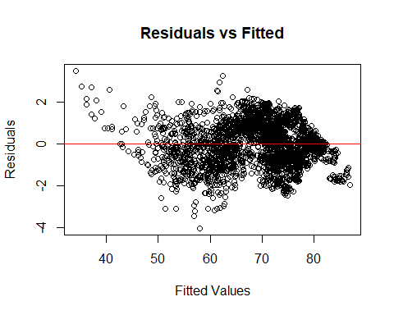

# QQ plot  
qqPlot(new_model2)

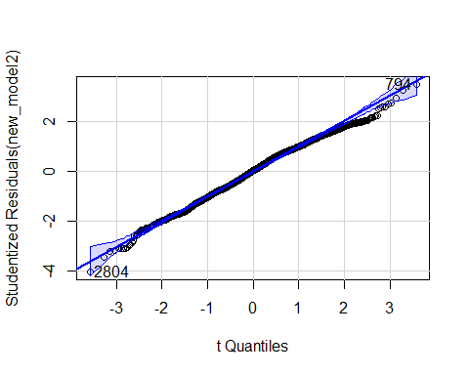

## [1] 794 2804

# histogram of residuals  
hist(studres(new_model2), breaks = 10, freq = F, col="cornflowerblue",  
 xlab = "Studentized Residuals")

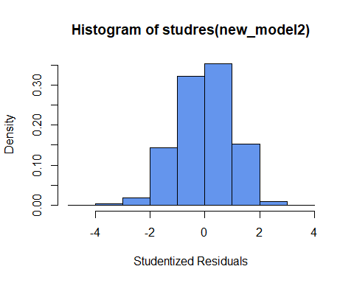

# cook's distance  
  
cooks_d <- cooks.distance(new_model2)  
plot(cooks_d)

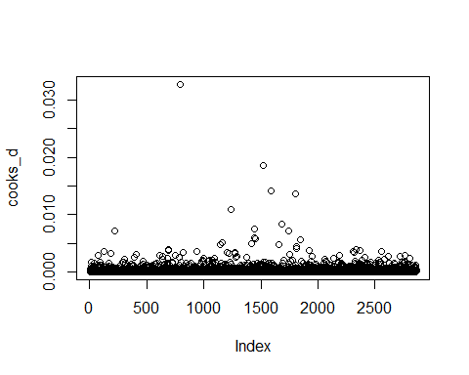

# remove influential points flagged by cook's distance  
  
n <- nrow(data)  
  
influential_point <- which(cooks_d > (4 / n))  
  
cleaned_data <- data[-influential_point,]  
  
cleaned_new_model2 <- lm(Life_expectancy ~   
 Alcohol_consumption +  
 Hepatitis_B +  
 Measles +  
 BMI +  
 Diphtheria +  
 Incidents_HIV +  
 GDP_per_capita +  
 Population_mln ++  
 Thinness_five_nine_years +  
 Schooling +  
 Economy_status_Developed,  
 data = cleaned_data  
)  
  
summary(cleaned_new_model2)

##   
## Call:  
## lm(formula = Life_expectancy ~ Alcohol_consumption + Hepatitis_B +   
## Measles + BMI + Diphtheria + Incidents_HIV + GDP_per_capita +   
## Population_mln + +Thinness_five_nine_years + Schooling +   
## Economy_status_Developed, data = cleaned_data)  
##   
## Residuals:  
## Min 1Q Median 3Q Max   
## -12.210 -2.614 0.057 2.821 8.274   
##   
## Coefficients:  
## Estimate Std. Error t value Pr(>|t|)   
## (Intercept) 2.446e+01 1.169e+00 20.927 < 2e-16 ***  
## Alcohol_consumption -2.842e-02 2.682e-02 -1.059 0.289511   
## Hepatitis_B -2.598e-02 6.982e-03 -3.721 0.000203 ***  
## Measles 1.827e-02 4.631e-03 3.945 8.19e-05 ***  
## BMI 9.450e-01 4.888e-02 19.332 < 2e-16 ***  
## Diphtheria 1.855e-01 8.030e-03 23.101 < 2e-16 ***  
## Incidents_HIV -1.719e+00 3.651e-02 -47.075 < 2e-16 ***  
## GDP_per_capita 1.170e-04 6.405e-06 18.264 < 2e-16 ***  
## Population_mln 4.121e-03 5.461e-04 7.547 6.04e-14 ***  
## Thinness_five_nine_years 9.544e-02 2.165e-02 4.408 1.08e-05 ***  
## Schooling 6.494e-01 4.116e-02 15.778 < 2e-16 ***  
## Economy_status_Developed 1.506e+00 2.886e-01 5.216 1.96e-07 ***  
## ---  
## Signif. codes: 0 '***' 0.001 '**' 0.01 '*' 0.05 '.' 0.1 ' ' 1  
##   
## Residual standard error: 3.579 on 2722 degrees of freedom  
## Multiple R-squared: 0.8472, Adjusted R-squared: 0.8466   
## F-statistic: 1372 on 11 and 2722 DF, p-value: < 2.2e-16

cleaned_cooks_d <- cooks.distance(cleaned_new_model2)  
plot(cleaned_cooks_d)

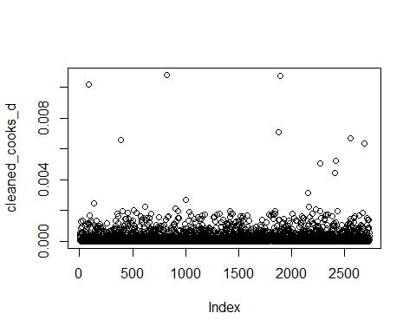

library(car)  
library(MASS)  
  
# residuals vs fitted values  
plot(fitted(cleaned_new_model2), studres(cleaned_new_model2),  
 main="Residuals vs Fitted",  
 xlab="Fitted Values", ylab="Residuals")  
abline(h = 0, col = "red")

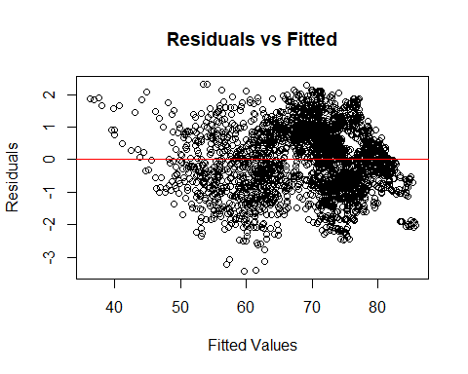

# QQ plot  
qqPlot(cleaned_new_model2)

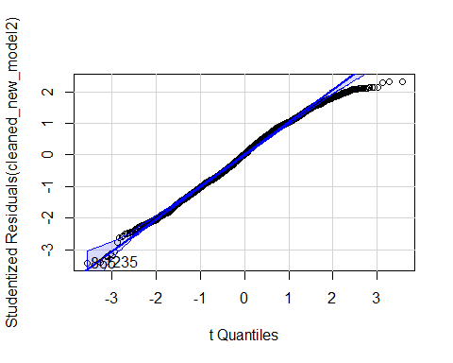

## 865 1235   
## 830 1182

# histogram of residuals  
hist(studres(cleaned_new_model2), breaks = 10, freq = F, col="cornflowerblue",  
 xlab = "Studentized Residuals")

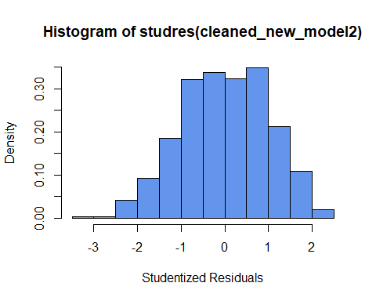

# New Transformations

# log transformation  
  
log_cleaned_new_model2 <- lm(log(Life_expectancy) ~   
 Alcohol_consumption +  
 Hepatitis_B +  
 Measles +  
 BMI +  
 Diphtheria +  
 Incidents_HIV +  
 GDP_per_capita +  
 Population_mln ++  
 Thinness_five_nine_years +  
 Schooling +  
 Economy_status_Developed,  
 data = cleaned_data  
)  
  
summary(log_cleaned_new_model2)

##   
## Call:  
## lm(formula = log(Life_expectancy) ~ Alcohol_consumption + Hepatitis_B +   
## Measles + BMI + Diphtheria + Incidents_HIV + GDP_per_capita +   
## Population_mln + +Thinness_five_nine_years + Schooling +   
## Economy_status_Developed, data = cleaned_data)  
##   
## Residuals:  
## Min 1Q Median 3Q Max   
## -0.22248 -0.03907 0.00188 0.04390 0.14723   
##   
## Coefficients:  
## Estimate Std. Error t value Pr(>|t|)   
## (Intercept) 3.512e+00 1.806e-02 194.460 < 2e-16 ***  
## Alcohol_consumption -1.830e-04 4.146e-04 -0.441 0.658951   
## Hepatitis_B -4.203e-04 1.079e-04 -3.895 0.000101 ***  
## Measles 2.053e-04 7.158e-05 2.868 0.004165 **   
## BMI 1.538e-02 7.555e-04 20.359 < 2e-16 ***  
## Diphtheria 3.028e-03 1.241e-04 24.396 < 2e-16 ***  
## Incidents_HIV -2.951e-02 5.642e-04 -52.302 < 2e-16 ***  
## GDP_per_capita 1.518e-06 9.899e-08 15.337 < 2e-16 ***  
## Population_mln 6.270e-05 8.439e-06 7.430 1.45e-13 ***  
## Thinness_five_nine_years 1.981e-03 3.346e-04 5.922 3.58e-09 ***  
## Schooling 1.025e-02 6.361e-04 16.112 < 2e-16 ***  
## Economy_status_Developed 1.484e-02 4.461e-03 3.327 0.000891 ***  
## ---  
## Signif. codes: 0 '***' 0.001 '**' 0.01 '*' 0.05 '.' 0.1 ' ' 1  
##   
## Residual standard error: 0.05531 on 2722 degrees of freedom  
## Multiple R-squared: 0.8485, Adjusted R-squared: 0.8479   
## F-statistic: 1386 on 11 and 2722 DF, p-value: < 2.2e-16

# residuals vs fitted values  
plot(fitted(log_cleaned_new_model2), studres(log_cleaned_new_model2),  
 main="Residuals vs Fitted",  
 xlab="Fitted Values", ylab="Residuals")  
abline(h = 0, col = "red")

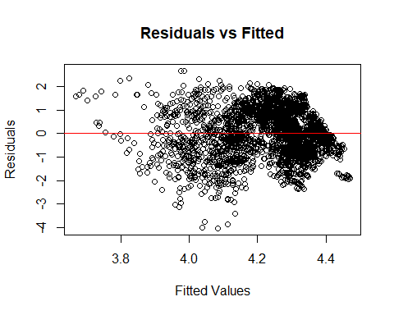

# QQ plot  
qqPlot(log_cleaned_new_model2)

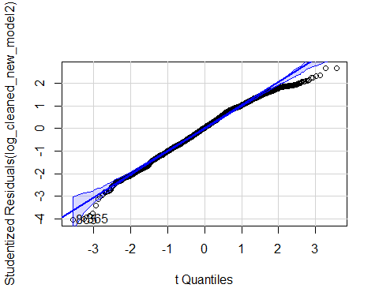

## 365 865   
## 353 830

# histogram of residuals  
hist(studres(log_cleaned_new_model2), breaks = 10, freq = F, col="cornflowerblue",  
 xlab = "Studentized Residuals")

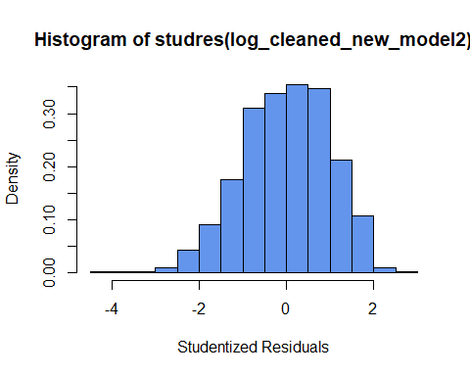

# square root transformation  
  
sqrt_cleaned_new_model2 <- lm(sqrt(Life_expectancy) ~   
 Alcohol_consumption +  
 Hepatitis_B +  
 Measles +  
 BMI +  
 Diphtheria +  
 Incidents_HIV +  
 GDP_per_capita +  
 Population_mln ++  
 Thinness_five_nine_years +  
 Schooling +  
 Economy_status_Developed,  
 data = cleaned_data  
)  
  
summary(log_cleaned_new_model2)

##   
## Call:  
## lm(formula = log(Life_expectancy) ~ Alcohol_consumption + Hepatitis_B +   
## Measles + BMI + Diphtheria + Incidents_HIV + GDP_per_capita +   
## Population_mln + +Thinness_five_nine_years + Schooling +   
## Economy_status_Developed, data = cleaned_data)  
##   
## Residuals:  
## Min 1Q Median 3Q Max   
## -0.22248 -0.03907 0.00188 0.04390 0.14723   
##   
## Coefficients:  
## Estimate Std. Error t value Pr(>|t|)   
## (Intercept) 3.512e+00 1.806e-02 194.460 < 2e-16 ***  
## Alcohol_consumption -1.830e-04 4.146e-04 -0.441 0.658951   
## Hepatitis_B -4.203e-04 1.079e-04 -3.895 0.000101 ***  
## Measles 2.053e-04 7.158e-05 2.868 0.004165 **   
## BMI 1.538e-02 7.555e-04 20.359 < 2e-16 ***  
## Diphtheria 3.028e-03 1.241e-04 24.396 < 2e-16 ***  
## Incidents_HIV -2.951e-02 5.642e-04 -52.302 < 2e-16 ***  
## GDP_per_capita 1.518e-06 9.899e-08 15.337 < 2e-16 ***  
## Population_mln 6.270e-05 8.439e-06 7.430 1.45e-13 ***  
## Thinness_five_nine_years 1.981e-03 3.346e-04 5.922 3.58e-09 ***  
## Schooling 1.025e-02 6.361e-04 16.112 < 2e-16 ***  
## Economy_status_Developed 1.484e-02 4.461e-03 3.327 0.000891 ***  
## ---  
## Signif. codes: 0 '***' 0.001 '**' 0.01 '*' 0.05 '.' 0.1 ' ' 1  
##   
## Residual standard error: 0.05531 on 2722 degrees of freedom  
## Multiple R-squared: 0.8485, Adjusted R-squared: 0.8479   
## F-statistic: 1386 on 11 and 2722 DF, p-value: < 2.2e-16

# residuals vs fitted values  
plot(fitted(sqrt_cleaned_new_model2), studres(sqrt_cleaned_new_model2),  
 main="Residuals vs Fitted",  
 xlab="Fitted Values", ylab="Residuals")  
abline(h = 0, col = "red")

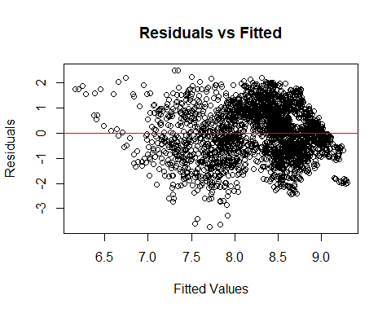

# QQ plot  
qqPlot(sqrt_cleaned_new_model2)

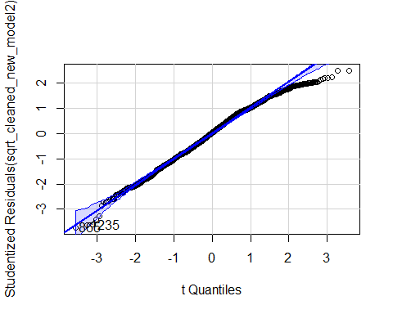

## 865 1235   
## 830 1182

# histogram of residuals  
hist(studres(sqrt_cleaned_new_model2), breaks = 10, freq = F, col="cornflowerblue",  
 xlab = "Studentized Residuals")

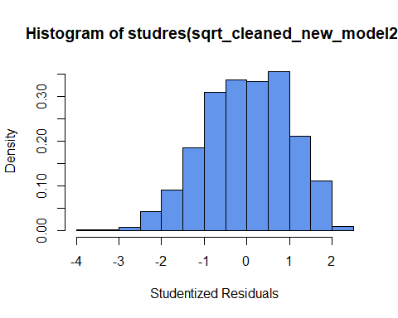

# box-cox transformation  
  
boxcox_result <- boxcox(cleaned_new_model2)

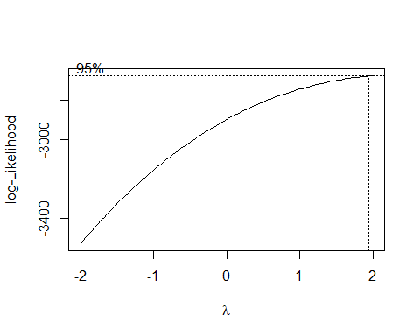

lambda <- boxcox_result$x[which.max(boxcox_result$y)]  
  
boxcox1_cleaned_new_model2 <- lm((Life_expectancy ^ lambda) ~   
 Alcohol_consumption +  
 Hepatitis_B +  
 Measles +  
 BMI +  
 Diphtheria +  
 Incidents_HIV +  
 GDP_per_capita +  
 Population_mln ++  
 Thinness_five_nine_years +  
 Schooling +  
 Economy_status_Developed,  
 data = cleaned_data  
)  
  
summary(boxcox1_cleaned_new_model2)

##   
## Call:  
## lm(formula = (Life_expectancy^lambda) ~ Alcohol_consumption +   
## Hepatitis_B + Measles + BMI + Diphtheria + Incidents_HIV +   
## GDP_per_capita + Population_mln + +Thinness_five_nine_years +   
## Schooling + Economy_status_Developed, data = cleaned_data)  
##   
## Residuals:  
## Min 1Q Median 3Q Max   
## -1393.07 -348.71 4.71 357.31 1171.00   
##   
## Coefficients:  
## Estimate Std. Error t value Pr(>|t|)   
## (Intercept) -7.667e+02 1.561e+02 -4.912 9.54e-07 ***  
## Alcohol_consumption -5.781e+00 3.582e+00 -1.614 0.106687   
## Hepatitis_B -3.231e+00 9.324e-01 -3.465 0.000538 ***  
## Measles 2.942e+00 6.185e-01 4.757 2.06e-06 ***  
## BMI 1.164e+02 6.528e+00 17.831 < 2e-16 ***  
## Diphtheria 2.298e+01 1.072e+00 21.432 < 2e-16 ***  
## Incidents_HIV -2.034e+02 4.876e+00 -41.726 < 2e-16 ***  
## GDP_per_capita 1.797e-02 8.553e-04 21.007 < 2e-16 ***  
## Population_mln 5.433e-01 7.292e-02 7.450 1.25e-13 ***  
## Thinness_five_nine_years 8.390e+00 2.891e+00 2.902 0.003739 **   
## Schooling 8.322e+01 5.497e+00 15.139 < 2e-16 ***  
## Economy_status_Developed 2.712e+02 3.855e+01 7.034 2.53e-12 ***  
## ---  
## Signif. codes: 0 '***' 0.001 '**' 0.01 '*' 0.05 '.' 0.1 ' ' 1  
##   
## Residual standard error: 477.9 on 2722 degrees of freedom  
## Multiple R-squared: 0.8429, Adjusted R-squared: 0.8423   
## F-statistic: 1328 on 11 and 2722 DF, p-value: < 2.2e-16

# residuals vs fitted values  
plot(fitted(boxcox1_cleaned_new_model2), studres(boxcox1_cleaned_new_model2),  
 main="Residuals vs Fitted",  
 xlab="Fitted Values", ylab="Residuals")  
abline(h = 0, col = "red")

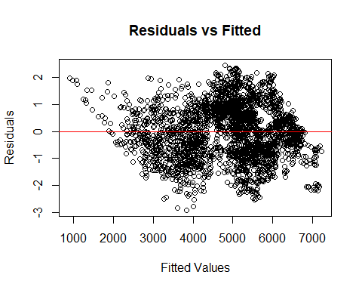

# QQ plot  
qqPlot(boxcox1_cleaned_new_model2)

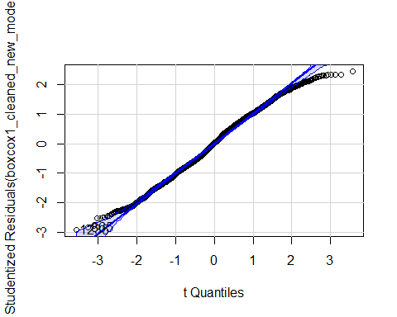

## 865 1235   
## 830 1182

# histogram of residuals  
hist(studres(boxcox1_cleaned_new_model2), breaks = 10, freq = F, col="cornflowerblue",  
 xlab = "Studentized Residuals")

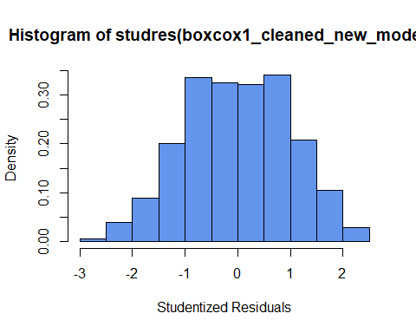

boxcox2_cleaned_new_model2 <- lm((((Life_expectancy ^ lambda) - 1) / 2) ~   
 Alcohol_consumption +  
 Hepatitis_B +  
 Measles +  
 BMI +  
 Diphtheria +  
 Incidents_HIV +  
 GDP_per_capita +  
 Population_mln ++  
 Thinness_five_nine_years +  
 Schooling +  
 Economy_status_Developed,  
 data = cleaned_data  
)  
  
summary(boxcox2_cleaned_new_model2)

##   
## Call:  
## lm(formula = (((Life_expectancy^lambda) - 1)/2) ~ Alcohol_consumption +   
## Hepatitis_B + Measles + BMI + Diphtheria + Incidents_HIV +   
## GDP_per_capita + Population_mln + +Thinness_five_nine_years +   
## Schooling + Economy_status_Developed, data = cleaned_data)  
##   
## Residuals:  
## Min 1Q Median 3Q Max   
## -696.54 -174.35 2.35 178.65 585.50   
##   
## Coefficients:  
## Estimate Std. Error t value Pr(>|t|)   
## (Intercept) -3.838e+02 7.804e+01 -4.919 9.24e-07 ***  
## Alcohol_consumption -2.891e+00 1.791e+00 -1.614 0.106687   
## Hepatitis_B -1.616e+00 4.662e-01 -3.465 0.000538 ***  
## Measles 1.471e+00 3.092e-01 4.757 2.06e-06 ***  
## BMI 5.820e+01 3.264e+00 17.831 < 2e-16 ***  
## Diphtheria 1.149e+01 5.362e-01 21.432 < 2e-16 ***  
## Incidents_HIV -1.017e+02 2.438e+00 -41.726 < 2e-16 ***  
## GDP_per_capita 8.984e-03 4.277e-04 21.007 < 2e-16 ***  
## Population_mln 2.716e-01 3.646e-02 7.450 1.25e-13 ***  
## Thinness_five_nine_years 4.195e+00 1.446e+00 2.902 0.003739 **   
## Schooling 4.161e+01 2.748e+00 15.139 < 2e-16 ***  
## Economy_status_Developed 1.356e+02 1.927e+01 7.034 2.53e-12 ***  
## ---  
## Signif. codes: 0 '***' 0.001 '**' 0.01 '*' 0.05 '.' 0.1 ' ' 1  
##   
## Residual standard error: 239 on 2722 degrees of freedom  
## Multiple R-squared: 0.8429, Adjusted R-squared: 0.8423   
## F-statistic: 1328 on 11 and 2722 DF, p-value: < 2.2e-16

# residuals vs fitted values  
plot(fitted(boxcox2_cleaned_new_model2), studres(boxcox2_cleaned_new_model2),  
 main="Residuals vs Fitted",  
 xlab="Fitted Values", ylab="Residuals")  
abline(h = 0, col = "red")

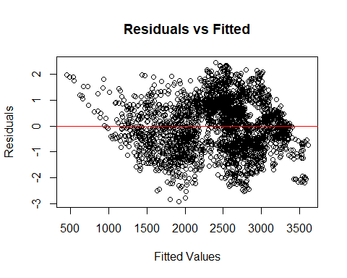

# QQ plot  
qqPlot(boxcox2_cleaned_new_model2)

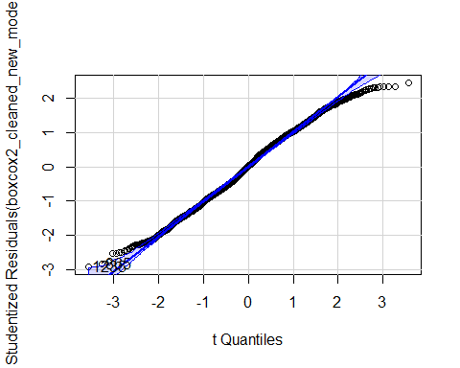

## 865 1235   
## 830 1182

# histogram of residuals  
hist(studres(boxcox2_cleaned_new_model2), breaks = 10, freq = F, col="cornflowerblue",  
 xlab = "Studentized Residuals")

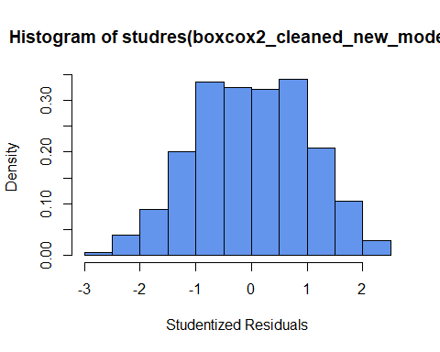

Now that we have transformed variables, we will compare their AIC values to determine which is best.

AIC(cleaned_new_model2, log_cleaned_new_model2, sqrt_cleaned_new_model2, boxcox1_cleaned_new_model2, boxcox2_cleaned_new_model2)

## df AIC  
## cleaned_new_model2 13 14744.3901  
## log_cleaned_new_model2 13 -8056.1950  
## sqrt_cleaned_new_model2 13 -469.7285  
## boxcox1_cleaned_new_model2 13 41507.2209  
## boxcox2_cleaned_new_model2 13 37717.0921

BIC(cleaned_new_model2, log_cleaned_new_model2, sqrt_cleaned_new_model2, boxcox1_cleaned_new_model2, boxcox2_cleaned_new_model2)

## df BIC  
## cleaned_new_model2 13 14821.2659  
## log_cleaned_new_model2 13 -7979.3192  
## sqrt_cleaned_new_model2 13 -392.8527  
## boxcox1_cleaned_new_model2 13 41584.0967  
## boxcox2_cleaned_new_model2 13 37793.9679

The log transformation has the lowest AIC and BIC values, indicating that it is the best model out of the original and these transformations. The tails of the QQ plot are not as good as the original mode but we think this is a valid trade off for the better AIC/BIC values.

# Final look at models

log_model6 <- lm(log(Life_expectancy) ~   
 Infant_deaths +  
 Adult_mortality +  
 Alcohol_consumption +  
 Hepatitis_B +  
 BMI +  
 Diphtheria +  
 Incidents_HIV +  
 GDP_per_capita +  
 Thinness_ten_nineteen_years +  
 Schooling,  
 data = data  
)  
  
sqrt_model6 <- lm(sqrt(Life_expectancy) ~   
 Infant_deaths +  
 Adult_mortality +  
 Alcohol_consumption +  
 Hepatitis_B +  
 BMI +  
 Diphtheria +  
 Incidents_HIV +  
 GDP_per_capita +  
 Thinness_ten_nineteen_years +  
 Schooling,  
 data = data  
)  
  
squared_model6 <- lm((Life_expectancy) ^ 2 ~   
 Infant_deaths +  
 Adult_mortality +  
 Alcohol_consumption +  
 Hepatitis_B +  
 BMI +  
 Diphtheria +  
 Incidents_HIV +  
 GDP_per_capita +  
 Thinness_ten_nineteen_years +  
 Schooling,  
 data = data  
)  
  
log_new_model2 <- lm(log(Life_expectancy) ~   
 Alcohol_consumption +  
 Hepatitis_B +  
 Measles +  
 BMI +  
 Diphtheria +  
 Incidents_HIV +  
 GDP_per_capita +  
 Population_mln +  
 Thinness_five_nine_years +  
 Schooling +  
 Economy_status_Developed,  
 data = data  
)  
  
sqrt_new_model2 <- lm(sqrt(Life_expectancy) ~   
 Alcohol_consumption +  
 Hepatitis_B +  
 Measles +  
 BMI +  
 Diphtheria +  
 Incidents_HIV +  
 GDP_per_capita +  
 Population_mln +  
 Thinness_five_nine_years +  
 Schooling +  
 Economy_status_Developed,  
 data = data  
)  
  
squared_new_model2 <- lm((Life_expectancy) ^ 2 ~   
 Alcohol_consumption +  
 Hepatitis_B +  
 Measles +  
 BMI +  
 Diphtheria +  
 Incidents_HIV +  
 GDP_per_capita +  
 Population_mln +  
 Thinness_five_nine_years +  
 Schooling +  
 Economy_status_Developed,  
 data = data  
)  
  
AIC(model6, log_model6, sqrt_model6, squared_model6, new_model2, log_new_model2, sqrt_new_model2, squared_new_model2)

## df AIC  
## model6 12 10122.60193  
## log_model6 12 -14023.20345  
## sqrt_model6 12 -6056.54814  
## squared_model6 12 38965.56700  
## new_model2 13 15931.27545  
## log_new_model2 13 -7863.11069  
## sqrt_new_model2 13 36.03168  
## squared_new_model2 13 43897.50726

BIC(model6, log_model6, sqrt_model6, squared_model6, new_model2, log_new_model2, sqrt_new_model2, squared_new_model2)

## df BIC  
## model6 12 10194.1216  
## log_model6 12 -13951.6838  
## sqrt_model6 12 -5985.0284  
## squared_model6 12 39037.0867  
## new_model2 13 16008.7551  
## log_new_model2 13 -7785.6310  
## sqrt_new_model2 13 113.5114  
## squared_new_model2 13 43974.9869

# residuals vs fitted values  
plot(fitted(model6), studres(model6),  
 main="Residuals vs Fitted",  
 xlab="Fitted Values", ylab="Residuals")  
abline(h = 0, col = "red")



# QQ plot  
qqPlot(model6)

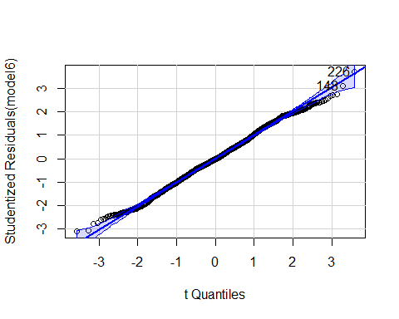

## [1] 148 226

# histogram of residuals  
hist(studres(model6), breaks = 10, freq = F, col="cornflowerblue",  
 xlab = "Studentized Residuals")



# Residuals vs Fitted Values (Log Original Model)  
plot(fitted(log_model6), studres(log_model6),  
 main = "Residuals vs Fitted (Log Original Model)",  
 xlab = "Fitted Values", ylab = "Studentized Residuals (Log Model)")  
abline(h = 0, col = "red")

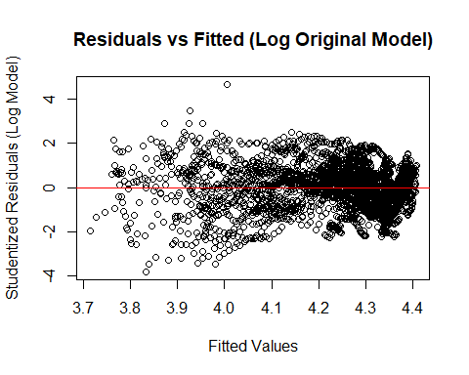

# QQ Plot (Log Original Model)  
qqPlot(log_model6,   
 main = "QQ Plot of Residuals (Log Original Model)")

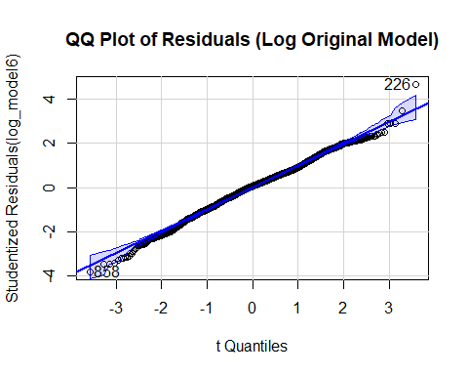

## [1] 226 858

# Histogram of Residuals (Log Original Model)  
hist(studres(log_model6), breaks = 10, freq = FALSE, col = "cornflowerblue",  
 xlab = "Studentized Residuals",   
 main = "Histogram of Residuals (Log Original Model)")

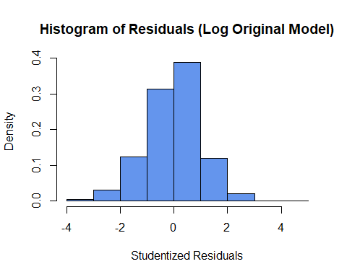

# residuals vs fitted values  
plot(fitted(new_model2), studres(new_model2),  
 main="Residuals vs Fitted",  
 xlab="Fitted Values", ylab="Residuals")  
abline(h = 0, col = "red")



# QQ plot  
qqPlot(new_model2)

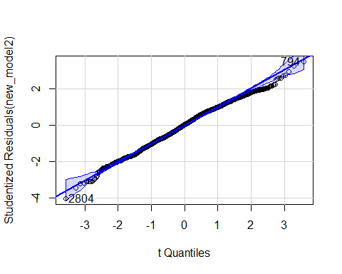

## [1] 794 2804

# histogram of residuals  
hist(studres(new_model2), breaks = 10, freq = F, col="cornflowerblue",  
 xlab = "Studentized Residuals")



# Residuals vs Fitted Values Plot  
plot(fitted(log_new_model2), studres(log_new_model2),  
 main = "Residuals vs Fitted (Log Adjusted Model)",  
 xlab = "Fitted Values", ylab = "Studentized Residuals (Log Model)")  
abline(h = 0, col = "red")

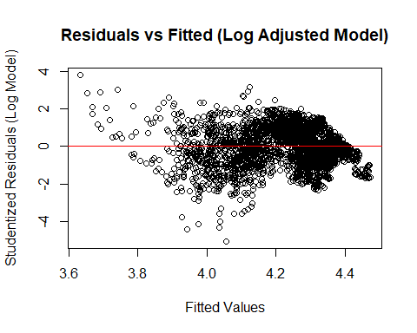

# QQ Plot  
qqPlot(log_new_model2,   
 main = "QQ Plot of Residuals (Log Adjusted Model)")

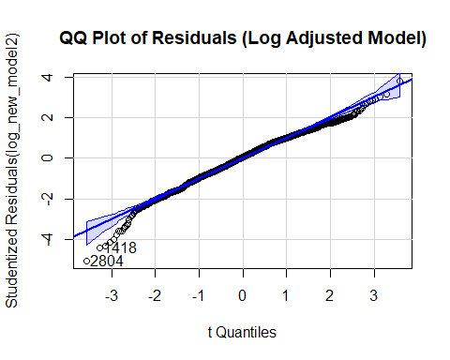

## [1] 1418 2804

# Histogram of Residuals  
hist(studres(log_new_model2), breaks = 10, freq = FALSE, col = "cornflowerblue",  
 xlab = "Studentized Residuals",   
 main = "Histogram of Residuals (Log Adjusted Model)")

