1. **New;**

Create a new script, **investing_download_today_login.py** based oninvesting_download_thisweek_login.py. This script will not create any investing_output.csv file. I will just update the Tables;

* **eco_events**
* **news_headlines**

with actual values, if required (corresponding event_name in the Table eco_events_impact has no_actual column value = False).

**url** same as current script investing_download_thisweek_login.py); https://www.investing.com/economic-calendar/

The script will be using **Today Tab instead of This Week Tab** for downloading Data.

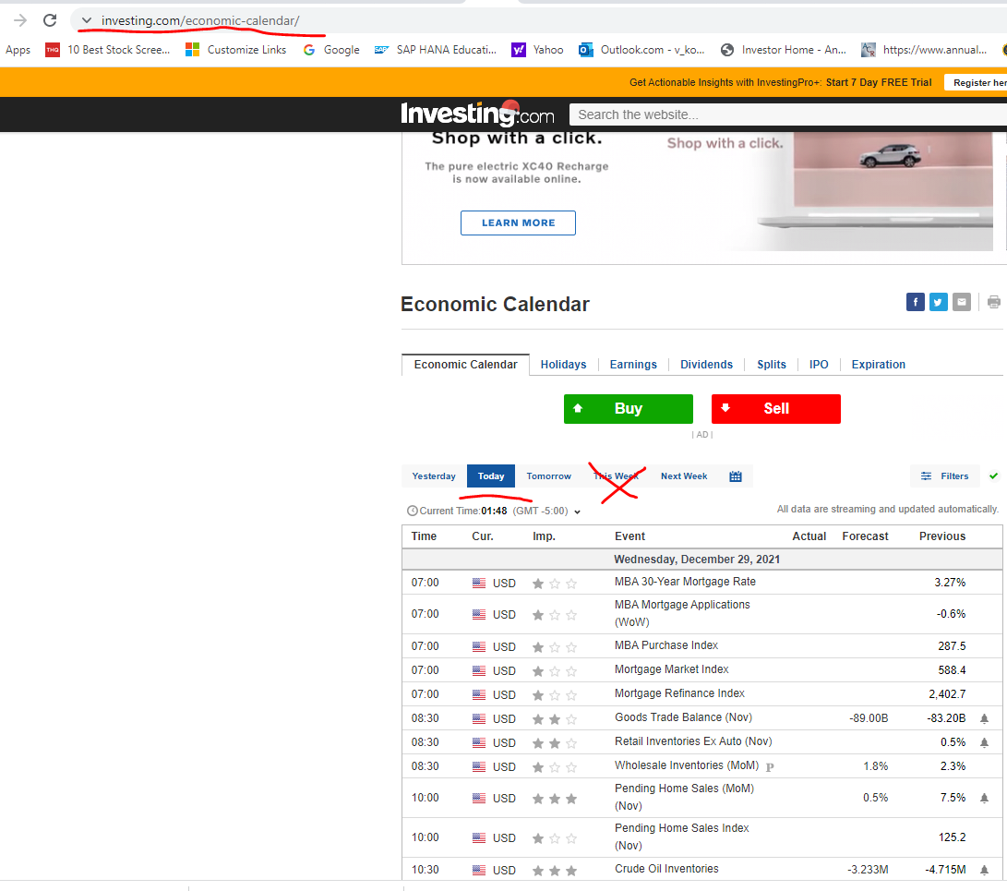

This script will be iterative in nature and will have sleep time in minutes specified in Control.csv.

**Table definitions** are attached in;

* Table_Definition_eco_events.sql
* Table_Definition_eco_events_impact.sql
* Table_Definition_news_headlines.sql

**Logic for conversion of data to Table column values** is provided in;

* Correspondence_EcoEvents_to_Output_CSV.xlsx in the Correspondence sheet.

**Table news_headlines Insert;** Script should also insert a row in the news_headlines Table based on logic provided in;

* Correspondence_EcoEvents_to_Output_CSV.xlsx in the news_headlines_correspondence sheet.

news_headlines Table insert will be triggered by availability of Actual values for the first time (Not in eco_events Table) for the event_name. In case the matching event_name in eco_events_impact Table has no_actual column value = True then script will not wait for the Actual values. Script will insert the corresponding row in the Table news_headlines on the event_date and event_time.

news_headlines Table insert will be driven primarily by the Table values found in the Table eco_events_impact for the matching event_name (except for the headline). Symbols & url will be pulled from eco_events_impact based on matching the eco_events.event_name with eco_events_impact.event_name as follows;

eco_events.event_name LIKE eco_events_impact.event_name

eco_events_impact.event_name column values contain wildcard and end with percent sing ("%")

1. **Upgrade;**

**Script;** investing_download_thisweek_login.py

1. Before creating investing_output.csv in the Data sub-folder. Script should **UpSert (Insert if no row found, else Update) the Table;**

* **eco_events**

**in PostgreSQL**.

This script will be executed once a day.

**Logic for conversion of data to Table column values** is provided in;

* Correspondence_EcoEvents_to_Output_CSV.xlsx in the Correspondence sheet.

1. Script should use Control.csv in Control sub-folder to pick up the **database login parameters** from the Control.csv.