Azure Web API Publishing with Azure API Management
Day 82 Lab Report
Created from the provided assignment brief and screenshots

Topic | Publish a .NET Web API to Azure App Service and expose it through Azure API Management
Goal | Validate APIM setup, subscription-key protection, request limiting, and endpoint monitoring
Evidence | Visual Studio publish output, Azure portal screenshots, Postman tests, and metrics view

Objective
The assignment demonstrates how to create a Web API in Visual Studio, publish it to Azure App Service, place it behind Azure API Management, and verify the exposed endpoint using valid and invalid subscription keys. The final validation includes policy configuration and monitoring.

Procedure and Evidence

1. Publish the Web API from Visual Studio
The first step is publishing the application to Azure App Service. The publish result confirms that the project was deployed successfully and the target framework and app service details were captured.
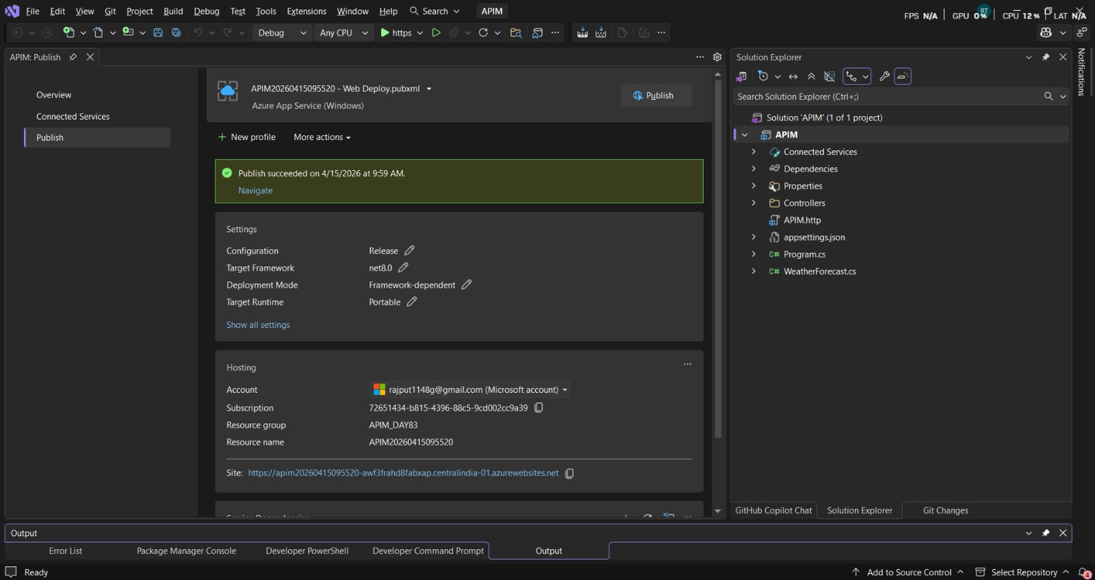
Visual Studio publish success screen showing the Web API deployed to Azure App Service.

2. Confirm the App Service in Azure Portal
After publishing, the App Service resource is checked in Azure to verify that the web app is running and available in the correct subscription and resource group.
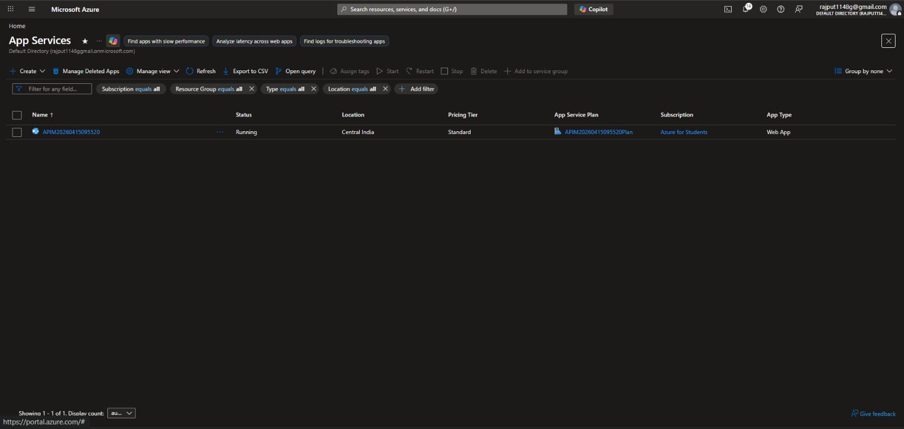
Azure App Services list confirming that the published web app is running in the portal.

3. Create and register the API in APIM
The API Management workspace is used to create the API entry that will front the backend application. This is the point where the app is exposed through APIM rather than directly to consumers.
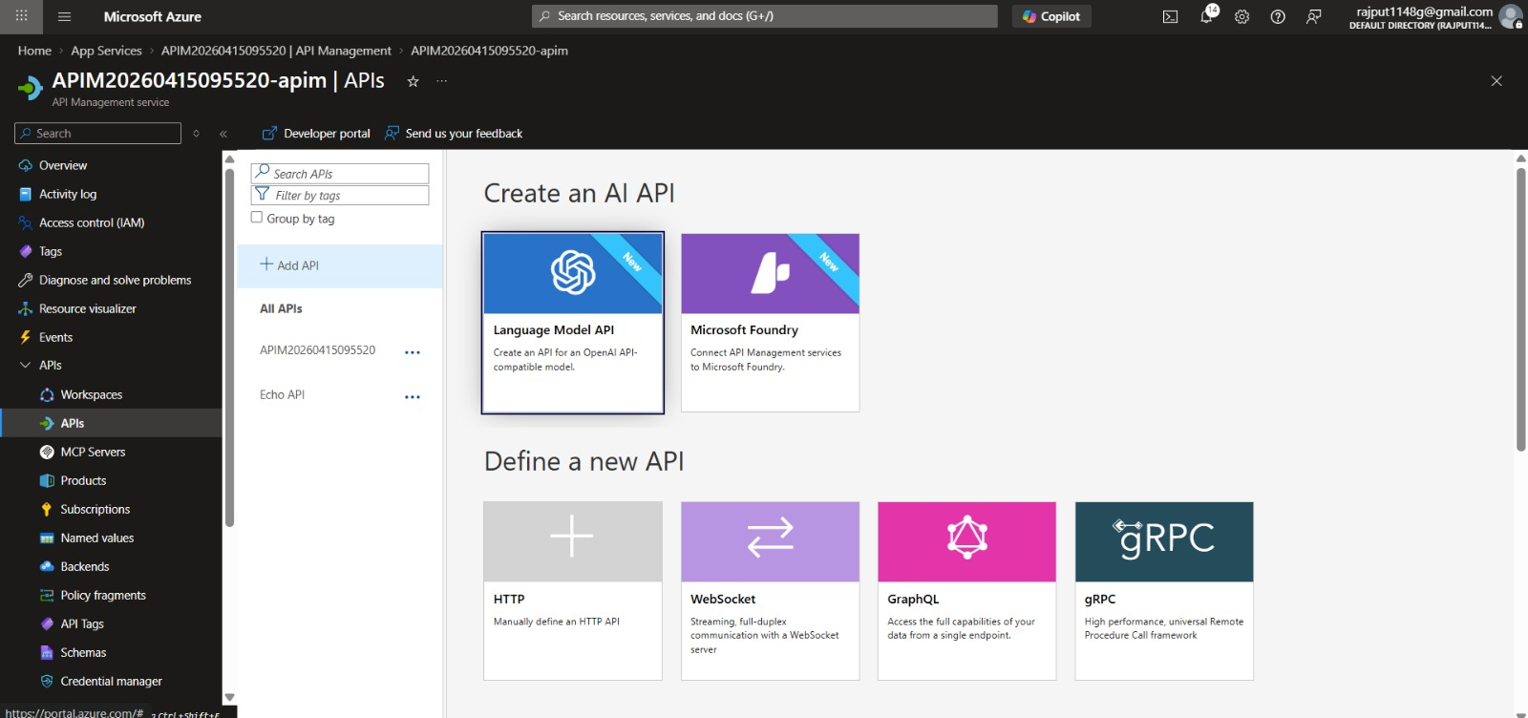
API Management portal where the API is being created and the available API templates are shown.

4. Review API gateway and backend routing
The design view shows the frontend, inbound processing, backend, and outbound processing sections. This confirms that APIM is acting as the gateway between clients and the app service backend.
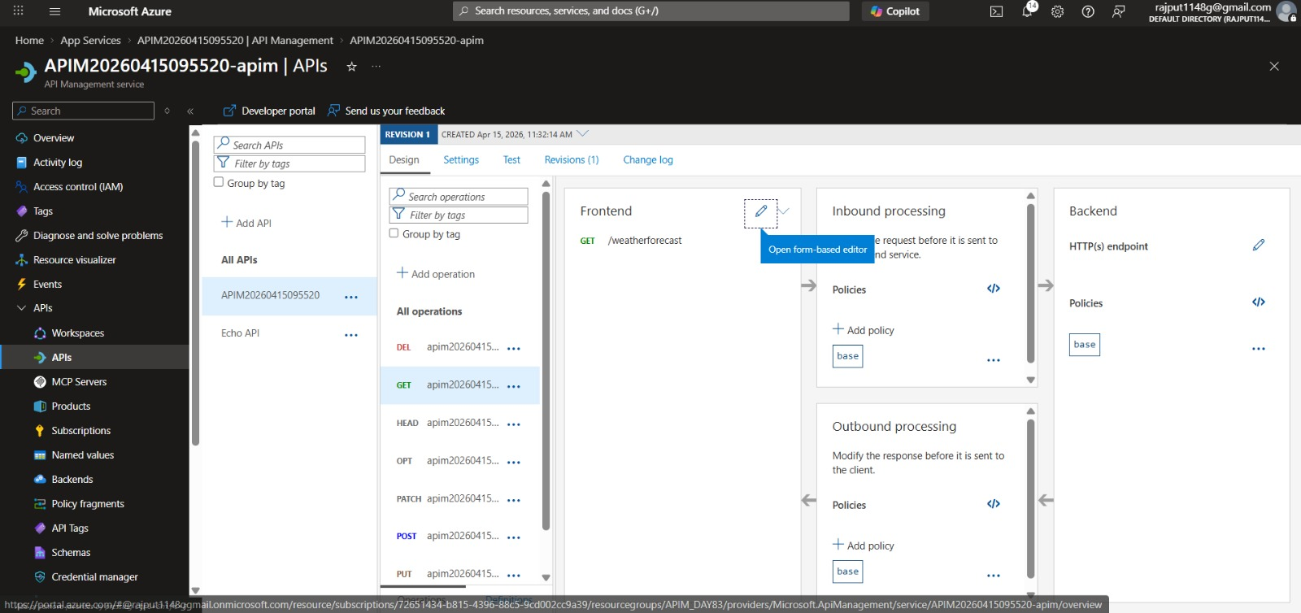
API Management design view showing frontend, inbound processing, backend, and outbound policies.

5. Inspect policy options in APIM
The policy catalog shows the available policy building blocks, including rate limiting, validation, header control, and JWT enforcement. These policies are the main controls used to govern API access.
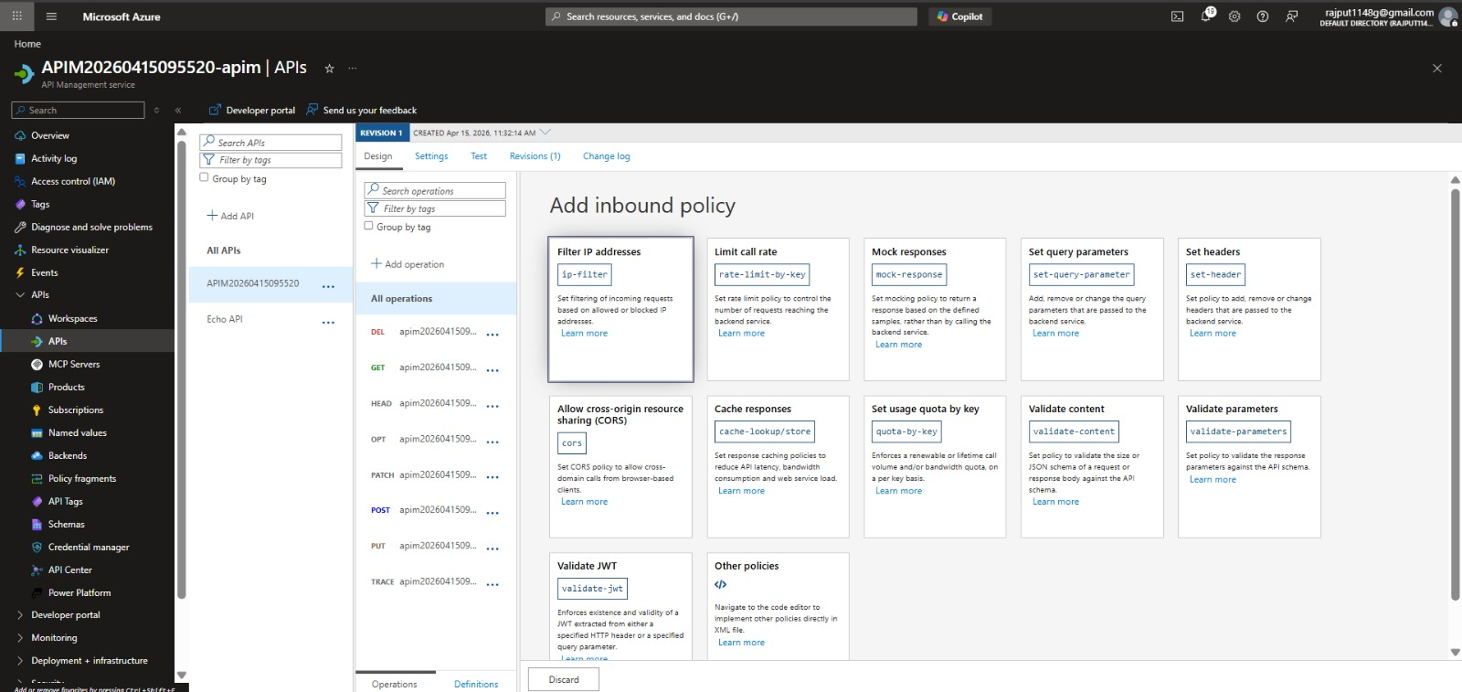
Policy portal showing the available inbound policy options such as rate limiting, validation, and header control.

6. Apply request-limiting or backend policy settings
A policy is configured to control how requests are handled before they reach the backend service. This step is important for protecting the API and shaping traffic behavior.
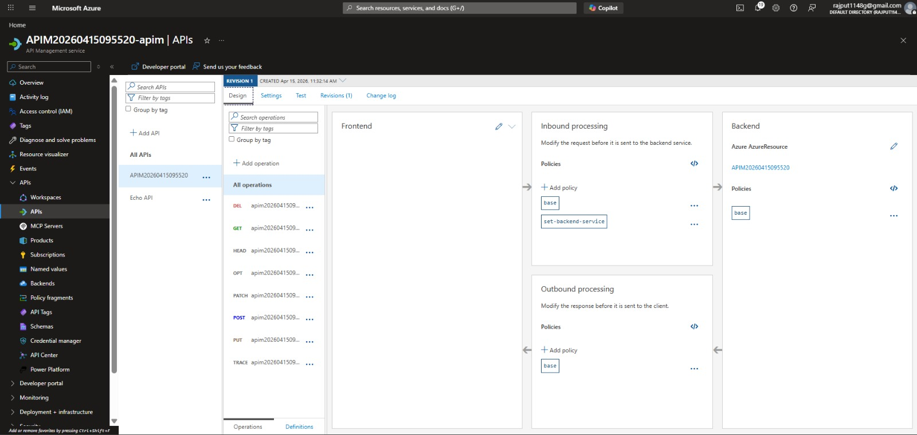
Configured APIM policy showing backend service mapping and the base policy applied for request control.

7. Test the API with a valid subscription key
A Postman request is sent with the Ocp-Apim-Subscription-Key header. The 200 OK response confirms that authenticated access through APIM works correctly.
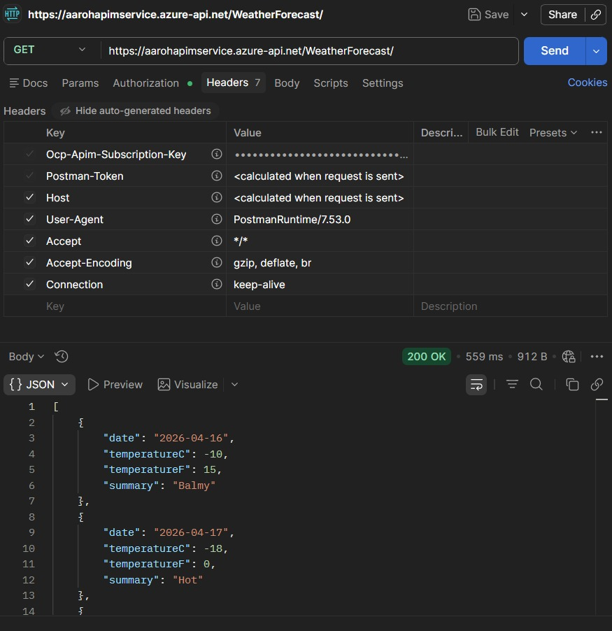
Postman request sent with the subscription key and receiving a successful 200 OK response.

8. Test the API without a valid subscription key
The same endpoint is tested without valid credentials. The 401 Access Denied response confirms that APIM is enforcing subscription-based access control.
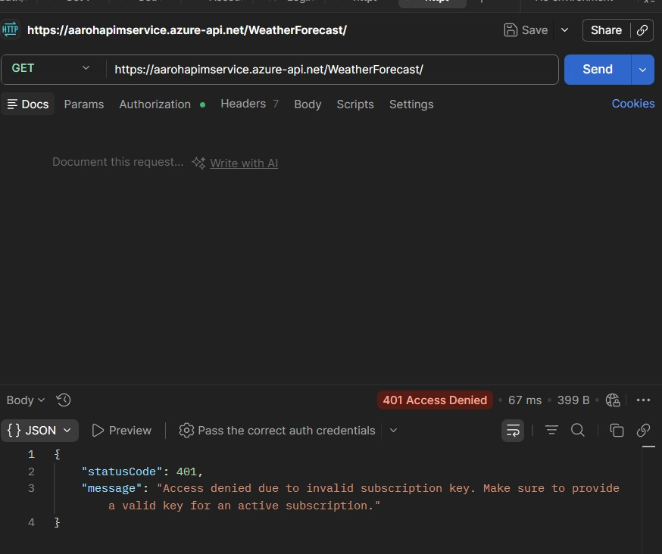
Postman request without a valid subscription key returning 401 Access Denied.

9. Monitor request counts and success responses
The metrics view confirms that successful HTTP 2xx traffic is being recorded after API calls are made. This validates that the deployment is active and observable.
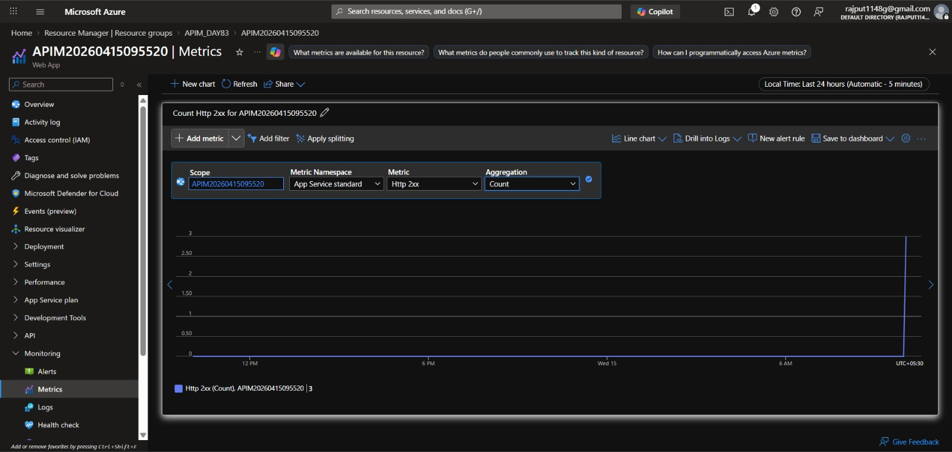
Azure metrics view showing the HTTP 2xx count for the deployed app service.

Conclusion
The lab successfully demonstrates an end-to-end Azure API Management flow: the Web API is published to App Service, exposed through APIM, protected with subscription keys, tested through Postman, and monitored through Azure metrics. The screenshots together provide clear proof of deployment, policy control, and endpoint validation.

Appendix: Screenshot Traceability
- api application publish.jpeg - Visual Studio publish success screen showing the Web API deployed to Azure App Service.
- app service.jpeg - Azure App Services list confirming that the published web app is running in the portal.
- api management.jpeg - API Management portal where the API is being created and the available API templates are shown.
- api gateway created.jpeg - API Management design view showing frontend, inbound processing, backend, and outbound policies.
- all policy portal.jpeg - Policy portal showing the available inbound policy options such as rate limiting, validation, and header control.
- policy created for limiting request.jpeg - Configured APIM policy showing backend service mapping and the base policy applied for request control.
- Authorize Access.jpeg - Postman request sent with the subscription key and receiving a successful 200 OK response.
- unAuthorized Access.jpeg - Postman request without a valid subscription key returning 401 Access Denied.
- matrix in mantoring.jpeg - Azure metrics view showing the HTTP 2xx count for the deployed app service.

