**ASSIGNMENT-3**

Name:Jammula Renuka Devi

Email:renukaj0624@gmail.com

Phone Number:9908129280

Roll Number:20NN1A05D8

College:VNITSW,Palakaluru road,Guntur.

**RestFul API code**

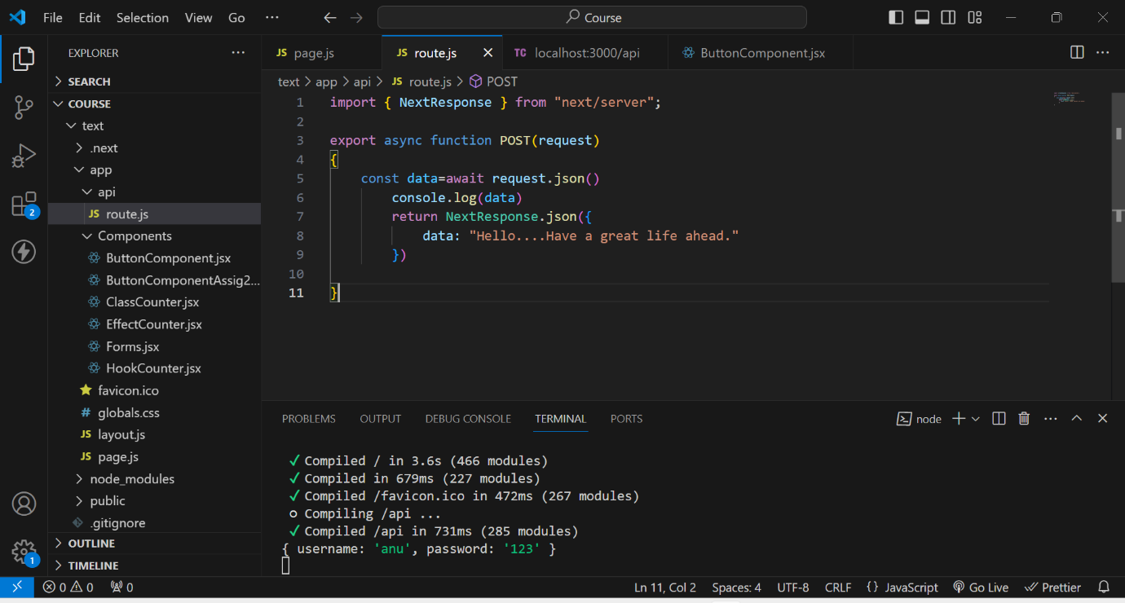

**Rest Output on ThunderClient**

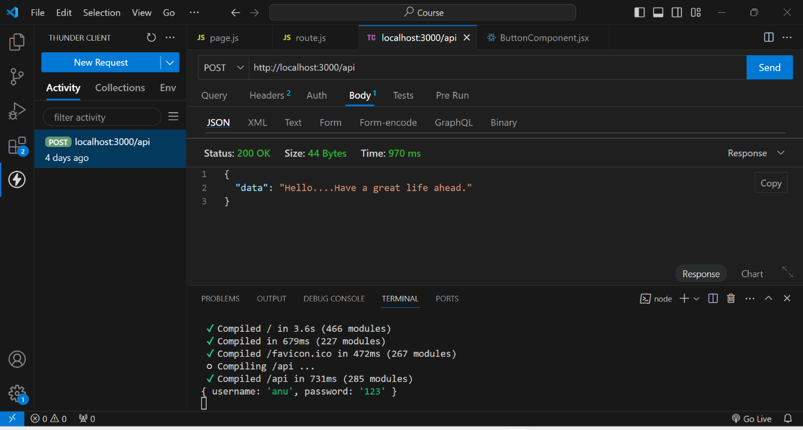

**DataBase Creation**

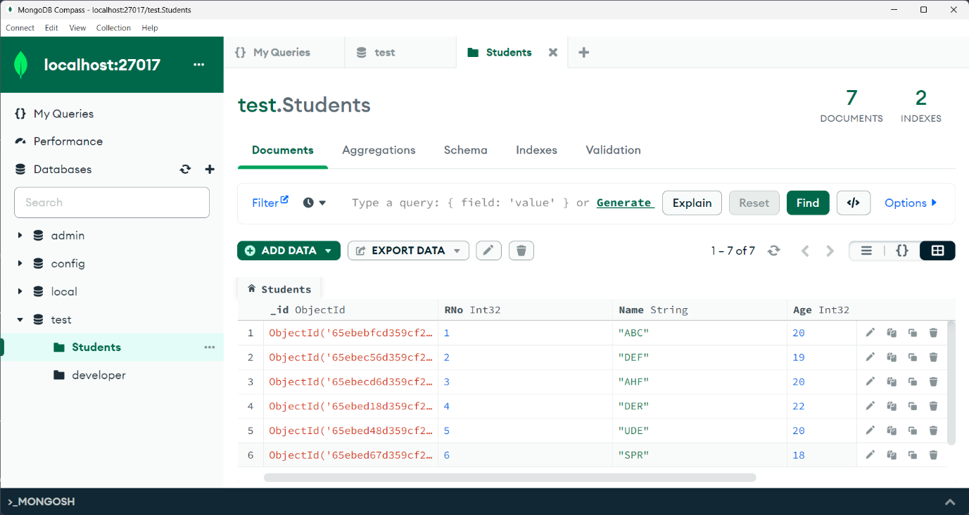

**Indexing Creation**

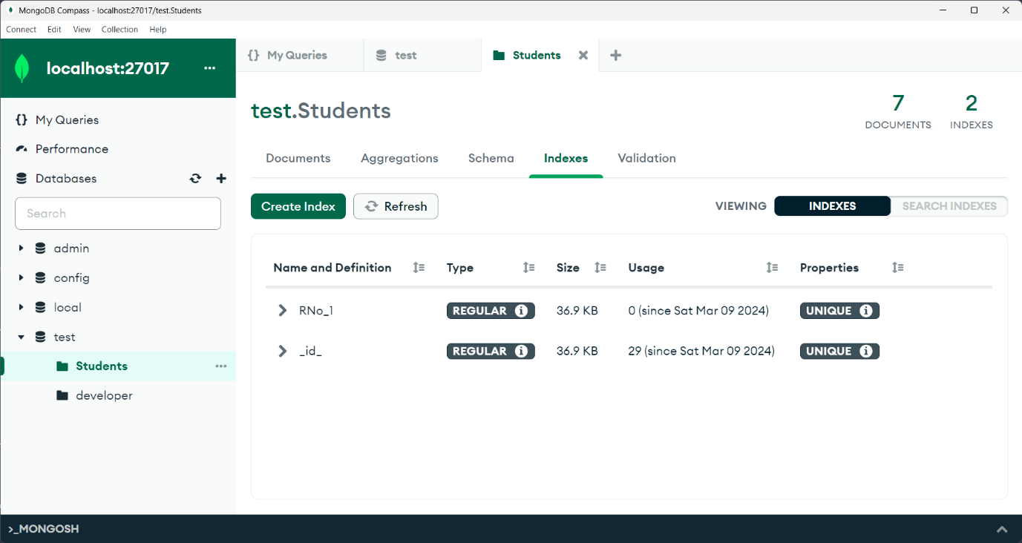

**Indexing usage**

