Joshua Herrick
CSD325 Module 7.2
10/23/26

Figure 1: Initial city_functions.py Output Showing Three City and Country Combinations
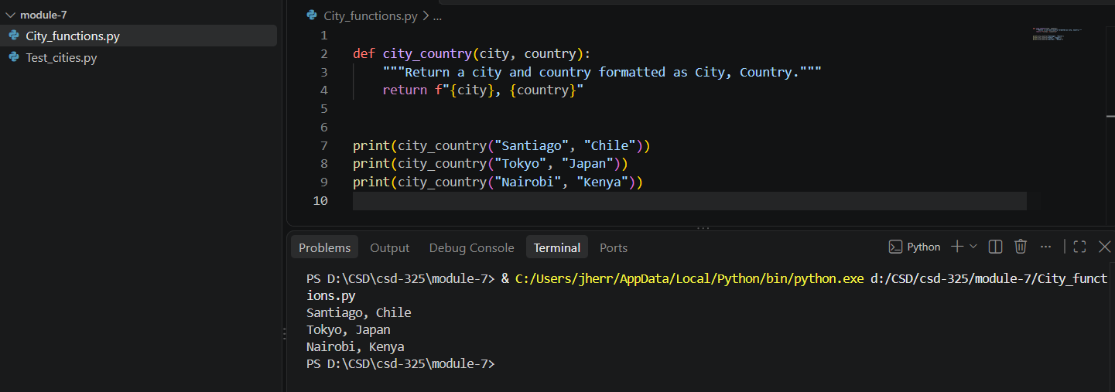

Figure 2: Unit test passes for the original city and country format.
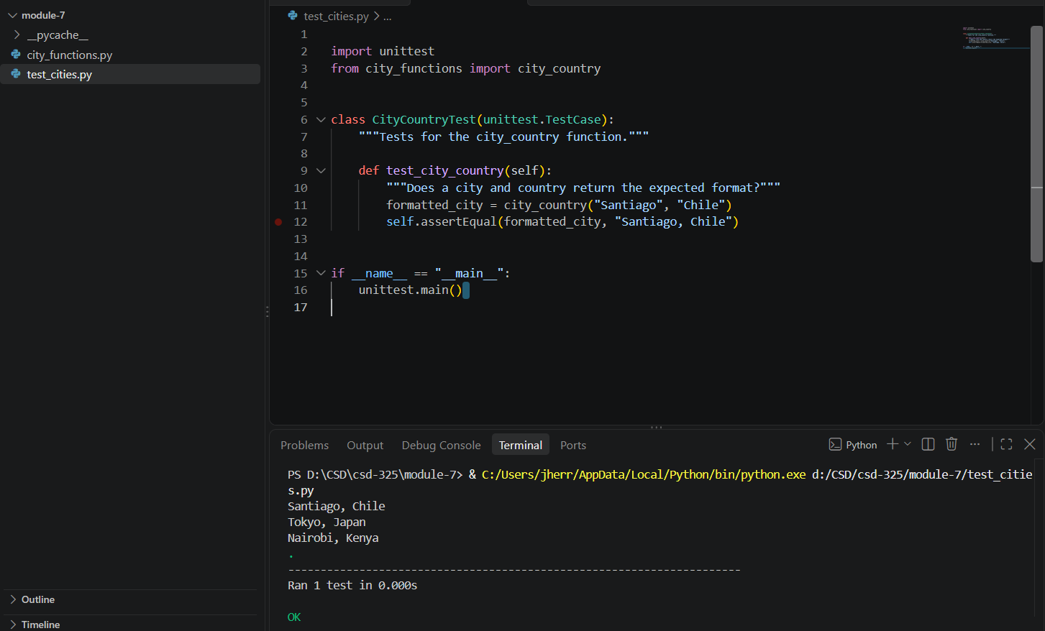

Figure 3: Unit Test Failure After Making Population a Required Parameter
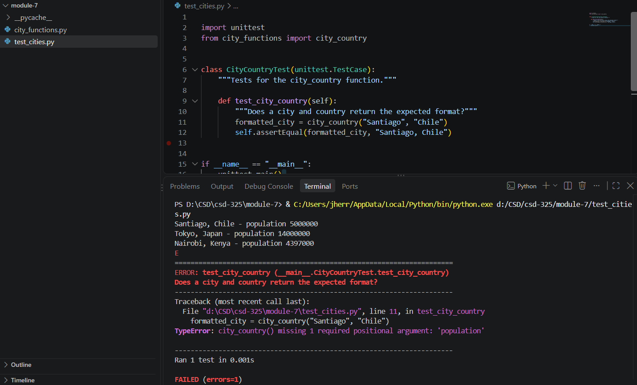

Figure 4: Unit Test Passes After Making Population an Optional Parameter
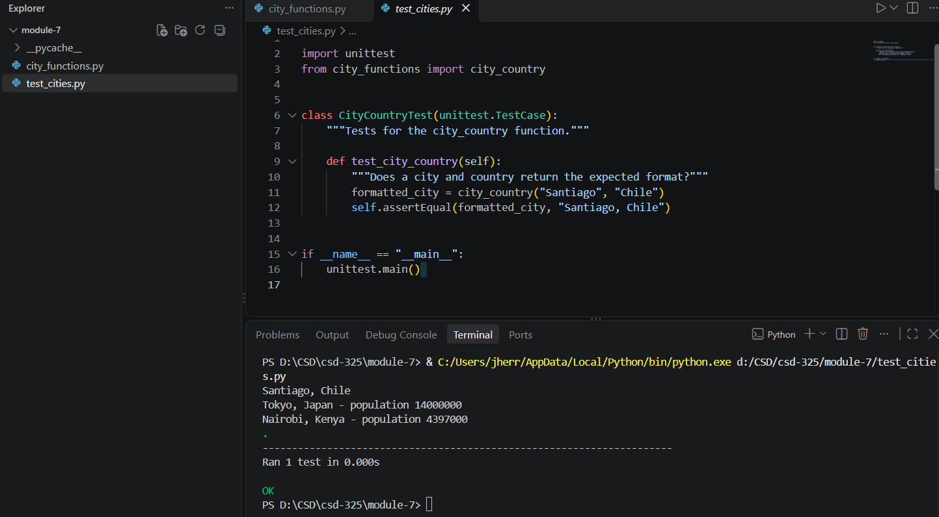

Figure 5: Unit Test Failure After Making Language a Required Parameter
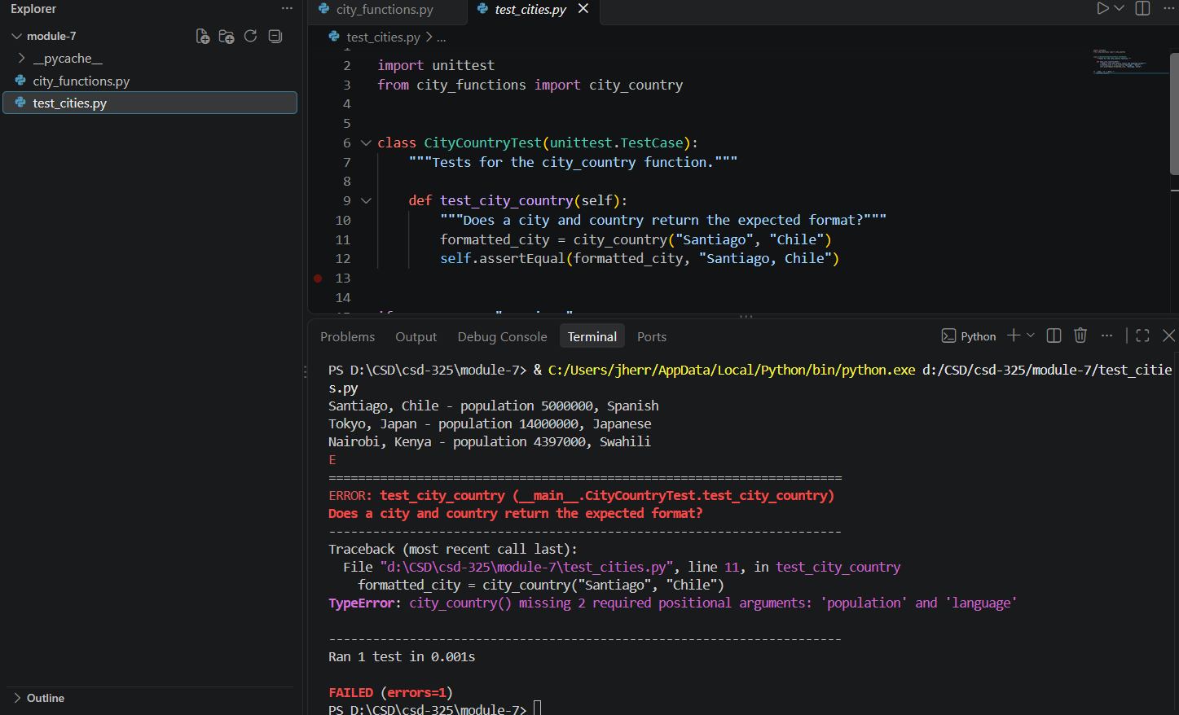

Figure 6: Unit Test Passes After Making Population and Language Optional
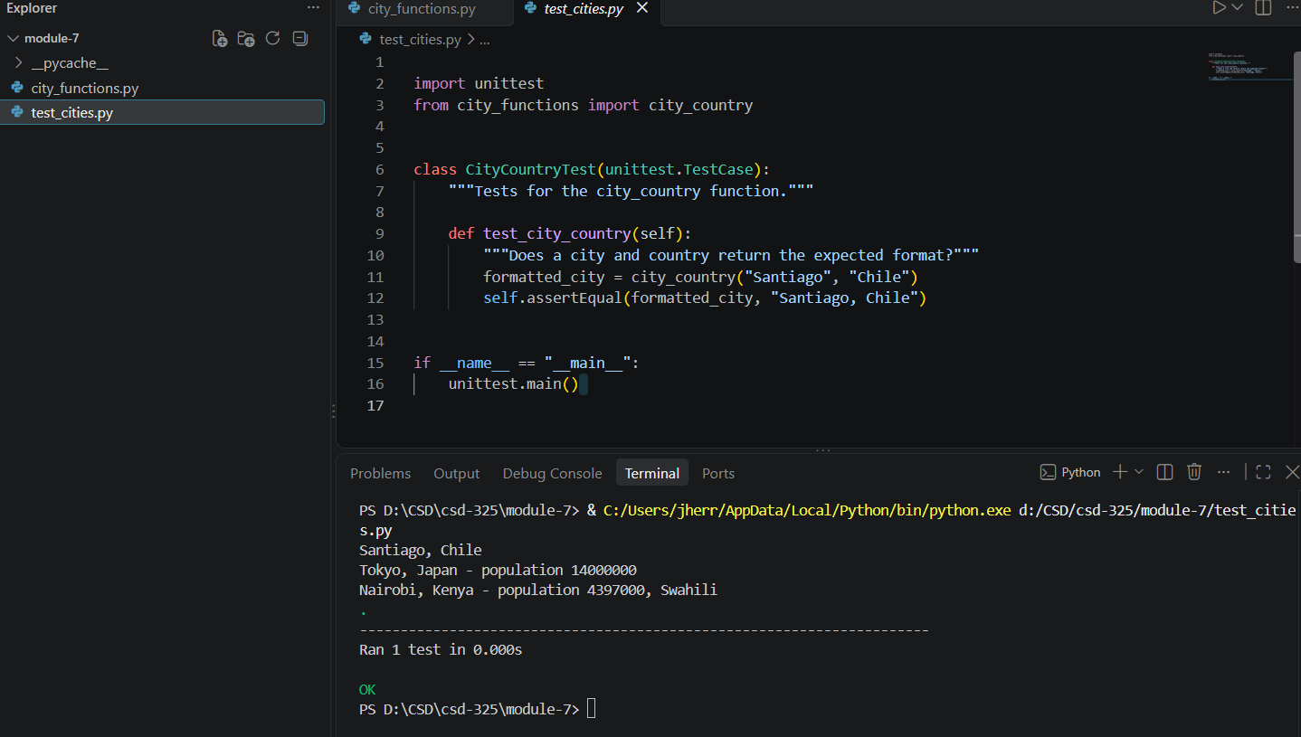

Figure 7: Final City and Country Function Demonstrating Optional Population and Language Parameters


