Joshua Herrick
CSD325 module 8.2
10/31/26

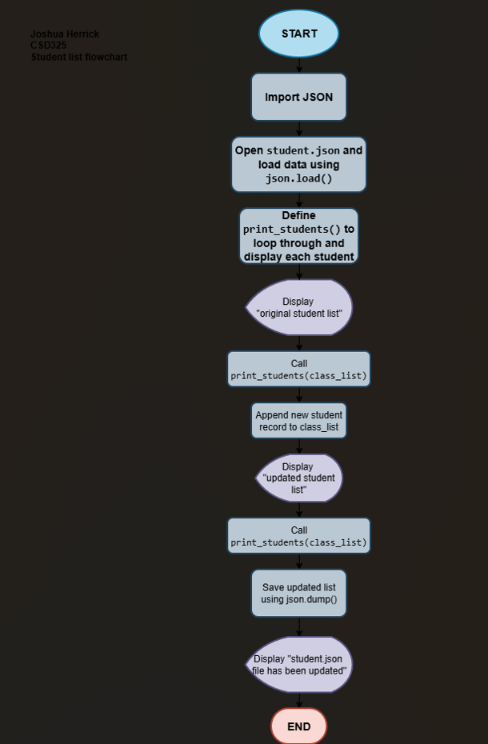

Caption: Figure 1: Program Output Showing Original and Updated Student Lists

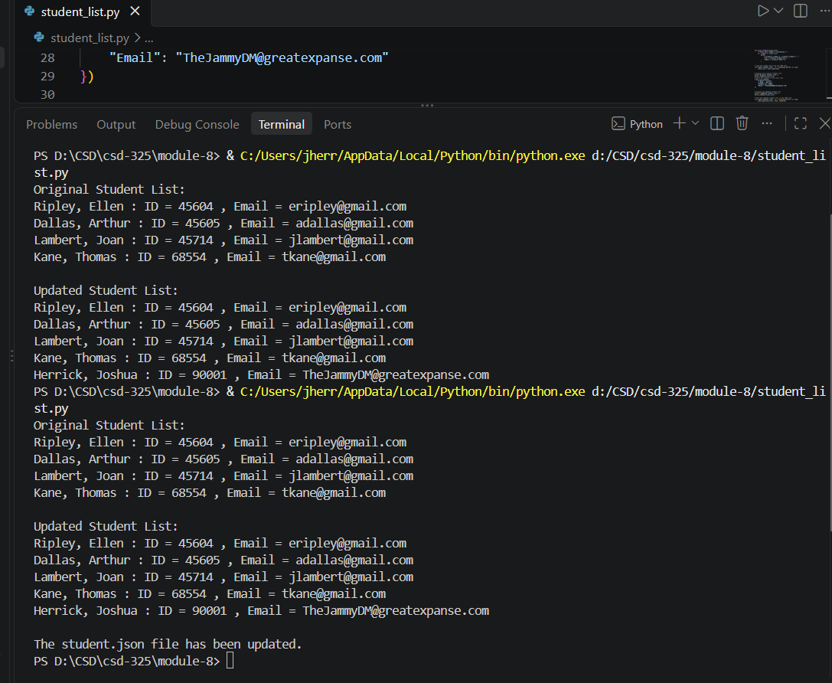

Caption: Figure 2: Updated student.json File Containing Five Student Records

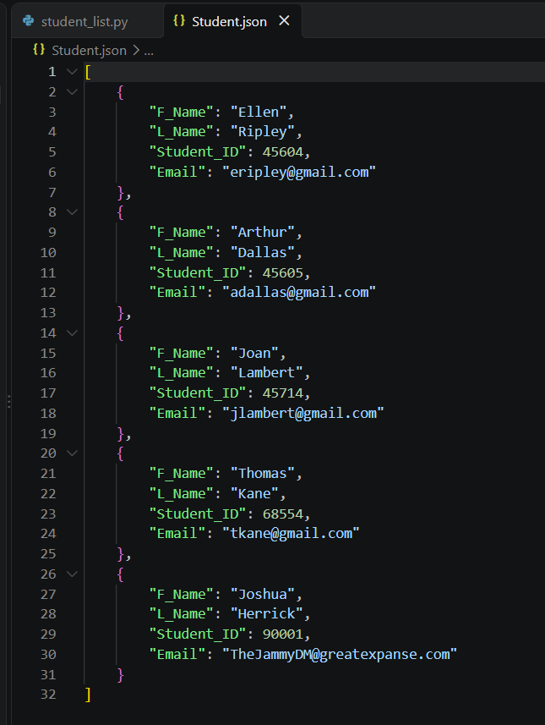

[
{
"F_Name": "Ellen",
"L_Name": "Ripley",
"Student_ID": 45604,
"Email": "eripley@gmail.com"
},
{
"F_Name": "Arthur",
"L_Name": "Dallas",
"Student_ID": 45605,
"Email": "adallas@gmail.com"
},
{
"F_Name": "Joan",
"L_Name": "Lambert",
"Student_ID": 45714,
"Email": "jlambert@gmail.com"
},
{
"F_Name": "Thomas",
"L_Name": "Kane",
"Student_ID": 68554,
"Email": "tkane@gmail.com"
},
{
"F_Name": "Joshua",
"L_Name": "Herrick",
"Student_ID": 90001,
"Email": "TheJammyDM@greatexpanse.com"
}
]

