Joshua Herrick
CSD325 Week 9
APIs

ScreenShot1: Testing the API code

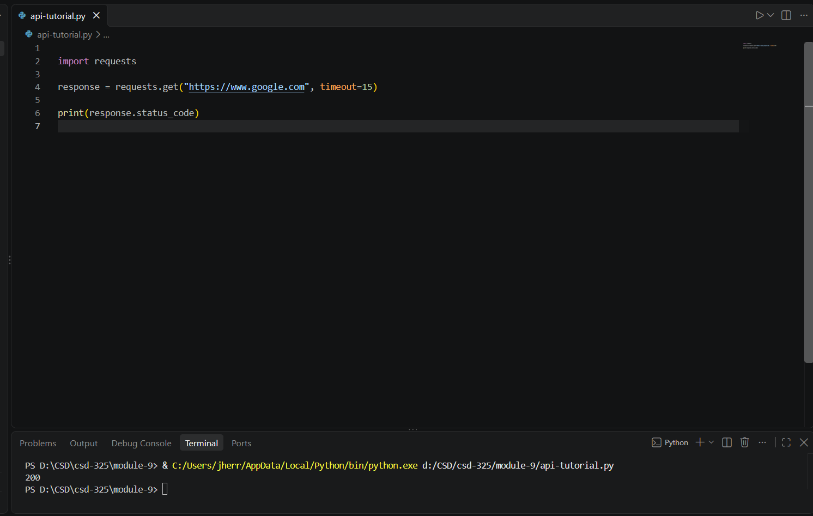

ScreenShot2: Retrieving Astronaut Data

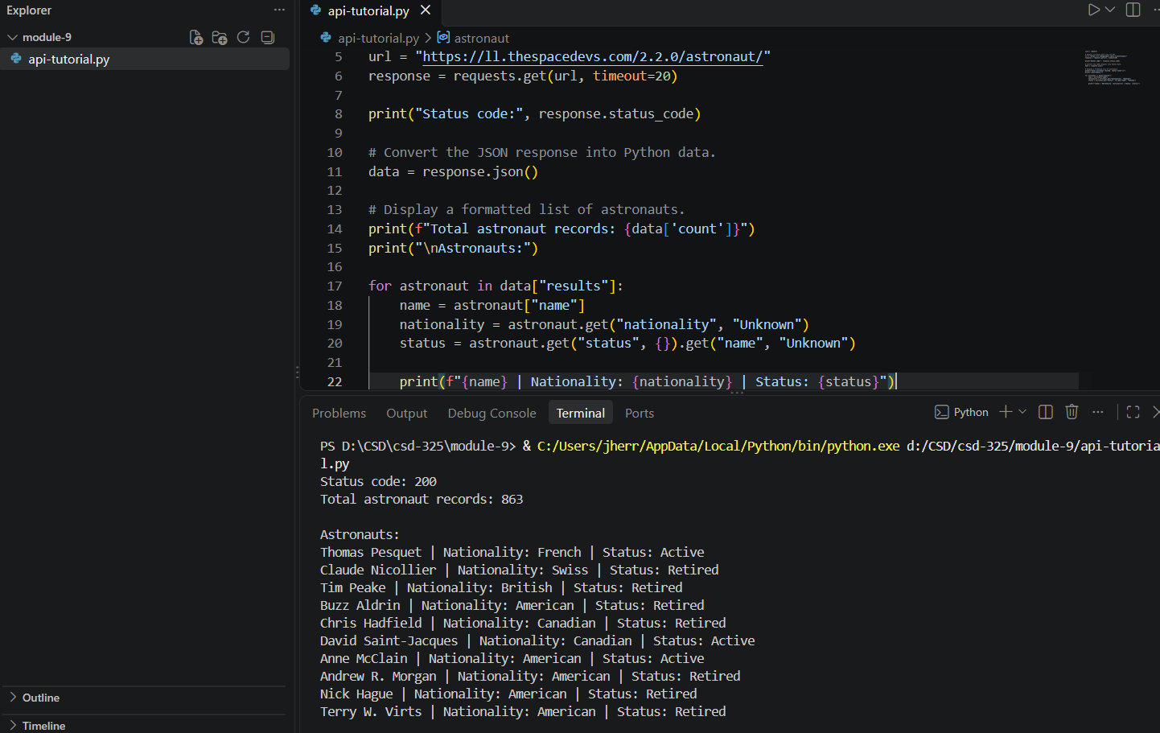

ScreenShot3: Retrieving data For D&D



