Joshua Herrick
CSD-325 Module 2.2
Debugging Screenshots

Debugging Step 1: Breakpoint

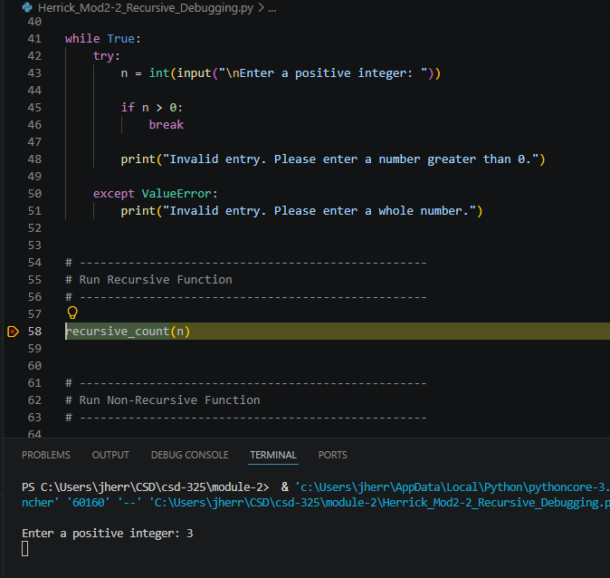

Debugging Step 2: Step Into Function
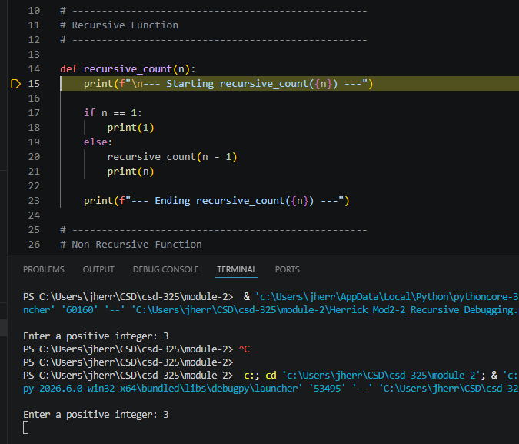

Debugging Step 3: Step Over
