SEVEN SEAS STRATEGIES | Healthcare Intelligence & Data Analytics | sevenseasstrategies.com

Full Stack Developer
Technical Assignment - Specimen Check-In Vertical Slice
ROLE Full Stack Developer | STACK .NET / Vue.js or Angular / Azure | STAGE Technical Assignment

1. Overview
Thank you for your interest in the Full Stack Developer role at Seven Seas Strategies. This assignment asks you to build a small but complete vertical slice of a real feature from one of our healthcare SaaS products. It is deliberately scoped so a strong engineer can complete the core in a focused sitting; depth and judgment matter more than volume.

Target effort: 6–8 focused hours. Please submit within 5 calendar days of receiving this brief. We do not want you to grind on this - if you hit the time budget, stop, ship what you have, and use the write-up to explain what you would do next.

What we are really evaluating: how you model data, how you keep tenant data isolated and patient data safe, how faithfully you translate a design into a working UI, and how clearly you reason about an Azure deployment. We care about a clean, correct, well-explained slice - not a feature-complete clone of the screen.

2. Product Context
IPI Pro is a cloud-hosted platform used by pathology labs to receive specimens. When a clinic ships specimens to the lab, it sends a manifest - an itemised list of the specimen bottles in the shipment. At the lab’s receiving desk, a technician loads the manifest and checks in each bottle: confirming what physically arrived against what the manifest says should have arrived.
Mismatches are routine and clinically important: a bottle on the manifest may be missing (“coming tomorrow”), or a bottle may arrive that is not on the manifest at all. Each mismatch becomes a tracked discrepancy that must be resolved before the manifest is closed. Every action is auditable, and every lab (tenant) must only ever see its own data.
The accompanying screenshot of the Check-In screen is your design reference. Treat it as the target: infer the layout, colours, spacing, and component styling from it, and fill in the interaction details yourself. We are deliberately not handing you the source markup - translating a finished design into clean front-end code is part of what we are assessing.

3. The Assignment
Build a working Specimen Check-In feature: a Vue.js front-end (matching the design reference) talking to an ASP.NET Core Web API backed by a relational database via Entity Framework Core. A lab technician should be able to open a manifest, see its expected specimens, mark bottles as received, flag missing or off-manifest bottles as discrepancies, and close the manifest once everything is reconciled.
The feature is multi-tenant. Every request operates in the context of a single lab, and no request may read or write another lab’s data. You may represent the current tenant/user however you like (a header, a token claim, a seeded session) - but tenant isolation must be enforced on the server, not just hidden in the UI. 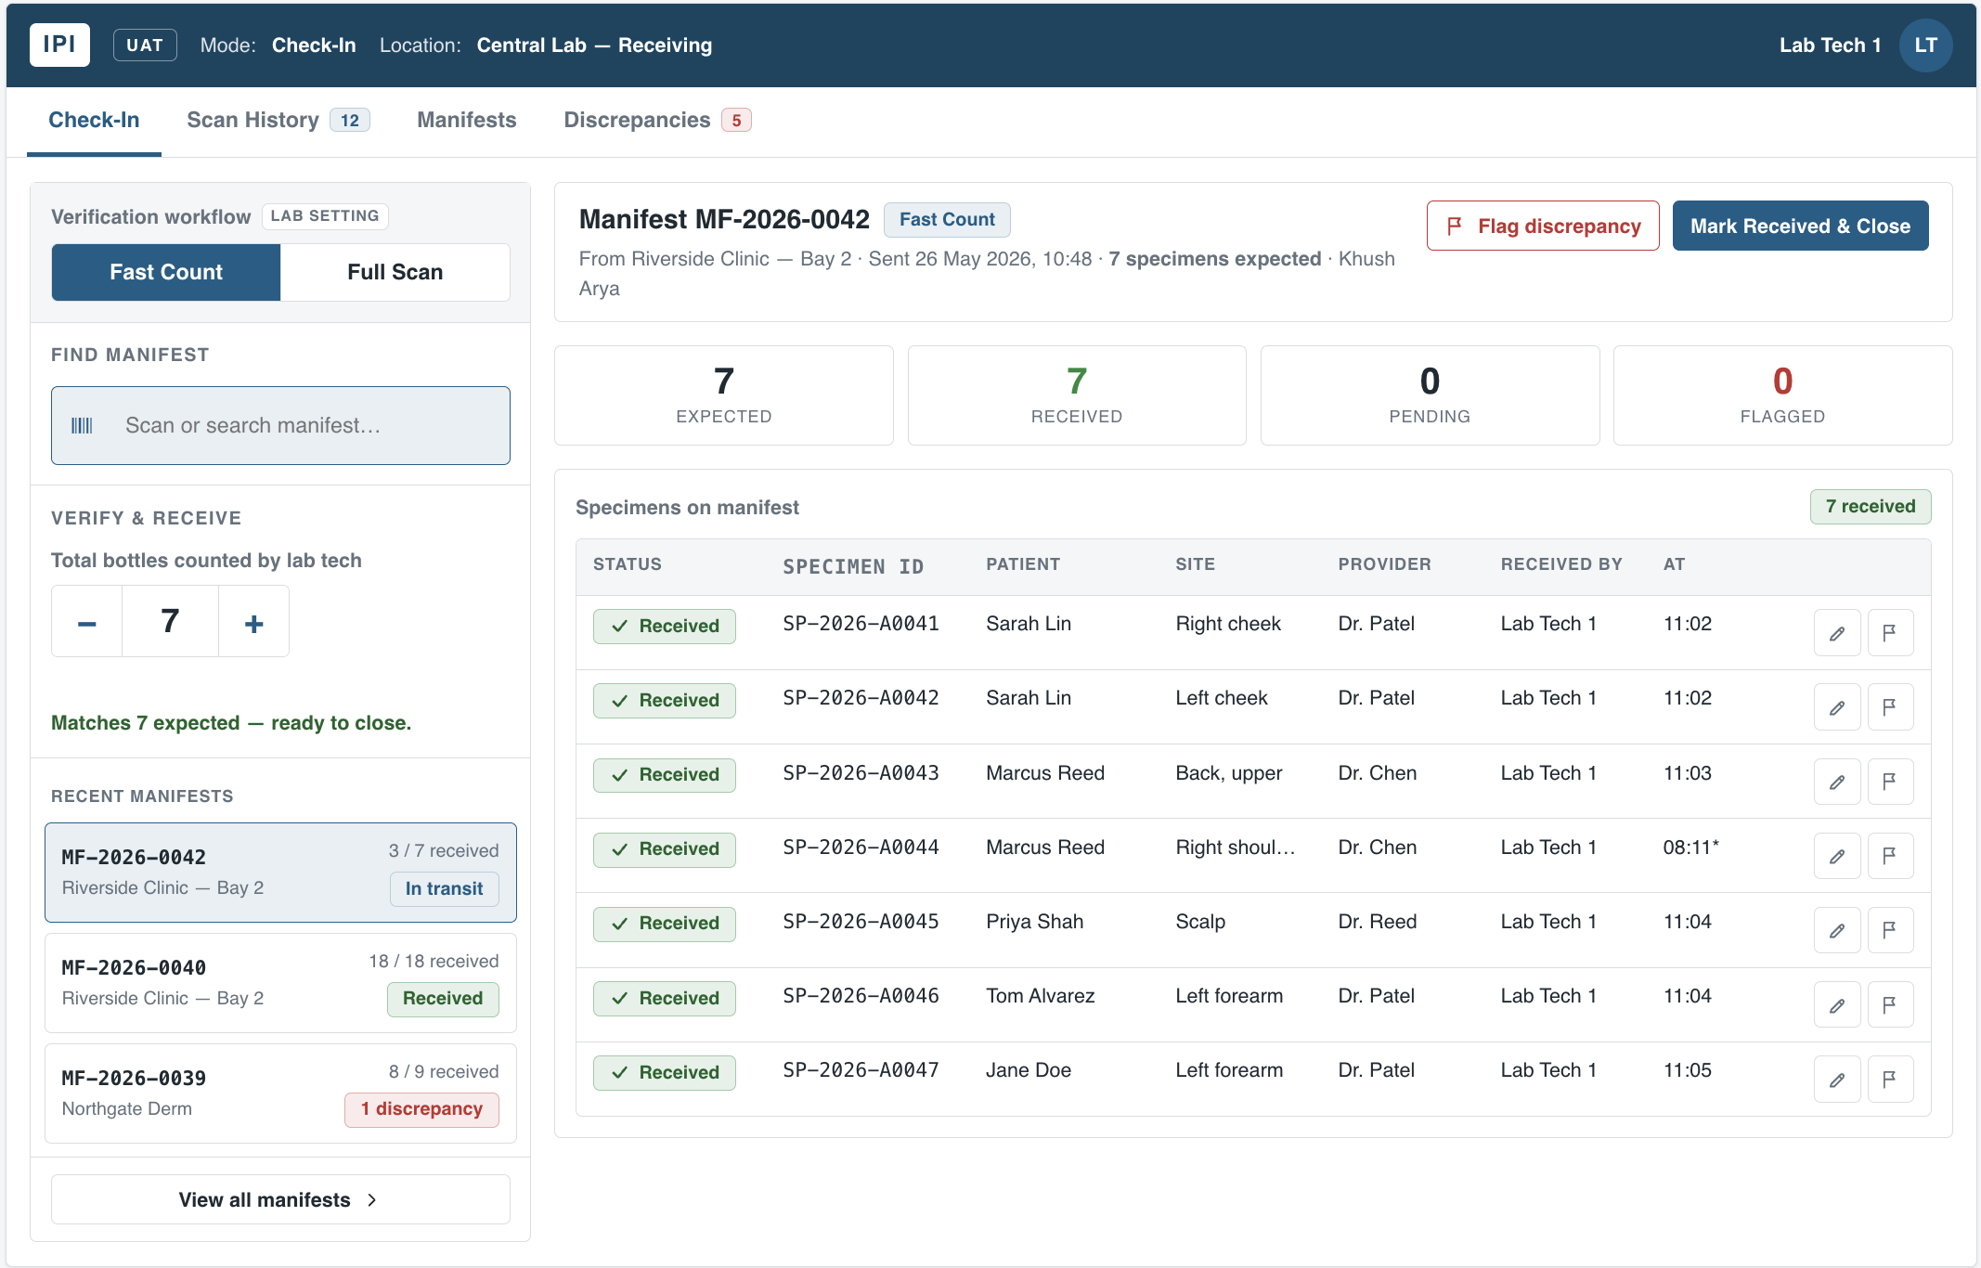

3.1 Core Requirements - Backend (required)
- ASP.NET Core Web API (.NET 6, 7, or 8). RESTful endpoints, returning JSON.
- Entity Framework Core with a code-first model and at least one migration committed to the repo. SQL Server / Azure SQL is preferred; SQLite is acceptable if it lets you ship faster (state your choice).
- Server-enforced tenant scoping on every read and write. A request scoped to Lab A must never return or mutate Lab B’s manifests, specimens, or discrepancies.
- Endpoints to: list manifests for the current lab; get a manifest with its specimens; mark a specimen received; flag a specimen as missing; record an off-manifest specimen and raise a discrepancy; close a manifest (only when reconciled).
- Idempotent / safe handling of a duplicate scan (receiving the same specimen twice should not corrupt counts) and a clear, structured error response for invalid actions.
- Seed data: at minimum two labs, a few manifests each, and enough specimens to demonstrate received / missing / off-manifest states.
- At least a handful of automated tests covering the core reconciliation logic and tenant isolation.

3.2 Core Requirements - Front-End (required)
- Vue.js (Vue 3 preferred; SFCs, Composition API encouraged). React/Angular are accepted per the JD, but Vue is what we use - choose accordingly.
- Reproduce the Check-In screen shown in the design reference: the manifest worklist on the left and the manifest detail on the right - the specimen table, status pills, running counts, and the verify/close actions. Match the visual language (colours, spacing, type, pill and button styles) as closely as you reasonably can by eye.
- Wire the UI to your API: selecting a manifest loads its specimens; receiving / flagging a specimen calls the backend and reflects the new state; counts and the “ready to close” status update live.
- Handle the empty state, a loading state, and at least one error path (e.g., a failed action) gracefully.
You do not need to build the other tabs visible in the reference (Scan History, Manifests, Discrepancies). The Check-In screen is the deliverable; the other tabs are context only.

3.3 Stretch Goals - pick what showcases you (optional)
Only after the core works end-to-end. Pick one or two that play to your strengths; we would rather see one stretch done well than four half-done. Note in your write-up which you attempted.
- Background processing: on manifest close, generate a reconciliation summary asynchronously (an Azure Functions worker triggered by a Storage Queue message, writing the artifact to Blob Storage). A local stand-in is fine if you describe the Azure mapping.
- Audit log: append every check-in action to an immutable event log (a Cosmos DB container, or a document-store abstraction) - the kind of trail that would power a Scan History view.
- Optimistic concurrency: handle two technicians receiving against the same manifest at once without lost updates.
- Front-end tests: component/unit tests (Jest/Vitest) and/or an end-to-end happy path (Cypress/Playwright).
- CI: an Azure DevOps or GitHub Actions pipeline that builds and runs the tests.

4. Suggested Data Model
A starting point, not a spec - adjust as you see fit, but be ready to justify your choices. Every tenant-owned row must carry (or be reachable from) a Lab/Tenant key.
Entity | Key fields | Notes
Lab (Tenant) | Id, Name | The isolation boundary
Clinic | Id, LabId, Name | Where a manifest originates
Manifest | Id, LabId, ClinicId, Code, Status, SentAt | Status: InTransit / Open / Closed / ClosedWithDiscrepancy
Specimen | Id, ManifestId, Code, Patient, Site, Provider, Status | Status: Pending / Received / Flagged / Added
CheckInEvent | Id, ManifestId, SpecimenId, Action, UserId, At | Audit trail of every scan/action
Discrepancy | Id, ManifestId, SpecimenId, Type, Note, Status | Type: Missing / OffManifest; Status: Open / Resolved

5. Suggested API Contract
Indicative only - name and shape endpoints as you prefer. Tenant context is assumed on every call.
Method + path | Purpose | Notes
GET /manifests | List manifests for the current lab | Filterable by status
GET /manifests/{id} | Manifest detail + specimens | 404 if not in this tenant
POST /manifests/{id}/specimens/{sid}/receive | Mark a specimen received | Idempotent on duplicate
POST /manifests/{id}/specimens/{sid}/flag | Flag a specimen as missing | Raises a discrepancy
POST /manifests/{id}/specimens | Add an off-manifest specimen | Raises a discrepancy
POST /manifests/{id}/close | Close the manifest | Reject unless reconciled / flagged

6. Architecture Write-Up (required, short)
In your README, answer these briefly - a few sentences each. We weight clear reasoning over essay length. This is where you show the Azure and security judgment the role needs, without having to build all of it.
- Azure topology: How would you deploy this - App Service, Azure SQL, Functions, Front Door/CDN, Blob, Queues? Sketch the request and background-job paths.
- Session & state: How would you manage user sessions across multiple App Service instances behind a load balancer?
- HIPAA-aware handling: What would you do to keep patient data safe in transit, at rest, and in logs in this multi-tenant system?
- Tenant isolation: Explain how your code guarantees one lab cannot reach another’s data, and how you would test that it holds as the codebase grows.
- If you had two more days: what would you build or harden next, and why?

7. Ground Rules & Constraints
- Backend must be ASP.NET Core (C#) with Entity Framework Core. Front-end should be Vue.js.
- Use Git from the first commit. We will read your history - small, meaningful commits tell us more than one big drop.
- AI tools are fine and expected; you own and must be able to explain every line you submit. We may ask you to walk through any part of it.
- Do not deploy to live Azure or spend money. A local-runnable repo plus the written architecture is exactly what we want.
- No real patient data - use only the synthetic seed data.

8. What We Are NOT Looking For
- A pixel-perfect clone of every screen. Match the Check-In screen; skip the rest.
- Authentication infrastructure (login pages, OAuth flows). A simple seeded/stubbed tenant+user context is fine - spend your time on isolation logic, not login UI.
- Heavy abstraction, premature microservices, or framework gymnastics. Boring, clear code wins.
- 100% test coverage. A few well-chosen tests on the logic that matters beat exhaustive trivial ones.

9. What to Submit
- A Git repository - a link (GitHub/GitLab/Azure Repos) or a zipped repo with the .git history intact.
- A README with: how to run the backend and front-end locally, the stack/DB choices you made, the architecture write-up (Section 6), and a short note on what you would do with more time.
- Anything we need to run it (connection strings via a .env.example, seed/migrate commands).

Send your submission to arajput@sevenseasstrategies.com with the subject line “Full Stack Assignment - <Your Name>”.

10. How We Score It
Indicative weighting. Strong judgment in a smaller surface beats sprawl.
Area | Weight | What earns marks
Backend correctness & data modeling | 20% | Sound EF Core model, working migrations, correct reconciliation logic
Multi-tenant isolation & data safety | 20% | Server-side isolation, no leaks, HIPAA-aware handling & logging
Front-end fidelity & UX | 20% | Matches the design reference, wired to the API, sensible states
Code quality, structure & tests | 15% | Readable, organised, meaningful tests, clean Git history
Architecture write-up (Azure) | 15% | Realistic Azure topology, session/state, isolation reasoning
Stretch & polish | 5% | A stretch goal done well; thoughtful README
Functional Understanding | 5% | Understanding developed through assignment & research

Questions about the assignment are welcome - email arajput@sevenseasstrategies.com. Good luck, and have fun with it.

