Apptainer / Singularity Definition File Guide
Rocky Linux 8.10 build host pattern with Windows file staging, DNF/YUM installs, Slurm client pieces, and Python wheel builds
Prepared for James Amos

Scope
This guide shows what to write in a practical Apptainer/Singularity definition file and what to run on the Linux build host around it. It assumes Rocky Linux 8.10 as the base container OS and a Linux server that stages build files from a Windows SMB share.

1. Design decisions to use
- Use a Rocky Linux 8.10 OCI base image, pinned to a version tag rather than latest.
- Mount the Windows share on the Linux build host and stage files locally before running apptainer build.
- Use %files to copy staged files into the image before %post runs.
- Use dnf in %post. yum normally maps to DNF on Enterprise Linux 8 family systems, but dnf is clearer and should be preferred in new recipes.
- Install Slurm client/development components only when needed. Do not try to run slurmctld or slurmd as persistent services inside the SIF image.
- Build a local /opt/wheelhouse during %post, then install Python packages from that wheelhouse. This creates a reproducible artifact trail inside the image.
- Use %test to fail the build early when Python, pip, compilers, or required packages are broken.
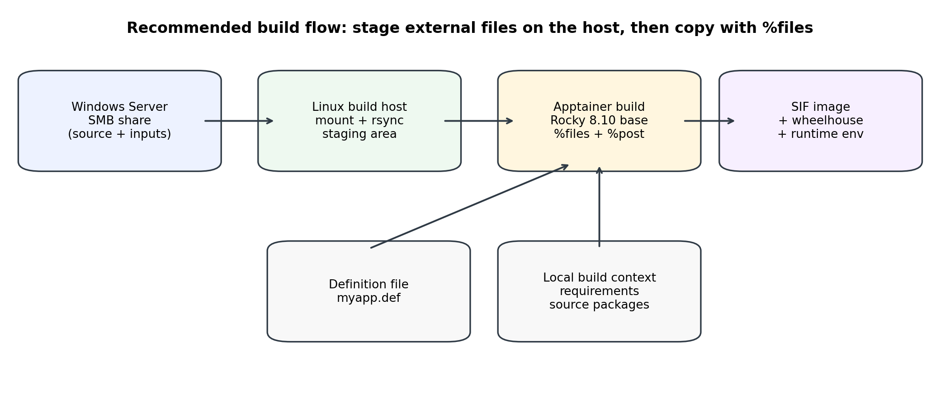
Figure 1. Recommended host-to-container build flow.

2. Host-side preparation: pull files from Windows safely
Do not put SMB credentials, mount commands, or Windows UNC paths directly in the definition file. The definition file should be portable and deterministic. The Linux build host should mount the Windows share, stage only the files required for the build, and then the definition file should copy those staged files with %files.
Host-side Windows share staging script
# Host-side setup. Do this on the Linux build server, not inside %post.
sudo dnf install -y cifs-utils rsync apptainer

sudo install -d -m 0750 /mnt/win_build_drop
sudo install -d -m 0750 /srv/container-builds/myapp/context

# Use a root-owned credential file. Do not put passwords in the .def file.
sudo tee /root/.smb-build.cred >/dev/null <<'EOF'
username=build_user
password=REPLACE_ME
# domain=MYDOMAIN # Optional, if required by AD/Windows.
EOF
sudo chmod 600 /root/.smb-build.cred

# Mount the Windows share on the build host.
sudo mount -t cifs //WIN-SERVER/BuildDrop /mnt/win_build_drop \
-o credentials=/root/.smb-build.cred,vers=3.0,iocharset=utf8,\
uid=$(id -u),gid=$(id -g),file_mode=0640,dir_mode=0750

# Stage only the build context you want copied into the image.
rsync -a --delete /mnt/win_build_drop/myapp/ \
/srv/container-builds/myapp/context/

3. Recommended build context layout
Keep the definition file next to a staged context directory. The definition file can use absolute paths for clarity, or relative paths if every build is launched from the same working directory.
Build-context layout
context/
requirements.txt
constraints.txt
src/
my_package/
pyproject.toml
README.md
src/
my_package/
__init__.py
cli.py
another_package/
pyproject.toml
src/
another_package/
__init__.py

4. Definition file anatomy
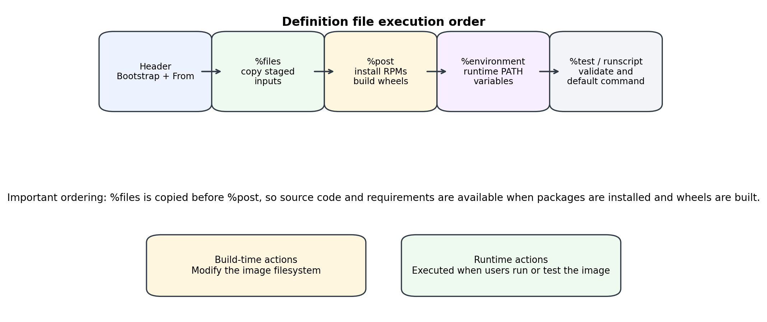
Figure 2. Apptainer definition file execution order.
Section | Purpose | What to put there
Header | Select the base OS / bootstrap source. | Bootstrap: docker and From: rockylinux/rockylinux:8.10.
%files | Copy files from the Linux build host into the container before %post. | requirements, constraints, source packages, config templates, license files.
%post | Install RPMs, create directories, compile software, build wheels, and write runtime env hooks. | dnf installs, gcc toolset setup, Slurm client/devel install, pip wheel / pip install.
%environment | Runtime environment variables. | PATH, LD_LIBRARY_PATH, LANG, PYTHONNOUSERSITE, app-specific paths.
%test | Build-time and post-build validation. | python --version, pip check, command -v gcc, import checks.
%runscript | Default behavior for apptainer run image.sif. | Start Python, a CLI entry point, or pass through command arguments.

5. Full Rocky 8.10 definition-file template
Use this as a starting point. Replace /srv/container-builds/myapp/context with your actual staged build context and update package lists to match your cluster and Python package requirements.
myapp-rocky810.def
Bootstrap: docker
From: rockylinux/rockylinux:8.10

%labels
Maintainer James Amos
Description Rocky 8.10 Apptainer image with Python, GCC toolset, Slurm client pieces, and local wheels
BaseOS Rocky Linux 8.10

%help
This image is built from Rocky Linux 8.10. It installs a compiler stack,
Python 3.9, optional Slurm client/development packages, and Python wheels
built from staged source directories under /opt/build/src.

%files
/srv/container-builds/myapp/context/requirements.txt /opt/build/requirements.txt
/srv/container-builds/myapp/context/constraints.txt /opt/build/constraints.txt
/srv/container-builds/myapp/context/src /opt/build/src
/srv/container-builds/myapp/context/README.md /opt/build/README.md

%post -c /bin/bash
set -euo pipefail

export DNF_YUM_AUTO_YES=1
export PIP_DISABLE_PIP_VERSION_CHECK=1
export PIP_NO_CACHE_DIR=1

echo "== Rocky release =="
cat /etc/rocky-release || cat /etc/os-release

echo "== Base OS update and repository setup =="
dnf -y update
dnf -y install dnf-plugins-core epel-release ca-certificates
dnf -y config-manager --set-enabled powertools || true

echo "== System build dependencies =="
dnf -y groupinstall "Development Tools"
dnf -y install \
bash coreutils findutils which file git curl wget rsync \
tar gzip bzip2 xz unzip patch make cmake ninja-build \
gcc gcc-c++ gcc-gfortran redhat-rpm-config rpm-build \
openssl-devel bzip2-devel libffi-devel zlib-devel xz-devel \
readline-devel sqlite-devel ncurses-devel tk-devel \
glibc-langpack-en python39 python39-devel python39-pip \
python39-setuptools python39-wheel python39-numpy

echo "== Optional newer compiler toolset for compiled Python extensions =="
dnf -y install gcc-toolset-12 gcc-toolset-12-gcc-c++ \
gcc-toolset-12-gcc-gfortran || true

if [ -f /opt/rh/gcc-toolset-12/enable ]; then
# Needed during wheel compilation in this build stage.
source /opt/rh/gcc-toolset-12/enable
fi

echo "== Optional Slurm client/development packages =="
# Prefer the same Slurm major/minor version as the host cluster.
# If these packages are unavailable in your approved repos, install from
# your site RPM repo or omit them and bind host Slurm commands at runtime.
dnf -y install slurm slurm-devel munge-libs || true

PY=/usr/bin/python3.9
${PY} -m pip install --upgrade pip setuptools wheel build

echo "== Build a wheelhouse from requirements and local source packages =="
mkdir -p /opt/wheelhouse

# Build wheels for third-party requirements. Remove --no-binary=:all: if
# you prefer prebuilt wheels from PyPI or an internal package index.
if [ -s /opt/build/requirements.txt ]; then
${PY} -m pip wheel \
--wheel-dir /opt/wheelhouse \
--constraint /opt/build/constraints.txt \
--requirement /opt/build/requirements.txt
fi

# Build wheels for every staged source directory containing pyproject.toml.
if [ -d /opt/build/src ]; then
while IFS= read -r -d '' pkgdir; do
echo "Building wheel for ${pkgdir}"
${PY} -m pip wheel --no-deps --wheel-dir /opt/wheelhouse "${pkgdir}"
done < <(find /opt/build/src -mindepth 1 -maxdepth 2 \
-type f -name pyproject.toml -printf '%h\0')
fi

echo "== Install from the local wheelhouse only =="
if [ -s /opt/build/requirements.txt ]; then
${PY} -m pip install \
--no-index --find-links=/opt/wheelhouse \
--requirement /opt/build/requirements.txt
fi

find /opt/wheelhouse -maxdepth 1 -name '*.whl' -print0 | \
xargs -0 -r ${PY} -m pip install \
--no-index --find-links=/opt/wheelhouse

echo "== Runtime environment hooks =="
cat >> "$APPTAINER_ENVIRONMENT" <<'EOF'
export LANG=en_US.UTF-8
export LC_ALL=en_US.UTF-8
export PYTHONNOUSERSITE=1
export PIP_NO_CACHE_DIR=1
export PATH=/opt/rh/gcc-toolset-12/root/usr/bin:$PATH
export LD_LIBRARY_PATH=/opt/rh/gcc-toolset-12/root/usr/lib64:${LD_LIBRARY_PATH:-}
EOF

echo "== Cleanup package caches, but keep /opt/wheelhouse for auditability =="
dnf clean all
rm -rf /var/cache/dnf /root/.cache/pip /tmp/* /var/tmp/*

%environment
export LANG=en_US.UTF-8
export LC_ALL=en_US.UTF-8
export PYTHONNOUSERSITE=1
export PIP_NO_CACHE_DIR=1
export PATH=/opt/rh/gcc-toolset-12/root/usr/bin:$PATH
export LD_LIBRARY_PATH=/opt/rh/gcc-toolset-12/root/usr/lib64:${LD_LIBRARY_PATH:-}

%test
/usr/bin/python3.9 --version
/usr/bin/python3.9 -m pip --version
/usr/bin/python3.9 -m pip check
test -d /opt/wheelhouse
command -v gcc
command -v g++
command -v sbatch || true

%runscript
if [ "$#" -eq 0 ]; then
exec /usr/bin/python3.9
else
exec "$@"
fi

6. Python package source and wheel workflow
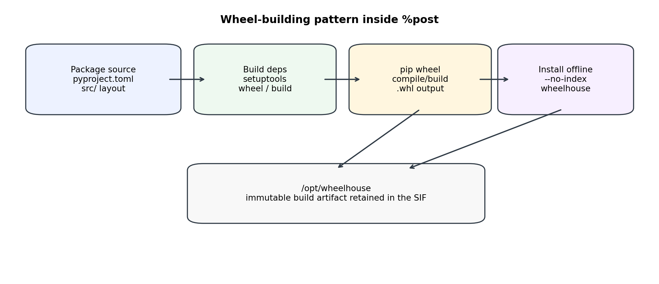
Figure 3. Wheel-building pattern inside %post.
Each local package should have a pyproject.toml. The example below uses setuptools as the build backend and src/ package layout.
Minimal pyproject.toml for a local source package
[build-system]
requires = ["setuptools>=69", "wheel"]
build-backend = "setuptools.build_meta"

[project]
name = "my_package"
version = "0.1.0"
description = "Example package built into a wheel inside the Apptainer image"
readme = "README.md"
requires-python = ">=3.9"
authors = [{name = "Your Team"}]
dependencies = [
"numpy>=1.24",
]

[project.scripts]
my-package-cli = "my_package.cli:main"

[tool.setuptools.packages.find]
where = ["src"]

6.1 Offline or locked-down wheel builds
If the Linux build server cannot reach PyPI or external Git repositories, stage a directory of approved bootstrap wheels from Windows or an internal artifact repository and then force pip to use --no-index --find-links.
Offline wheelhouse pattern
# More controlled build pattern when the build server cannot reach PyPI.
# Stage pre-approved wheels in context/bootstrap_wheels first, then copy them
# with %files into /opt/build/bootstrap_wheels.

PY=/usr/bin/python3.9
${PY} -m pip install \
--no-index \
--find-links=/opt/build/bootstrap_wheels \
--upgrade pip setuptools wheel build

${PY} -m pip wheel \
--no-index \
--find-links=/opt/build/bootstrap_wheels \
--wheel-dir /opt/wheelhouse \
--requirement /opt/build/requirements.txt

7. DNF/YUM, GCC toolset, and Rocky 8.10 notes
- Use dnf -y install for normal package installation. On Rocky/RHEL 8 family systems, yum is generally compatibility-facing DNF behavior, but dnf is the clearer command to document.
- Install dnf-plugins-core if you need config-manager inside the image.
- On Rocky 8, PowerTools is the Rocky 8 repository name that corresponds broadly to the CRB concept used in later releases. Enabling it often resolves development-library dependencies.
- For C/C++/Fortran Python extensions, start with groupinstall "Development Tools" plus python39-devel and the relevant -devel system libraries.
- gcc-toolset packages install under /opt/rh/gcc-toolset-*/root/usr/bin and do not automatically replace /usr/bin/gcc. Source /opt/rh/gcc-toolset-12/enable during %post if you need that compiler for wheel builds.
- Clean DNF and pip caches at the end of %post to keep the SIF smaller. Keep /opt/wheelhouse when auditability is more valuable than image size.

8. Slurm installation and runtime strategy
Preferred Slurm model
Treat Slurm as a host/cluster service. The container should usually contain your application runtime, not the Slurm controller or compute-node daemon stack. Install Slurm client commands and slurm-devel only when your application needs sbatch/srun inside the container or links against libslurm.

- Match the Slurm version to the host cluster whenever possible. Client/server version mismatches can create confusing failures.
- If the site provides Slurm through modules, a bind-mounted host path, or a shared filesystem, use that rather than installing a different Slurm in the image.
- If the code compiles against Slurm APIs, install slurm-devel during %post from the same repo family the cluster uses.
- If you are building a demo single-node Slurm system, do that on hosts or VMs. Persistent services, systemd, cgroups, munge keys, and slurm.conf management do not belong in a normal immutable application SIF.
Typical host Slurm submission using an Apptainer image
# Submit from the host, execute inside the SIF on compute nodes.
sbatch run_myapp.sbatch

# run_myapp.sbatch
#!/bin/bash
#SBATCH --job-name=myapp
#SBATCH --nodes=1
#SBATCH --ntasks=1
#SBATCH --cpus-per-task=4
#SBATCH --time=01:00:00
#SBATCH --output=logs/%x-%j.out

module load apptainer 2>/dev/null || true

apptainer exec \
--bind /scratch:/scratch \
--bind /shared:/shared \
/shared/containers/myapp-rocky810.sif \
python3.9 -m my_package.cli --input /shared/data/input.csv

9. Build, test, and create image artifacts
The commands below create both a production SIF image and an optional sandbox image for debugging. Build the sandbox while iterating; ship the SIF.
Build and validation commands
cd /srv/container-builds/myapp

# Normal SIF build. Use sudo only if your site does not allow fakeroot builds.
apptainer build --fakeroot myapp-rocky810.sif myapp-rocky810.def

# Debug build: writable sandbox for inspection while developing the recipe.
apptainer build --fakeroot --sandbox myapp-rocky810-sandbox myapp-rocky810.def

# Run and validate.
apptainer test myapp-rocky810.sif
apptainer exec myapp-rocky810.sif python3.9 -m pip check
apptainer exec myapp-rocky810.sif python3.9 -c "import sys; print(sys.version)"

10. Troubleshooting matrix
Symptom | Likely fix
dnf cannot find gcc-toolset-* | Ensure AppStream is enabled. On Rocky 8, PowerTools can also be required for some development dependencies. Use dnf repolist and dnf search gcc-toolset.
slurm RPMs do not resolve | Use the same Slurm packaging source as the cluster. If the container only submits jobs from the host, omit Slurm daemons and use host Slurm commands. If the code links libslurm, install slurm-devel matching the host version.
pip tries to download during offline build | Pre-stage build dependencies and wheels, then use --no-index --find-links. Build isolation may require build-system dependencies from pyproject.toml.
compiled Python packages fail | Confirm gcc/g++/gfortran, Python headers, BLAS/LAPACK, OpenSSL, libffi, and the relevant -devel RPMs are installed. Source gcc-toolset before building wheels.
Windows share paths fail in %files | %files paths are evaluated on the Linux build host. Mount and rsync the SMB share first, then point %files at the staged Linux path.
image builds but runtime misses environment | Put runtime exports in %environment or append to $APPTAINER_ENVIRONMENT during %post. Build-time shell variables do not automatically persist at runtime.

11. Security and reproducibility checklist
- Never put Windows passwords, tokens, SSH keys, or repository credentials in the definition file.
- Pin the base image tag or digest. Avoid latest.
- Use a constraints.txt file for Python dependencies. Freeze only after testing on the target architecture.
- Retain /opt/wheelhouse or export it to an artifact store for provenance.
- Prefer internal mirrors for RPMs and Python wheels in regulated or air-gapped environments.
- Use apptainer test in CI or after every build.
- Avoid running long-lived services inside the container unless your site has explicitly designed for Apptainer instances.
- Document the host build command, Apptainer version, base image tag/digest, and source artifact checksum.

12. Quick reference: what goes where
Need | Location / method
Pull files from Windows | Host shell script: mount.cifs + rsync into /srv/container-builds/.../context
Copy staged files into image | %files
Install OS packages | %post with dnf -y install / groupinstall
Install GCC Toolset | %post, then source /opt/rh/gcc-toolset-12/enable before compiling
Install Slurm client/devel | %post if required; otherwise use host Slurm at runtime
Build Python wheels from source | %post with python3.9 -m pip wheel ...
Install Python packages from wheels | %post with pip install --no-index --find-links=/opt/wheelhouse
Set runtime environment | %environment and/or $APPTAINER_ENVIRONMENT
Create the image | apptainer build --fakeroot myapp-rocky810.sif myapp-rocky810.def

13. References consulted
- Apptainer User Guide: Definition Files — https://apptainer.org/docs/user/main/definition_files.html
- Apptainer User Guide: Build a Container — https://apptainer.org/docs/user/main/build_a_container.html
- Apptainer User Guide: Fakeroot feature — https://apptainer.org/docs/user/main/fakeroot.html
- Rocky Linux Documentation: DNF package manager — https://docs.rockylinux.org/10/guides/package_management/dnf_package_manager/
- Rocky Linux Wiki: Repositories — https://wiki.rockylinux.org/rocky/repo/
- Rocky Linux Documentation: Deploying Slurm on Rocky Linux — https://docs.rockylinux.org/10/guides/hpc/slurm-rocky/
- SchedMD Slurm Quick Start Administrator Guide — https://slurm.schedmd.com/quickstart_admin.html
- Python Packaging User Guide: Writing pyproject.toml — https://packaging.python.org/en/latest/guides/writing-pyproject-toml/
- pip documentation: pip wheel — https://pip.pypa.io/en/stable/cli/pip_wheel/
- Docker Hub: rockylinux/rockylinux tags — https://hub.docker.com/r/rockylinux/rockylinux/tags

