VENDOR SELF SERVICE PORTAL

Module installation : Add the module vendor_self_service_portal in your repository,restart the service and Update the App list by navigating in to Apps menu in your database.Then you can search for the module and can be installed from there itself.

Configurations : Once the module get installed,give the appropriate Vendor Forecast access rights for the users in thieir corresponding user profiles.

Nb: Its important to configure any of the Vendor Forecast group for the Users to access Vendor Forecasting and Order Adjustment menus.

About the module :

Vendor Self-Service Portal
Manages Vendor Forecast and Order Adjustment Request

Key Features


Vendor security groups
Products Forecasting based on permissions
Sale order adjustment requests and Submission with mail

Work Flow Screenshots01

1)Vendor Forecast
Configure vendor groups.
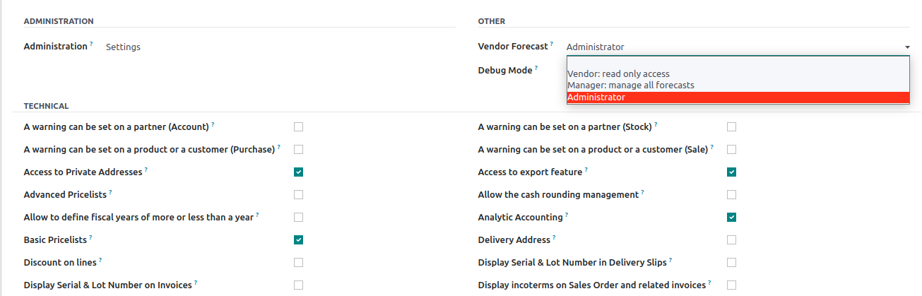
Admin and Manager can create forecast records.
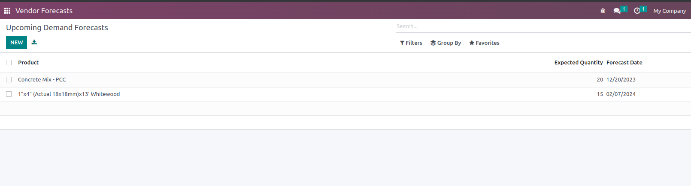
Vendors can only read records in coming quarter.
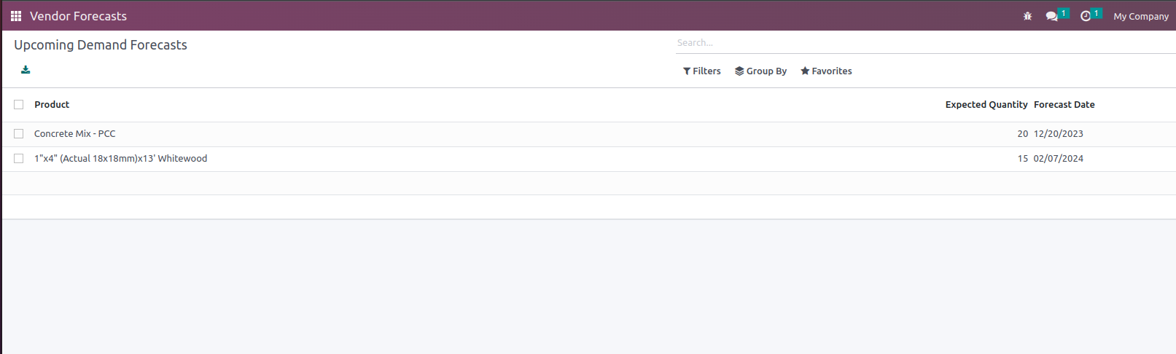

2) Order Adjustment Request
Create Order Adjustment Request.
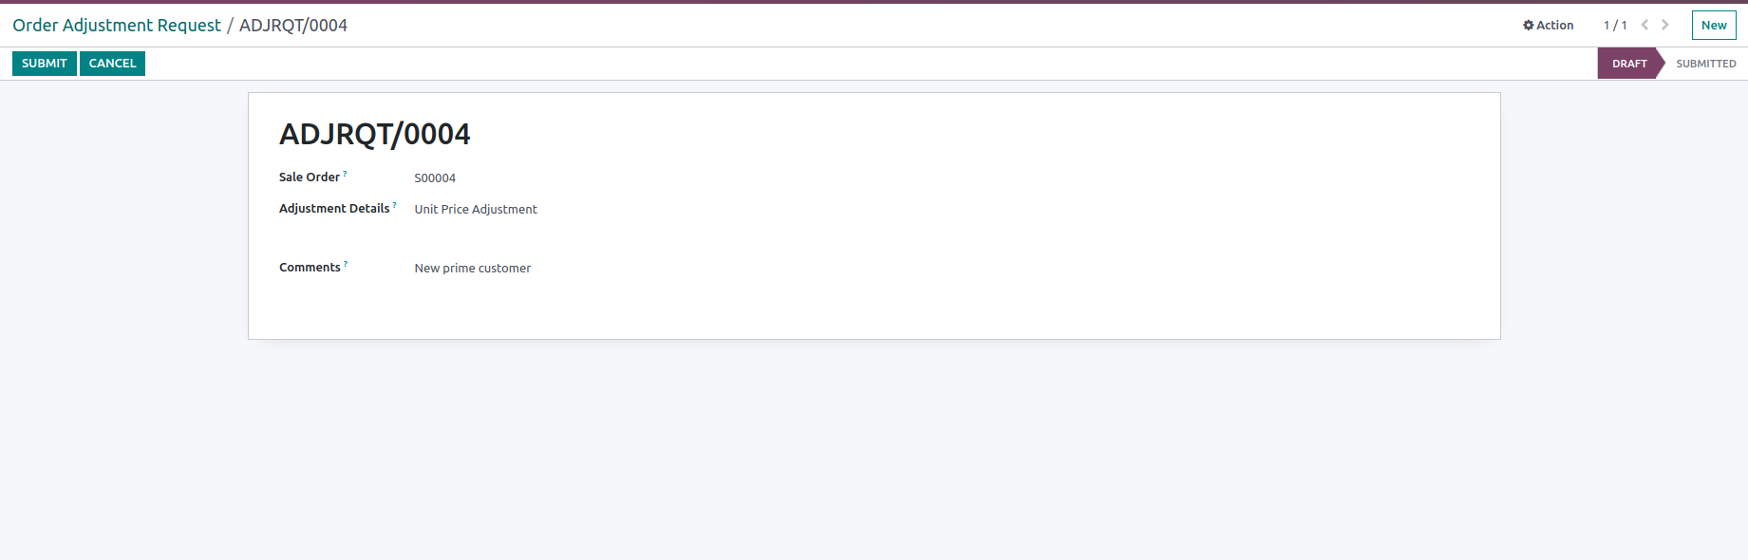
Submit the request and Confirm mail with added recepients in the procurement team.
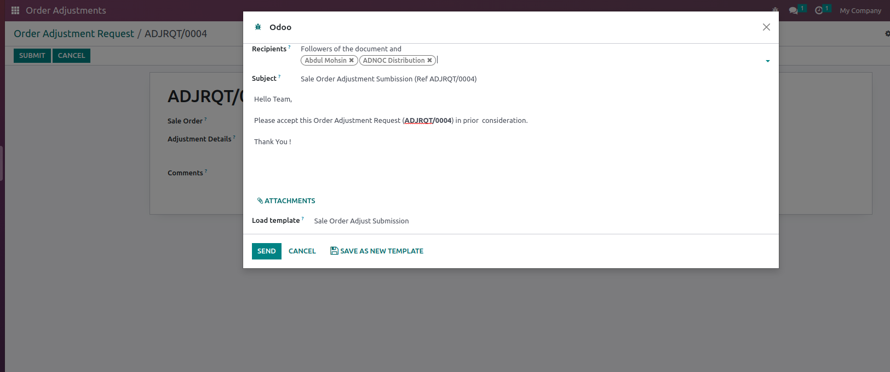
Mail Notification
