Early Diabetes Prediction Using Machine Learning:
A Medical Decision Support System
Jamshaid Amjad | AI in Healthcare — Capstone Project | May 2026

Abstract
Diabetes mellitus is a chronic metabolic disorder affecting over 500 million people globally. Early identification of at-risk individuals is critical for timely intervention and improved outcomes. This project develops and evaluates a machine learning pipeline for binary diabetes classification using the Pima Indians Diabetes Dataset. Three complementary models — Logistic Regression, Random Forest, and a Multilayer Perceptron (MLP) — are trained on clinically relevant features and compared on a held-out test set. The MLP achieves the highest ROC-AUC of 0.875, while Logistic Regression attains the best F1 score of 0.683. Results suggest that ensemble and neural models generalise well, with Glucose and BMI consistently identified as the most discriminative features.
1. Introduction
Diabetes affects approximately 537 million adults worldwide and is projected to rise to 783 million by 2045 (IDF, 2021). Type 2 diabetes, which accounts for over 90% of cases, progresses silently and is frequently diagnosed late — after irreversible organ damage has occurred. Automated screening tools that can flag high-risk individuals from routine clinical measurements offer a cost-effective complement to clinical judgement.
This project addresses the task of binary classification: predicting whether a patient is diabetic based on eight tabular clinical features. The clinical context is primary-care screening, where a model capable of high sensitivity can prioritise patients for confirmatory testing. Three model families are compared to balance interpretability (Logistic Regression), predictive power (Random Forest), and representation learning (MLP).
2. Methods
2.1 Dataset & Preprocessing
The Pima Indians Diabetes Dataset (NIDDK, n=768) contains eight clinical features: number of pregnancies, plasma glucose concentration, diastolic blood pressure, triceps skin-fold thickness, serum insulin, BMI, diabetes pedigree function, and age. The outcome is binary (1 = diabetic, 0 = non-diabetic). The dataset is imbalanced (65% negative, 35% positive).
The preprocessing pipeline applies the following steps, all transformers fitted exclusively on training data to prevent leakage: (1) biologically impossible zeros in Glucose, BMI, Insulin, BloodPressure, and SkinThickness are replaced with NaN; (2) a stratified 70/15/15 train-validation-test split is applied; (3) missing values are imputed with the training-set median; (4) features are standardised with StandardScaler; (5) the top-5 features are selected by averaging ANOVA F-test and Random Forest importance ranks (selected: Glucose, BMI, Insulin, Age, Pregnancies); (6) SMOTE oversampling is applied to the training set only to address class imbalance.
2.2 Models
Three models are trained and compared. Logistic Regression (LR) serves as an interpretable linear baseline (L-BFGS solver, max_iter=1000). Random Forest (RF) is an ensemble of 300 decision trees; hyperparameters (n_estimators, max_depth, min_samples_split, min_samples_leaf) are optimised via 5-fold GridSearchCV, yielding max_depth=10, n_estimators=100. The MLP comprises two hidden layers (Dense-16 → ReLU → Dropout-0.2 → Dense-8 → ReLU → Dense-1 → Sigmoid), trained with Adam (lr=1e-3), BCEWithLogitsLoss, a ReduceLROnPlateau scheduler, and early stopping (patience=10).
2.3 Evaluation
Models are evaluated on the held-out test set (n=116) using accuracy, precision, recall, F1 score, and ROC-AUC. Five-fold cross-validation on the combined train+validation set is additionally reported for LR and RF to assess stability. Confusion matrices, ROC curves, and a feature importance plot are generated for interpretability.
3. Results
Table 1 summarises test-set performance across all three models. The MLP achieves the highest ROC-AUC (0.875), indicating strong probabilistic discrimination. Logistic Regression attains the best F1 score (0.683) and accuracy (0.776). All three models substantially outperform a majority-class baseline (ROC-AUC = 0.500).
Model | Accuracy | Precision | Recall | F1 Score | ROC-AUC
Logistic Regression | 0.776 | 0.683 | 0.683 | 0.683 | 0.866
Random Forest | 0.767 | 0.694 | 0.610 | 0.649 | 0.841
MLP | 0.767 | 0.675 | 0.659 | 0.667 | 0.875
Majority Baseline | 0.647 | — | 0.000 | 0.000 | 0.500
Table 1. Test-set performance metrics for all three models (n=116).
Cross-validation F1 (5-fold) on the combined train+validation set yielded 0.718 ± 0.029 for Logistic Regression and 0.801 ± 0.042 for Random Forest, confirming that RF generalises robustly across folds. Feature importance analysis (Figure 1) consistently identifies Glucose as the strongest predictor, followed by BMI and Age, consistent with the clinical literature.
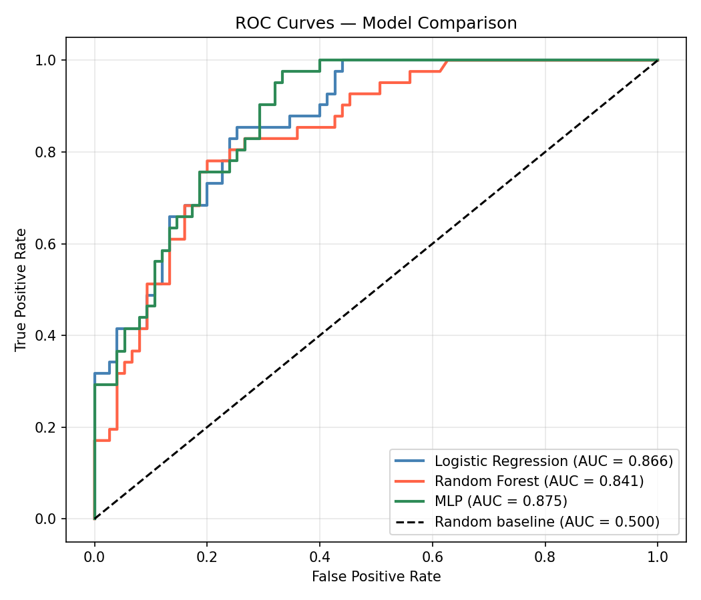 | 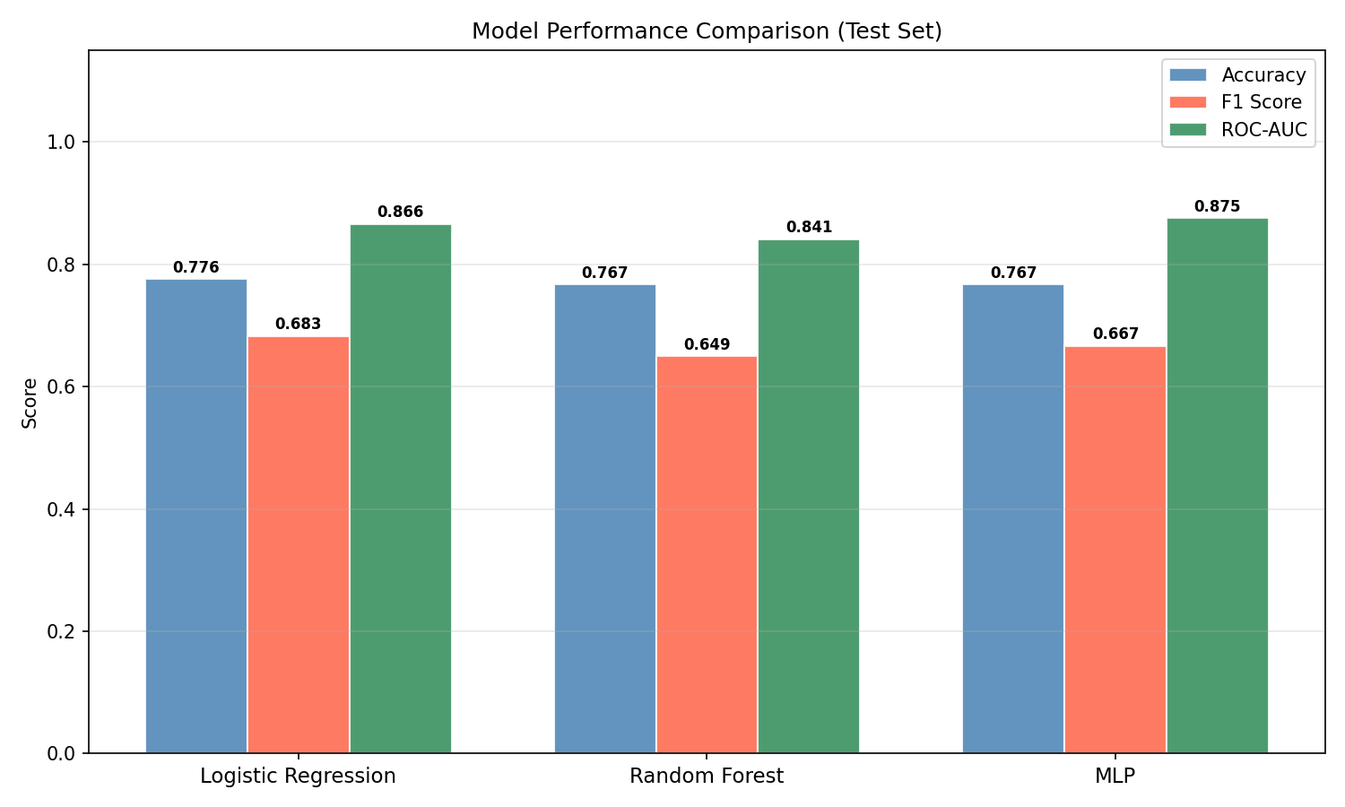
Figure 1. Left: ROC curves for all three models on the held-out test set. Right: Grouped bar chart comparing Accuracy, F1, and ROC-AUC.
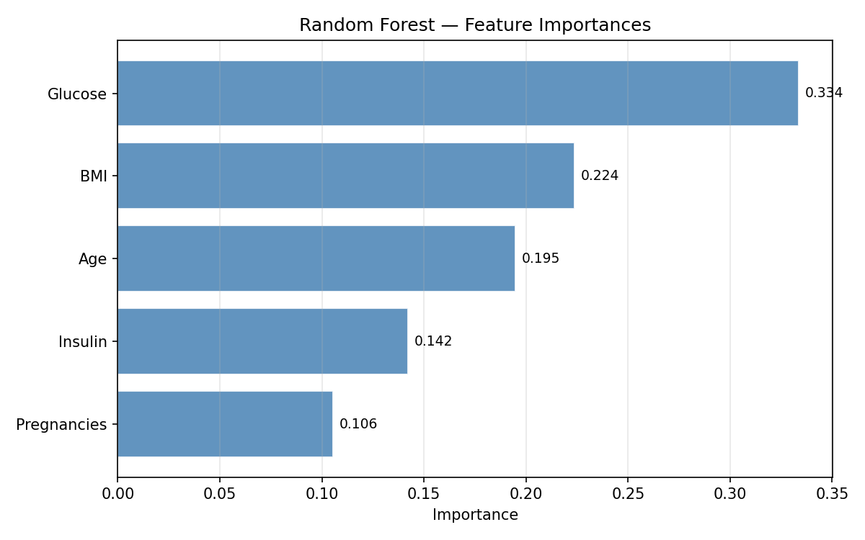
Figure 2. Random Forest feature importances for the five selected features.
4. Discussion & Conclusion
All three models achieve test accuracy above 76% and ROC-AUC above 0.84, demonstrating that routine clinical measurements are sufficient for meaningful diabetes screening. The MLP's superior ROC-AUC (0.875) suggests that non-linear feature interactions contribute to discrimination, though its F1 score is comparable to Logistic Regression. The Random Forest's strong cross-validation performance (CV F1 = 0.801) indicates robust generalisation despite a slightly lower test F1 (0.649), likely due to the small test set size (n=116).
Glucose and BMI emerge as the most informative features across all methods, consistent with clinical guidelines that use fasting plasma glucose and body-mass index as primary diabetes risk indicators. Insulin and SkinThickness, despite high missingness (~30–49%), remain in the selected feature set, suggesting that even partially observed variables carry predictive signal after median imputation.
Limitations include the small, demographically homogeneous dataset (Pima women only), which limits external validity. Future work should validate on larger, diverse cohorts, explore uncertainty quantification (e.g., calibration curves), and incorporate additional clinical features such as HbA1c. Deploying such a model in practice would require prospective validation and careful attention to fairness across demographic groups.
In conclusion, this project demonstrates that a well-engineered machine learning pipeline — combining principled preprocessing, feature selection, class-imbalance correction, and hyperparameter tuning — can produce clinically useful diabetes screening predictions from standard tabular data.
References
- International Diabetes Federation (2021). IDF Diabetes Atlas, 10th edition. Brussels, Belgium.
- Smith, J.W. et al. (1988). Using the ADAP learning algorithm to forecast the onset of diabetes mellitus. Proceedings of the Annual Symposium on Computer Application in Medical Care, 261–265.
- Chawla, N.V. et al. (2002). SMOTE: Synthetic minority over-sampling technique. Journal of Artificial Intelligence Research, 16, 321–357.
- Pedregosa, F. et al. (2011). Scikit-learn: Machine learning in Python. Journal of Machine Learning Research, 12, 2825–2830.
- Paszke, A. et al. (2019). PyTorch: An imperative style, high-performance deep learning library. NeurIPS, 32.

