BIO DATA
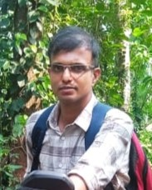

Name : Hussain.P
Mobile : 6282550510
Email id : 1234hussainjasi@gmal.com
Father’s Name : Muhammed
Gender : Male
Date of Birth : 10/05/1989
Marital Status : Married
Religion : Muslim
Languages Known : Malayalam
Qualification : SSLC

: Basic Computer Knowledge
: Photoshop,CorelDraw,Pagemaker,word

Experience : Worked in Supermarket
: Owned a printing press
: Worked in a printing press
: Worked as Painter, polishing

Address : Pari (house) Manhappatta Post
Tharikulam

Place : Tharikulam Signature
Date : 20/10/25

