What is the expected output of the following code?
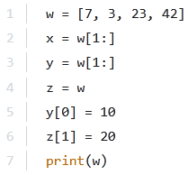
- A. [7, 3, 23, 42]
- B. [7, 20, 23, 42]
- C. [10, 20, 42]
- D. [10, 20, 23, 42]
Take a look at the snippet and choose one of the following statements which is true:
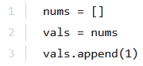
- A. vals is longer than nums
- B. nums and vals are of the same length
- C. nums is longer than vals
What is the expected output of the following code?
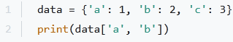
- A. (1, 2)
- B. The code is erroneous.
- C. {'a':1, 'b':2}
- D. [1,2]

How many elements does the L list contain?
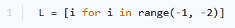
- A. one
- B. two
- C. three
- D. zero

What is the output of the following snippet?
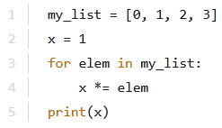
- A. 1
- B. 0
- C. 6
What is the expected output of the following code?
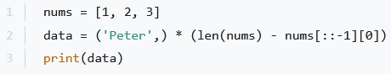
- A. ('Peter', 'Peter',)
- B. PeterPeter
- C. The code is erroneous.
- D. ('Peter')
- E. ()
What is the expected output of the following code?
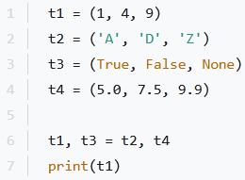
- A. The program will cause an error.
- B. (1, 4, 9)
- C. ('A', 'D', 'Z')
- D. (5.0, 7.5, 9.9)

What is the expected output of the following code?
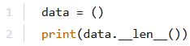
- A. The code is erroneous.
- B. 1
- C. 0
- D. None
What is the expected output of the following code?
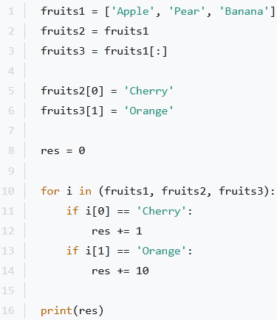
- A. 22
- B. 12
- C. 0
- D. 11
What is the expected output of the following code?
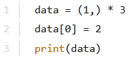
- A. (2, 1, 1)
- B. (1, 1, 1)
- C. (2, 2, 2)
- D. The code is erroneous.
Which one of the lines should you put in the snippet below to match the expected output?
Expected output:
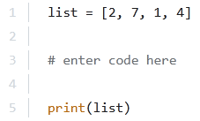
- A. sorted(list)
- B. sort(list)
- C. list.sort()
- D. list.sorted()
Which of the following sentences are true about the code? (Choose two.)
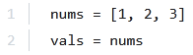
- A. nums and vals are different lists
- B. vals is longer than nums
- C. nums and vals are different names of the same list
- D. nums and vals have the same length
The second assignment:
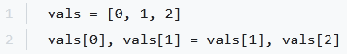
- A. extends the list
- B. doesn't change the list's length
- C. shortens the list
What is the expected output of the following code?
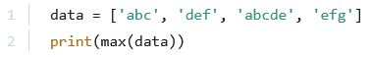
- A. efg
- B. abc
- C. def
- D. The code is erroneous.
- E. abcde
- F. None of the above.
Which function does in-place reversal of objects in a list?
- A. list.sort([func])
- B. list.pop(obj=list[-1])
- C. list.remove(obj)
- D. list.reverse()

