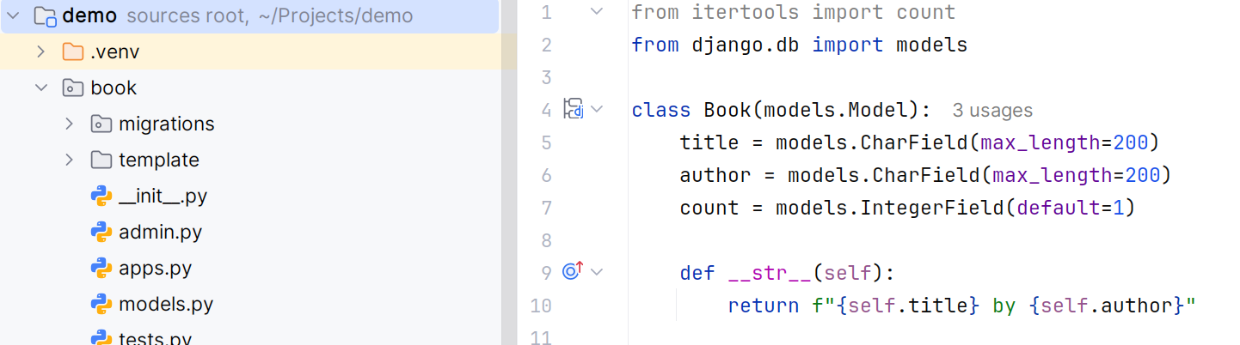
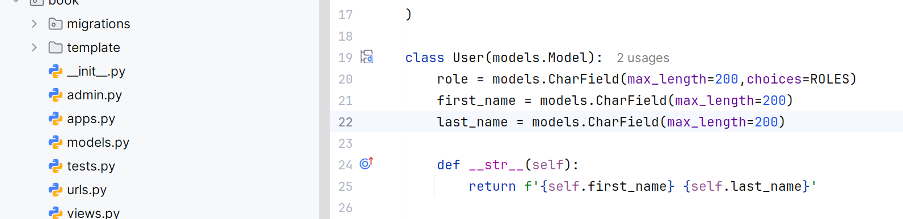
2 ta modul yarat: models.py da yani book dega app ni ichida
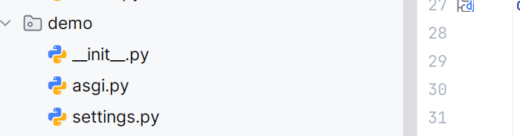
Keyin settings demo loyihani ichida bu yerga kel:
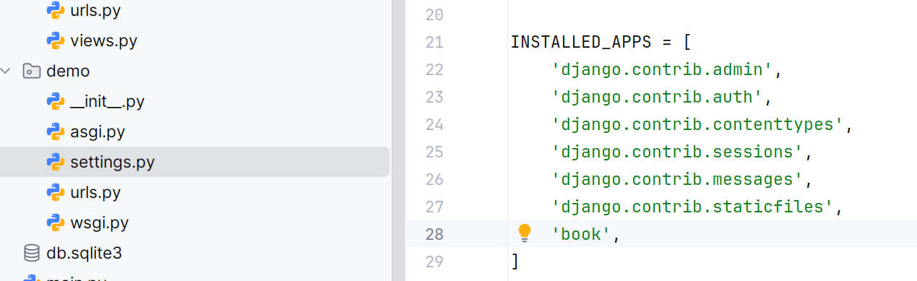
Huddi shu installed_apps bolimining oxuriga yaratgan book app ni qosh :
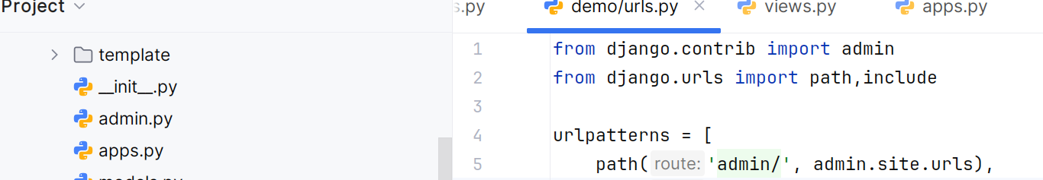
Keyin urls settingsni pastida bu yerga kelib mana buni yoz.
Hop: python3 manage.py makemigrations qilib:
pytohn3 manage.py createsuperuser deb yoz :
User-> rizo
Password -> 1234
Tasdiqla 1234
Keyn -> no/yes -> yes ni bos:
Va oxurigi bosqish pytohn3 manage.py runserver -> lokal hosga otib googledan yuqoridagi urlga
127....8000/admin -> deb yoz va admi oynasiga o’tadi user parolni kiririb kir va natijasini menga yubor telegramdan..

