Topic

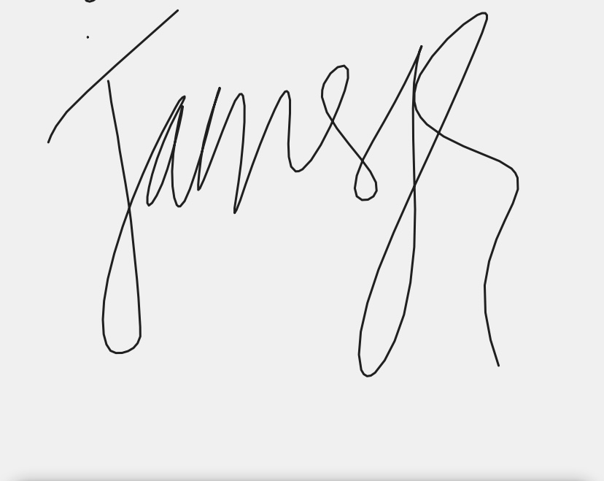

Submitted by:

Bhashkar Paudyal

Grade XII ‘D3’

Roll no 12 or 13

Submmission Signature

Submitted to:

………. Department

Aprroval Signature