Practical 5
2500031613_U.Moksha
- Implement a producer-consumer communication system using anonymous pipes where the parent process generates data and the child process consumes it. Measure the communication efficiency.
Commands:

Code: 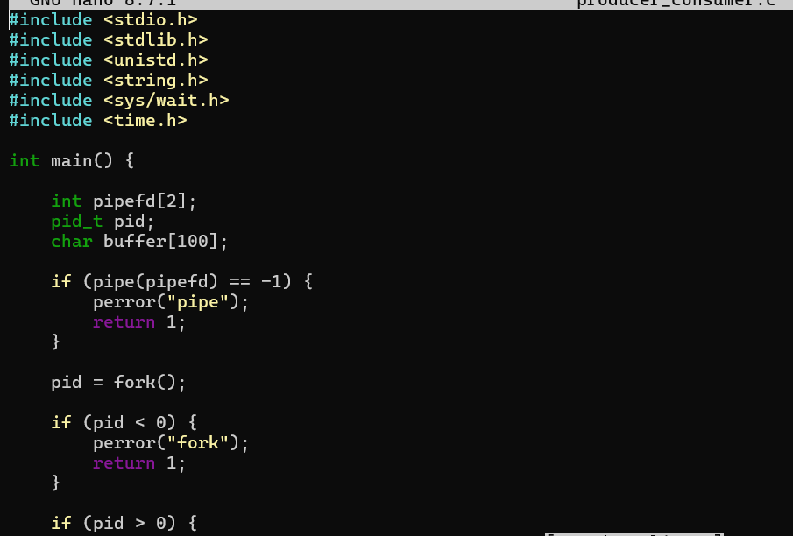
Output:
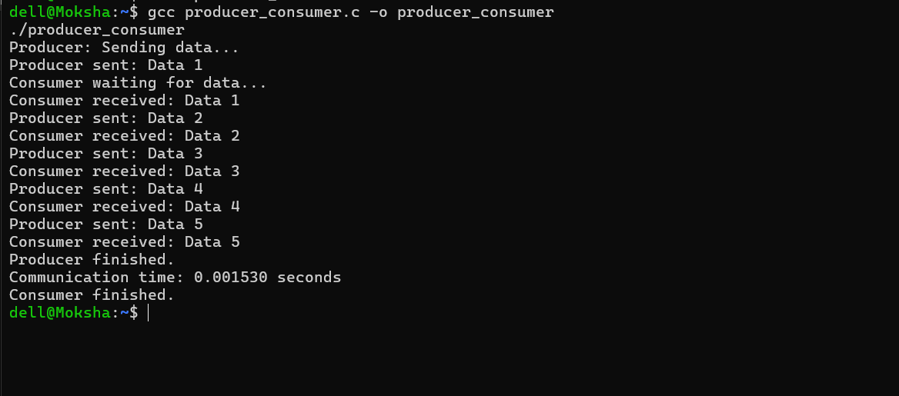
2.Develop a program that executes the equivalent of the shell command: ls -l | grep ".c" using fork(), pipe(), dup2(), and exec() system calls.
Commands:
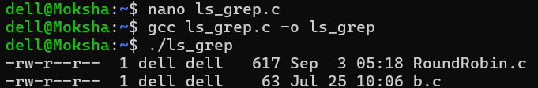

Code:
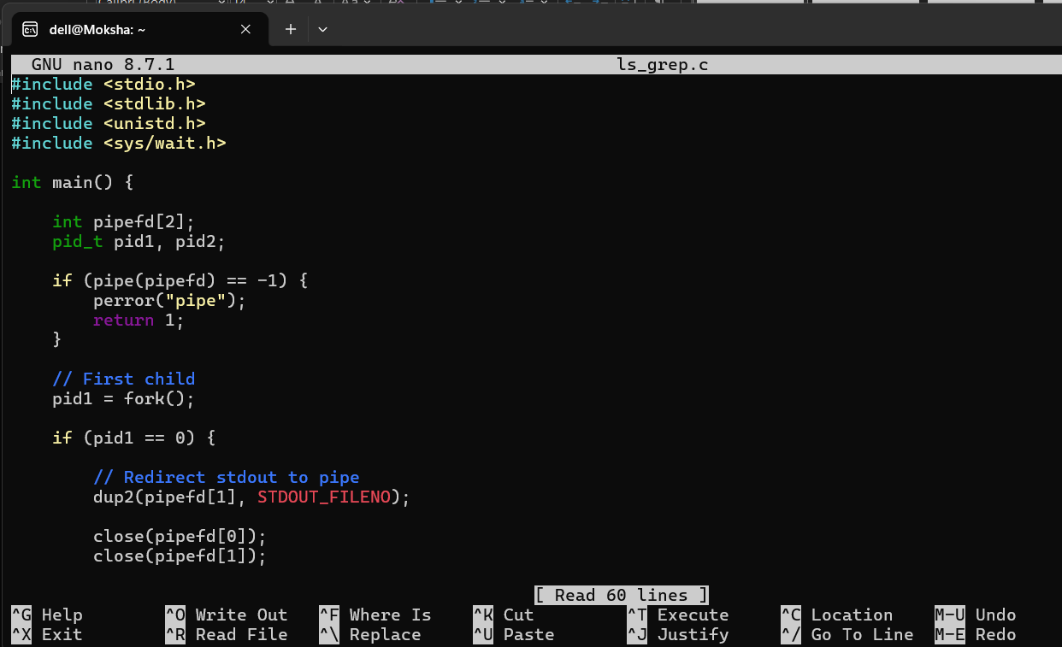

Output: