Practical 4
2500031613_U.Moksha Ratna
- Write a C program where a parent process creates multiple child processes and synchronizes their completion using wait() and waitpid(). Compare the behavior of both functions.
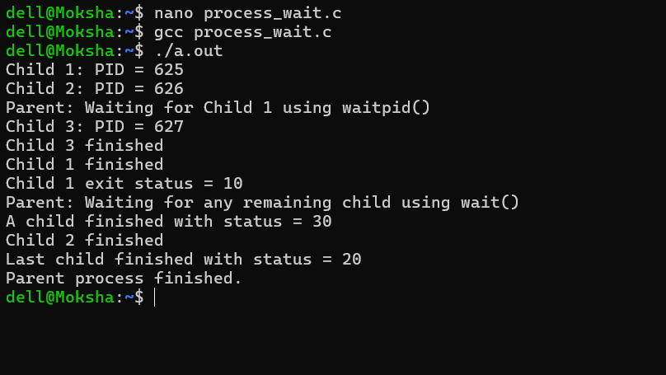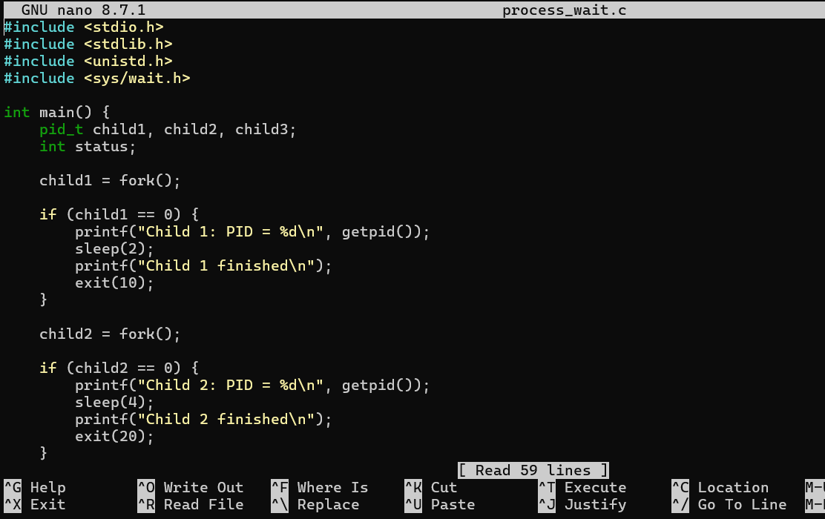

Create a scenario where a child process becomes a zombie process. Investigate the process table and then modify the program to eliminate zombie processes using proper synchronization techniques.
