OSSP (25CS2104E) – Skill 1
Name: U.Moksha Ratna
Roll No: 2500031613
Subject: Operating Systems and Systems Programming (OSSP)
Skill No: 1
Title: Linux VM Setup, GCC Configuration, Git Repository, Shell Architecture, Makefile, fork (), exec(), Process Tree & System Call Tracing.
Aim
To install and verify Linux, configure GCC, set up a Git repository, understand shell architecture, build a Makefile, execute fork() and exec() system calls, inspect the process tree, and practice system call tracing.
Software Requirements
- Ubuntu 26.04 LTS
- GCC Compiler
- Git
- Nano Editor
Step 1: Verify Linux Installation
Command:
uname -a
lsb_release –a
These commands display the Linux kernel version and Ubuntu distribution details to verify that Linux is installed.
Output: 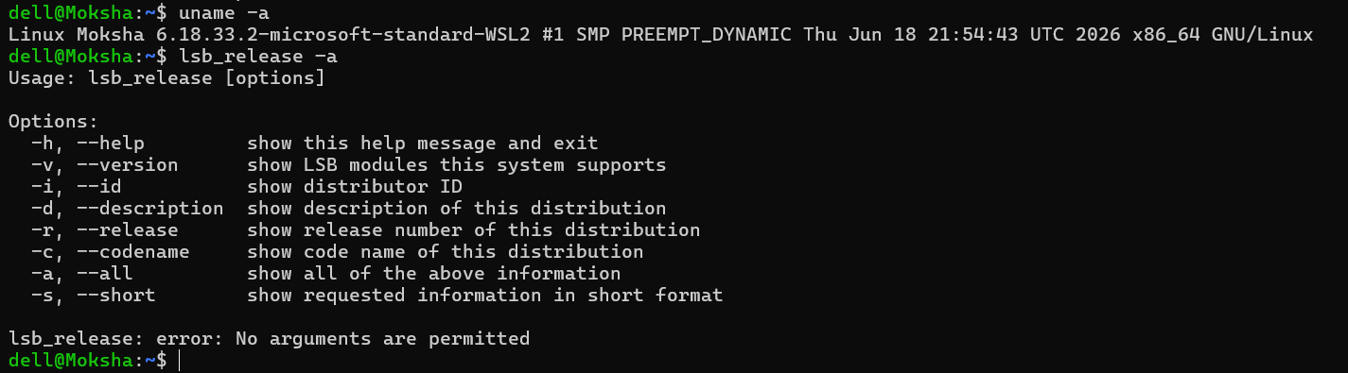
Step 2: Verify GCC Compiler
Command:
gcc –version
Checks whether the GNU C Compiler is installed successfully.
Output:

Step 3: Navigate to Project Directory
Command:
cd ~/CPUCommanders_OSSP/2500031613_Skill/Skill1
Explanation: Moves into the Skill-1 project folder.
Output:
Step 4: Understand Shell Architecture
Commands:
echo $SHELL
pwd
whoami
Explanation:
- echo $SHELL → Displays the current shell.
- pwd → Shows the present working directory.
- whoami → Displays the logged-in username.
Output:
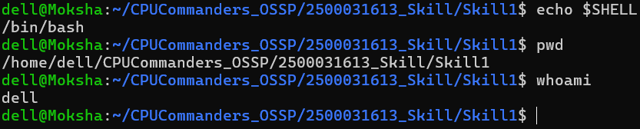
Step 5: Create fork.c
Command:
nano fork.c
Type this C program:
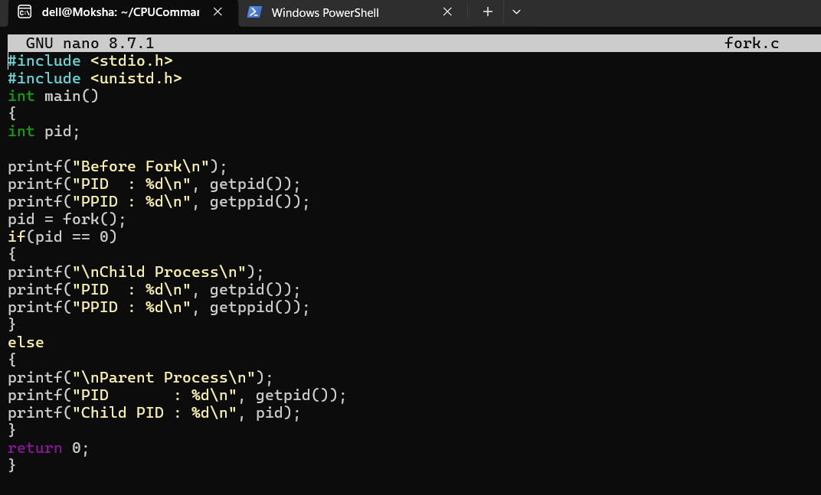
Save: Ctrl + O → Enter → Ctrl + X
Step 6: Compile and Execute fork()
Commands:
gcc fork.c
./a.out
Explanation: The program creates a child process using fork() and displays the PID and PPID of both parent and child processes.
Output:
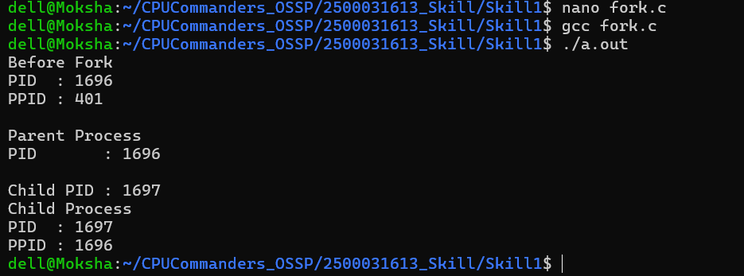
Step 7: Create exec.c
Command:
nano exec.c

Type the C program:
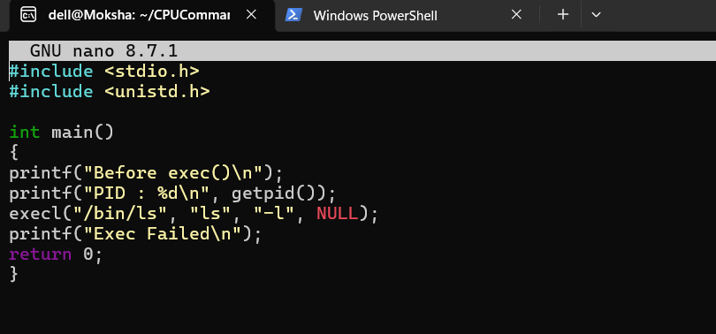
Save: Ctrl + O → Enter → Ctrl + X
Step 8: Compile and Execute exec()
Commands:
gcc exec.c
./a.out
Explanation: execl() replaces the current process with the Linux ls -l command.
Output:
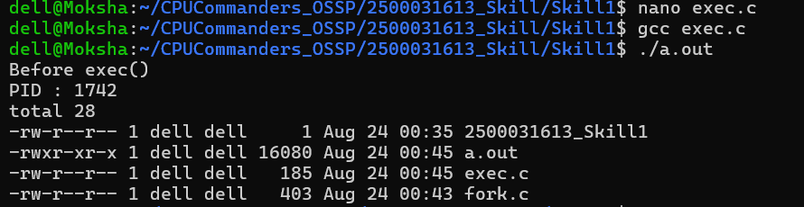
Step 9: Inspect Process Tree
Command:
pstree –p

Explanation: Displays the hierarchy of running processes along with their Process IDs.
Output:
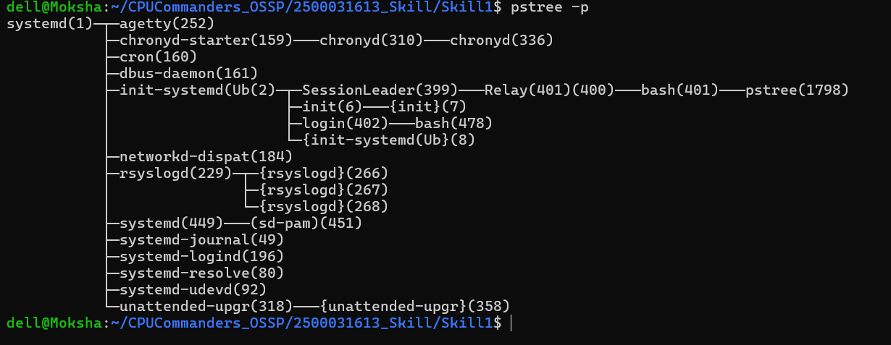
Step 10: Practice System Call Tracing
Command:
strace ./a.out

Explanation: Traces all the system calls executed by the program.
Output:
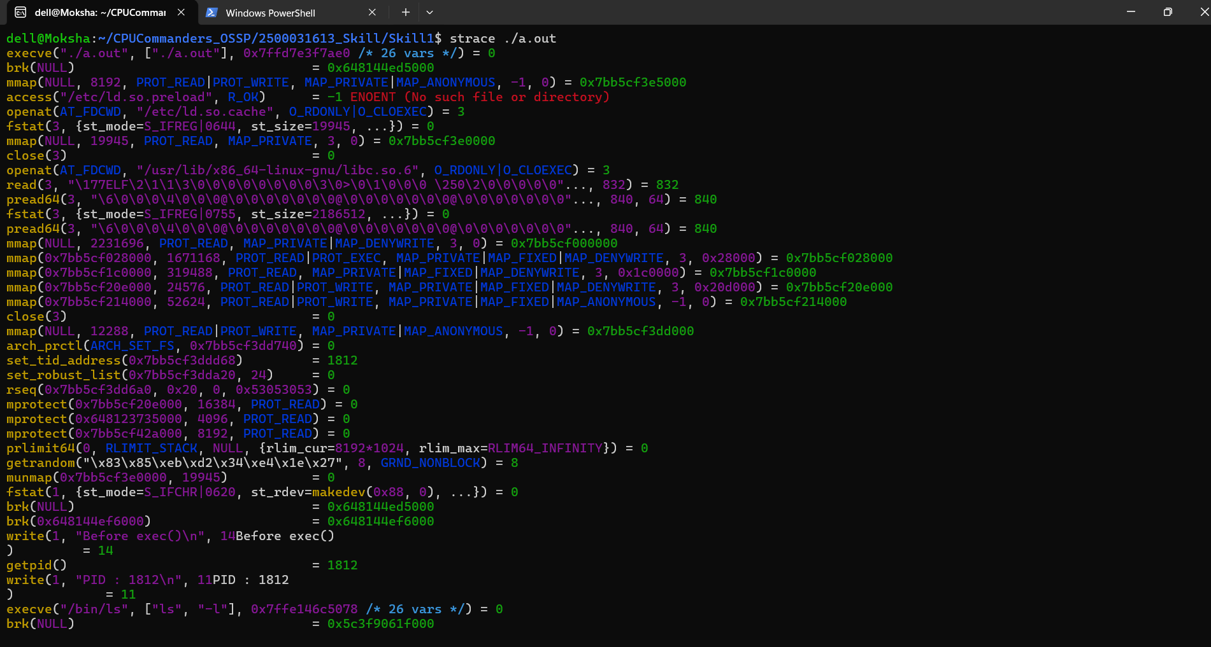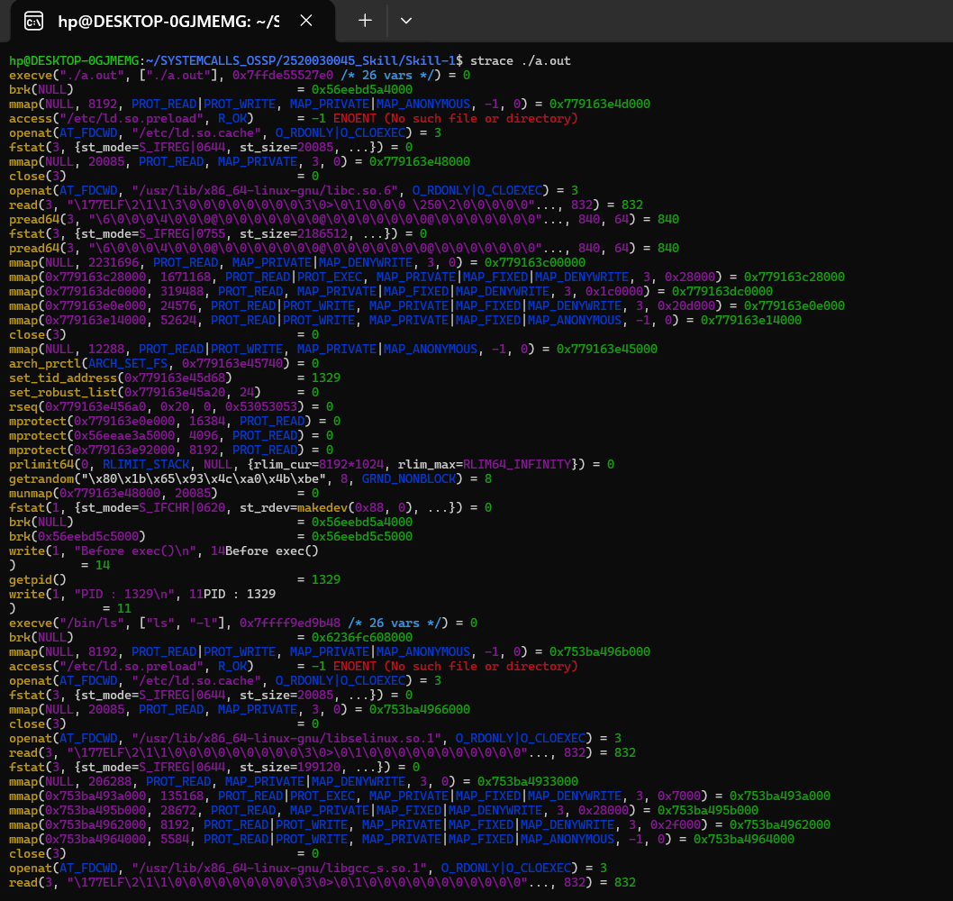
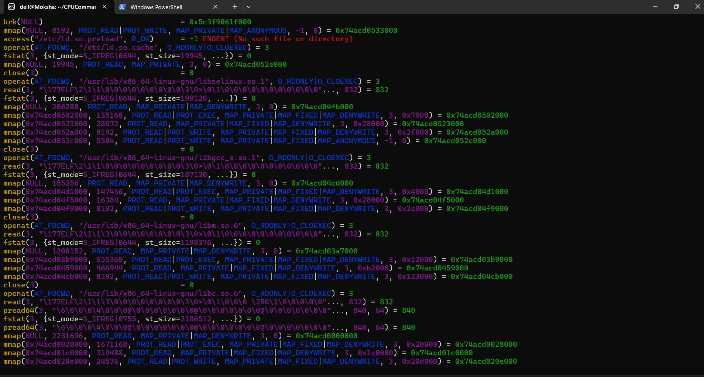
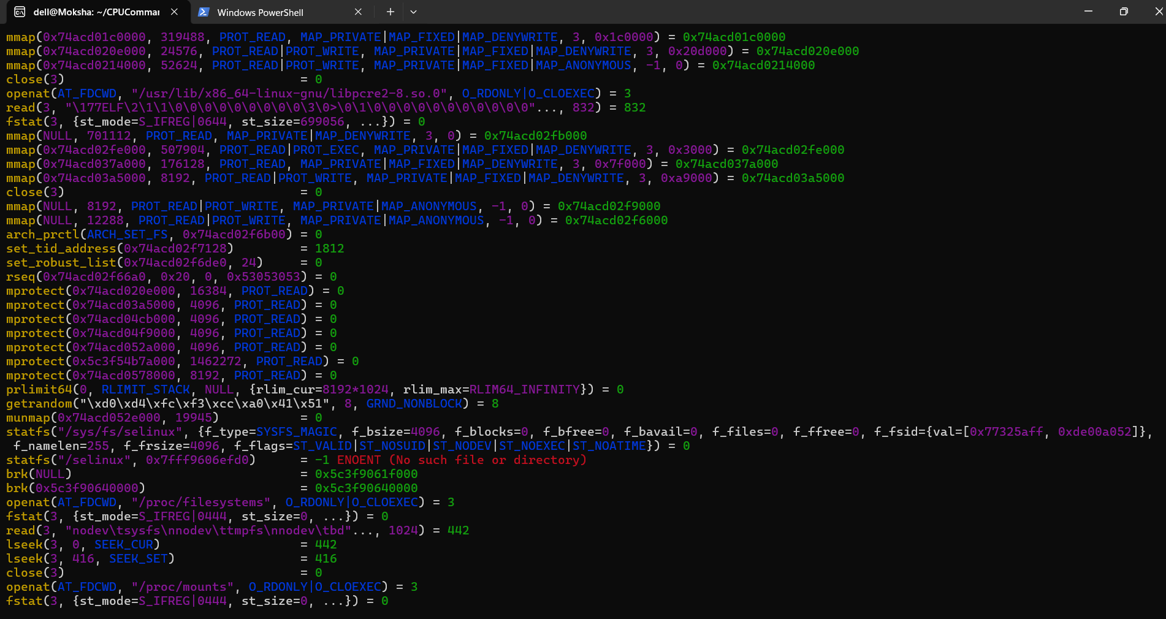
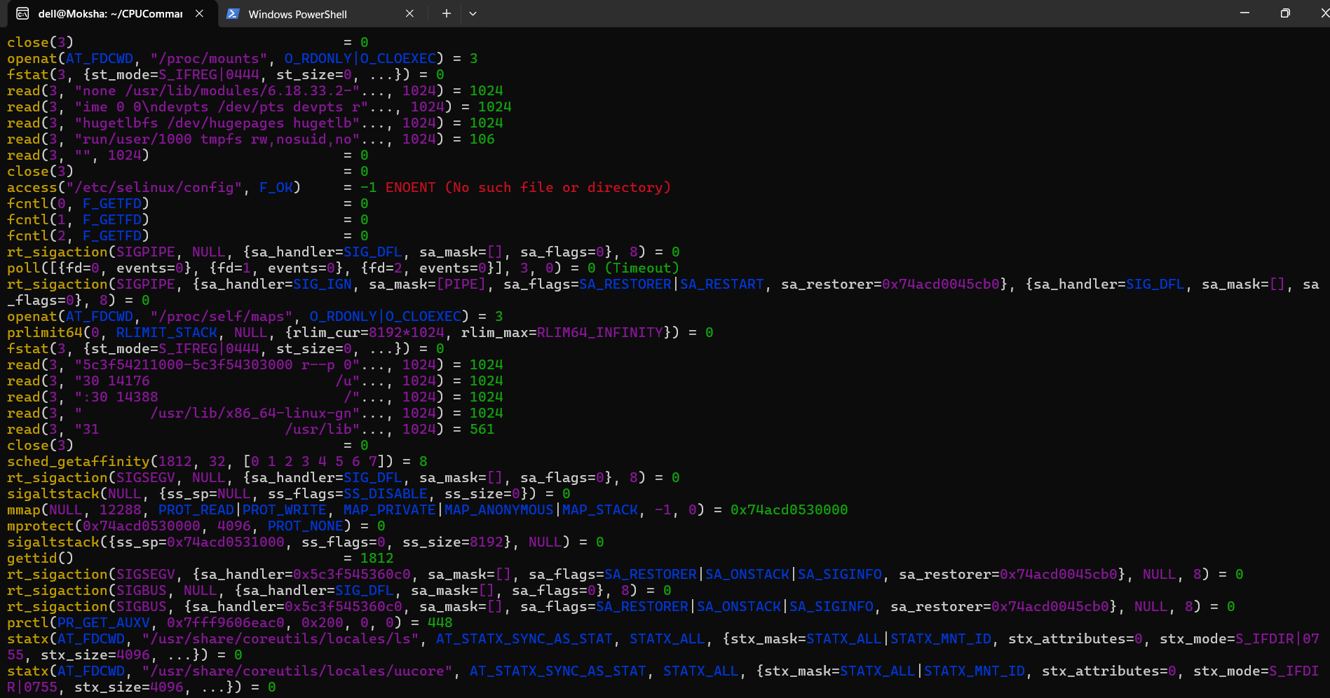
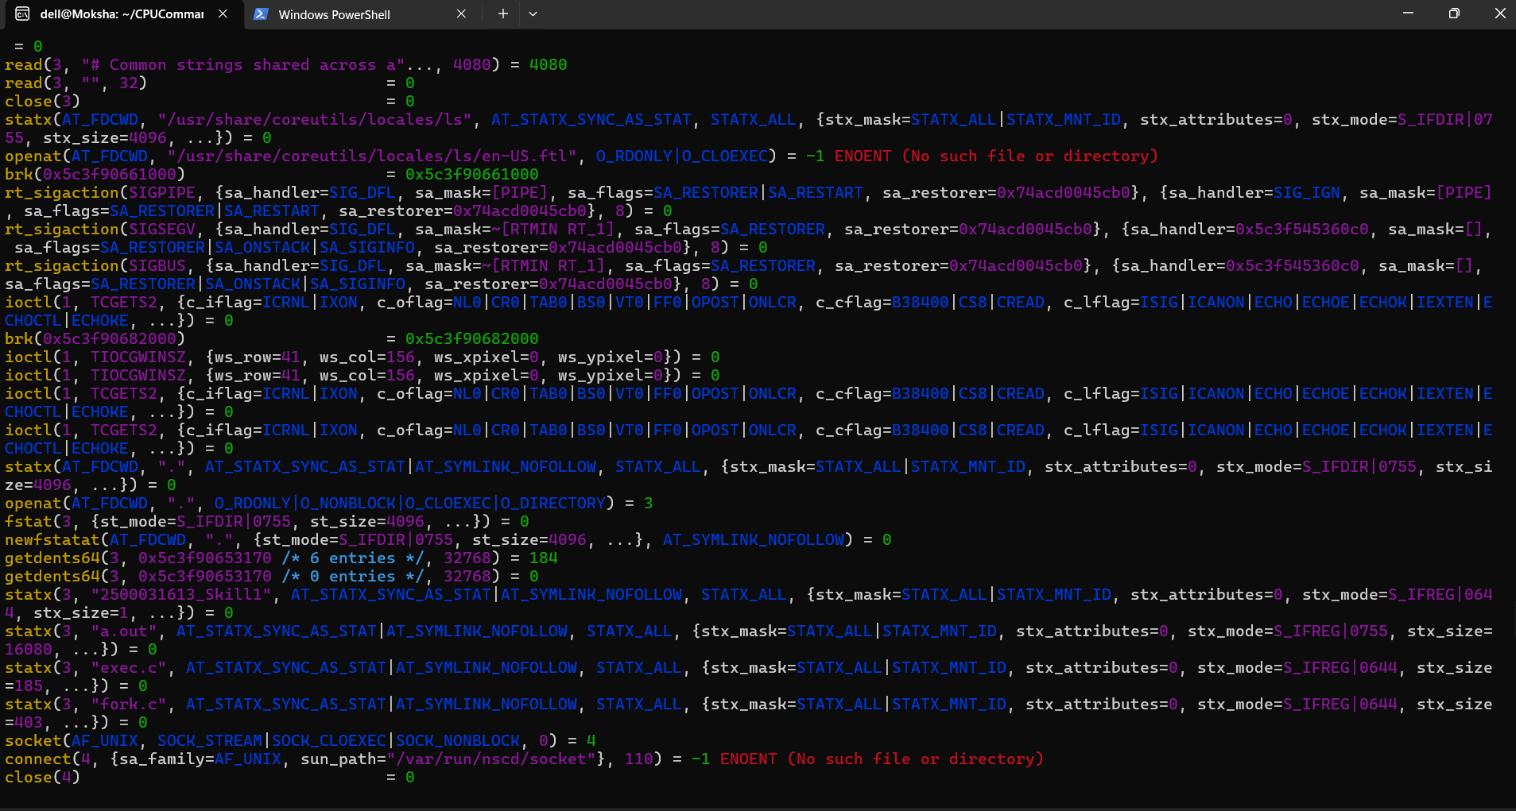
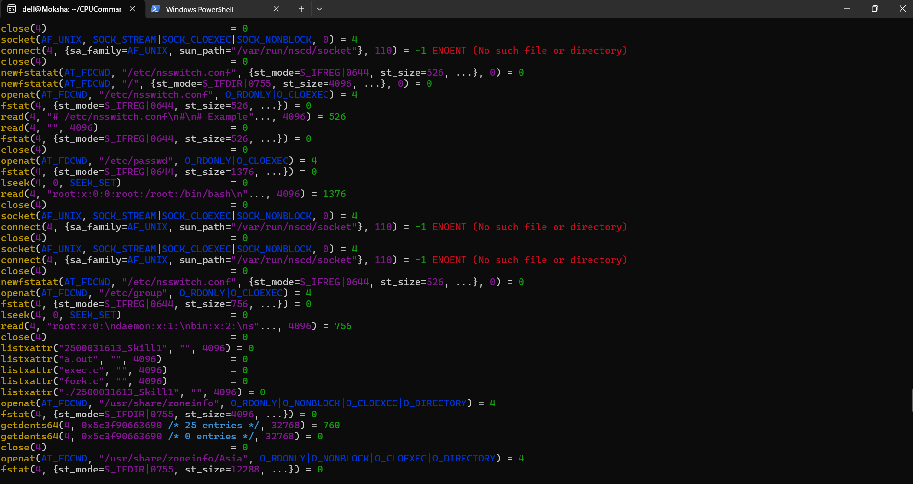
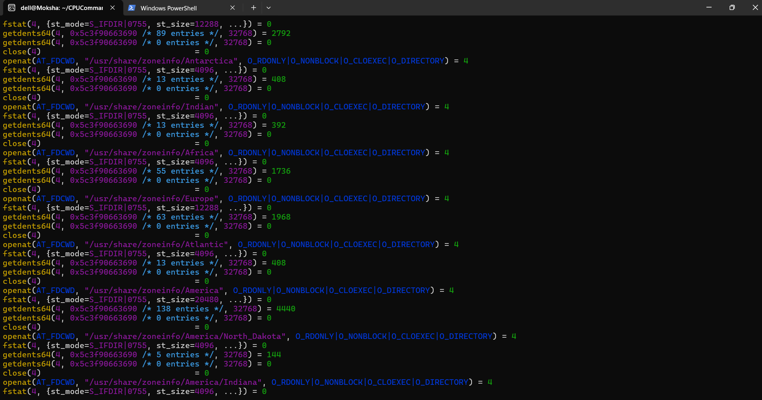
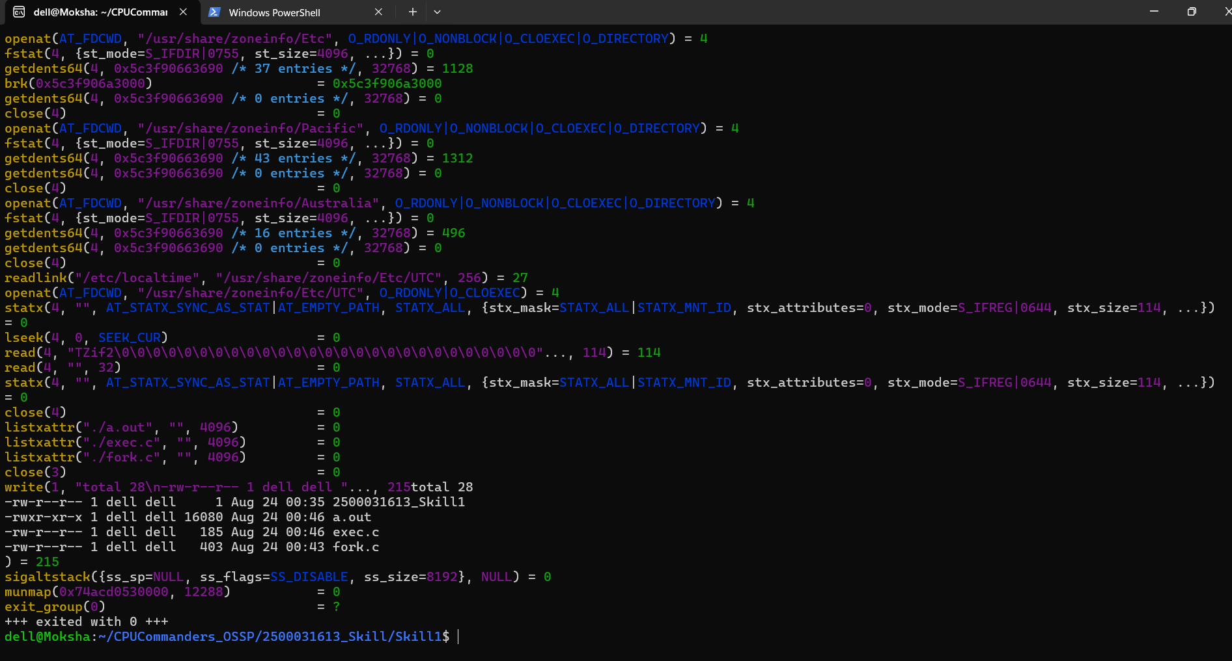
Step 11: Create Makefile
Command:
nano Makefile

Type this in the Makefile:
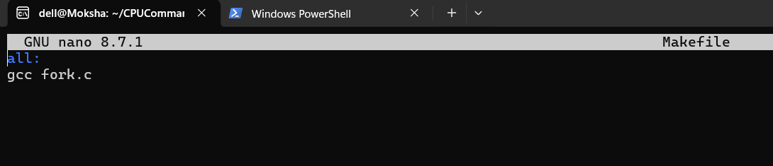
Save and execute:
make
./a.out
Explanation: The Makefile automates the compilation process using the make command.
Output: 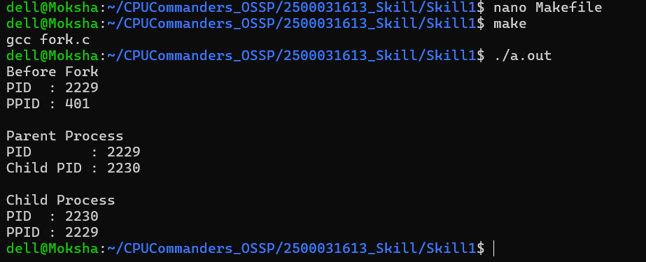
Result
Successfully verified Linux and GCC, created a Git project structure, understood shell architecture, executed fork() and exec() system calls, viewed the process tree, traced system calls using strace, and compiled the program using a Makefile.

