Practical 6
2500031613_U.Moksha
- Create a client-server application using Named Pipes (FIFOs). The client sends messages and the server processes and responds to them. Analyze FIFO behavior when multiple clients communicate simultaneously.
Commands:
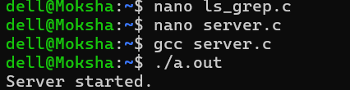
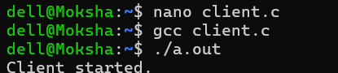
Code: 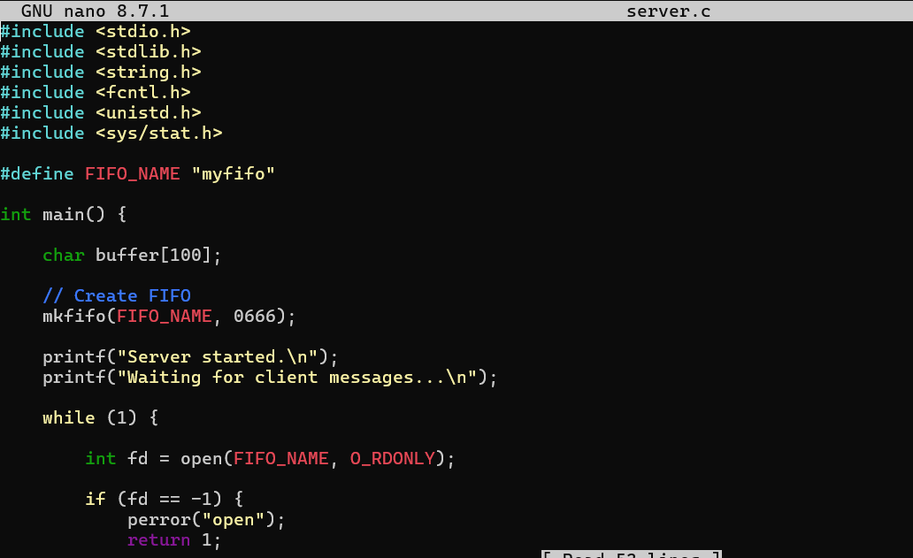
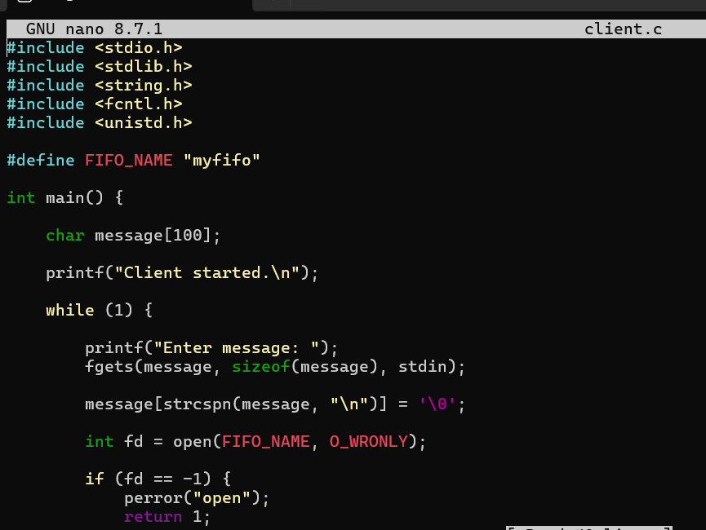

Output:
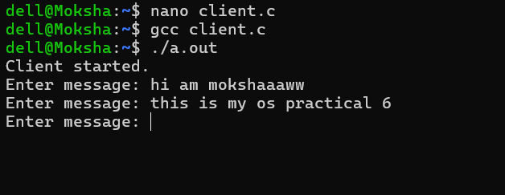
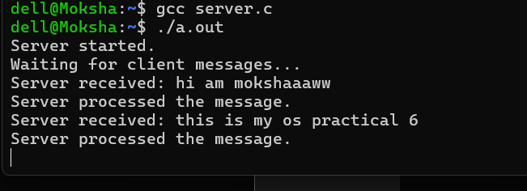
2.Create a POSIX signal handling program that captures SIGINT, SIGTERM, and SIGUSR1. Demonstrate asynchronous event handling and explain the role of signal handlers.
Commands:
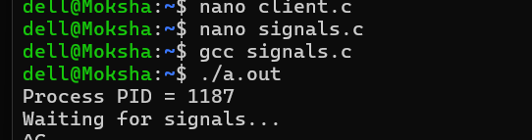
Code:
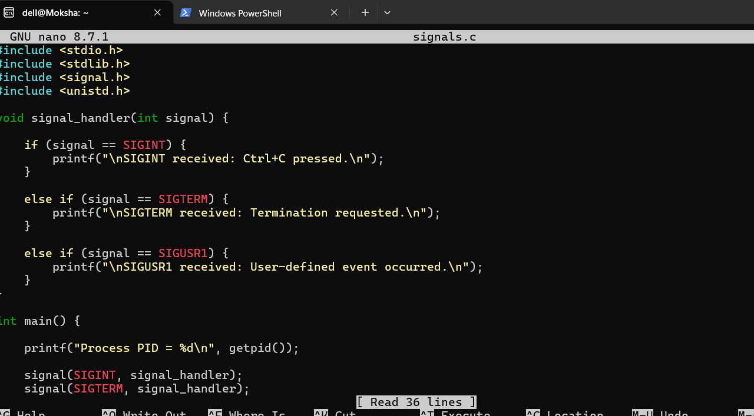
Ouput:
