Exploratory Data Analysis (EDA) Report
Travel Time Prediction Using Ridge and Lasso Regression
Dataset: 3000 records × 10 columns

1. Dataset Overview
The dataset contains trip-level records used to predict travel time based on numerical and categorical trip features.
Metric | Value
Number of records | 3000
Number of columns | 10
Total missing values | 15
Duplicate rows | 0
Average Travel Time (minutes) | 43
Average Distance (km) | 13.18
Average Speed (km/h) | 37.31
Average Number of Signals | 8.3
Minimum Travel Time (minutes) | 3
Maximum Travel Time (minutes) | 353.8
Missing values were found only in the Weather column (15 records) and were handled during preprocessing. No duplicate rows were present in the dataset.

2. Categorical Feature Distribution
The table below summarizes the count of records across each category for the key categorical features.
Metric | Value
Traffic_Level | Medium: 1174, Low: 1057, High: 769
Weather | Clear: 1676, Rainy: 745, Foggy: 386, Stormy: 178, NaN: 15
Road_Type | City Road: 1479, Highway: 932, Rural Road: 589
Vehicle_Type | Car: 1484, Bike: 783, Bus: 446, Truck: 287
Day_of_Week | Tuesday: 465, Wednesday: 431, Thursday: 428, Friday: 428, Monday: 427, Sunday: 426, Saturday: 395
Time_of_Day | Night: 806, Evening: 746, Afternoon: 744, Morning: 704

3. Average Travel Time by Category
Average travel time was analyzed across each categorical feature to identify which conditions are associated with longer or shorter trips.

3.1 By Traffic Level
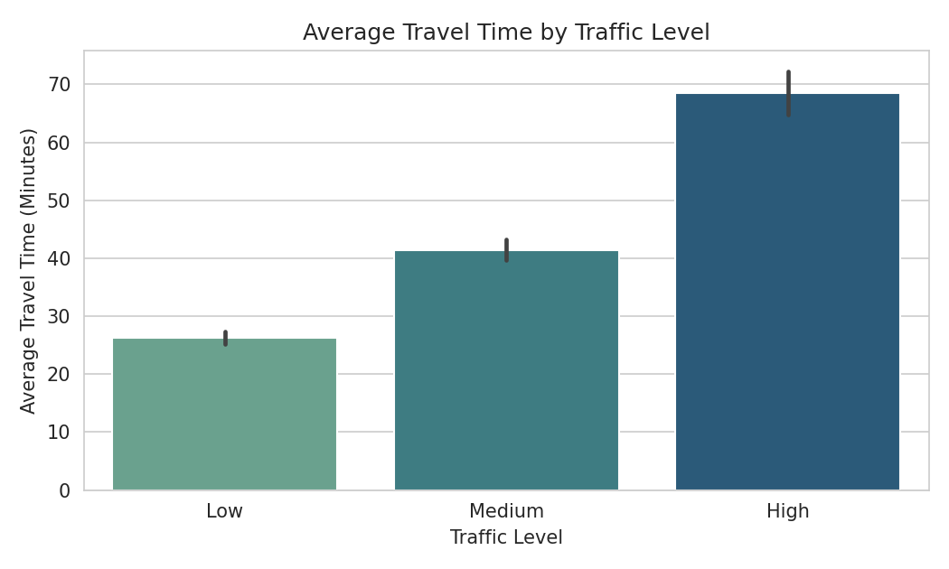
Figure 1: Average Travel Time by Traffic Level
High traffic trips take on average 68.49 minutes, compared to 26.28 minutes for low traffic — roughly 2.6× longer.

3.2 By Weather
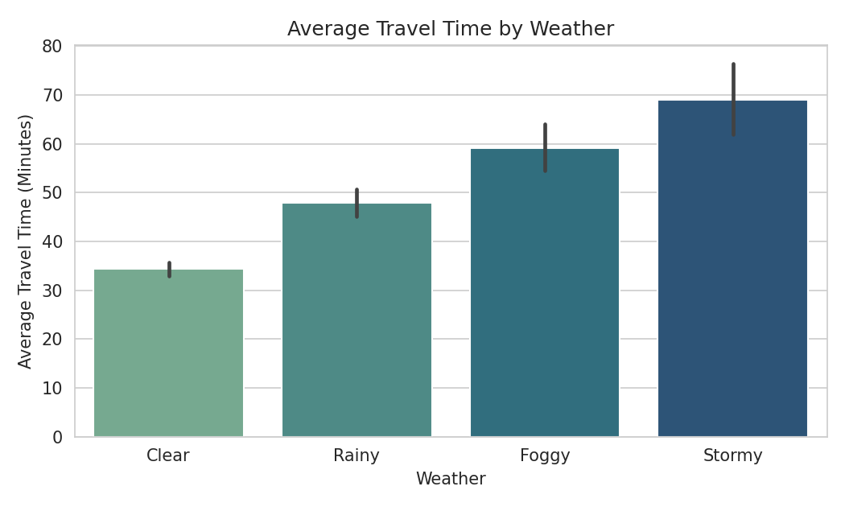
Figure 2: Average Travel Time by Weather
Stormy conditions show the highest average travel time (68.96 minutes), compared to clear weather (34.34 minutes).

3.3 By Road Type
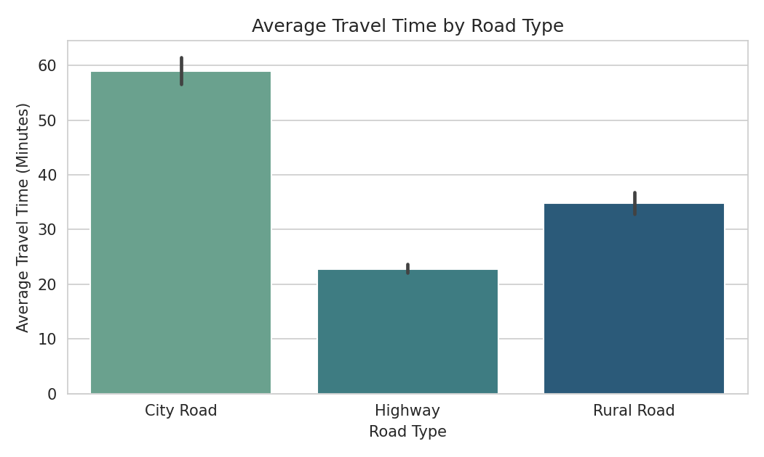
Figure 3: Average Travel Time by Road Type
City roads show the highest average travel time (59.01 minutes) due to higher signal density, while highways show the lowest (22.81 minutes).

3.4 By Vehicle Type
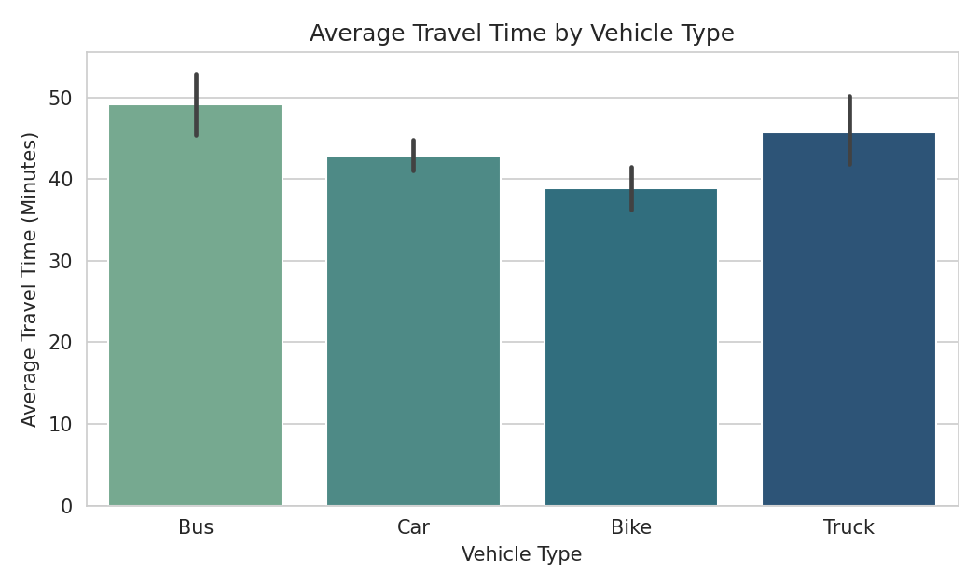
Figure 4: Average Travel Time by Vehicle Type
Buses show the highest average travel time (49.15 minutes), while bikes show the lowest (38.82 minutes).

3.5 By Time of Day
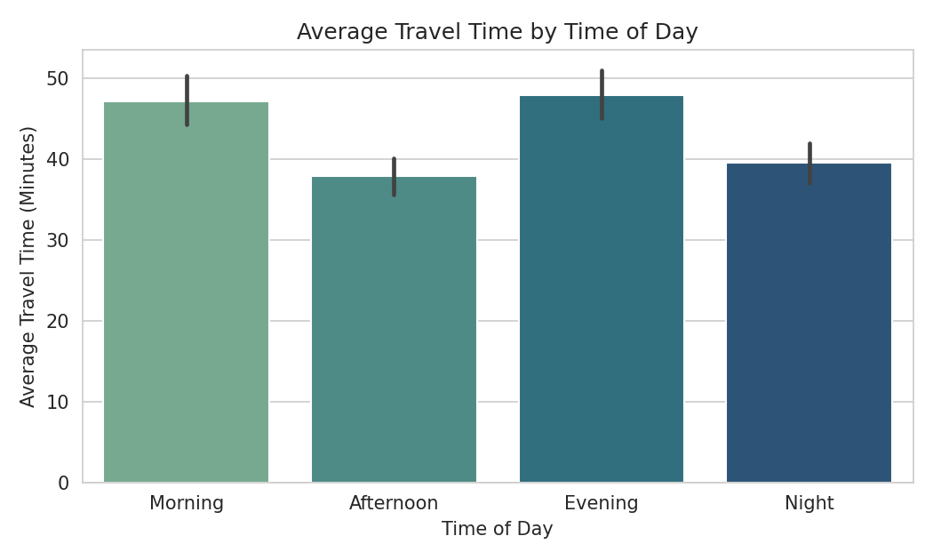
Figure 5: Average Travel Time by Time of Day
Morning and evening (rush-hour) periods show noticeably higher travel times (47.15 and 47.97 minutes) compared to afternoon (37.87 minutes).

4. Distribution of Numerical Features
Histograms below show the distribution shape of each numerical feature, with a kernel density estimate (KDE) overlay.

4.1 Distance (km)
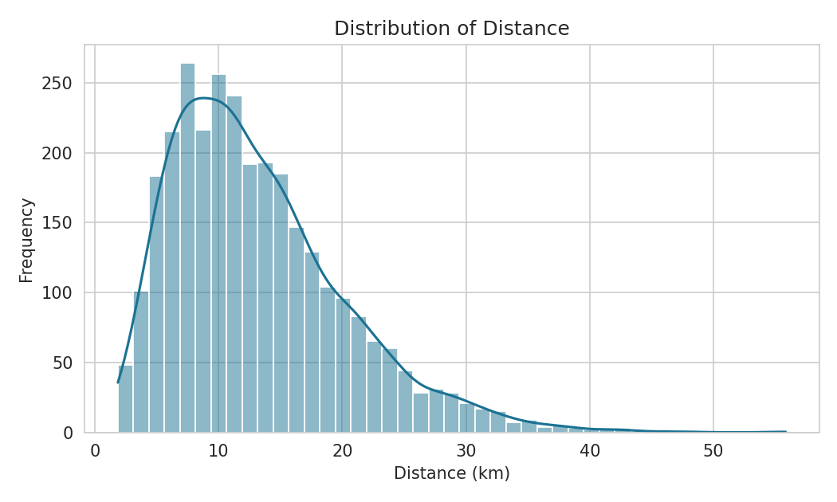
Figure 6: Distribution of Distance

4.2 Average Speed (km/h)
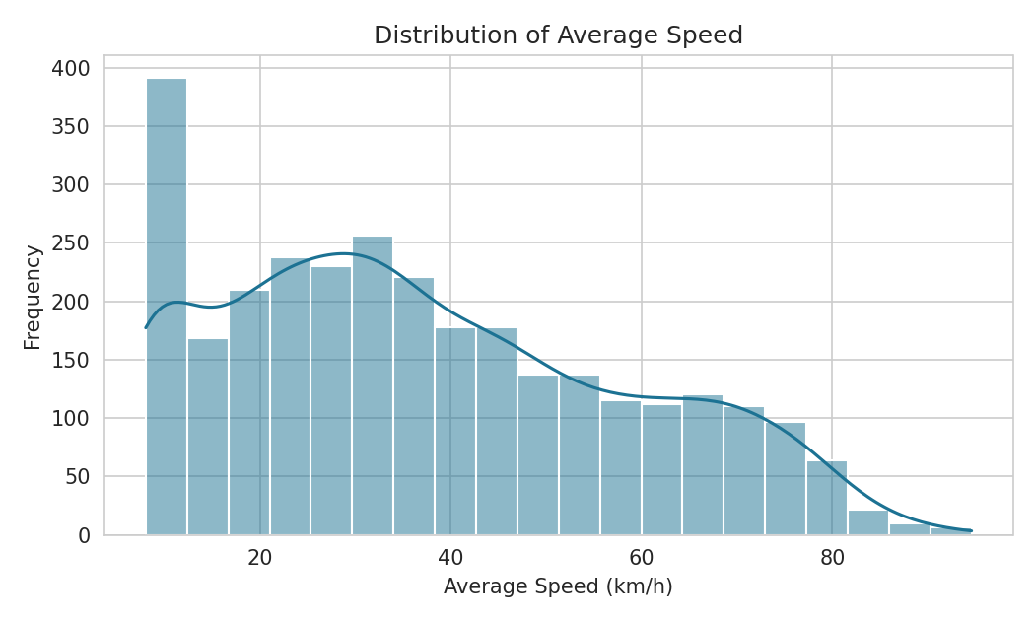
Figure 7: Distribution of Average Speed

4.3 Number of Signals
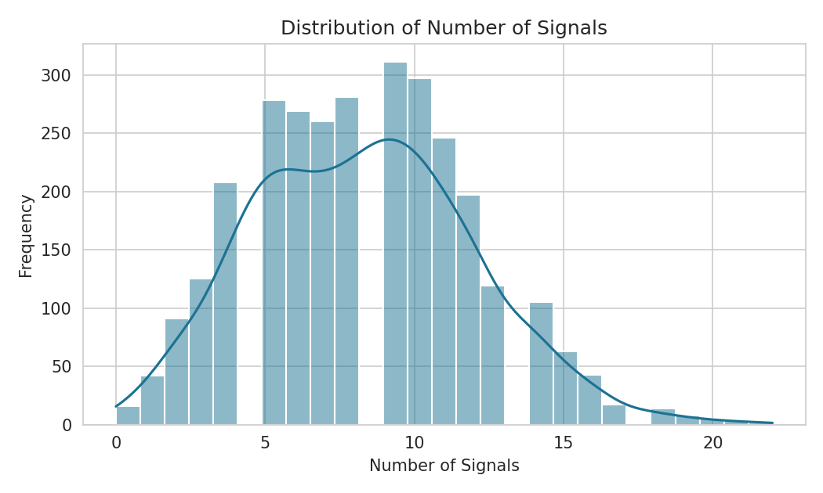
Figure 8: Distribution of Number of Signals

4.4 Travel Time (Minutes) — Target Variable
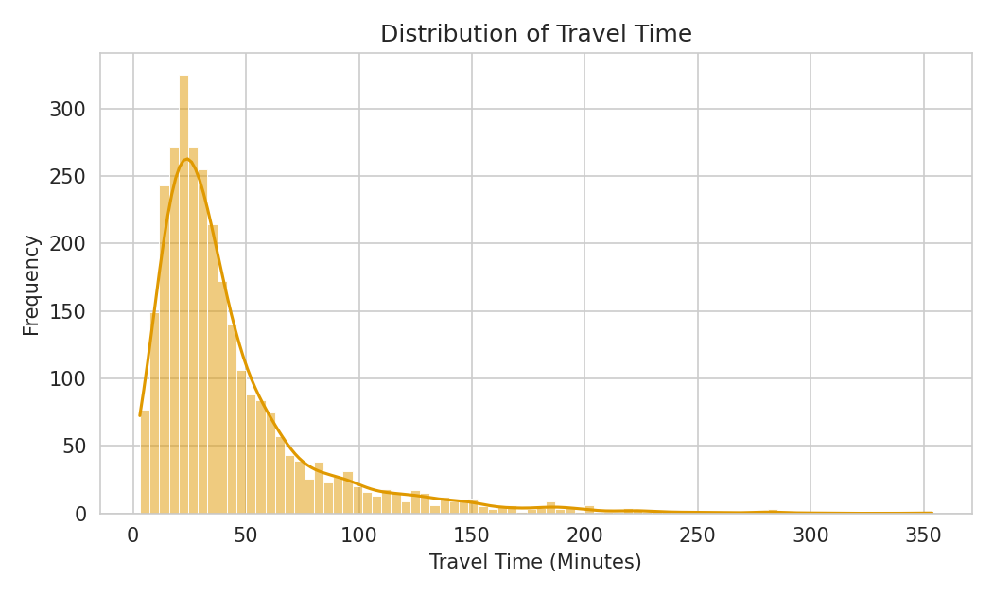
Figure 9: Distribution of Travel Time
The target variable is right-skewed, with most trips completed in under 60 minutes and a long tail of longer trips under adverse conditions (heavy traffic, storms). This supports considering a log-transform of the target before regression modeling.

5. Outlier Analysis (Boxplots)
Boxplots were used to visually inspect the spread and potential outliers in each numerical feature.
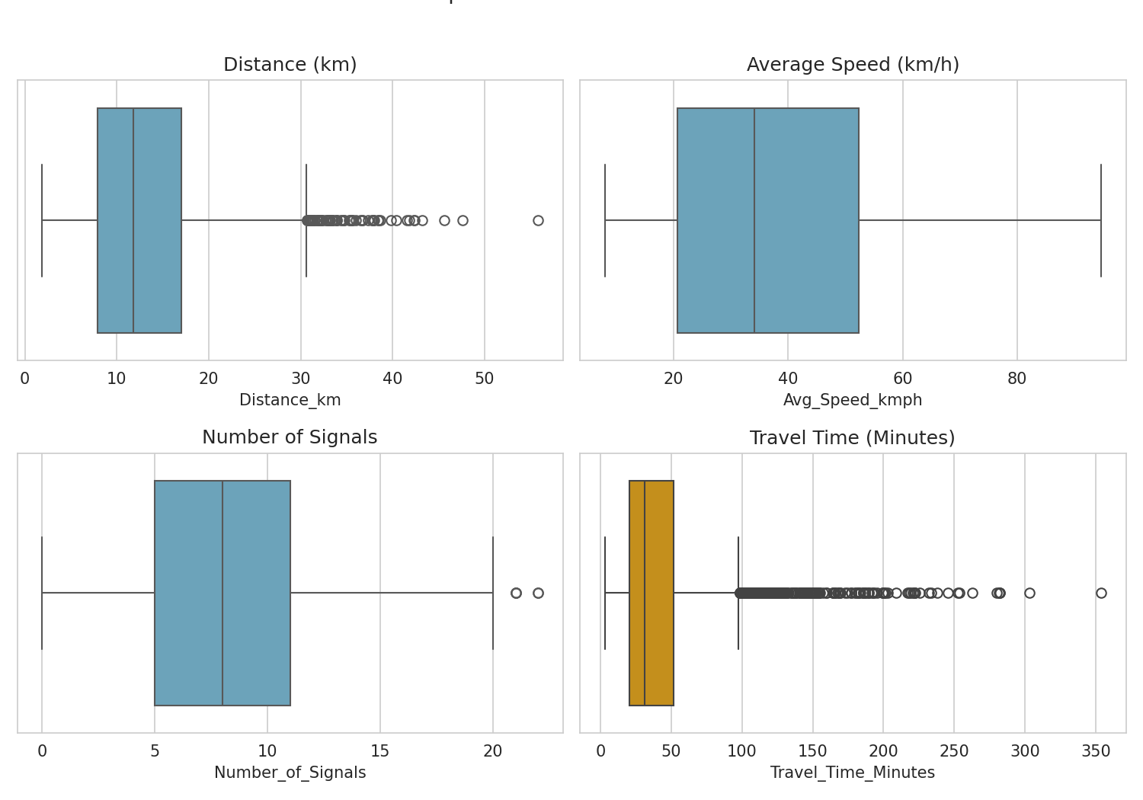
Figure 10: Boxplots of Distance, Speed, Signals, and Travel Time

6. Correlation Analysis
A correlation heatmap was generated to examine the linear relationships between numerical features — directly motivating the use of Ridge and Lasso regularization in this project.
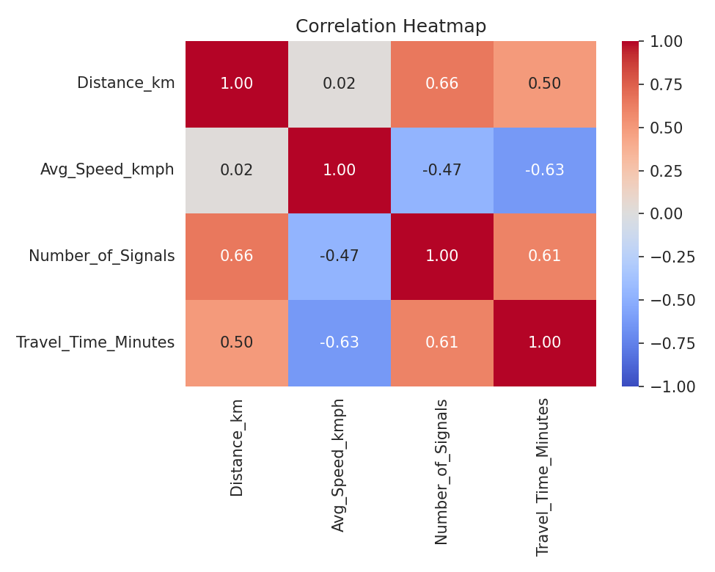
Figure 11: Correlation Heatmap of Numerical Features
Key observations:
- Distance_km and Number_of_Signals are moderately correlated (r = 0.66) — longer trips pass through more signals.
- Avg_Speed_kmph is negatively correlated with Travel_Time_Minutes (r = -0.63) — higher speed reduces travel time, as expected.
- Number_of_Signals is positively correlated with Travel_Time_Minutes (r = 0.61).
- This correlation between Distance_km and Number_of_Signals is an example of multicollinearity — directly motivating the use of Ridge and Lasso regression over plain linear regression.

7. Relationship Between Features and Travel Time

7.1 Distance vs Travel Time
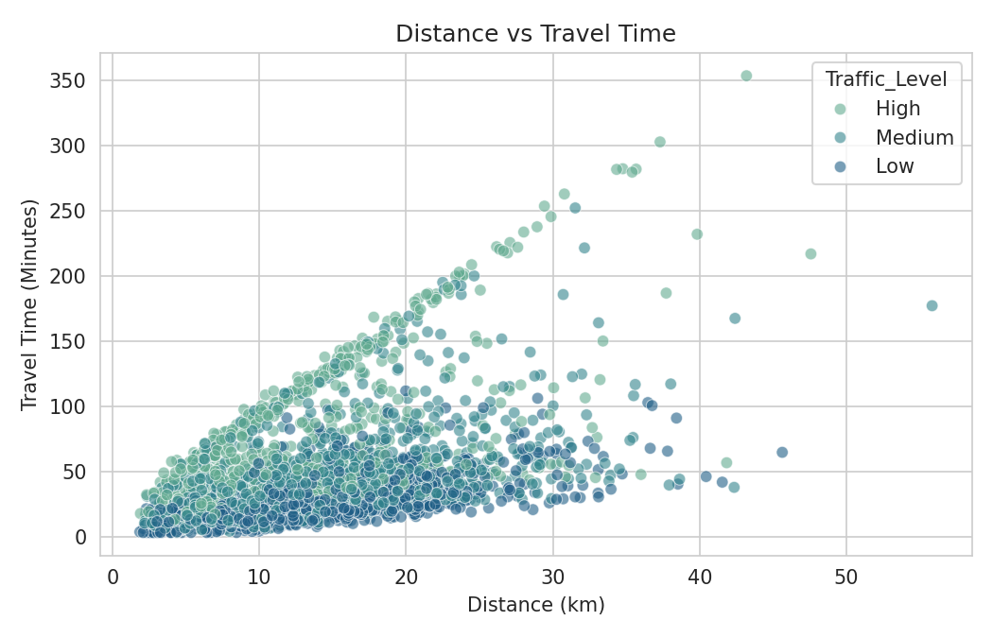
Figure 12: Distance vs Travel Time (colored by Traffic Level)
Travel time increases with distance, and the effect is amplified under high traffic conditions.

7.2 Average Speed vs Travel Time
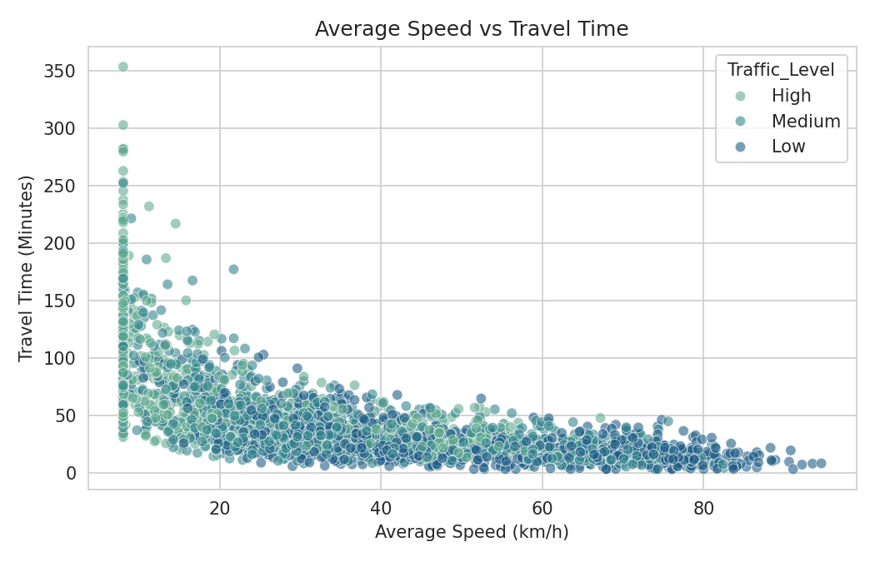
Figure 13: Average Speed vs Travel Time (colored by Traffic Level)
A clear inverse relationship is visible — as average speed increases, travel time decreases.

7.3 Number of Signals vs Travel Time
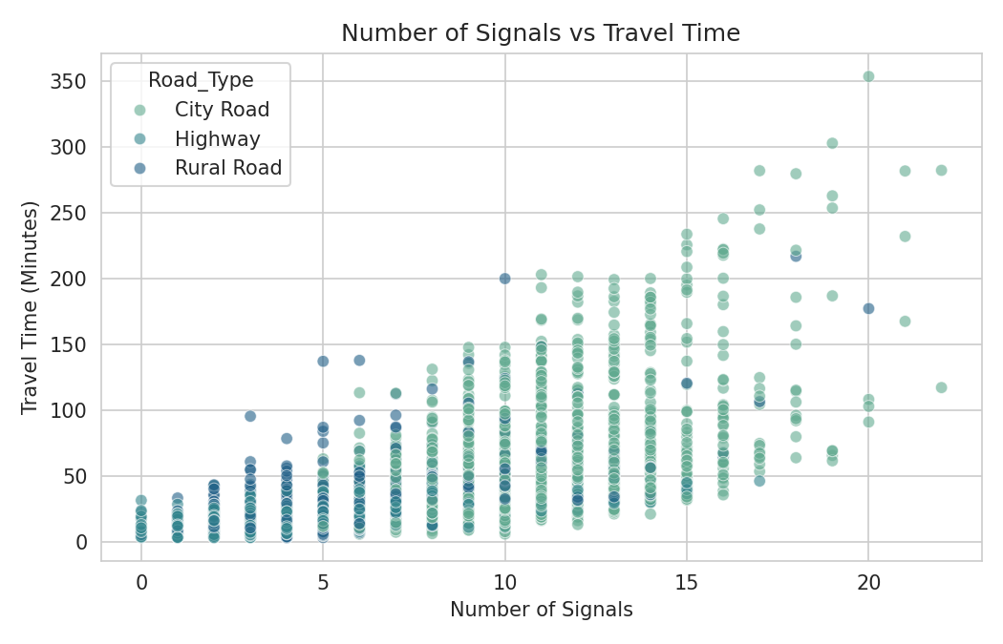
Figure 14: Number of Signals vs Travel Time (colored by Road Type)
More signals are generally associated with longer travel times, particularly on city roads.

7.4 Traffic Level vs Travel Time (Boxplot)
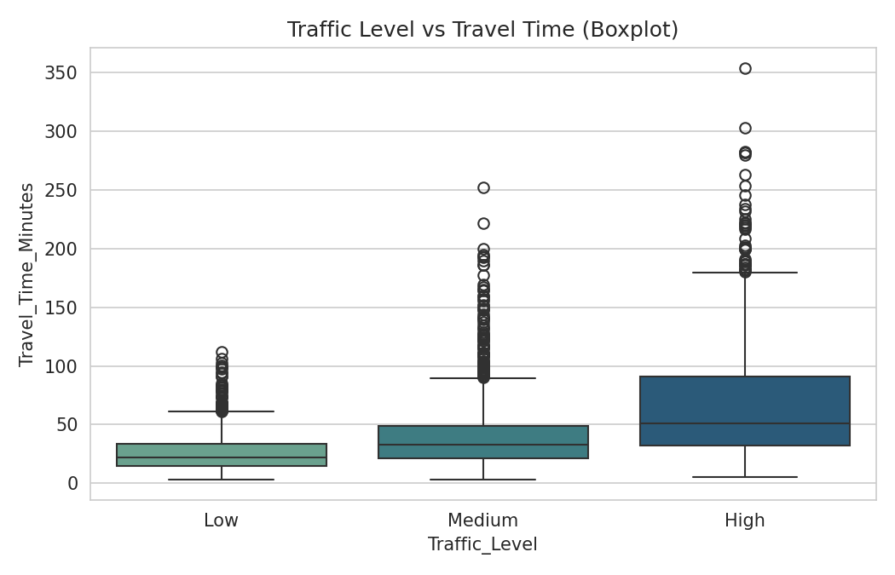
Figure 15: Traffic Level vs Travel Time

7.5 Weather vs Travel Time (Boxplot)
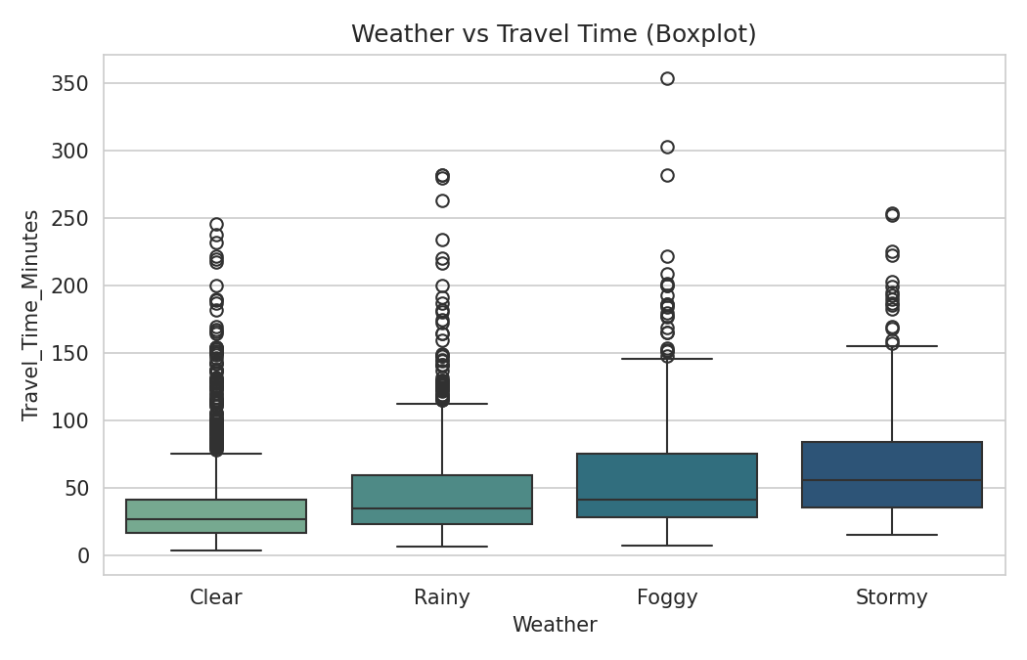
Figure 16: Weather vs Travel Time

8. Summary of Findings
- The dataset contains 3,000 trip records with no duplicate rows and only 15 missing values (in the Weather column).
- Travel time is strongly influenced by traffic level, weather, road type, and number of signals.
- The target variable (Travel_Time_Minutes) is right-skewed, suggesting a log-transformation may improve model performance.
- Distance and Number_of_Signals show moderate correlation (r = 0.66), confirming the presence of multicollinearity among engineered/raw features.
- These findings directly motivate the use of Ridge and Lasso regression to stabilize coefficient estimates and identify the most influential features for predicting travel time.

