**Today Agenda**

* Build Management introduction
* Maven Usage in test Automation
* Installation & Configurations
* Maven Dependency
* Maven Build Life Cycle
* Maven Project structure
* Maven Plugin
* Maven Parameter
* Maven Profiling

1. Why Maven used in Development?

In case of development, maven will be used for build creation & deployment processes

Build creation process: processes of converting source Code format in to executable format

Build Deployment: processes of installing the build in to testing Server/ Environment

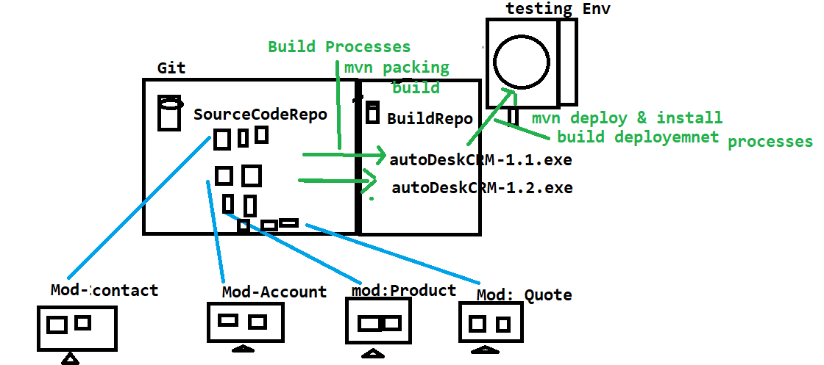

1. What is the use of Maven in Automation.

It is a build testing tool, which is used to check the integration & Compilations issues between the framework components, whenever one user done the modification, addition deletion happened in the framework

1. Why maven is required?

When multiple engineers working with the same framework, their might be chances of one engineer modification might affect entire framework, in order to resolve this issue we go for Maven.

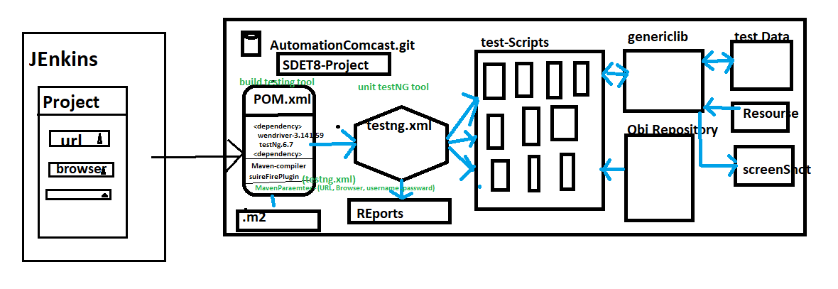

1. Advantages of Maven
2. Check the integration & compilation issue between the framework component whenever modification, addition deletion happened in the framework
3. handle dependencies jars
4. create framework configuration quick setup for new engineers (because all the required dependencies jar. Versions declared in POM.xml, you just to get the framework & run the POM(Update Maven Project) /CMD>mvn test)
5. provide framework folder structure
6. we can run the test script in command Line without Eclipse
7. Which is used to check framework build broken or not ?
8. Maven majorly support in Jenkins for CD/CI[Jenkins]
9. Maven also support Profiling (we can have multiple testing.xml file in one Project, so that we go for Profile to execute specific xml file via CMD)

i. Maven also support Command Line parameters

1. What all the Maven Software required to handle maven Project in real time?

* Two software available in Maven

1. Maven Ellipse Plugin

🡺 Maven Ellipse Plugin : it’s a default plugin available in Eclipse Ide , used to create project in Eclipse

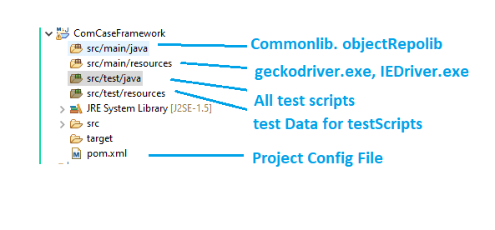

1. Maven Command Line Plugin

🡺Maven Command Line Plugin : it’s should be installed explicitly in all local computers , used to handle the Maven project in CMD line

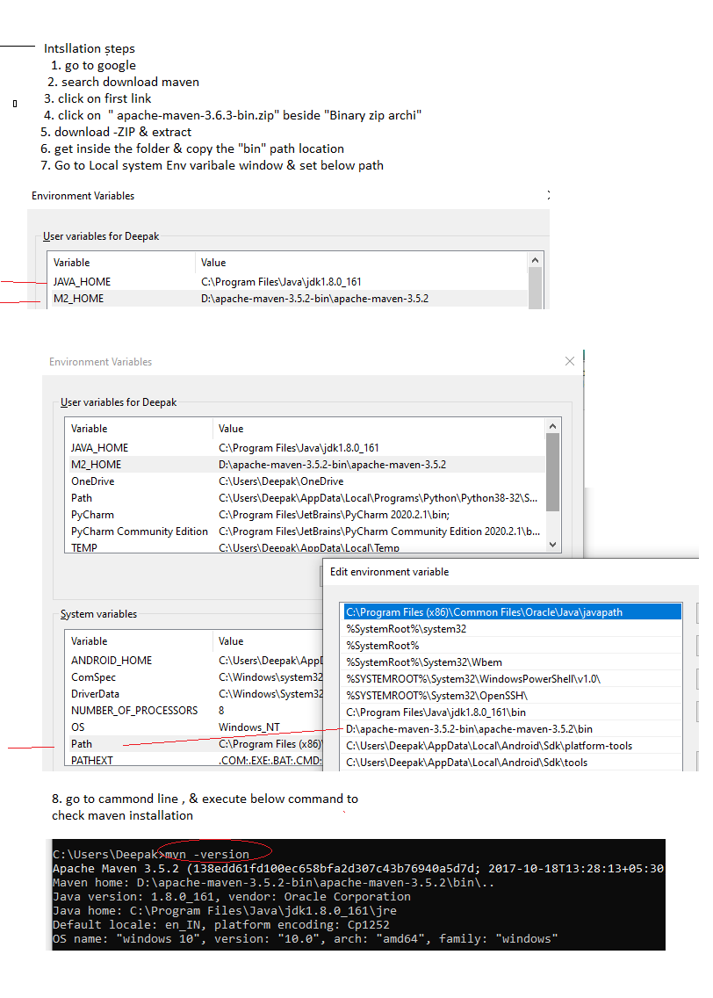

1. How to execute testscripts in CMD
2. PRojecr🡺 RightClick🡺 Properies 🡺 copy the Project location

EG : C:\Users\Deepak\eclipse-workspace\ComCaseFramework

1. Open CMD

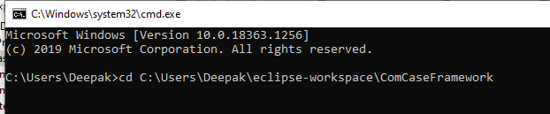

1. Execute Maven commands
2. How To handle dependency in Maven ?

Dependency is advance feature in maven which is used to get all the required jars from the Global repository(http://mvnrepository.com) to Local repository(C://user/.m2) & attach to the project automatically.

1. Explain maven Build Life Cylcle

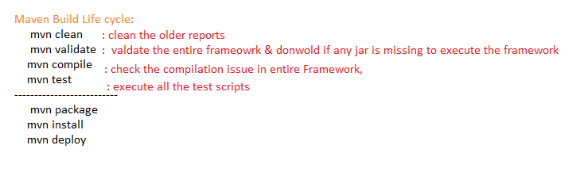

1. How to execute only one test using maven Cmd

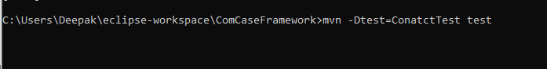

1. What is Maven Parameter & Why its Required?

Maven Parameter help us to Pass the Parameter from the command line without eclipse ,

So that all the test scripts can be executed based on run time parameter ,which is also used Jeninks

-Dkey = value

Useage in java/Selenium Code

String var = system.getProperty(“Key”)

Eclipse Usage

Right Click on testing File -> Run Configuration 🡺

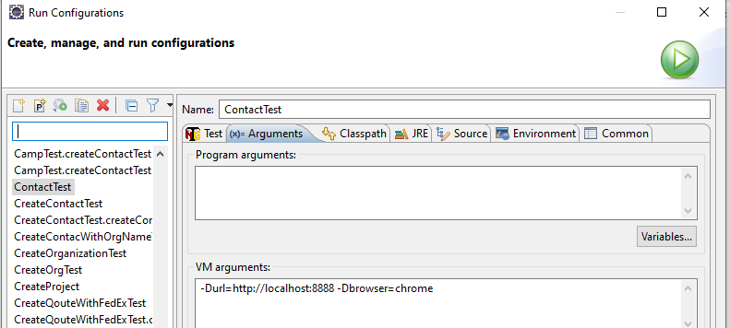

1. What is Maven Profiling & why it’s Required?

Profiling help us to execute specific testing.xml via Pom File , when we have multiple testing.xml available in same Project

