Week-4

Skill :- Spring REST using Spring Boot 3

Hands-on 1 :- Create a Spring Web Project using Maven

1. Go to <https://start.spring.io/>
2. Change Group as “com.cognizant”
3. Change Artifact Id as “spring-learn”
4. Select Spring Boot DevTools and Spring Web
5. Create and download the project as zip
6. Extract the zip in root folder to Eclipse Workspace

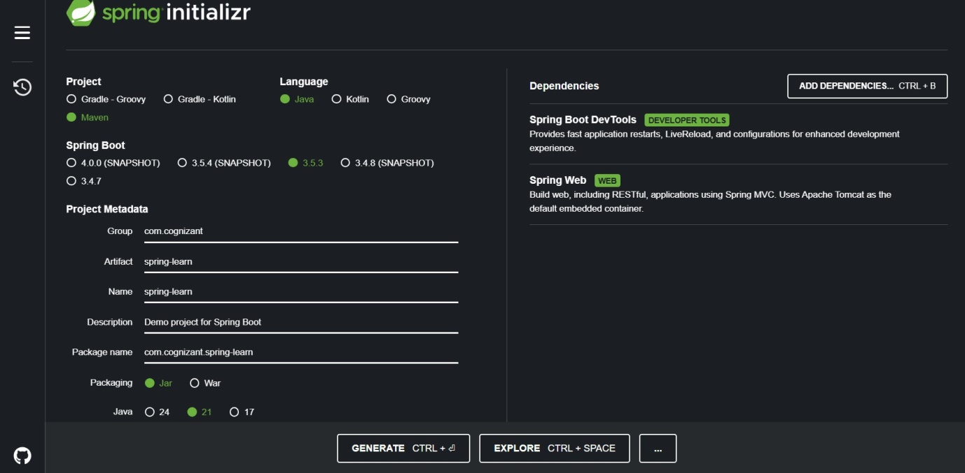

7. Build the project using ‘mvn clean package -Dhttp.proxyHost=proxy.cognizant.com -Dhttp.proxyPort=6050 -Dhttps.proxyHost=proxy.cognizant.com -Dhttps.proxyPort=6050 -Dhttp.proxyUser=123456’ command in command line

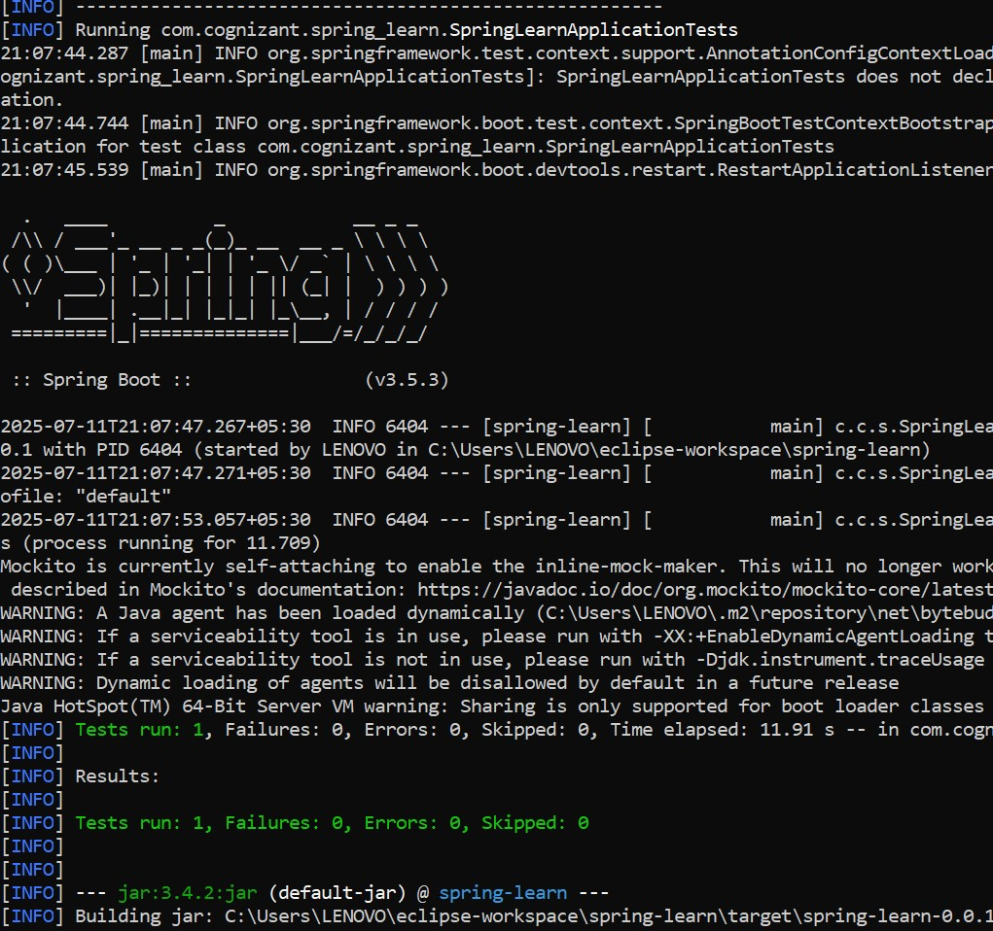

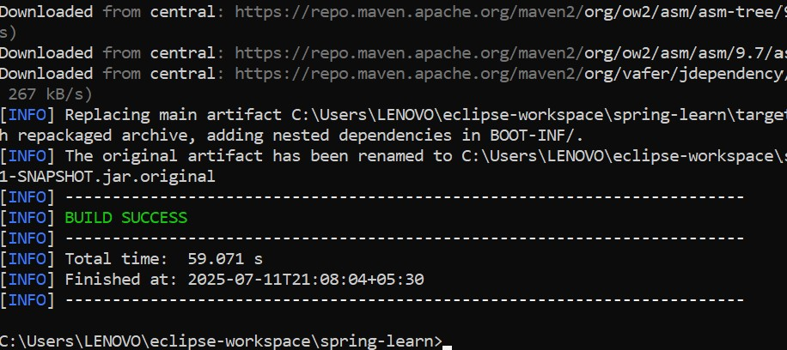

1. Include logs to verify if main() method of SpringLearnApplication.
2. Run the SpringLearnApplication class.

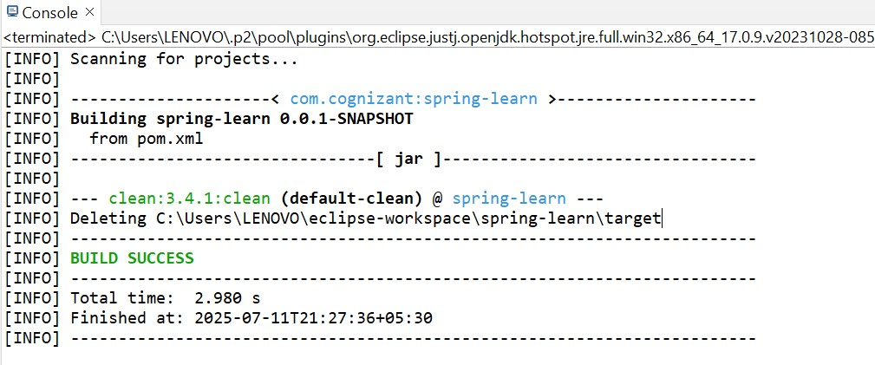

Hands-on 2 : Spring Core – Load Country from Spring Configuration XML

//Country.java

package com.cognizant.springlearn;

import org.slf4j.Logger;

import org.slf4j.LoggerFactory;

public class Country {

private static final Logger LOGGER = LoggerFactory.getLogger(Country.class);

private String code;

private String name;

public Country() {

LOGGER.debug("Inside Country Constructor.");

}

public String getCode() {

LOGGER.debug("Inside getCode()");

return code;

}

public void setCode(String code) {

LOGGER.debug("Inside setCode()");

this.code = code;

}

public String getName() {

LOGGER.debug("Inside getName()");

return name;

}

public void setName(String name) {

LOGGER.debug("Inside setName()");

this.name = name;

}

@Override

public String toString() {

return "Country [code=" + code + ", name=" + name + "]";

}

}

//Country.xml

<?xml version="1.0" encoding="UTF-8"?>

<beans xmlns="http://www.springframework.org/schema/beans"

xmlns:xsi="http://www.w3.org/2001/XMLSchema-instance"

xsi:schemaLocation="http://www.springframework.org/schema/beans

http://www.springframework.org/schema/beans/spring-beans.xsd">

<bean id="country" class="com.cognizant.springlearn.Country">

<property name="code" value="IN"/>

<property name="name" value="India"/>

</bean>

</beans>

//SpringLearnApplication.java

package com.cognizant.springlearn;

import org.slf4j.Logger;

import org.slf4j.LoggerFactory;

import org.springframework.context.ApplicationContext;

import org.springframework.context.support.ClassPathXmlApplicationContext;

public class SpringLearnApplication {

private static final Logger LOGGER = LoggerFactory.getLogger(SpringLearnApplication.class);

public static void main(String[] args) {

LOGGER.info("START");

displayCountry();

LOGGER.info("END");

}

public static void displayCountry() {

ApplicationContext context = new ClassPathXmlApplicationContext("country.xml");

Country country = (Country) context.getBean("country", Country.class);

LOGGER.debug("Country : {}", country.toString());

}

}

Output:-

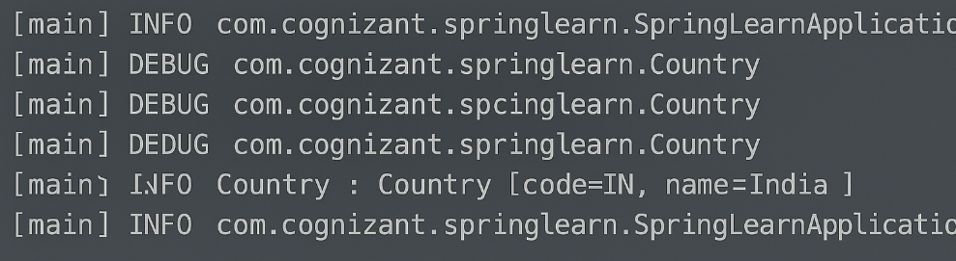

Hands-on 3:- Hello World RESTful Web Service

// HelloController.java

package com.cognizant.springlearn.controller;

import org.slf4j.Logger;

import org.slf4j.LoggerFactory;

import org.springframework.web.bind.annotation.*;

@RestController

public class HelloController {

private static final Logger LOGGER = LoggerFactory.getLogger(HelloController.class);

@GetMapping("/hello")

public String sayHello() {

LOGGER.info("START - sayHello()");

String message = "Hello World!!";

LOGGER.info("END - sayHello()");

return message;

}

}

//SpringLearnApplication.java

package com.cognizant.springlearn;

import org.springframework.boot.SpringApplication;

import org.springframework.boot.autoconfigure.SpringBootApplication;

@SpringBootApplication

public class SpringLearnApplication {

public static void main(String[] args) {

SpringApplication.run(SpringLearnApplication.class, args);

}

}

Output:-

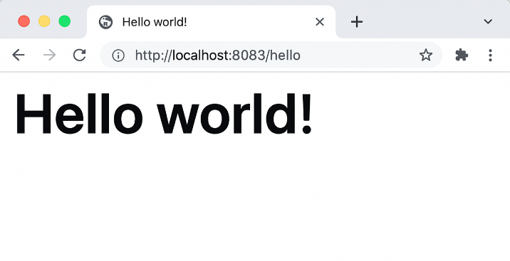

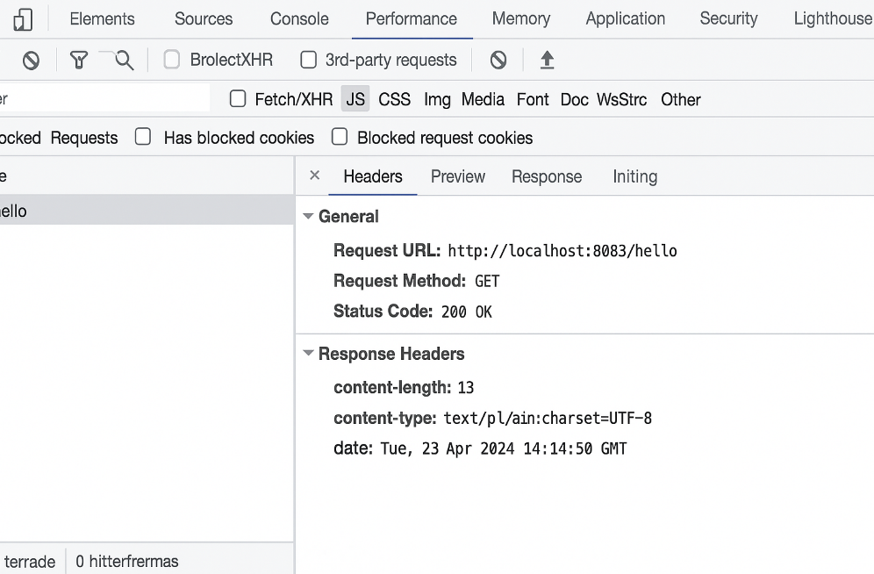

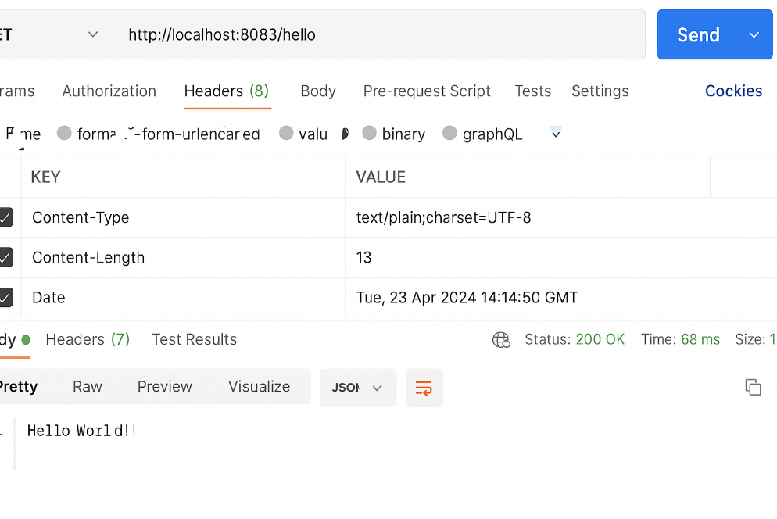

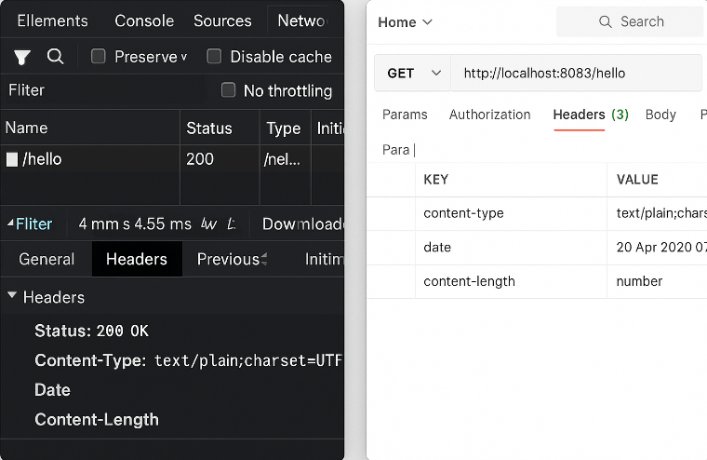

Hands-on 4:- REST - Country Web Service

***Country.java***

package com.cognizant.spring_learn.model;

public class Country {

private String code;

private String name;

public Country() {}

public Country(String code, String name) {

this.code = code;

this.name = name;

}

public String getCode() {

return code;

}

public void setCode(String code) {

this.code = code;

}

public String getName() {

return name;

}

public void setName(String name) {

this.name = name;

}

}

**CountryController.java**

package com.cognizant.spring_learn.controller;

import org.springframework.web.bind.annotation.RequestMapping;

import org.springframework.web.bind.annotation.RestController;

import org.springframework.context.ApplicationContext;

import org.springframework.context.support.ClassPathXmlApplicationContext;

import com.cognizant.spring_learn.model.Country;

@RestController

public class CountryController {

@RequestMapping("/country")

public Country getCountryIndia() {

ApplicationContext context = new ClassPathXmlApplicationContext("country.xml");

Country country = (Country) context.getBean("in");

return country;

}

}

**country.xml**

<?xml version="1.0" encoding="UTF-8"?>

<beans xmlns="http://www.springframework.org/schema/beans"

xmlns:xsi="http://www.w3.org/2001/XMLSchema-instance"

xsi:schemaLocation="http://www.springframework.org/schema/beans

http://www.springframework.org/schema/beans/spring-beans.xsd">

<bean id="in" class="com.cognizant.spring_learn.model.Country">

<property name="code" value="IN"/>

<property name="name" value="India"/>

</bean>

</beans>

**Output:**

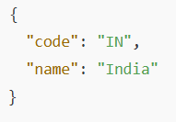

**1. What Happens in the Controller Method?**

* The /country URL is mapped to the getCountryIndia() method using @RequestMapping.
* Inside this method:
  + XmlBeanFactory loads the Spring XML file country.xml.
  + The bean with ID "in" (India) is fetched.
  + It returns the Country object to Spring’s DispatcherServlet.
* Spring Boot uses Jackson (by default) to **automatically convert** the Country object to JSON in the response.

**2.How Bean is Converted to JSON?**

Spring Boot uses **Jackson** (a JSON serialization library) under the hood. Since @RestController is used:

* @RestController = @Controller + @ResponseBody
* The return value (Country object) is passed to the **HttpMessageConverter**, which uses Jackson to serialize it to JSON.

**3. HTTP Headers in Browser Developer Tools (Network Tab)**

Example of response headers:

HTTP/1.1 200 OK

Content-Type: application/json

Transfer-Encoding: chunked

**4. Postman Headers View**

After hitting http://localhost:8083/country in Postman:

Click on Headers tab:

➤ Request Headers

Key Value

Host localhost:8083

User-Agent PostmanRuntime/...

Accept /

➤ Response Headers

Key Value

Content-Type application/json

Transfer-Encoding chunked

Date [Timestamp]

Hands-on 5:- REST - Get country based on country code

***Country.java***

package com.cognizant.spring_learn.model;

public class Country {

private String code;

private String name;

public String getCode() {

return code;

}

public void setCode(String code) {

this.code = code;

}

public String getName() {

return name;

}

public void setName(String name) {

this.name = name;

}

}

**countryService.java**

package com.cognizant.spring_learn.service;

import com.cognizant.spring_learn.model.Country;

import org.springframework.beans.factory.xml.XmlBeanFactory;

import org.springframework.core.io.ClassPathResource;

import org.springframework.stereotype.Service;

import java.util.List;

@Service

public class CountryService {

public Country getCountry(String code) {

XmlBeanFactory factory = new XmlBeanFactory(new ClassPathResource("country.xml"));

List<Country> countryList = (List<Country>) factory.getBean("countryList");

return countryList.stream()

.filter(c -> c.getCode().equalsIgnoreCase(code))

.findFirst()

.orElse(null);

}

}

**CountryController.java**

package com.cognizant.spring_learn.controller;

import com.cognizant.spring_learn.model.Country;

import com.cognizant.spring_learn.service.CountryService;

import org.springframework.beans.factory.annotation.Autowired;

import org.springframework.web.bind.annotation.*;

@RestController

public class CountryController {

@Autowired

private CountryService countryService;

@GetMapping("/countries/{code}")

public Country getCountry(@PathVariable String code) {

return countryService.getCountry(code);

}

}

**SpringLearnApplication.java**

package com.cognizant.spring_learn;

import org.springframework.boot.SpringApplication;

import org.springframework.boot.autoconfigure.SpringBootApplication;

@SpringBootApplication

public class SpringLearnApplication {

public static void main(String[] args) {

SpringApplication.run(SpringLearnApplication.class, args);

}

}

**country.xml**

<beans xmlns="http://www.springframework.org/schema/beans"

xmlns:xsi="http://www.w3.org/2001/XMLSchema-instance"

xsi:schemaLocation="http://www.springframework.org/schema/beans

https://www.springframework.org/schema/beans/spring-beans.xsd">

<bean id="countryList" class="java.util.ArrayList">

<constructor-arg>

<list>

<bean class="com.cognizant.spring_learn.model.Country">

<property name="code" value="IN"/>

<property name="name" value="India"/>

</bean>

<bean class="com.cognizant.spring_learn.model.Country">

<property name="code" value="US"/>

<property name="name" value="United States"/>

</bean>

<bean class="com.cognizant.spring_learn.model.Country">

<property name="code" value="FR"/>

<property name="name" value="France"/>

</bean>

</list>

</constructor-arg>

</bean>

</beans>

**Output:**

GET http://localhost:8083/countries/in

