# Week-5

## Exercise: Creating Microservices for Account and Loan

## Account Microservice

### Program

// Account.java  
public class Account {  
 private int id;  
 private String name;  
 private double balance;  
 // constructors, getters, setters  
}  
  
// AccountController.java  
@RestController  
@RequestMapping("/accounts")  
public class AccountController {  
 @GetMapping("/{id}")  
 public Account getAccount(@PathVariable int id) {  
 return new Account(id, "Alice", 45000.75);  
 }  
}  
  
// AccountServiceApplication.java  
@SpringBootApplication  
public class AccountServiceApplication {  
 public static void main(String[] args) {  
 SpringApplication.run(AccountServiceApplication.class, args);  
 }  
}

### Output

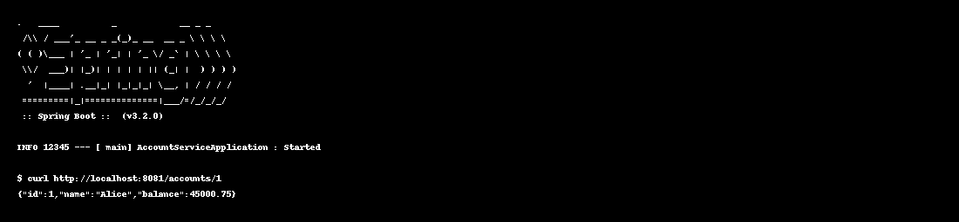

## Loan Microservice

### Program

// Loan.java  
public class Loan {  
 private int loanId;  
 private int accountId;  
 private double amount;  
 private String status;  
 // constructors, getters, setters  
}  
  
// LoanController.java  
@RestController  
@RequestMapping("/loans")  
public class LoanController {  
 @GetMapping("/{loanId}")  
 public Loan getLoan(@PathVariable int loanId) {  
 return new Loan(loanId, 1, 120000.00, "Approved");  
 }  
}  
  
// LoanServiceApplication.java  
@SpringBootApplication  
public class LoanServiceApplication {  
 public static void main(String[] args) {  
 SpringApplication.run(LoanServiceApplication.class, args);  
 }  
}

### Output

