Week-7

Skill :- React

Hands-on 1: 9.Create a React Application named “cricketapp” with the following components:

Step1:

npx create-react-app cricketapp

cd cricketapp

npm start

Step2:-

//ListofPlayers.js

// src/components/ListofPlayers.js

import React from "react";

const ListofPlayers = () => {

const players = [

{ name: "Rohit", score: 95 },

{ name: "Virat", score: 88 },

{ name: "Rahul", score: 65 },

{ name: "Shreyas", score: 50 },

{ name: "Jadeja", score: 75 },

{ name: "Ashwin", score: 60 },

{ name: "Shami", score: 45 },

{ name: "Bumrah", score: 85 },

{ name: "Gill", score: 92 },

{ name: "Surya", score: 70 },

{ name: "Pant", score: 68 },

];

const filteredPlayers = players.filter(player => player.score < 70);

return (

<div>

<h2>All Players</h2>

<ul>

{players.map((player, idx) => (

<li key={idx}>

{player.name} - {player.score}

</li>

))}

</ul>

<h2>Players with Score Below 70</h2>

<ul>

{filteredPlayers.map((player, idx) => (

<li key={idx}>

{player.name} - {player.score}

</li>

))}

</ul>

</div>

);

};

export default ListofPlayers;

//IndianPlayers.js

// src/components/IndianPlayers.js

import React from "react";

const IndianPlayers = () => {

const T20players = ["Rohit", "Virat", "Hardik"];

const RanjiTrophy = ["Jaiswal", "Sarfaraz", "Gaikwad"];

// Merge arrays using spread operator

const mergedPlayers = [...T20players, ...RanjiTrophy];

// Destructuring example

const [odd1, even1, odd2, even2] = mergedPlayers;

return (

<div>

<h2>Merged Players</h2>

<ul>

{mergedPlayers.map((player, idx) => (

<li key={idx}>{player}</li>

))}

</ul>

<h2>Odd Team Players</h2>

<p>{odd1}, {odd2}</p>

<h2>Even Team Players</h2>

<p>{even1}, {even2}</p>

</div>

);

};

export default IndianPlayers;

//App.js

// src/App.js

import React from "react";

import ListofPlayers from "./components/ListofPlayers";

import IndianPlayers from "./components/IndianPlayers";

function App() {

const flag = true; // Toggle this between true/false to test

return (

<div className="App">

<h1>Cricket App</h1>

{flag ? <ListofPlayers /> : <IndianPlayers />}

</div>

);

}

export default App;

Output:-

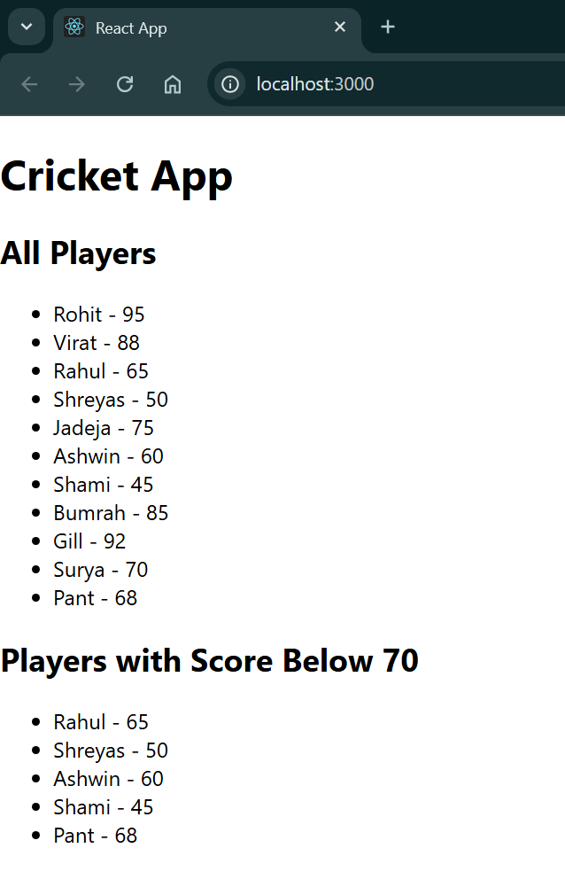

Handson 2:- 10.Create an element to display the heading of the page. Attribute to display the image of the office space Create an object of office to display the details like Name, Rent and Address. Create a list of Object and loop through the office space item to display more data.

Step1:

npx create-react-app officespacerentalapp

cd officespacerentalapp

Step2:-

//App.js

import React from 'react';

// Define a single office space object (can be reused later)

const singleOffice = {

name: "TechPark HQ",

rent: 75000,

address: "MG Road, Bangalore",

imageUrl: "https://via.placeholder.com/300x200?text=Office+Space"

};

// Define a list of multiple office spaces

const officeList = [

{

name: "Workspace One",

rent: 50000,

address: "Indiranagar, Bangalore"

},

{

name: "Startup Hub",

rent: 62000,

address: "Koramangala, Bangalore"

},

{

name: "Innovate Place",

rent: 58000,

address: "HSR Layout, Bangalore"

},

{

name: "Elite Towers",

rent: 70000,

address: "Whitefield, Bangalore"

}

];

// Function to apply inline style based on rent

const getRentStyle = (rent) => {

return {

color: rent < 60000 ? 'red' : 'green',

fontWeight: 'bold'

};

};

function App() {

return (

<div style={{ padding: "20px", fontFamily: "Arial" }}>

{/\* Heading using JSX \*/}

<h1>Office Space Rental App</h1>

{/\* Image using JSX attributes \*/}

<img src={singleOffice.imageUrl} alt="Office" style={{ width: "300px", height: "200px" }} />

{/\* Displaying object using JSX \*/}

<h2>{singleOffice.name}</h2>

<p><strong>Rent:</strong> <span style={getRentStyle(singleOffice.rent)}>{singleOffice.rent}</span></p>

<p><strong>Address:</strong> {singleOffice.address}</p>

<hr />

{/\* Loop through office list \*/}

<h2>Available Office Spaces</h2>

<ul>

{officeList.map((office, index) => (

<li key={index} style={{ marginBottom: "20px", listStyle: "none" }}>

<h3>{office.name}</h3>

<p>

<strong>Rent:</strong>{" "}

<span style={getRentStyle(office.rent)}>{office.rent}</span>

</p>

<p><strong>Address:</strong> {office.address}</p>

</li>

))}

</ul>

</div>

);

}

export default App;

Output:-

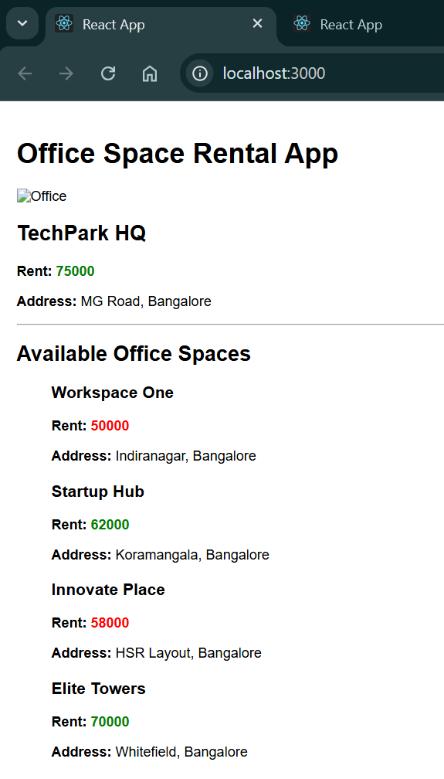

Hands-on 3: 11. Create a React Application “eventexamplesapp” to handle various events of the form elements in HTML.

Step1:

npx create-react-app eventexamplesapp

cd eventexamplesapp

Step2:-

// src/components/Counter.js

import React, { Component } from "react";

class Counter extends Component {

constructor(props) {

super(props);

this.state = {

count: 0,

};

// Bind the traditional function if not using arrow functions

this.increment = this.increment.bind(this);

}

increment() {

this.setState((prevState) => ({ count: prevState.count + 1 }));

this.sayHello(); // Invoking another method

}

sayHello() {

alert("Hello! You clicked increment.");

}

decrement = () => {

this.setState((prevState) => ({ count: prevState.count - 1 }));

};

sayWelcome = (message) => {

alert(`Message: ${message}`);

};

handleSyntheticEvent = (e) => {

// Synthetic event object

e.preventDefault();

alert("I was clicked");

};

render() {

return (

<div style={{ marginBottom: "40px" }}>

<h2>Counter Example</h2>

<p>Count: {this.state.count}</p>

<button onClick={this.increment}>Increment</button>

<button onClick={this.decrement}>Decrement</button>

<br />

<br />

<button onClick={() => this.sayWelcome("Welcome to React!")}>

Say Welcome

</button>

<br />

<br />

<button onClick={this.handleSyntheticEvent}>Synthetic Event</button>

</div>

);

}

}

export default Counter;

// src/components/CurrencyConvertor.js

import React, { useState } from "react";

const CurrencyConvertor = () => {

const [rupees, setRupees] = useState("");

const [euros, setEuros] = useState(null);

const handleChange = (e) => {

setRupees(e.target.value);

};

const handleSubmit = (e) => {

e.preventDefault(); // Synthetic event

const conversionRate = 0.011; // 1 INR = 0.011 EURO approx

setEuros((rupees \* conversionRate).toFixed(2));

};

return (

<div>

<h2>Currency Convertor</h2>

<form onSubmit={handleSubmit}>

<label>Enter amount in INR: </label>

<input type="number" value={rupees} onChange={handleChange} />

<button type="submit">Convert</button>

</form>

{euros && <p>Converted Amount: €{euros}</p>}

</div>

);

};

export default CurrencyConvertor;

// src/App.js

import React from "react";

import Counter from "./components/Counter";

import CurrencyConvertor from "./components/CurrencyConvertor";

function App() {

return (

<div className="App" style={{ padding: "20px", fontFamily: "Arial" }}>

<h1>React Event Handling Examples</h1>

<Counter />

<hr />

<CurrencyConvertor />

</div>

);

}

export default App;

Output:-

