Week-8

Skill name : GIT-HOL

Hands-on 1: Familiar with Git commands like git init, git status, git add, git commit, git push, and git pull.



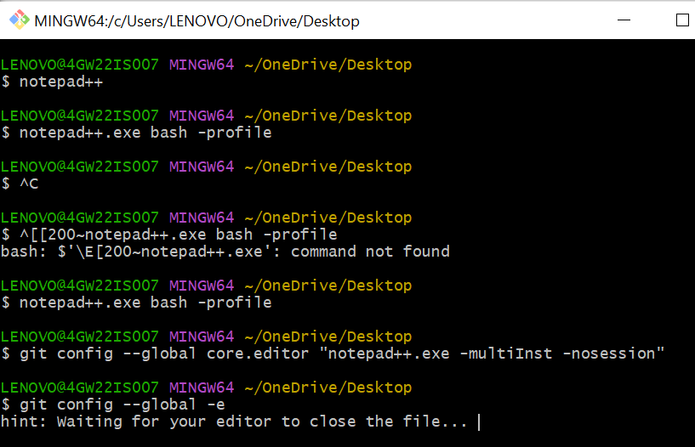

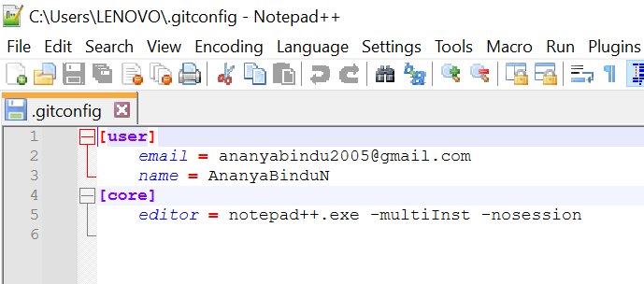

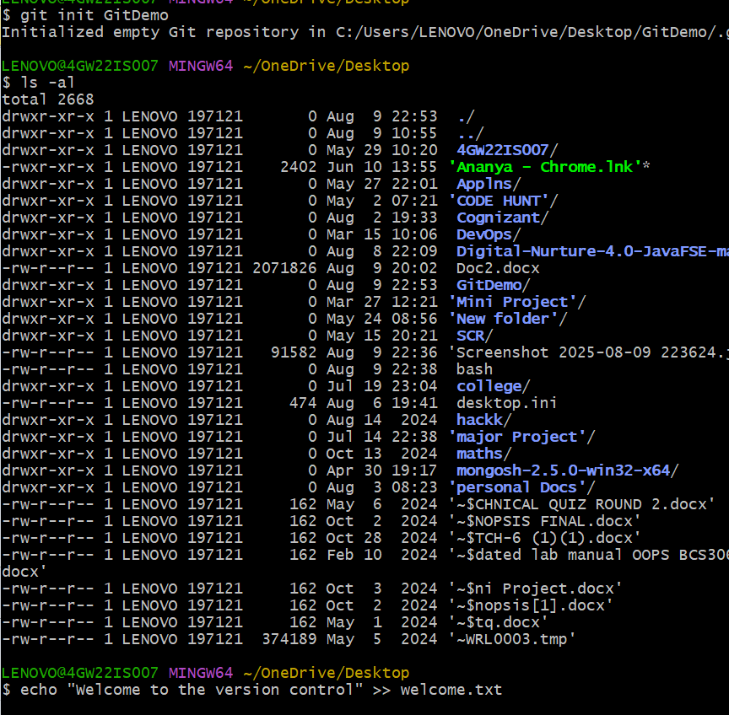

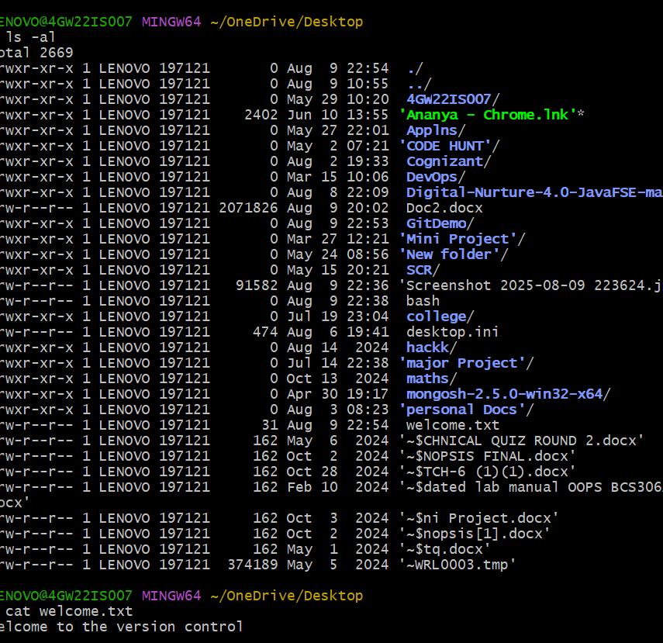

Hands-on 2:- Create a **“.log”** file and a **log folder** in the working directory of Git. Update the **.gitignore** file in such a way that on committing, these files (.log extensions and log folders) are ignored.

Verify if the git status reflects the same about working directory, local repository and git repository.

