DPJ – Practical Class 2
Technical Document – Animations with Code

Introduction
This technical document summarizes the steps, concepts, and implementation details of Practical Class 2 of the Design e Programação de Jogos (DPJ) course. The lab focuses on creating character animations driven by code in Unity, using the new Input System, Rigidbody2D physics, and the Animator with Blend Trees.
The main objective is to implement a fully controllable 2D character (Green Ninja) that moves in four directions and plays the corresponding walk and idle animations based on player input.

Project Setup
A new 2D Unity project named DPJ_Lab02 was created. The following windows were opened and docked for workflow efficiency:
Animation (Window > Animation > Animation)
Animator (Window > Animation > Animator)
The Input System package was installed via the Package Manager (Unity Registry).

Input Actions
Inside the Assets/Actions folder, a new Input Actions asset was created. This asset generates a C# class that provides type-safe access to the defined actions.
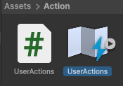
Action Map: Movement
Action “Move” – Action Type: Value, Control Type: Vector2
Binding: Up/Down/Left/Right Composite
Each direction was assigned to a keyboard key (WASD or arrow keys) using the Listen feature or by selecting the path manually.
After saving the asset, Unity automatically generates a corresponding C# class that can be instantiated in scripts.
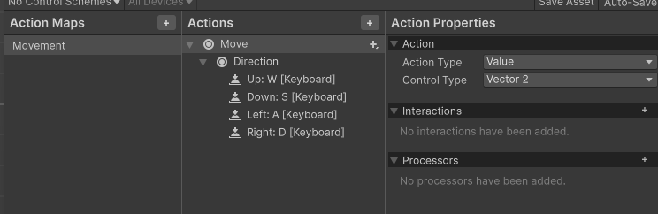

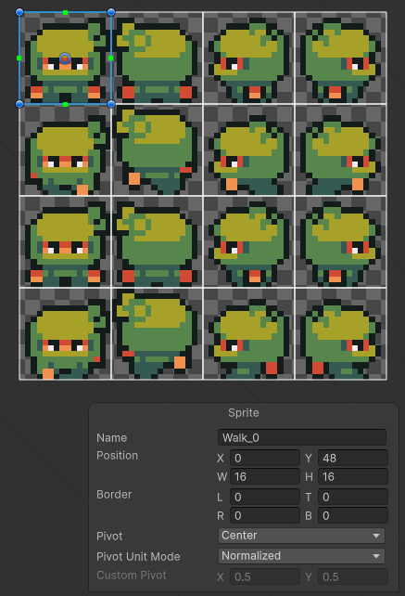
Sprite Preparation – Green Ninja
All animation sprites belonging to the “Green Ninja” character were selected and configured with the following import settings to ensure crisp pixel art rendering:
Pixels Per Unit: 16
Filter Mode: Point (no filter)
Compression: None
For the Walk spritesheet, the Sprite Editor was used with the following slicing parameters:
Type: Grid By Cell Size
Pixel Size: 16 × 16
Single sprites use Sprite Mode “Single”; animation sequences use Sprite Mode “Multiple”.

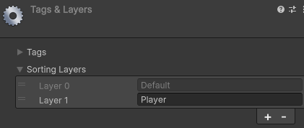
Sorting Layer
A new Sorting Layer named Player was created in the Sprite Renderer’s Additional Settings. The PlayerNinja GameObject was assigned to this layer so that it correctly renders above the background and tilemap layers.

PlayerMovement Script
A C# script named PlayerMovement.cs was created inside Assets/Scripts/Player and attached to the PlayerNinja GameObject.

Variables
The following private fields were declared:
[SerializeField] private float speed;
private <InputActionsClass> actions; – reference to the generated Input Actions class
private Rigidbody2D rb;
private Animator animator;
private Vector2 moveDirection;

Initialization (Awake)
In the Awake() method the references are obtained:
actions = new <InputActionsClass>();
rb = GetComponent<Rigidbody2D>();
animator = GetComponent<Animator>();

Enabling / Disabling Input
Two lifecycle methods ensure the Input Actions are only active while the component is enabled:
OnEnable() → actions.Enable();
OnDisable() → actions.Disable();

Physics Setup – Rigidbody2D
A Rigidbody2D component was added to PlayerNinja with the following settings:
Gravity Scale: 0 (top-down movement, not affected by gravity)
Constraints: Freeze Rotation Z (prevents the character from rotating on collisions)

Movement Logic
Movement is split into reading input and applying physics for clean separation of concerns.

ReadMovement()
Called every frame from Update():
moveDirection = actions.Movement.Move.ReadValue<Vector2>().normalized;

If the direction is zero the method returns early (and sets the Moving boolean to false for the idle state). Otherwise the Animator parameters are updated:
animator.SetFloat("MoveX", moveDirection.x);
animator.SetFloat("MoveY", moveDirection.y);
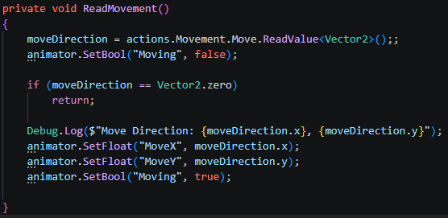
animator.SetBool("Moving", true);

Move()
Called from FixedUpdate() so that movement stays synchronized with the physics engine:
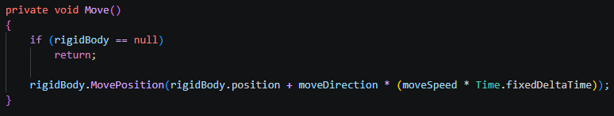
rb.MovePosition(rb.position + moveDirection * (speed * Time.fixedDeltaTime));

Animation Clips
A folder structure Assets/Animations/Player was created. Four walk animations were authored in the Animation window:
Walk_Down – frames: Walk_0 → Walk_4 → Walk_8 → Walk_12 → Walk_0 (loop)
Walk_Up
Walk_Left
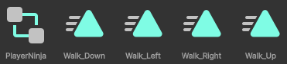
Walk_Right

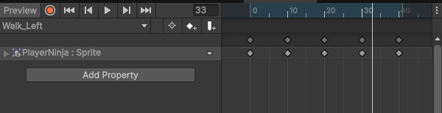
Keyframes were placed at frames 0, 10, 20, 30 and 40 to create a smooth looping walk cycle.

Animator Controller and Blend Tree
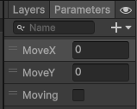
The default animation nodes generated when creating the clips were deleted. A new Blend Tree was created and configured as follows:
Blend Type: 2D Simple Directional
Parameters: MoveX (float) and MoveY (float)
Four Motions corresponding to the four walk directions.
Each motion was assigned the correct directional thresholds (e.g. Walk_Right → X = 1, Y = 0; Walk_Up → X = 0, Y = 1, etc.).
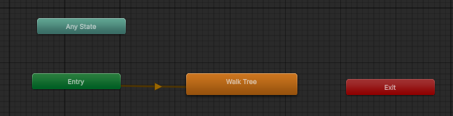

The Blend Tree automatically interpolates between the four directional animations according to the current values of MoveX and MoveY, producing smooth transitions when the player changes direction.
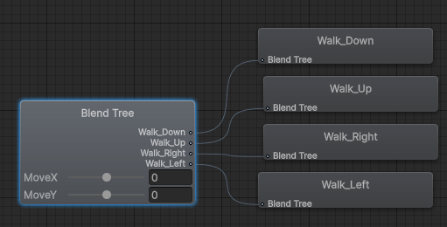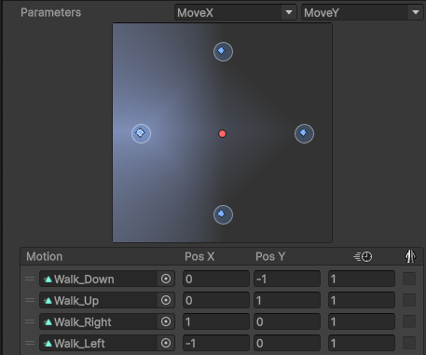

Idle Animations
The same sprite-slicing process was repeated for the Idle spritesheet. Four idle animation clips were created:
Idle_Down, Idle_Up, Idle_Left, Idle_Right
A second Blend Tree named Idle Tree was created with the same 2D Simple Directional setup.
Animator State Machine configuration:
A boolean parameter Moving was added.
Entry state points to the Idle Tree.
Transition Idle Tree → Move Tree: condition Moving = true.
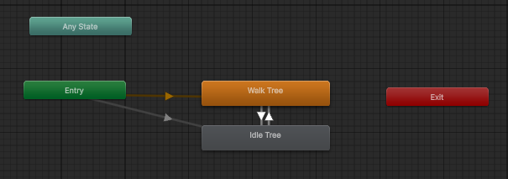
Transition Move Tree → Idle Tree: condition Moving = false.
In the ReadMovement() method the Moving parameter is set to false when no input is detected and to true otherwise. This produces an immediate switch between idle and walk states without any delay.

Summary of Key Concepts
Input System – Modern, flexible way to handle player input with generated C# classes.
Rigidbody2D.MovePosition – Physics-safe movement that respects collisions.
Blend Trees (2D Simple Directional) – Automatic blending of directional animations based on two float parameters.
Animator Parameters – Floats (MoveX/MoveY) and Bool (Moving) drive the state machine.

