DPJ – Practical Class 3
Technical Document – Design of Mechanics

Introduction
This technical document summarizes the steps, concepts and implementation details of Practical Class 3 of the Design e Programação de Jogos (DPJ). The laboratory continues the project started in Practical Class 2 and introduces Scriptable Objects, Interfaces, properties and Lambda expressions.
The main goal is to implement a health system for the player character, handle damage through a reusable interface, trigger a death animation, and prevent movement when the player has no remaining health.

Scriptable Objects – PlayerStats
A new script named PlayerStats was created inside Assets/Scripts/Player. Instead of inheriting from MonoBehaviour, the class inherits from ScriptableObject.
The attribute placed above the class definition allows the creation of asset instances from the Project window:
[CreateAssetMenu(fileName = "PlayerStats", menuName = "Player Stats")]
Inside the class the following fields were declared:
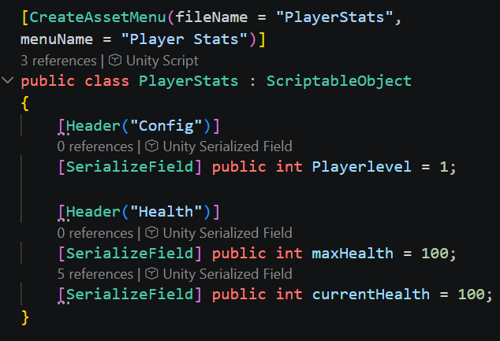
A folder Assets/SO was created and a Scriptable Object asset named “Player Stats” was instantiated from the Create menu. Logical default values were assigned in the Inspector.
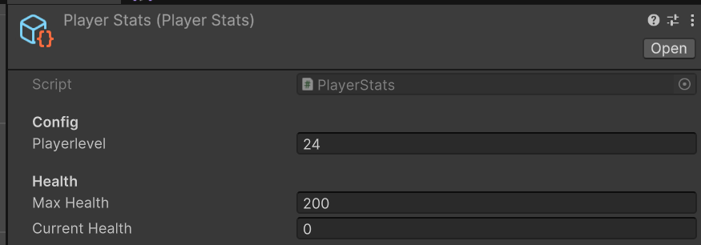

Interface – IDamageable
An interface named IDamageable was created inside Assets/Scripts/Extra. The keyword class was replaced by interface and the following method signature was defined:
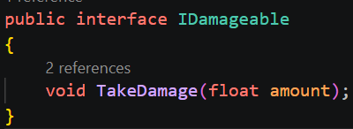
Interfaces define a contract that any implementing class must fulfil. This allows different GameObjects (player, enemies, destructible objects, etc.) to share a common damage-receiving API without sharing implementation details.

PlayerHealth Component
The script PlayerHealth was created inside the Player folder. It inherits from MonoBehaviour and implements the interface:
A serialized reference to the Scriptable Object was added:

TakeDamage Method
Because the class implements IDamageable, the method TakeDamage becomes publicly accessible. Inside the method:
The received amount is subtracted from playerStats.currentHealth.
An if statement checks whether current health is less than or equal to zero; if true, PlayerDead() is called.
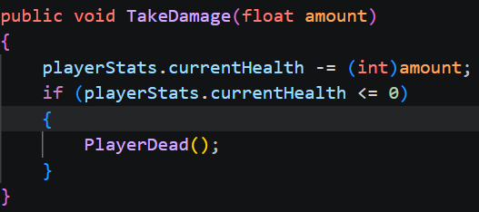

PlayerDead Method
The method logs a message to the Console:
Debug.Log("Jogador Derrotado");
Later this method was extended to also trigger the death animation.

Testing Damage
A temporary test block was placed inside Update():
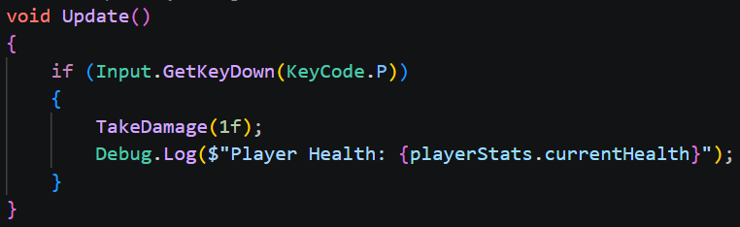
While in Play mode the PlayerStats asset can be selected in the Project window; pressing the P key repeatedly reduces the current health value and eventually triggers the death logic.

Death Animation
An animation clip named Player_Dead was created containing a single keyframe (frame 0) with the appropriate death sprite.
In the Animator Controller:
A Trigger parameter named Dead was added.
A transition from Any State to the Dead state was created.
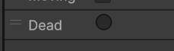

The condition of the transition was set to the Dead trigger.
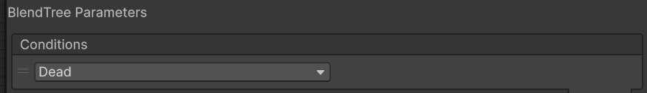

PlayerAnimations Script
A new script PlayerAnimations was created and attached to the player. It centralizes all Animator parameter access, improving readability and maintainability.

Hashed Parameter IDs
Using Animator.StringToHash avoids string lookups at runtime:
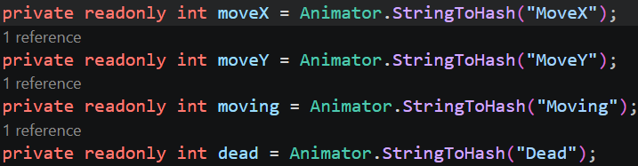
The Animator reference is obtained in Awake() via GetComponent<Animator>().

Public Methods
SetDeadAnimation() – calls animator.SetTrigger(dead);
SetMoveBoolTransition(bool value) – calls animator.SetBool(moving, value);
SetMoveAnimation(Vector2 dir) – sets the MoveX and MoveY float parameters using the hashed IDs.

Refactoring PlayerMovement
Direct calls to the Animator inside PlayerMovement were replaced by calls to the new PlayerAnimations component.

Connecting the Death Animation
In PlayerHealth a reference to PlayerAnimations was obtained. The PlayerDead() method was updated to call:
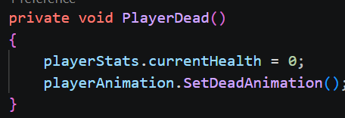

Player Class and Lambda Property
A new central component named Player was created. It holds a serialized reference to the PlayerStats Scriptable Object and exposes it through a read-only property using a Lambda expression:
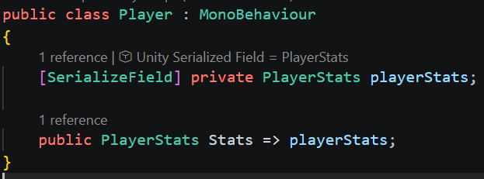
This expression-bodied property grants other scripts controlled access to the private stats field without exposing a public setter.

Preventing Movement When Dead
Inside PlayerMovement.Move() a guard clause was added at the beginning:
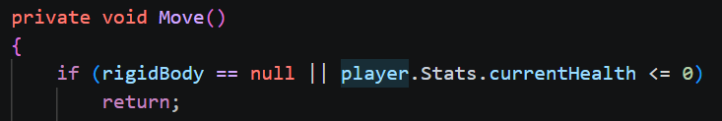
When the player’s health reaches zero the character stops responding to movement input while the death animation can still play.
— End of Technical Document —

