DPJ – Practical Class 4
Technical Document – UI and UX

Introduction
This technical document summarizes the steps, concepts and implementation details of Practical Class 4 of the Design e Programação de Jogos course. The laboratory introduces user interface (UI) and user experience (UX) concepts in Unity, focusing on Canvas, TextMeshPro, buttons, Scriptable Objects for questions, dynamic answer feedback, and a timer system with visual fill.
The main deliverable is a single-question questionnaire that reads data dynamically, tracks elapsed time, and provides clear visual feedback for correct and incorrect answers.

Project Setup
A new 2D Unity project named DPJ_Lab4 was created. The default scene was renamed to WhyUI.
A background image was imported and converted to the Sprite type so it could be used by UI Image components. The Game view resolution was set to Full HD for consistent layout testing.

Background Canvas and Title
A Canvas was created and renamed Background. An Image child was added and anchored to stretch across the entire screen (using the center preset combined with Shift + Alt so Pos X/Y/Z become zero and the image fills the parent). The background sprite was assigned as the Source Image.
A TextMeshProUGUI element named Title was created under the Background Canvas, positioned and styled as desired to display the main title of the interface.

Quiz Canvas and Answer Buttons
A second Canvas named QuizCanvas was created. Inside it a TextMeshProUGUI element was added for the question text.
A Button was created, its colours adjusted for visual clarity, then moved under an empty GameObject named Button Group. A Vertical Layout Group component was added to the group to automatically arrange the buttons. Three additional copies of the button were made (total of four answer options).
The final button was saved as a Prefab in a dedicated Prefabs folder and the four instances on the Canvas were replaced by prefab instances for easier future updates.
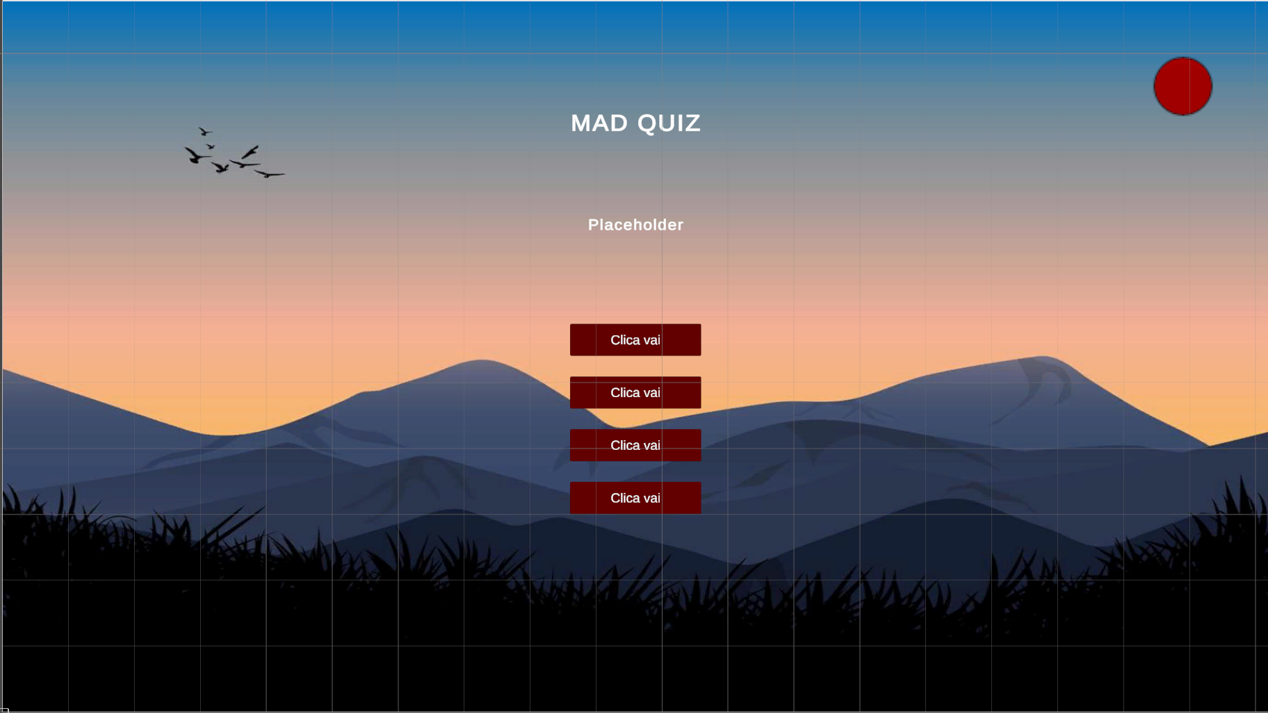

Question Scriptable Object
A script named QuestionSO.cs was created as a ScriptableObject with the attribute:
[CreateAssetMenu(fileName = "New Question", menuName = "Question")]
The following private serialized fields were defined:
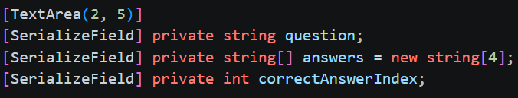
Public getter methods were added:
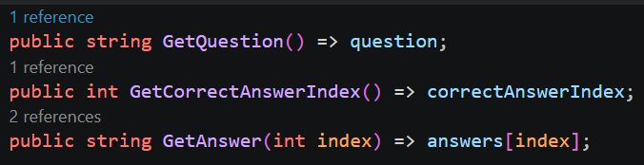
A concrete Question asset was created in a dedicated ScriptableObjects folder and filled with a question text, four possible answers and the correct answer index.

Questionaire Script
A new script Questionaire.cs was attached to the QuizCanvas. Key serialized fields include:
- QuestionSO reference
- TextMeshProUGUI for the question text
- GameObject[] array holding the four answer buttons
- Optional fields for score or current index tracking

DisplayQuestion
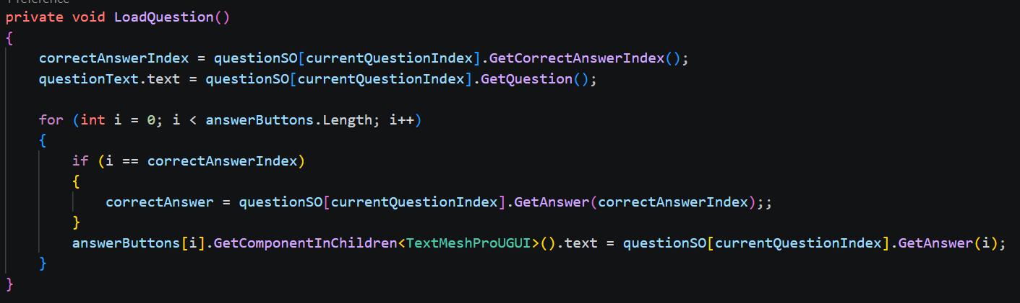
The method retrieves the question text from the ScriptableObject and assigns it to the TextMeshProUGUI. A for loop iterates over the button array, obtains each button’s TextMeshProUGUI child and sets its text to the corresponding answer from GetAnswer(i).
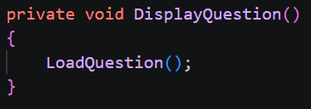

OnAnswerSelected
Each button’s OnClick event is wired to OnAnswerSelected(int index) with the appropriate index. The method compares the selected index with the correct answer index:
- If correct → the question text is changed to a success message.
- If incorrect → the correct answer is fetched via GetAnswer(CorrectAnswerIndex) and a feedback message is displayed.

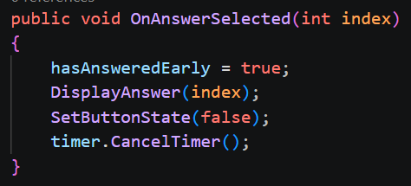

SetButtonState
A helper method SetButtonState(bool state) loops through the button array, obtains the Button component of each and sets interactable to the supplied state. After an answer is selected the buttons are disabled (state = false) to prevent further clicks.
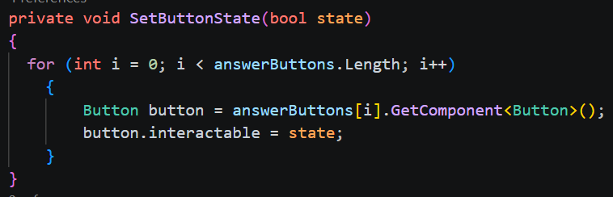

Timer System
An Image was added under QuizCanvas. Its Image Type was set to Filled and Fill Origin to Top. This Image visually represents the remaining time.
A child GameObject named Timer received a new script Timer.cs containing:
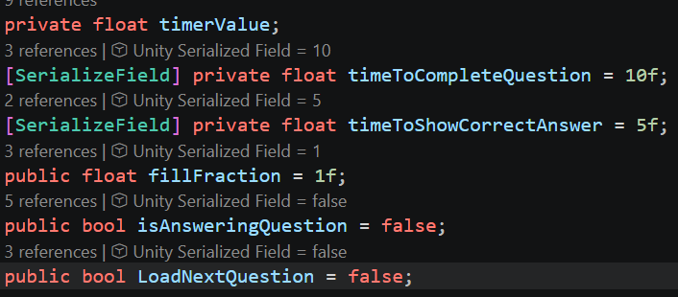

UpdateTimer Logic
Each frame timerValue is decremented by Time.deltaTime. When the value reaches zero the script switches between two phases:
- Answering phase – player can select an answer; fillFraction = timerValue / timeToCompleteQuestion.
- Review phase – correct answer is shown for a short period; fillFraction is recalculated against timeToShowCorrectAnswer.
The Questionaire script reads timer.fillFraction every frame and assigns it to the timer Image’s fillAmount, producing a smooth visual countdown.
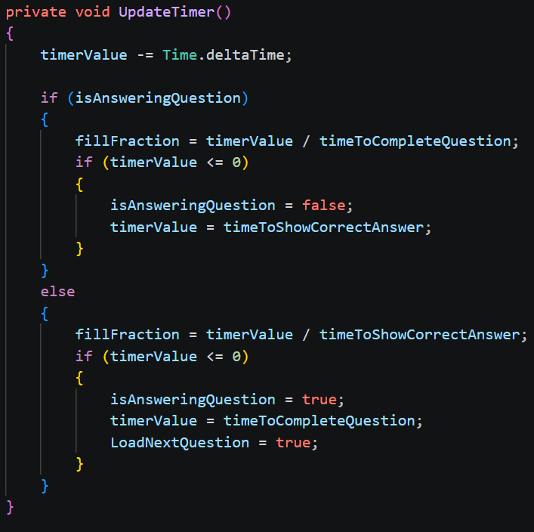

Early Answer Handling and Flow Control
A boolean hasAnsweredEarly was added to Questionaire. When the player clicks an answer the flag is set to true and the timer is cancelled via CancelTimer().
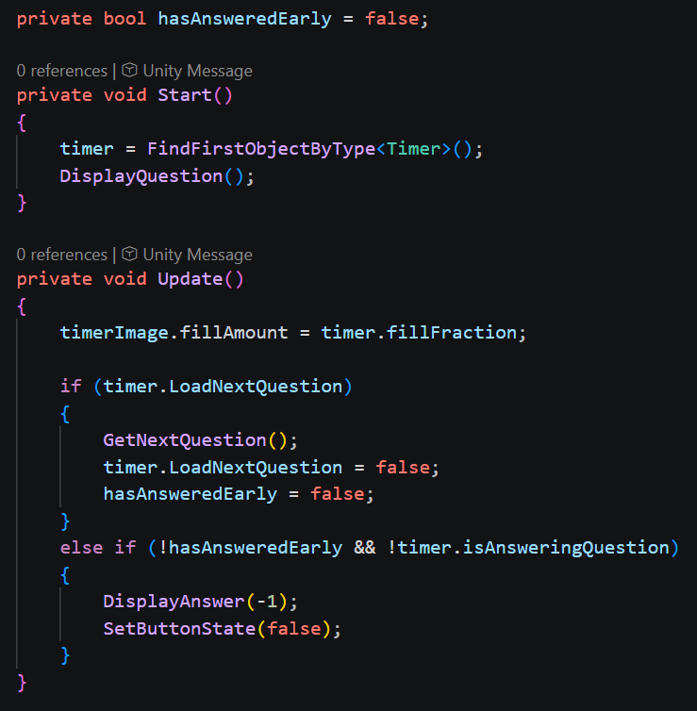

In Update the script checks:
- If the timer signals that the next question should load → call GetNextQuestion() and reset the flag.
- Else if the player hasn’t answered early and the timer ran out → call DisplayAnswer(-1) and disable the buttons.
DisplayAnswer(int index) centralises the correct/incorrect feedback logic previously located inside OnAnswerSelected, keeping the code clean and reusable.

GetNextQuestion
This method re-enables the answer buttons (SetButtonState(true)) and calls DisplayQuestion() so a new question is presented. In a multi-question extension this method would also advance the question index.
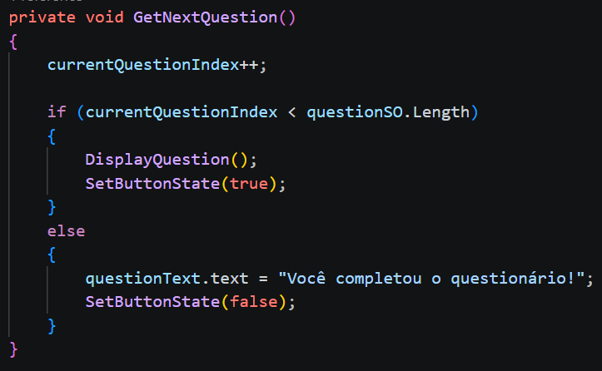

Summary of Key Concepts
- Canvas & RectTransform anchors – precise layout control for different screen resolutions.
- TextMeshPro – high-quality text rendering for UI.
- Vertical Layout Group – maintainable button arrangements.
- ScriptableObject for questions – data-driven content that can be edited without touching code.
- Filled Image as timer visual – intuitive remaining-time feedback.
- State flags (isAnsweringQuestion, hasAnsweredEarly) – clean separation of answering vs. review phases and early-answer handling.

— End of Technical Document —

